Force Required to Reach the Modulus of Rupture in a Balsawood Beam

Section 2, Team F

Gabriel DiMartino, Noah Sabra, Alex McCulloch, Payton Peters

Gonzaga University

9 March 2022

**Introduction**

The modulus of rupture is the physical limitation of a material. It serves as the boundary separating a firm structure from a destroyed one. Without this value many lives could be lost due to the unknown limitations of a material. ​Similarly, the shape of the object under load heavily influences the modulus of rupture as exerted forces are balanced on the whole object. The following report includes herein a design for a structural beam of balsawood, given the constraints of the length of beam, maximum height, maximum width, and the number of allowed square dowels.

**Background**

For beam designs, several variables can be altered to both increase and decrease performance. These include base size, beam height, and beam shape. The original beam was a single solid core beam of balsawood with a base of ¾ inch by 18 inches and a height of 1 inch. As a control, the original beam had a low modulus of rupture as the force exerted downward was not well balanced throughout the whole beam. In a paper released by the Arizona College of Optics, the downward force is used to explain how a beam can undergo a non-uniform or irregular bending and its effects on the object (Arizona College of Optics, 2016). To counteract the downward force and increase the modulus of rupture, the shape of the beam is critical in dispersing load. This is due to the neutral axis, the vertical center of an object. As load is exerted downwards and a normal force is exerted upwards on the end of the beam, the neutral axis serves as the middle ground and is critical in supporting the beam. If the design is flawed and the neutral axis is not well supported, then the modulus of rupture decreases. Moving forward, further testing will be needed to determine if other factors besides design can impact the modulus of rupture such as adhesive and method of manufacturing.

**Methods**

To maximize the modulus of rupture, a T beam was engineered with a base of 2 1/4in wooden dowels. 3 of these were stacked, creating a 2 by 3 grid of balsa wood. Finally, a single dowel was placed on the seam of the base to help share the load evenly. Originally deciding between a standard, I beam and this T beam, the T beam was chosen for its sturdy and force dispersion abilities. The 6 dowels bonded together created a solid foundation to support the neutral axis. Similarly, the single dowel at the top was optimal in dispersing load from the single pressure point to the entirety of the beam. Finally, this design satisfied all constraints as its height and length were within the size limit of the testing apparatus. Similarly, only 7 dowels were used for the maximum number of wooden dowels allowed. Modeling this design in MATLAB, data from an earlier experiment was used to find the average modulus of rupture in a single balsa dowel. This was done by finding the minimum, maximum and standard deviation of the dataset. Finally, this was combined with the calculated inertia () and neutral axis () where C is the vertical center of each dowel from the reference 0 at the base of the beam. The failure force was calculated in units of LBS. By modeling in MATLAB, the beams performance minimum, maximum, and average values were already known, allowing for clean data collection. Similarly, the predicted value of 432 pounds exceeded the control group's original modulus of rupture. Evaluation of the beam design was done using a MATLAB script calculating the applied force at the modulus of rupture within a predetermined time of 10 seconds. This data was then recorded alongside a visual aid showing the applied force both before and after the beam ruptured.

**Test Results and Analysis**

During the testing, the results showed that the 2 by 2 by 2 by 1 structure can have a range of 308 to 570 pounds of force. The expected force according to the failure force equation was 454.4 pounds of force, compared to the team’s mean breaking force of 405.8 pounds of force (Figure 5). In comparison to the data gained and the data expected, the results were below what was expected. This could be caused by the quality of construction for each beam. One beam was glued all at once while the others were made with a lack of glue due to a shortage of supply. These factors are a probable cause for the vast range of the beam and lower results than expected. In addition to this, if looking at figures 1 and 2, there are multiple peaks seen in the graph. These peaks are caused by pressure on the beam continuing after the first break. This also likely caused an error in the data.

**Conclusion**

Moving forward, this data in comparison to the predicted modulus of rupture shows a promise in industrial T beam applications. Further research will be necessary to test other variables outside of the control of this experiment. For example, changing the material, adhesive, and method of connecting the materials may allow for lighter and stronger beams. While the final data values varied from 308 to 572 pounds, many errors in manufacturing could be accounted for this large variance. For example, if equal pressure was applied and the adhesive was properly bounded to the material, the beams may have been more uniform in their creation. Finally, errors in the original modulus of rupture experiment may have had a systematic error within this test. Due to outliers in the original dataset, it will be important to recollect the MOR of balsawood dowels before applying the data to this experiment.

**Bibliography**

*Opti 222 W11 - University of Arizona*. Opti 222 Universuty of Arizona. (n.d.). Retrieved March 8, 2023, from <https://wp.optics.arizona.edu/optomech/wp-content/uploads/sites/53/2016/10/OPTI_222_W11.pdf>

**APPENDIX**

Alex McCulloch: Testing and data gathering (1.5 hours). 24.5%

Noah Sabra: Coding and data recording (1.5 hours). 24.5%

Payton Peters: Beam design and testing analysis (2 hours). 25.5%

Gabriel DiMartino: Research and writing (3 hours). 25.5%

**Figure 1**

*572 lbs. of Applied Force.*

**Figure 2**

*433 lbs. of Applied Force.*

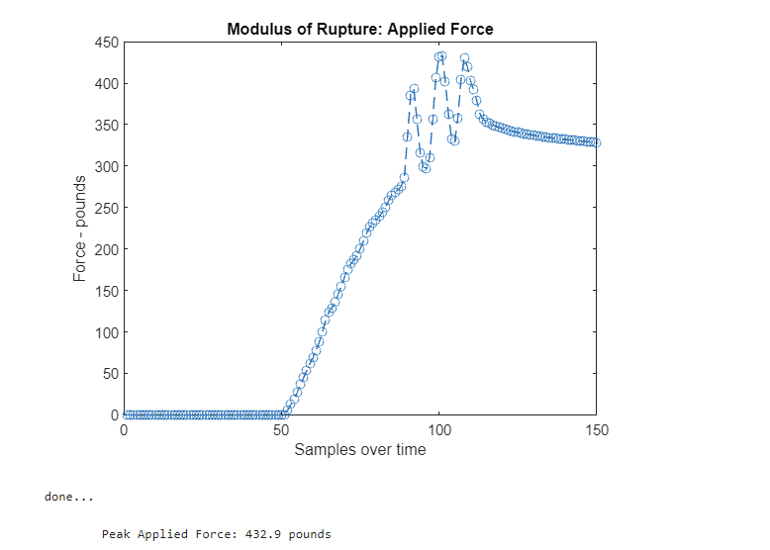

**Figure 3**

*308 lbs. of Applied Force.*

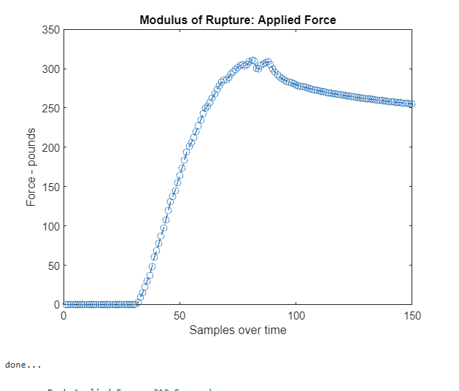

**Figure 4**

*310 lbs. of Applied Force.*

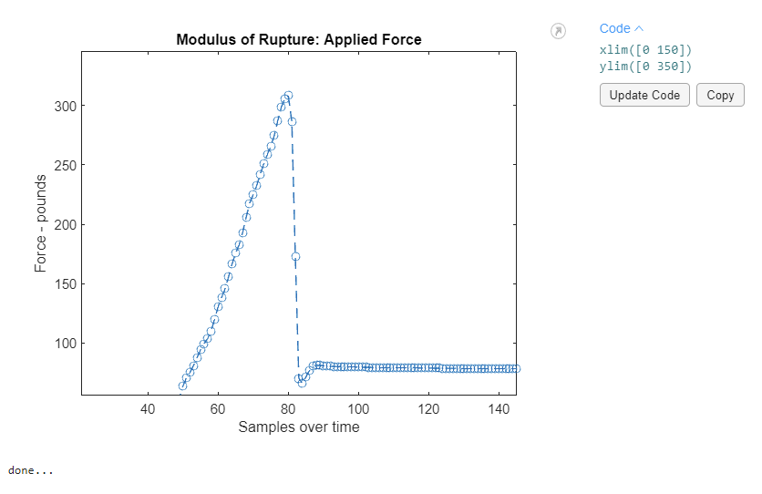

**Figure 5**

*Comparing the modeled beam’s applied force to the tested values.*

|  |  |  |
| --- | --- | --- |
|  | Model Beam | Tested Beam |
| Minimum Force (lbs.) | 46.1 | 308.0 |
| Maximum Force (lbs.) | 6354.1 | 572.2 |
| Median Force (lbs.) | 454.4 | 405.8 |

**Figure 6**

*Visualizations of the rupture and finished product.*

