Nathan Doan

Professor Kemper

PHYS 121L

11 April 2024

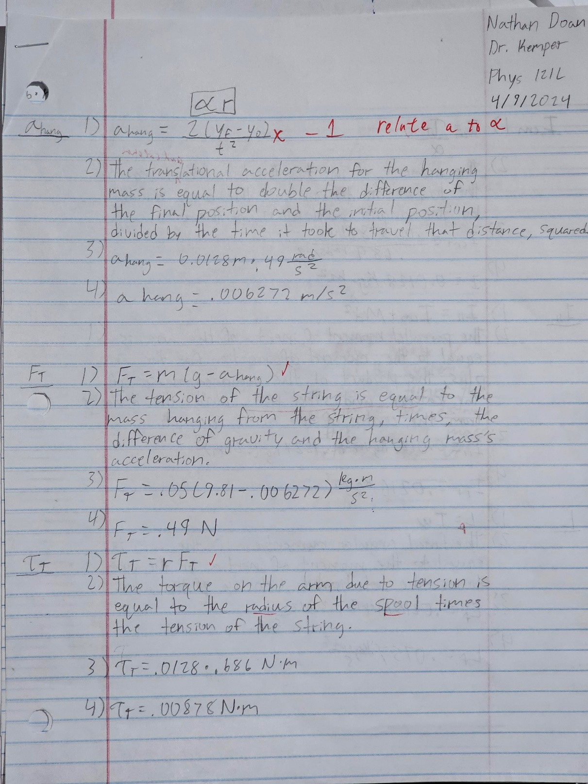**Sample Calcs**

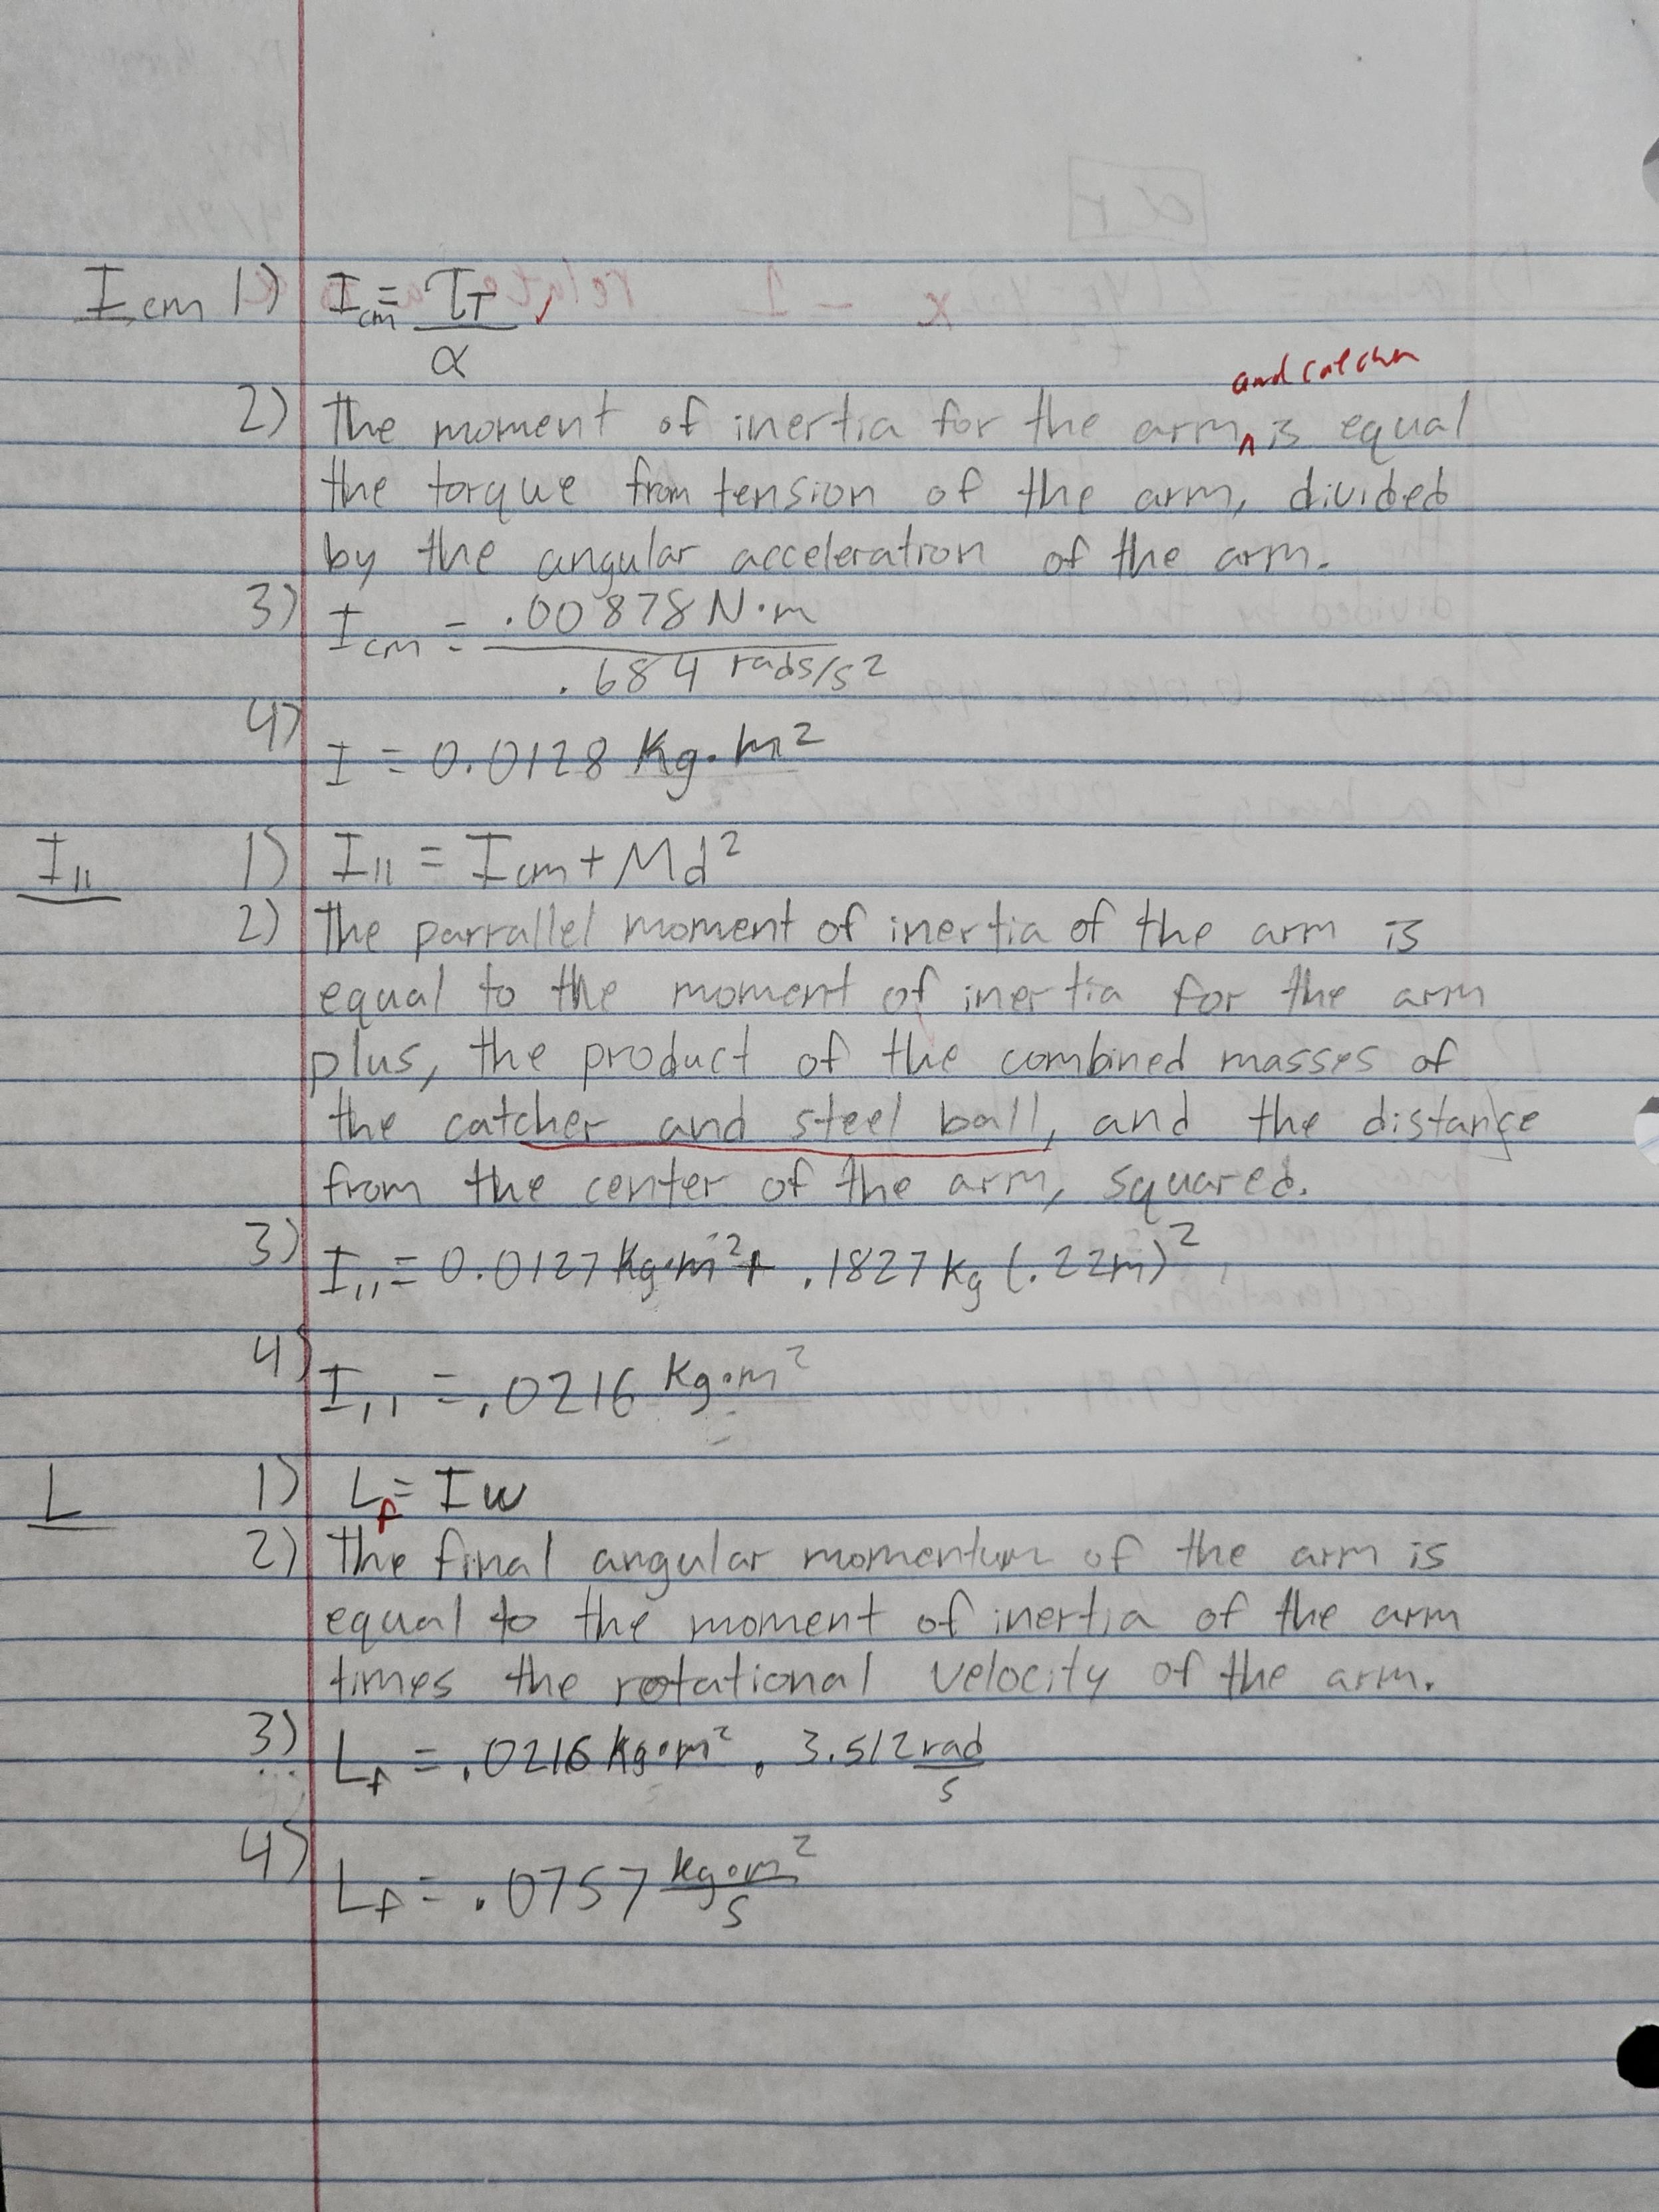

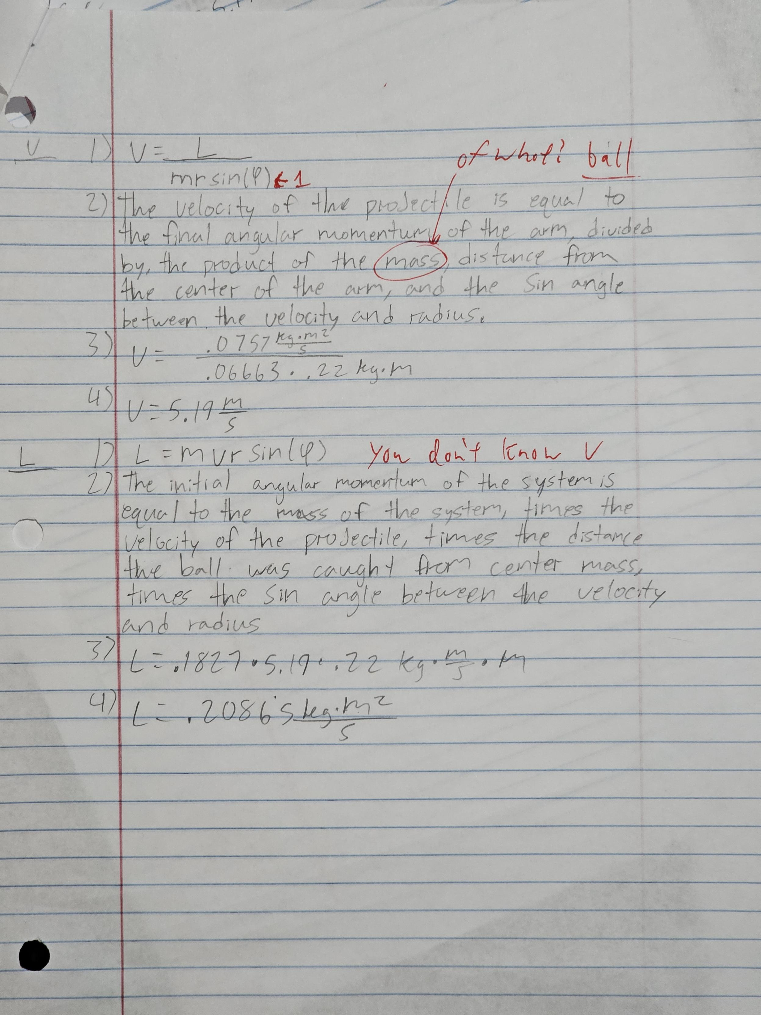

**Challenge**

To predict the angular speed of the system with additional mass, we first had to solve for angular momentum with our known mass, radius, and calculated velocity, finding L to be .0688 kg*m^2/s. Dividing this by the moment of inertia, which we found by adding our calculated average moment of inertia of the system to, the added mass times distance from center squared. Giving us an I of .03274 kg*m^2. Solving for angular speed gave us 2.1 rad/sec. However, we discovered a calculation error we made that give us the incorrect moment of inertia, instead, the correct moment of inertia should be .0247 kg*m^2.

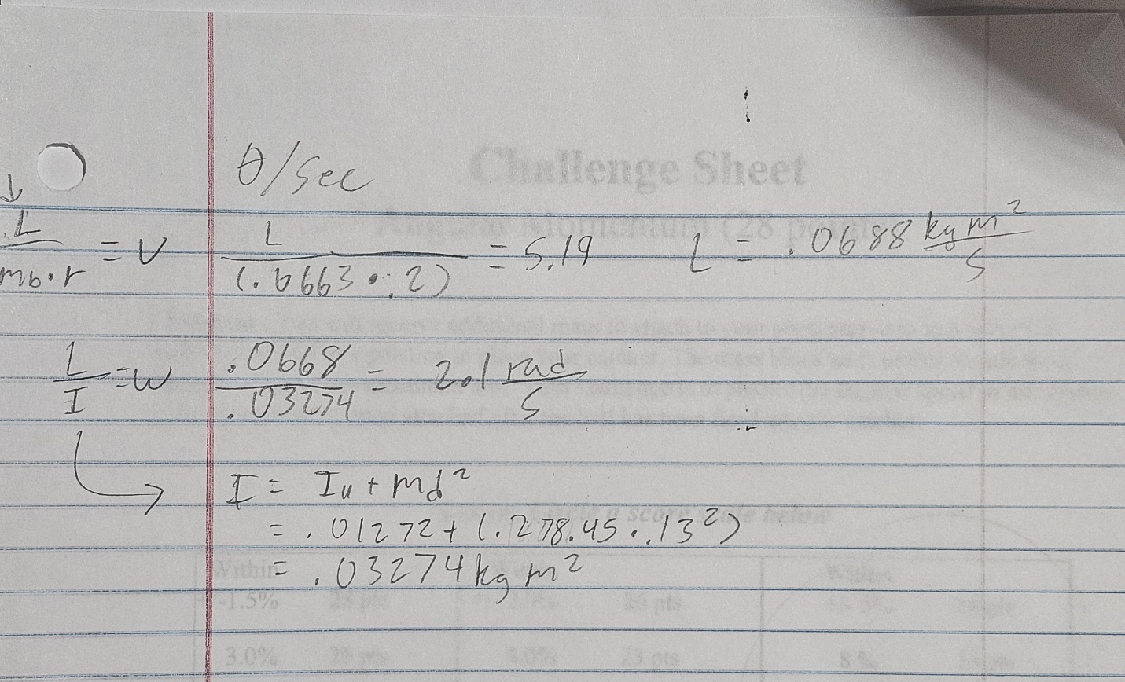

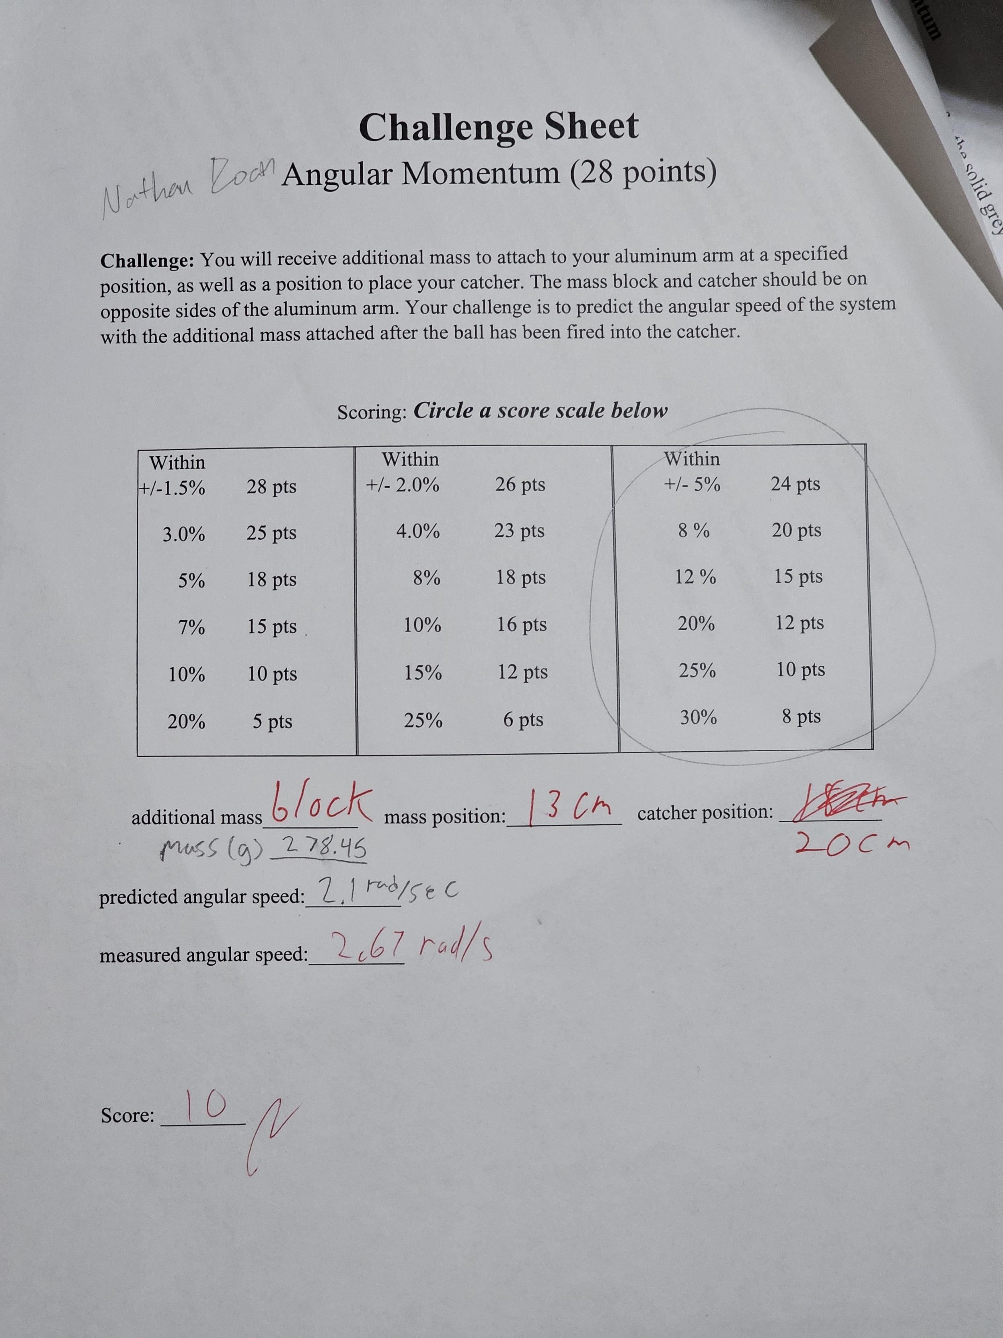

**Discussion**

1. For part 2, you neglected any frictional forces acting on the rotating axle by assuming the net torque equals the torque due to tension. What type of experimental error does this cause? (3 pts)

* The frictional forces being neglected from part 2 of the trials would cause a systematic error, as no number of5 repeated trials would reduce the error.

Below, assume torque due to friction is a constant value throughout the lab.

2. Would all 6 values of I from part 2 be affected by the same amount or would they differ? To answer this, think about the relative error in torque that a constant torque due to friction would cause for each of your torque values. (8 pts)

* The relative error in torque was measured to be 0.0068 N*m. Starting with 0.05 kg, every additional .05kg changes the torque by 0.0068 N*m. Therefore, all values for I is affected by the same amount.

3. Estimate the size of the error due to friction in your part 2 Results by calculating the ratio of the torque due to friction and the torque due to tension. This ratio is a relative error. Now assume that the angular acceleration had insignificant error. Is the error due to friction significant, based on this relative error/ratio? Explain how you can tell.

* Our calculated torque due to friction was 4.4E-4. Our relative error was 1.38E-6 N*m. The error due to friction was insignificant because its value is not within 5% of our torque’s uncertainty. μ is .0019.

4. Estimate the change in angular momentum caused by friction in part 3 after the collisions leading up to the measurement of angular speed. Assume that friction acted on the system for one second before the photogate measurement (and thus the effect on each run in part 3 was the same). State this change in angular momentum and whether or not it was significant.

* Using our calculated coefficient of friction, the torque due to friction is μ*r*v, yielding .002 N*m. The change in angular momentum due to friction is Tf*t, since t is 1 second, the change in angular momentum is .002 kg*m^2/s. This angular momentum is not significant because it is not within 2% of our uncertainty.