Nathan Doan

Professor Kemper

Phys 121L Sec. 4

9 February 2024

**Sample Calculations**

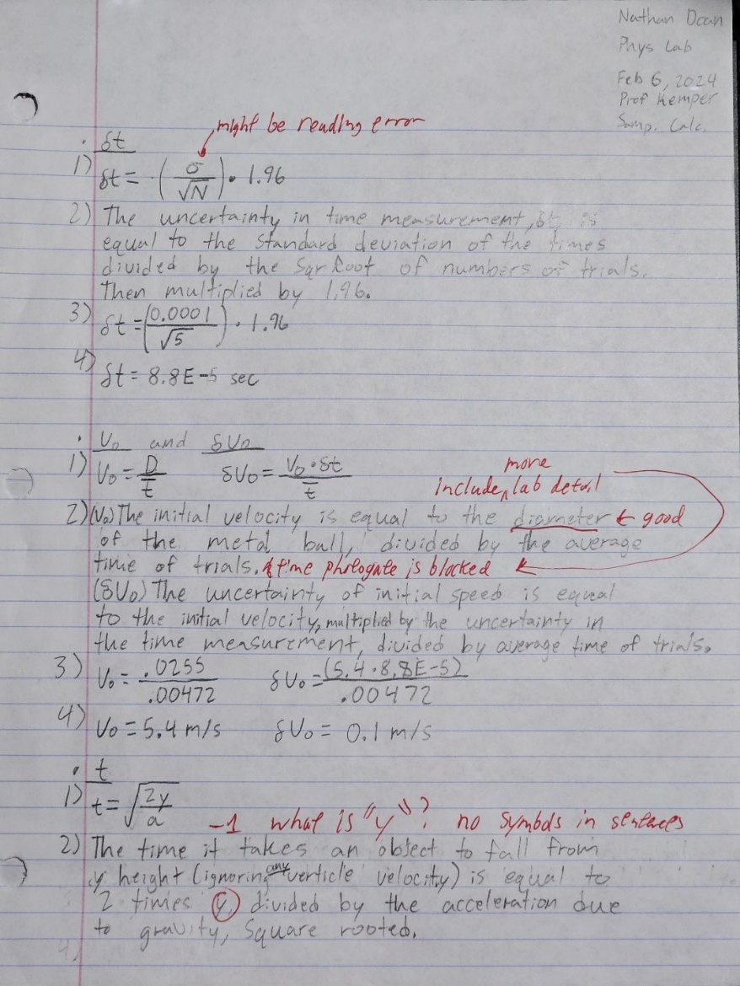

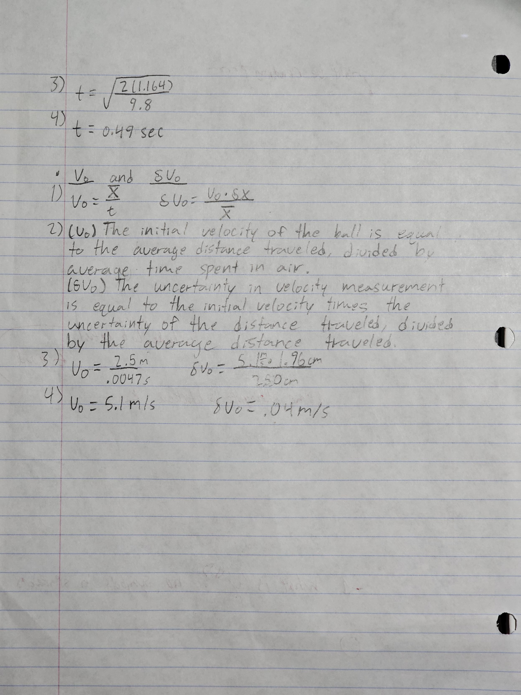

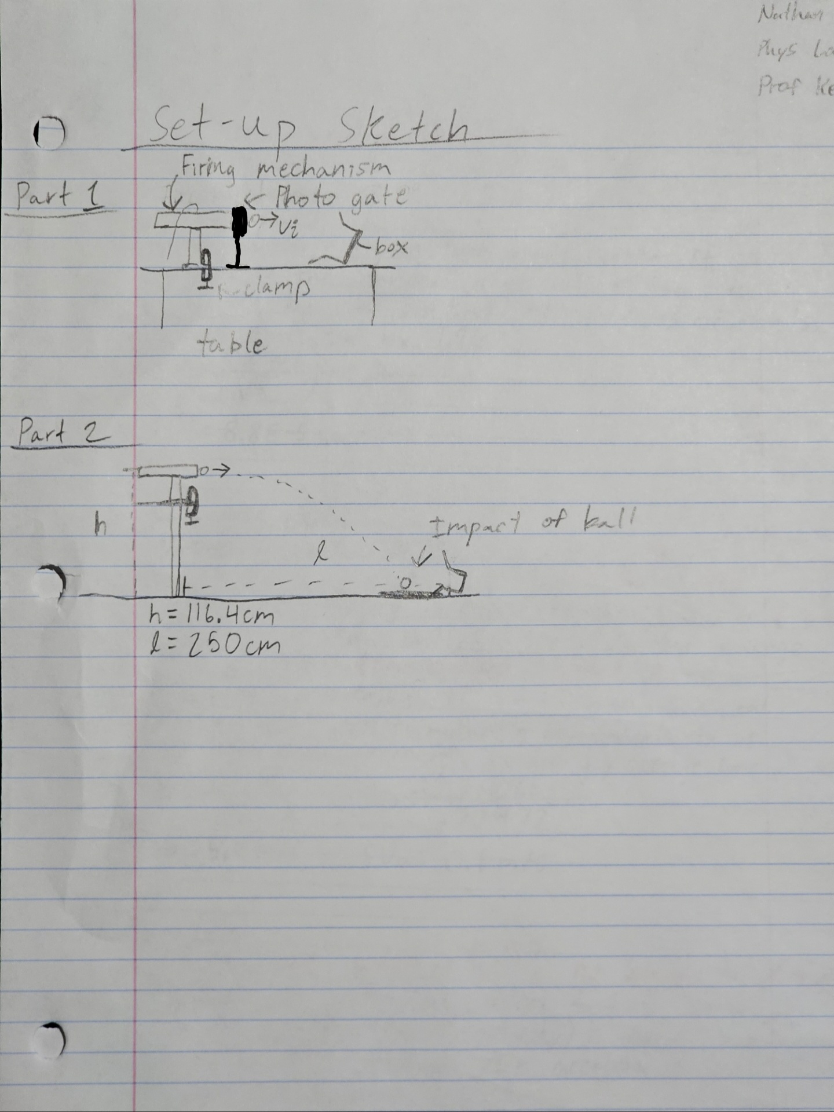

**Challenge**

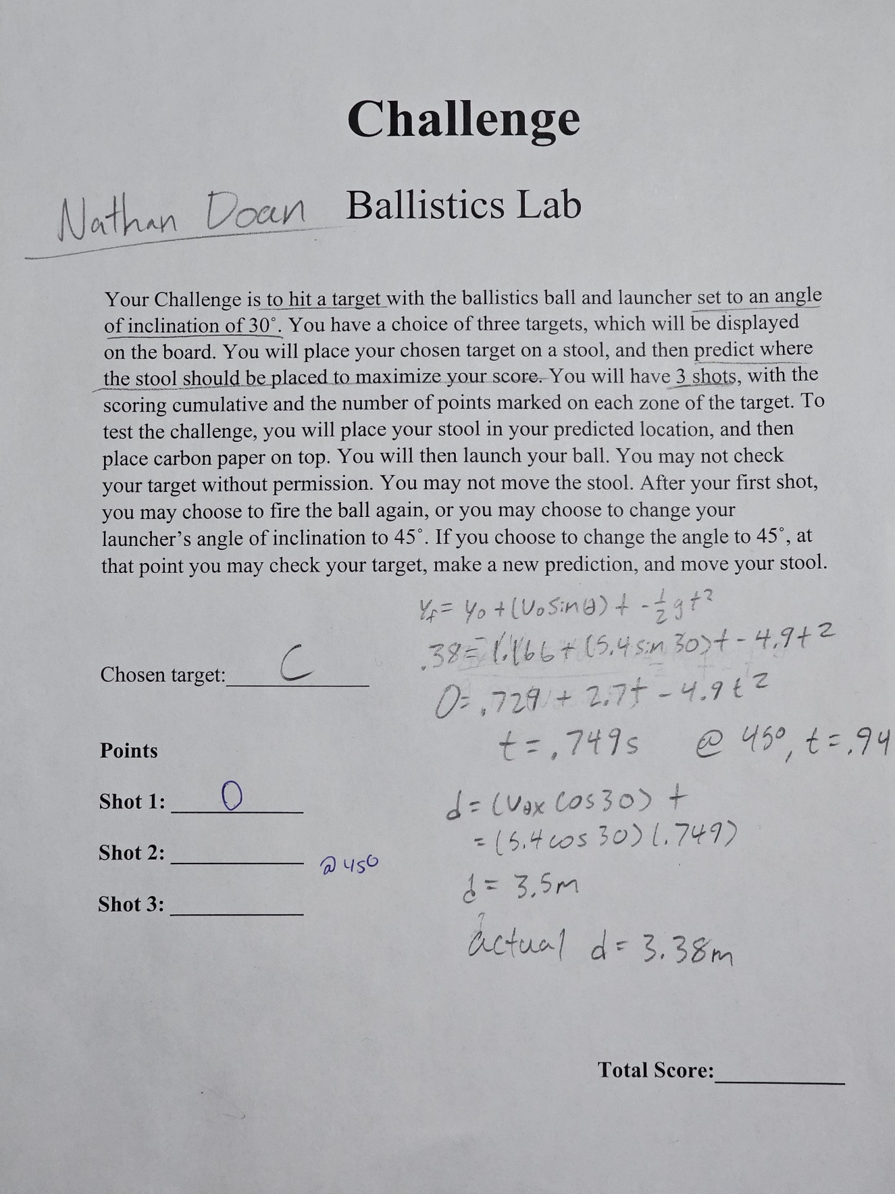

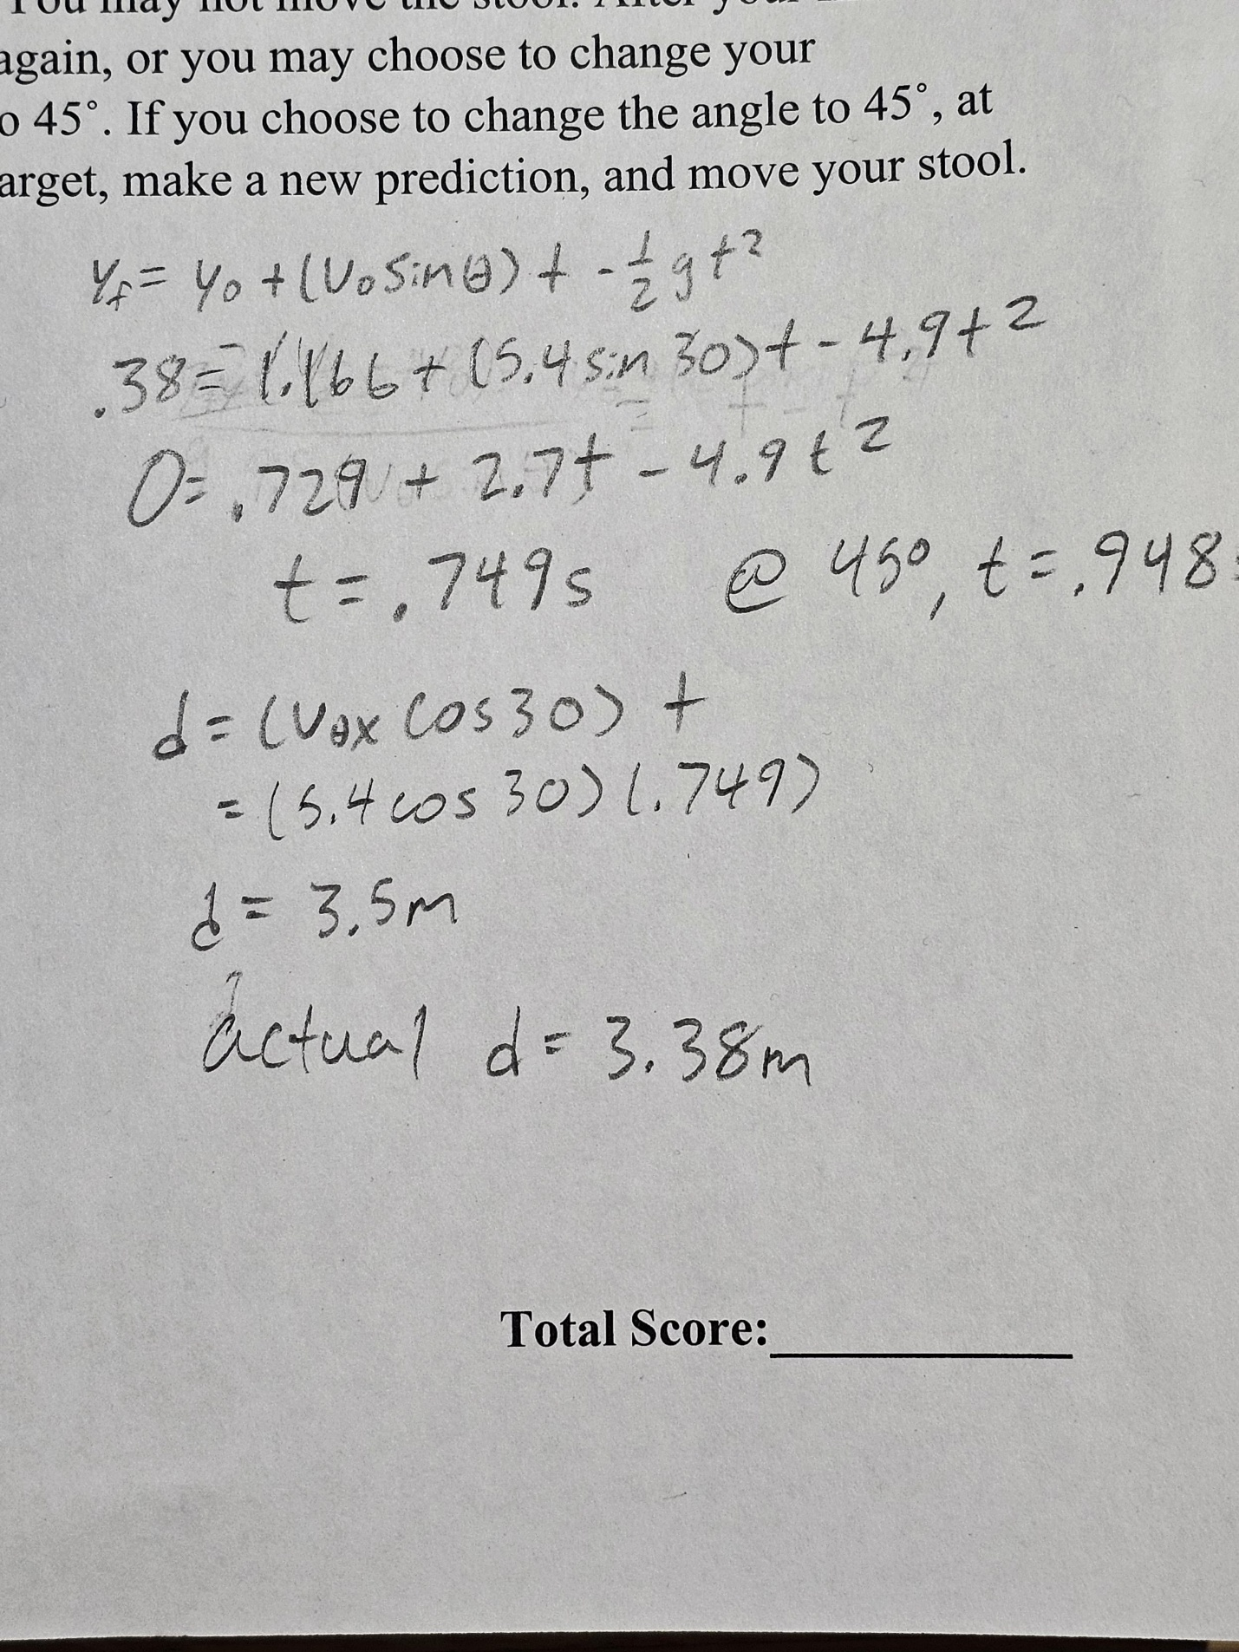

**Summary**

Using the height formula, we substituted our measured values to get a quadratic equation for (t) time. Using the quadratic formula, (t) time was found to be .749 seconds of flight time. Finding the velocity component of the horizontal axis allows us to calculate the distance, in meters, it would travel in that given time as d = 5.4 * cos(30) * (.749). d = 3.38m. However, our measured results traveled a smaller distance than we predicted. This must have been due to a systematic error during our previous measurements.

**Discussion Q’s**

1. How was the time measurement in part 1 affected when you set up the photogate significantly further from the mouth of the launcher? Why? Look at your data and both of your sketches for help. (8 pts)

* The time measurement in part 1 was affected by the distance from the launcher to the photogate by having the expected time lower than predicted. From the launcher to the photogate at 0 cm, the photogate measured the time it took the metal ball – at the center of its circumference, 2.55 cm – to block the laser. With the diameter of the metal ball, divided by the time the laser was blocked, we get its velocity. When we moved the photogate back 22 cm and shot the metal ball, while in free fall, it dropped down a mm or two but maintained its initial horizontal velocity. This only allowed the photogate to read a partial amount of its total diameter, having less time the metal ball blocked the laser as a result, which would affect a predicted velocity.

2. Explain which type of error, if any, is caused by setting up the photogate 20 cm from the launcher. (5 pts)

* By setting up the photogate 20 cm away from the mouth of the launcher, the beam that should read the full diameter of the metal ball will not be able to read it “end to end,” and instead will read only a portion. This is a systematic error as it will affect the predicted velocity if we were to calcuated it using the time measured from the photogate.

3. Look at your results from the two parts of the lab. Based on your results, decide if aerodynamic drag (air resistance) is insignificant by answering the following questions. (12 pts)

a. How would drag affect your Results (𝑣0 and 𝛿𝑣0)?

* If our trials were affected by air resistance, our predicted velocity would be higher than the measured. Then, the uncertainty of the velocity would be larger, as the metal ball would travel a smaller distance, resulting in a smaller average denominator.

b. Which experiment must drag affect more, 1, the Photogate or 2, Projectile Motion? Why?

* Part 2, projectile motion, would have significant aerodynamic drag compared to part 1, photogate, due to the metal ball spending more time in freefall in part 2, than part 1.

c. Now consider the two Result lines in your Five-Line summary. If drag were the only significant source of error in the experiment, then, based on your answers above, which Result would be greater?

* Based on our results and assuming drag was a significant source of error, we can predict that part 1, photogate, would have a larger predicted velocity than that of part 2’s.

d. If your actual Results do not match your answer to question “c” then drag must be insignificant. i.e. we can rule it out as a significant source of error. Note that we cannot definitively prove that drag is significant, because other sources of error may cause similar effects. So, based on your Results, is drag conclusively insignificant or might it be significant?

* Based on our results, drag showed to have some significant effects on our measurements.