Nathan Doan

Professor Kemper

PHYS 121L

29 March 2024

**Sample Calculations**

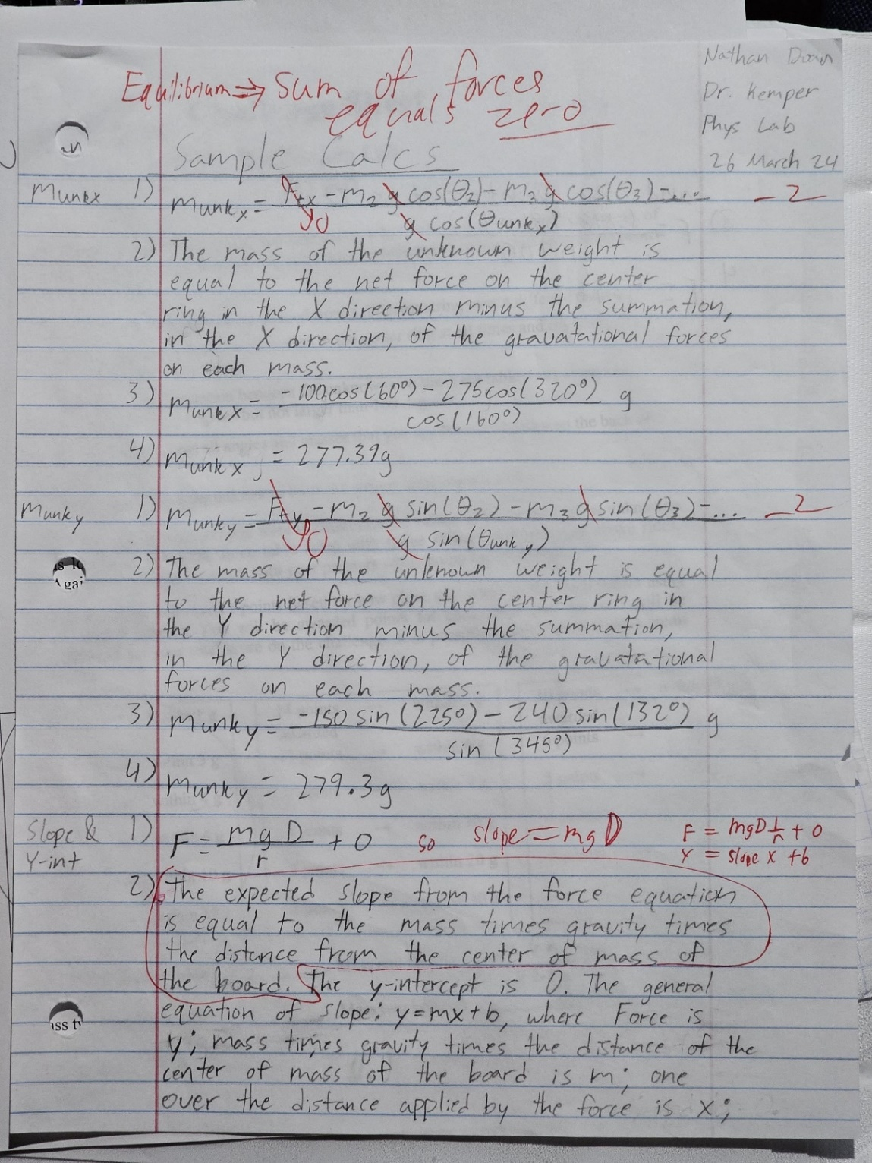

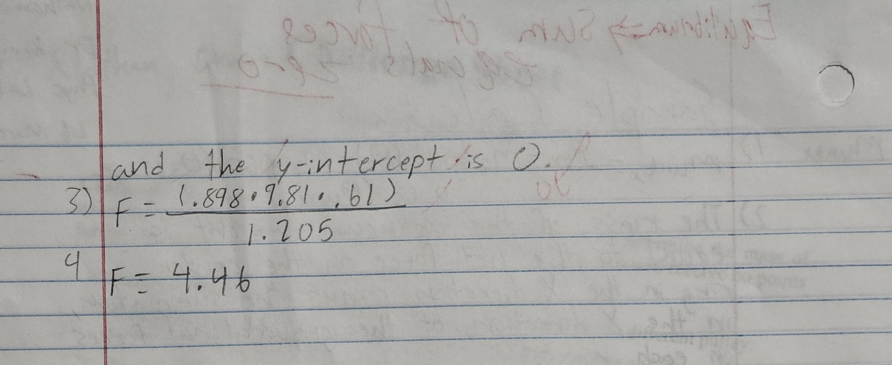

**Challenge**

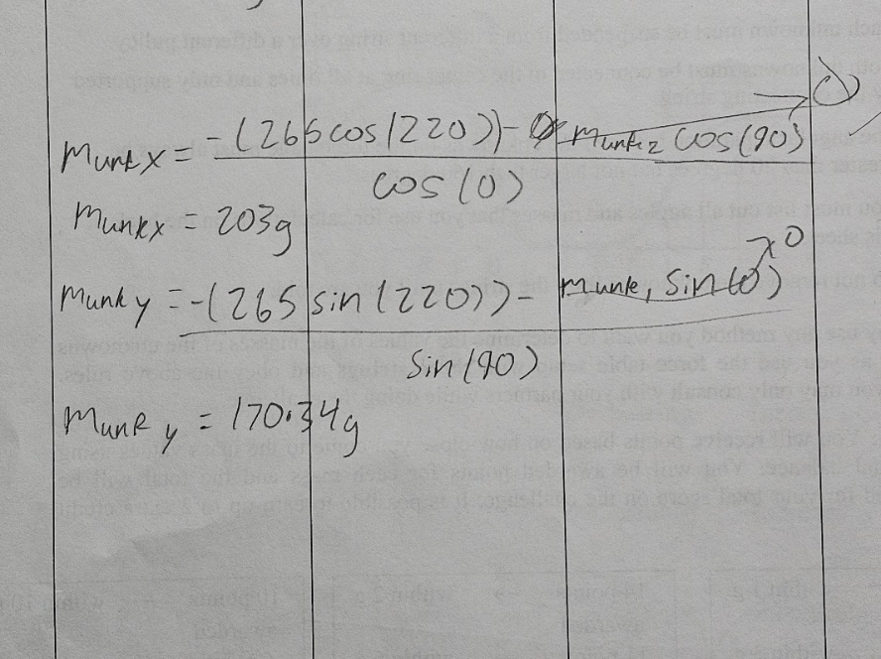To find the masses of both unknown masses, we set our first unknown mass at 0 degrees, our second unknown mass at 90 degrees, then we chose 265 g as our known mass at 220 degrees to balance the sets of masses on the force table. From there, assuming we had achieved equilibrium, we used 265*sin(220 degrees) to find the mass of the unknown at 90 degrees, and we used 265*cos(220 degrees) to find the mass of the unknown at 0 degrees.

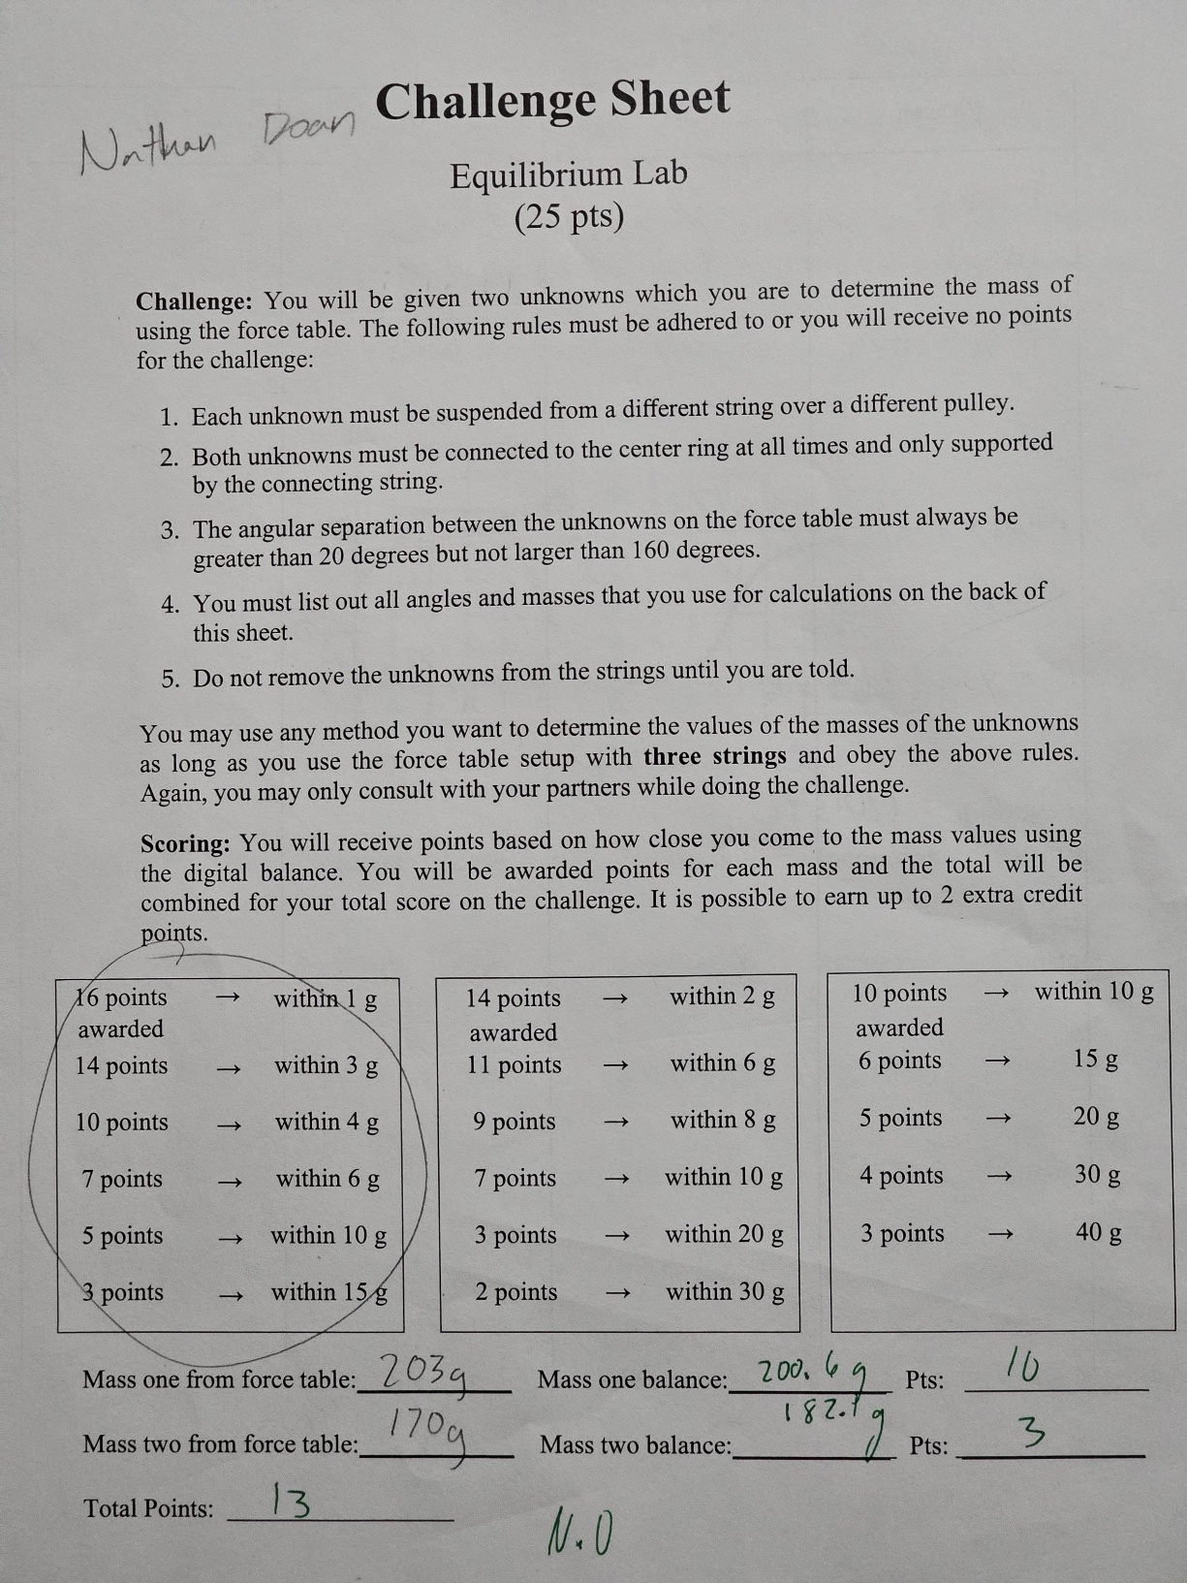

**Discussion Questions**

1. Imagine the pulleys on the force table are frictionless so that mechanical energy is conserved. If the ring rests at the center of the table, in equilibrium, and you pull on one of the masses just enough to pull the ring visibly out of the center, will the ring immediately return to rest in the center of the table? Why or why not? Consider Newton’s 1st law in your response. (9 PTS)

* Newton’s 1st law states that an object in motion stays in motion unless acted upon by a net external force. If the pulleys on the force table are frictionless and the system is in equilibrium, pulling the ring out of the center will disrupt equilibrium. Because mechanical energy is conserved, the forces of tension in the strings will work to restore the equilibrium, causing the ring to move back towards the center. However, the ring will not immediately return to rest in the center of the table. Instead, it will oscillate around the center position for a while before eventually coming to rest. This is due to the inertia of the ring and the masses: once in motion, it will stay in motion until acted upon by a net external force. Eventually, the system will return to rest in the center of the table.

2. a) In part 2, how do you know when the board is in equilibrium? b) State the weight of your board in newtons (N). c) Can the force that the probe exerts on the board in part 2 exceed the weight of the board when the system is in equilibrium? If yes, explain where the extra reaction force is exerted; if no, explain why not. Check that your answer is consistent with your data. (9 PTS)

* The weight of our board is 8.8 N. The board is in equilibrium when it remains stationery and level, indicating that the forces and torques are balanced. The force the probe exerts on the board can exceed the board's weight when the system is in equilibrium because of a reaction force exerted by the hinge. For the board to be in equilibrium, the sum of all vertical forces must be zero. Therefore the upward forces (the force from the probe and the reaction force from the hinge) must balance the downward force (the weight of the board).

3. Compare the uncertainties you found experimentally to the AE of the 3 mass values to determine what the most significant source of error might be. First, compare the relative uncertainties in m2 and q2, to the AE of the unknown mass, but be careful because θ2 does not have the usual form for relative uncertainty. Instead, put both δθ2 and θ2 in radians, and then multiply δθ2 by Cos θ2 for the relative uncertainty for the mass from the y-components; δθ2 Sin θ2 is the relative uncertainty for the mass found via the x-components (note that there is no division in these two terms). State these values for the three trials. Are the experimentally determined relative uncertainties comparable to the calculated AE? Why or why not? What does this tell you about where the error in the lab comes from? (7 pts)

* The experimentally determined uncertainties for mass measured in the x-direction are: .01 g for trials 1 and trials 2, and .03 g for trial 3s. For mass measured in the y-direction are: .01 for trials 1 and trials 2, and .02 g for trials 3. Comparing these values to our calculated value of AE, 4.59 g, the values are off by more than 400x. This can tell us an error came from a systematic error. One source of the error could have been from the friction and weight of the pulleys.