Nathan Doan

Professor Kemper

PHYS 121L Sec. 4

23 February 2024

**Sample Calculations**

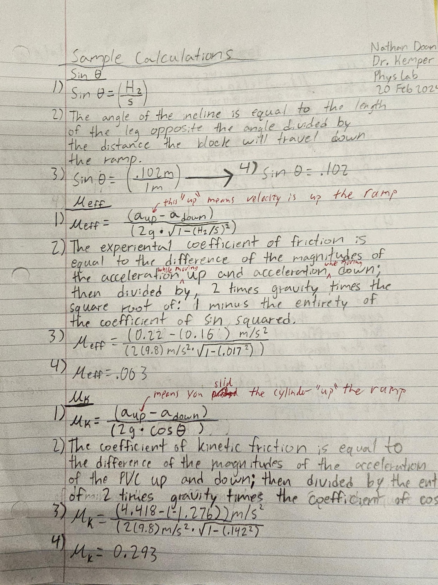

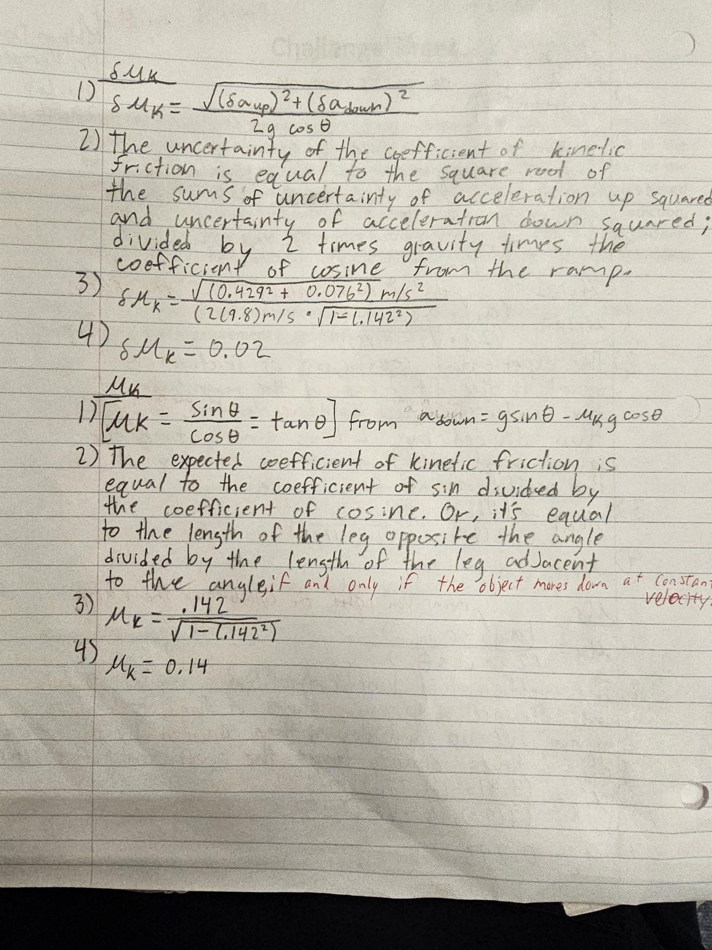

**Challenge**

To calculate the predicted acceleration of the cart and PVC pipe down the ramp with a known height difference, we used Newton’s second law of motion regarding net forces. We looked at all forces that could affect the system and concluded with: the force of the cart due to gravity, the net force of the PVC pipe due to gravity and friction, and the force of kinetic friction. The force of the cart has no friction (rather, it’s negligible), so there is only one variable to solve for. The net force of the PVC has gravity and kinetic friction, so we must solve for kinetic friction first. After solving for kinetic friction, we can now solve for the force of gravity on the PVC pipe. We now combine the net forces of the system and set them equal to the total mass of the system time acceleration, the variable we need to solve for which will yeild 1.03 m/s^2.

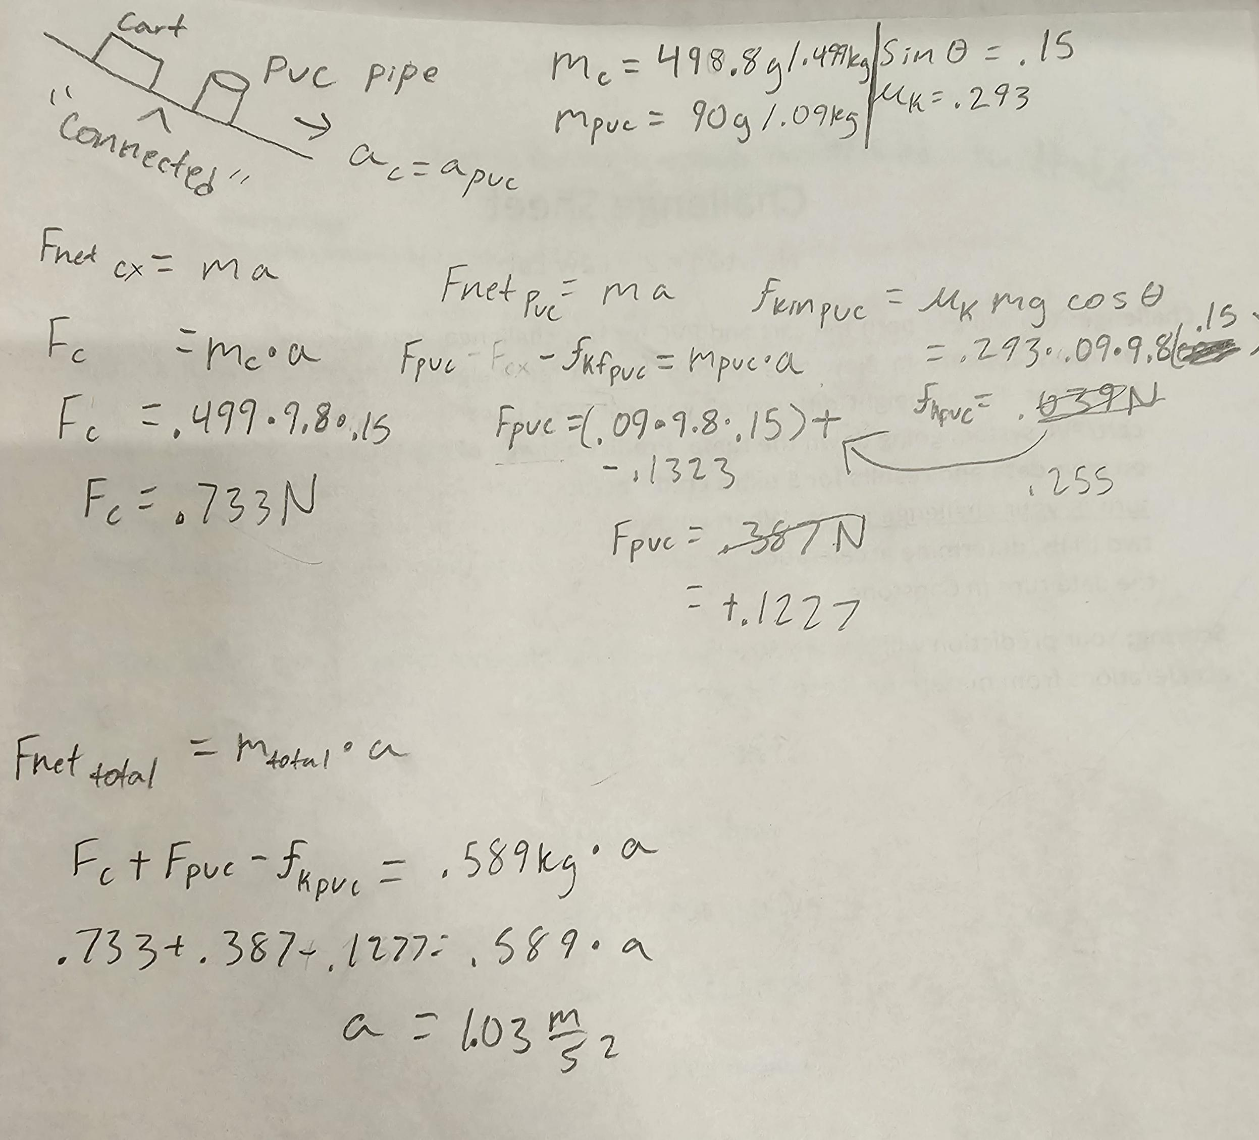

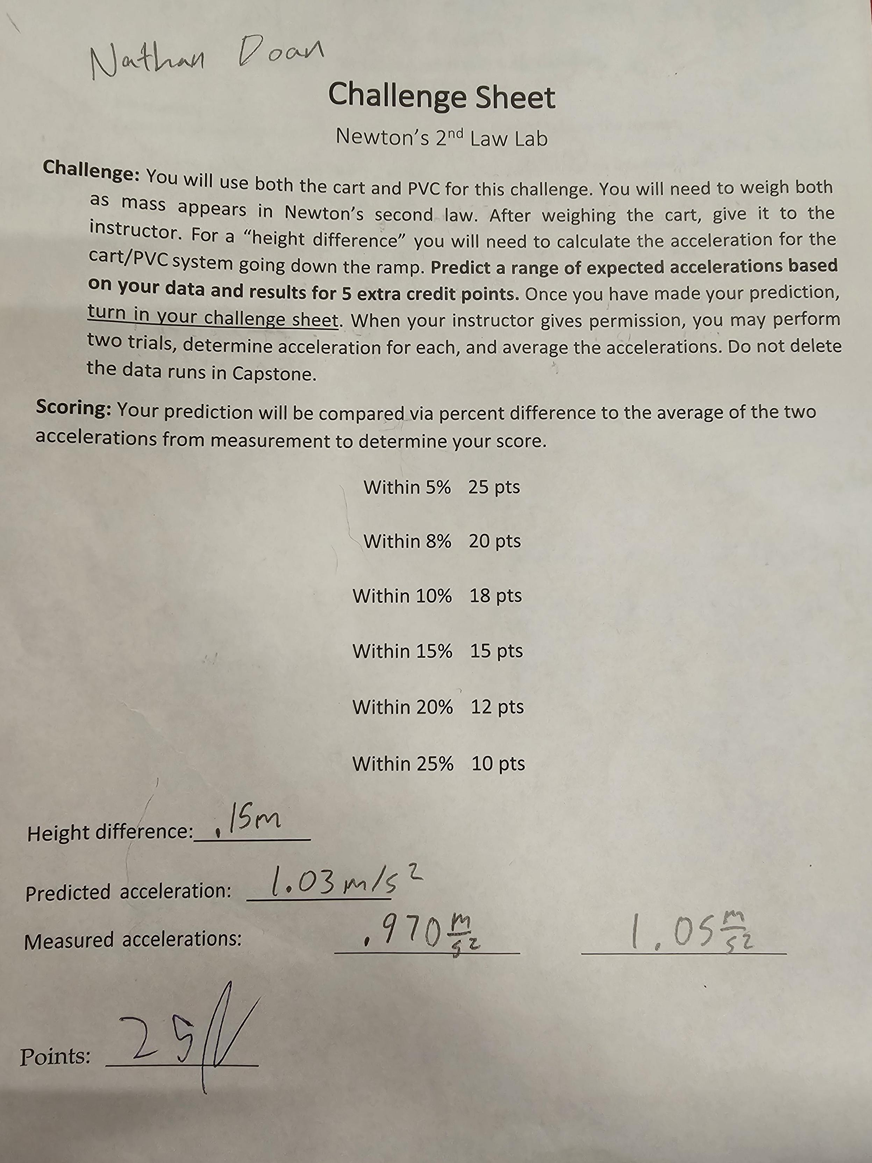

**Discussion**

In part 1, the effect of the friction is small but measurable. How does step 2.6 in the procedure help to eliminate the effects of friction in the acceleration values you recorded in Excel? (5 pts)

* By catching the cart in part 2.6 instead of letting it continue to roll down the ramp, it helps eliminate friction by eliminating the frictional force acting on the cart at that instant. When the cart is rolling up and down the ramp, the acceleration is equal to the net force acting on the object, with gravity pulling the cart down the ramp and friction opposing the movement of the direction an object is traveling. This net force is what causes the cart to accelerate downwards. When we caught the cart, the force of friction stopped affecting the cart because there was no more motion for friction to oppose. Which means that the acceleration at that moment was only due to gravity.

2. What will happen if the ramp is set to an angle 20 degrees higher than it was in part 2 of the lab, and your PVC cylinder is given a push up the ramp (in the same manner as during the lab, of course)? Describe the motion and calculate and state any acceleration values you can for the motion. (10 pts)

* The PVC pipe would slow down at a faster rate if we had set the angle of inclination 20 degrees higher than our original 8 degrees. The PVC pipe would slow down at a larger but constant rate compared to our original acceleration, due to the increased force of gravity. The coefficient of kinetic friction should remain the same, so calculating an acceleration with the increased 20 degrees would yield an average acceleration of 6.9 m/s^2 pointing down the ramp. By adding the net forces (Initial push, friction force, and force of gravity) and setting them equal to mass times acceleration we solve for force. Then change the values for sin and cosine and solve for the new acceleration. By continuing to increase the angle of incline, The acceleration on the PVC pipe down the ramp would continue to increase until it slips.

3. You should have a screenshot of your graphs from Capstone. On the velocity graph, use a textbox to label the following portions of the motion: the push, the cart rolling up the ramp, rolling down the ramp, and the catch. Label the direction of acceleration at each of these moments as well. (6 pts)

* 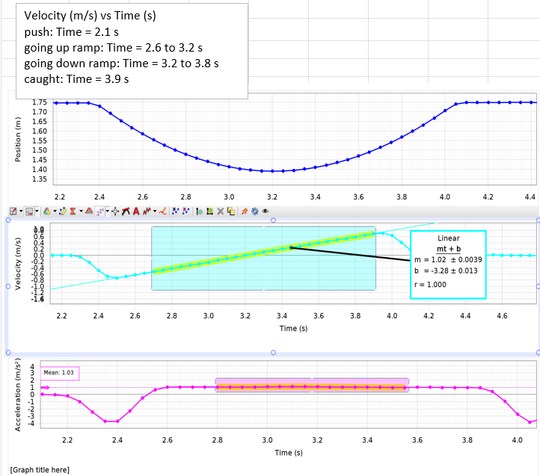

4. With the ramp at the first angle of inclination, you measured acceleration for two downhill runs: 1) releasing the cart from rest and 2) pushing the cart down the ramp. Does the acceleration vary significantly between the runs? Why or why not? Answer in terms of Newton’s 2nd law. (4 pts)

* The accelerations do not vary by a significant margin. The downwards acceleration of the cart pushed down the ramp is equal to the downwards acceleration of the cart let go from rest. This does not vary significantly because: although the cart pushed down the ramp has a higher starting velocity and acceleration, once the force of the push stops acting on it, the cart will accelerate the same speed as the cart let go from rest because there is no more external force acting on the carts except gravity, negligible friction and air resistance. The difference in the cart is the time it takes for each to reach the bottom and their final velocity.