## step2: Visualizing author topics

spooky_wrd_docs <- tidy(spooky_wrd_lda_6, matrix = "gamma")  
head(spooky_wrd_docs)

## # A tibble: 6 x 3  
## document topic gamma  
## <chr> <int> <dbl>  
## 1 id00001 1 0.168  
## 2 id00002 1 0.166  
## 3 id00003 1 0.167  
## 4 id00004 1 0.170  
## 5 id00005 1 0.168  
## 6 id00006 1 0.165

author_topics <- left_join(spooky_wrd_docs, spooky, by = c("document" = "id"))  
author_topics <- select(author_topics, -text)  
author_topics$topic <- as.factor(author_topics$topic)  
# Chooses the top topic per sentence  
author_topics <- ungroup(top_n(group_by(author_topics, document), 1, gamma))  
  
# Counts the number of sentences represented by each topic per author   
author_topics <- ungroup(count(group_by(author_topics, author, topic)))  
author_topics

## # A tibble: 18 x 3  
## author topic n  
## <chr> <fct> <int>  
## 1 EAP 1 1395  
## 2 EAP 2 1154  
## 3 EAP 3 1887  
## 4 EAP 4 1364  
## 5 EAP 5 1059  
## 6 EAP 6 1041  
## 7 HPL 1 1104  
## 8 HPL 2 687  
## 9 HPL 3 983  
## 10 HPL 4 702  
## 11 HPL 5 1071  
## 12 HPL 6 1088  
## 13 MWS 1 1270  
## 14 MWS 2 1116  
## 15 MWS 3 762  
## 16 MWS 4 1426  
## 17 MWS 5 746  
## 18 MWS 6 724

ggplot(author_topics) +  
 geom_col(aes(topic, n, fill = factor(topic)), show.legend = FALSE) +  
 facet_wrap(~ author, scales = "free", ncol = 4) +  
 coord_flip()

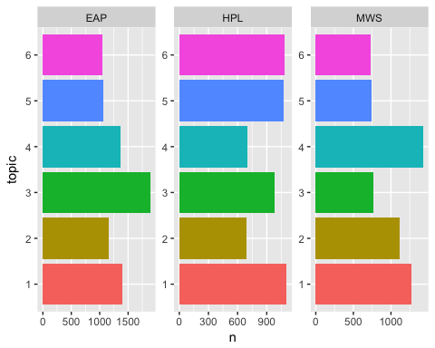 From plot, we learn different author focus on diffrernt topics. And combine 5 top words for each topics, we can get theme for each author.

# Section 5:Summary