# Section 4: Topic Models

We use the topicmodels package for this analysis. Since the topicmodels package doesn’t use the tidytext framework, we first convert our spooky_wrd dataframe into a document term matrix (DTM) matrix using tidytext tools.

# Counts how many times each word appears in each sentence  
sent_wrd_freqs <- count(spooky_wrd, id, word)  
head(sent_wrd_freqs)

## # A tibble: 6 x 3  
## id word n  
## <chr> <chr> <int>  
## 1 id00001 content 1  
## 2 id00001 idris 1  
## 3 id00001 mine 1  
## 4 id00001 of 1  
## 5 id00001 resolve 1  
## 6 id00001 this 1

# Creates a DTM matrix  
spooky_wrd_tm <- cast_dtm(sent_wrd_freqs, id, word, n)  
spooky_wrd_tm

## <<DocumentTermMatrix (documents: 19579, terms: 25616)>>  
## Non-/sparse entries: 444771/501090893  
## Sparsity : 100%  
## Maximal term length: 19  
## Weighting : term frequency (tf)

length(unique(spooky_wrd$id))

## [1] 19579

length(unique(spooky_wrd$word))

## [1] 25616

The matrix spooky_wrd_tm is a sparse matrix with 19467 rows, corresponding to the 19467 ids (or originally, sentences) in the spooky_wrd dataframe, and 24941 columns corresponding to the total number of unique words in the spooky_wrd dataframe. So each row of spooky_wrd_tm corresponds to one of the original sentences. The value of the matrix at a certain position is then the number of occurences of that word (determined by the column) in this specific sentence (determined by the row). Since most sentence/word pairings don’t occur, the matrix is sparse meaning there are many zeros.

## step1: Determine how many topics to use

Pick 6, 12 # of topics and to see if there are any dupilicate topics or not.

spooky_wrd_lda <- LDA(spooky_wrd_tm, k = 12, control = list(seed = 1234))  
spooky_wrd_topics <- tidy(spooky_wrd_lda, matrix = "beta")  
spooky_wrd_topics

## # A tibble: 307,392 x 3  
## topic term beta  
## <int> <chr> <dbl>  
## 1 1 content 0.0000758   
## 2 2 content 0.0000371   
## 3 3 content 0.00000905  
## 4 4 content 0.00000642  
## 5 5 content 0.0000749   
## 6 6 content 0.0000571   
## 7 7 content 0.0000414   
## 8 8 content 0.0000831   
## 9 9 content 0.0000607   
## 10 10 content 0.000180   
## # ... with 307,382 more rows

spooky_wrd_topics_5 <- ungroup(top_n(group_by(spooky_wrd_topics, topic), 5, beta))  
spooky_wrd_topics_5 <- arrange(spooky_wrd_topics_5, topic, -beta)  
spooky_wrd_topics_5 <- mutate(spooky_wrd_topics_5, term = reorder(term, beta))  
  
ggplot(spooky_wrd_topics_5) +  
 geom_col(aes(term, beta, fill = factor(topic)), show.legend = FALSE) +  
 facet_wrap(~ topic, scales = "free", ncol = 4) +  
 coord_flip()

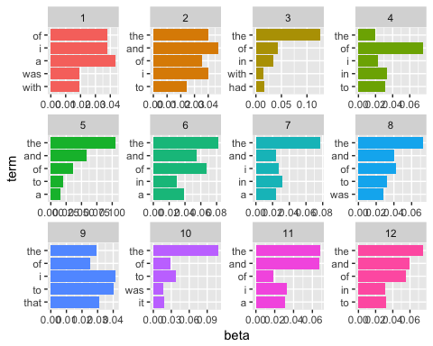

spooky_wrd_lda_6<-LDA(spooky_wrd_tm,k=6, control = list(seed = 1234))  
spooky_wrd_6_topics <- tidy(spooky_wrd_lda_6, matrix = "beta")  
spooky_wrd_6_topics

## # A tibble: 153,696 x 3  
## topic term beta  
## <int> <chr> <dbl>  
## 1 1 content 0.000117   
## 2 2 content 0.0000551   
## 3 3 content 0.0000141   
## 4 4 content 0.00000967  
## 5 5 content 0.000110   
## 6 6 content 0.0000846   
## 7 1 idris 0.000255   
## 8 2 idris 0.00000802  
## 9 3 idris 0.000300   
## 10 4 idris 0.000307   
## # ... with 153,686 more rows

spooky_wrd_6_topics_5 <- ungroup(top_n(group_by(spooky_wrd_6_topics, topic), 5, beta))  
spooky_wrd_6_topics_5 <- arrange(spooky_wrd_6_topics_5, topic, -beta)  
spooky_wrd_6_topics_5 <- mutate(spooky_wrd_6_topics_5, term = reorder(term, beta))  
ggplot(spooky_wrd_6_topics_5) +  
 geom_col(aes(term, beta, fill = factor(topic)), show.legend = FALSE) +  
 facet_wrap(~ topic, scales = "free", ncol = 4) +  
 coord_flip()

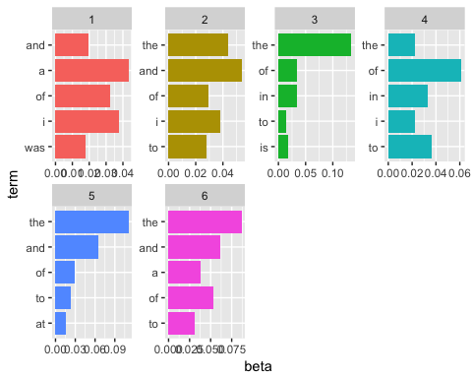 Compare 6, 12 topic, I would suggest 6, because when u pick 12, there are some kind of of duplicated.

In the above, we see that the first topic is characterized by words like “love”, “earth”, and “words” while the third topic includes the word “thousand”, and the fifth topic the word “beauty”. Note that the words “eyes” and “time” appear in many topics. This is the advantage to topic modelling as opposed to clustering when using natural language – often a word may be likely to appear in documents characterized by multiple topics.