<https://medium.com/andy-blog/day11-html%E5%85%83%E7%B4%A0%E9%82%8A%E7%95%8C%E9%97%9C%E4%BF%82-margin-padding-border-f9e434c947fd>

Day11-HTML元素邊界關係！margin、padding、border

順時針方向(上、右、下、左)

Transparent?

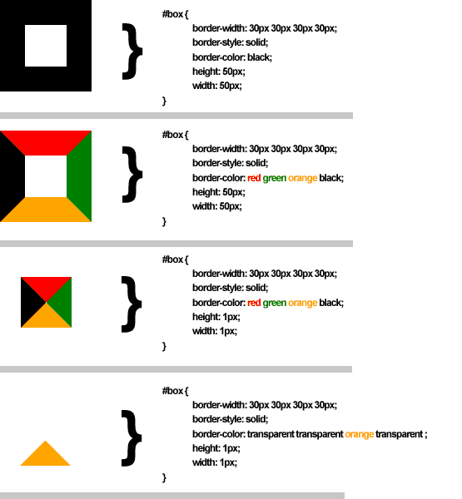

<https://fonts.google.com/>

google font

<https://developer.mozilla.org/zh-TW/docs/Web/HTML/Element/nav>

<nav>

<https://w3c.hexschool.com/blog/5667df85>

<https://medium.com/enjoy-life-enjoy-coding/css-%E5%85%A8%E9%83%BD%E6%98%AF%E5%81%87%E7%9A%84-%E9%97%9C%E6%96%BC%E9%82%A3%E4%BA%9B%E5%81%BD%E9%A1%9E%E5%92%8C%E5%81%BD%E5%85%83%E7%B4%A0-%E5%9F%BA%E6%9C%AC%E7%94%A8%E6%B3%95-4de48feb8607>

偽元素？

Css <div>、class選擇器、

CSS基本