KL ERP SYSTEM
A Real-World Case Study in Adaptive Software Engineering
User Stories · Process Model Selection · Technology Stack · Implementation · Evaluation
Name: G. Harshith Reddy
Roll Number:2420030527
Section:11

Table of Contents
1. Introduction and Case Study Selection
2. User Stories
3. Software Development Process Model
4. Programming Language and Technology Stack
5. System Architecture Overview
6. Step-by-Step Implementation
7. Evaluation Strategy
8. Conclusion and Future Scope

1. Introduction and Case Study Selection
This documentation presents a complete software engineering case study built around a KL ERP System — a campus Enterprise Resource Planning platform modeled on the operational needs of a university such as KL University. An ERP system was selected over an e-commerce alternative because it better demonstrates the core challenges emphasized in this course: multiple interacting modules with different stakeholders, role-based workflows, transactional data integrity, and the need for an incremental delivery approach where individual modules can be built, tested, and released independently.
The KL ERP System modeled in this case study consolidates four core administrative functions of a university into a single platform:
- Student Module — registration records, department/year tracking, and fee status.
- HR / Faculty Module — employee and faculty records, designations, and employment status.
- Finance Module — fee collections, salary disbursements, and expense tracking with a running ledger.
- Inventory Module — campus asset and equipment tracking across departments.
Each module is treated as a semi-independent increment with its own data model, screens, and user stories, which directly motivates the choice of process model discussed in Section 3.

2. User Stories
User stories were written from the perspective of the key stakeholders who would interact with a real campus ERP: the System Administrator (who manages master data during rollout), the Registrar / Academic Office staff, the HR Officer, the Finance/Accounts Officer, and the Facilities/Inventory Officer. Stories follow the standard "As a / I want to / So that" format and are grouped by module so that each group maps to one release increment.

2.1 Authentication & Access
ID | As a... | I want to... | So that...
US-01 | system user | log in with a username and password | only authorized staff can access student, financial, and HR data
US-02 | system user | be redirected to login if my session has expired | the system stays secure when I step away from my desk
US-03 | administrator | see my role displayed after logging in | I can confirm I have the correct access level before making changes

2.2 Student Module
ID | As a... | I want to... | So that...
US-04 | registrar | add a new student record with registration number, department, and year | the student is officially enrolled in the system
US-05 | registrar | view a list of all enrolled students at a glance | I can quickly check departmental strength
US-06 | registrar | see each student’s fee status (Paid / Pending / Overdue) | I can follow up with students who have outstanding dues
US-07 | academic office staff | filter students conceptually by department and year | I can generate department-wise reports (future increment)

2.3 HR / Faculty Module
ID | As a... | I want to... | So that...
US-08 | HR officer | add a new faculty or staff record with designation and department | new hires are reflected in the university’s official records
US-09 | HR officer | view all employees with their current status (Active / On Leave / Retired) | I can maintain an accurate headcount for payroll planning
US-10 | department head | see faculty contact details | I can reach staff for departmental coordination

2.4 Finance Module
ID | As a... | I want to... | So that...
US-11 | finance officer | record a fee payment against a student’s registration number | the university’s revenue records stay accurate and auditable
US-12 | finance officer | record salary disbursements and campus expenses | the ledger reflects all outgoing payments, not just incoming fees
US-13 | finance officer | see total revenue, total expenses, and net position on one screen | I can report the university’s financial health without manual spreadsheet work
US-14 | finance officer | mark a transaction as Completed, Pending, or Overdue | the ledger distinguishes settled transactions from ones still being chased

2.5 Inventory Module
ID | As a... | I want to... | So that...
US-15 | facilities officer | register a new campus asset with a unique asset code and location | every piece of equipment is traceable to a physical location
US-16 | facilities officer | view all assets with quantity and condition | I can plan replacement or maintenance budgets
US-17 | lab in-charge | see which assets are marked "Needs Repair" | I can prioritize maintenance requests

2.6 Administration Dashboard
ID | As a... | I want to... | So that...
US-18 | administrator | see a consolidated dashboard with student count, staff count, revenue, and pending fees | I get an at-a-glance summary without opening every module
US-19 | administrator | see the most recent finance transactions on the dashboard | I can spot unusual activity quickly

3. Software Development Process Model

3.1 Model Selected: Agile (Scrum), with Incremental Module Delivery
An Agile process, specifically Scrum with each module treated as a release increment, was selected for the KL ERP System. This choice follows directly from the nature of ERP systems: they consist of loosely coupled functional modules (Student, HR, Finance, Inventory) that share a common platform but have independent stakeholders and independently testable acceptance criteria, as reflected in the user story groupings in Section 2.

3.2 Justification
- Modules as sprints: each functional module (Student, HR, Finance, Inventory) was scoped, built, and demoed as a self-contained two-week sprint, mirroring how a real university would roll out ERP modules gradually rather than as one "big-bang" release.
- Stakeholder feedback loops: registrars, HR officers, and finance staff have different priorities; Agile’s sprint reviews allow each stakeholder group to validate their module without blocking the others.
- Evolving requirements: fee-status categories, asset-condition labels, and employee-status values are the kind of detail that is realistically refined after stakeholders see a working screen — Agile accommodates this without a costly re-specification phase.
- Early risk reduction: the highest-risk integration point (a shared authentication/session layer across all modules) was built first, in Sprint 0, so every subsequent module sprint could build on a proven foundation.

3.3 Why Not Waterfall or Spiral
A Waterfall model was considered and rejected because ERP requirements are rarely fully known upfront — a registrar’s exact reporting needs, for example, tend to emerge only after seeing a working student list. A Spiral model, which emphasizes heavy risk analysis per iteration, was judged to be more process overhead than this project warrants; the risk profile here (integration of independent CRUD modules behind shared auth) is well handled by Scrum’s lighter-weight sprint cadence.

3.4 Sprint Breakdown Used for This Implementation
Sprint | Scope | Key Deliverable
Sprint 0 | Project scaffolding, session-based authentication, shared UI shell | Login page + sidebar layout (US-01, US-02, US-03)
Sprint 1 | Student Module | Student CRUD + fee-status badges (US-04 to US-07)
Sprint 2 | HR / Faculty Module | Employee CRUD + status tracking (US-08 to US-10)
Sprint 3 | Finance Module | Transaction ledger + revenue/expense summary (US-11 to US-14)
Sprint 4 | Inventory Module | Asset register + condition tracking (US-15 to US-17)
Sprint 5 | Admin Dashboard & Integration | Cross-module KPI dashboard (US-18, US-19)

4. Programming Language and Technology Stack

4.1 Language Selected: JavaScript (Node.js), server-rendered with EJS
JavaScript running on Node.js was selected as the primary implementation language, with Express.js as the web framework, EJS for server-rendered views, and SQLite (via better-sqlite3) as the embedded relational database.

4.2 Justification
- Single language across the stack: using JavaScript for both the server and view templates removes context-switching overhead and keeps the codebase approachable for a small team, which matches the sprint-sized delivery model chosen in Section 3.
- Asynchronous I/O: Node.js’s non-blocking model suits an ERP system where many staff (registrar, HR, finance, facilities) issue concurrent requests against shared data.
- Mature ecosystem: Express, EJS, and better-sqlite3 are all stable, widely used npm packages, which reduces implementation risk for a time-boxed academic project.
- Server-rendered pages over a client-side SPA framework: an ERP admin console is fundamentally a set of CRUD forms and tables; server rendering keeps each module’s implementation small and avoids the added complexity of client-side state management and a separate API layer, which would be disproportionate for this scope.
- Relational integrity with low operational overhead: SQLite provides real relational storage, transactions, and unique constraints (used for registration numbers, employee IDs, and asset codes) without requiring a separately hosted database server — appropriate for a prototype that can later be pointed at PostgreSQL or MySQL with minimal code change, since the queries are written in standard SQL.

4.3 Technology Stack Summary
Layer | Technology | Purpose
Runtime | Node.js | JavaScript execution environment for the server
Web Framework | Express.js | Routing, session handling, request/response lifecycle
View Engine | EJS | Server-rendered HTML templates for each module
Database | SQLite (better-sqlite3) | Persistent relational storage for students, employees, finance, inventory
Auth | express-session | Server-side session cookies for login state
Styling | Hand-written CSS (CSS variables) | Consistent navy/blue ERP visual theme across modules

5. System Architecture Overview
The system follows a classic three-tier architecture appropriate for a server-rendered CRUD application:
- Presentation tier: EJS templates rendered per module (login, dashboard, students, hr, finance, inventory), sharing a common sidebar/topbar layout partial for visual consistency.
- Application tier: Express route handlers implement one GET (list/view) and one POST (create) route per module, with a shared requireAuth middleware guarding every module route behind the session cookie set at login.
- Data tier: SQLite tables — users, students, employees, finance, inventory — each with a unique business key (username, reg_no, emp_id, asset_code) enforced at the database level to prevent duplicate records.
This structure keeps each module’s route, query, and view co-located and independently deployable within a sprint, directly supporting the incremental delivery model chosen in Section 3.

6. Step-by-Step Implementation
The sections below walk through the working KL ERP application exactly as built and run for this case study, with screenshots captured directly from the live application (SQLite-backed, session-authenticated) rather than static mockups.

Step 1 — Authentication
The entry point is a login screen backed by the users table. Credentials are validated against the database, and a server-side session is created on success (US-01, US-02, US-03).

Figure 1. KL ERP login screen.

Step 2 — Administration Dashboard
After authentication, the administrator lands on a consolidated dashboard that aggregates live figures from all four modules: total students, active staff, fee revenue collected, and pending fee accounts, alongside the five most recent finance transactions and a campus-wide snapshot (US-18, US-19). Every figure shown is computed live with SQL aggregate queries (COUNT, SUM) against the current database state — not hard-coded.
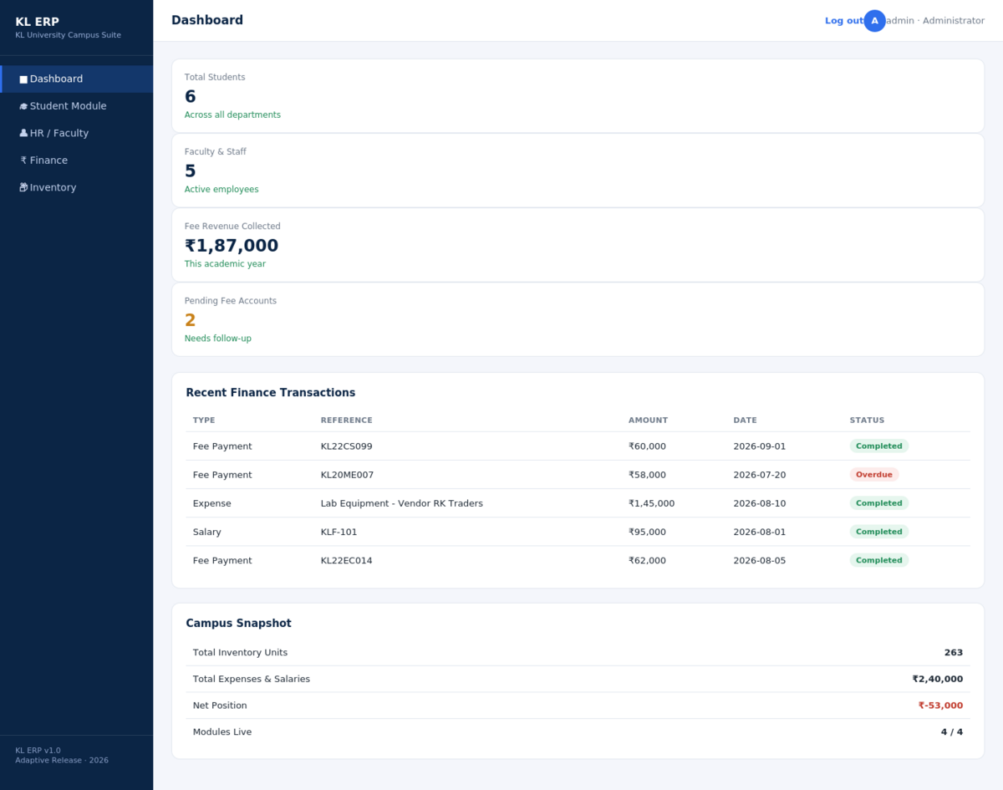
Figure 2. Consolidated administration dashboard.

Step 3 — Student Module
The Student module implements US-04 through US-07: an "Add New Student" form posts to the /students route, which performs a parameterized INSERT into the students table, then redirects back to the list so the new record appears immediately. The screenshot below was captured after submitting a new student record (KL22CS099) through the running application — the record is visible at the top of the table, confirming the create-then-list flow works end to end.
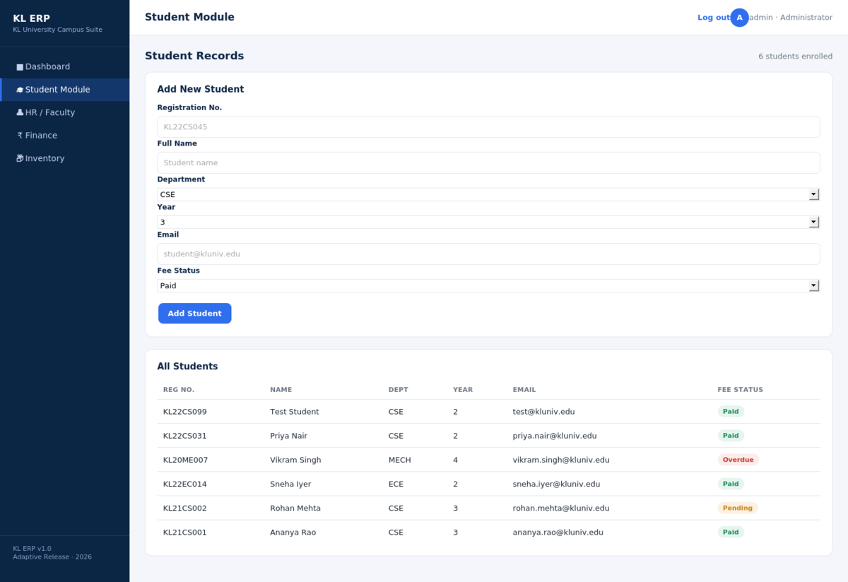
Figure 3. Student module — add form and live student list, including a record just created through the form.

Step 4 — HR / Faculty Module
The HR module (US-08 to US-10) mirrors the Student module’s structure: an add-employee form and a live-queried employee table with a status badge (Active / On Leave / Retired). Reusing the same list-plus-form pattern across modules was a deliberate architectural decision that made each subsequent sprint faster to implement.
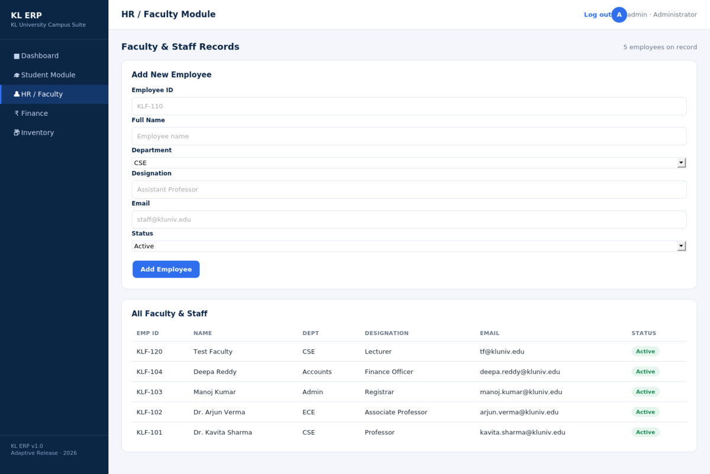
Figure 4. HR / Faculty module with a newly added faculty record.

Step 5 — Finance Module
The Finance module (US-11 to US-14) is the most business-critical module: it maintains a single finance table that records fee payments, salaries, and expenses as typed transactions. Revenue and expense totals shown at the top of the page are computed with conditional SQL aggregates (SUM ... WHERE txn_type IN (...)), and the net position is colour-coded green or red depending on its sign.
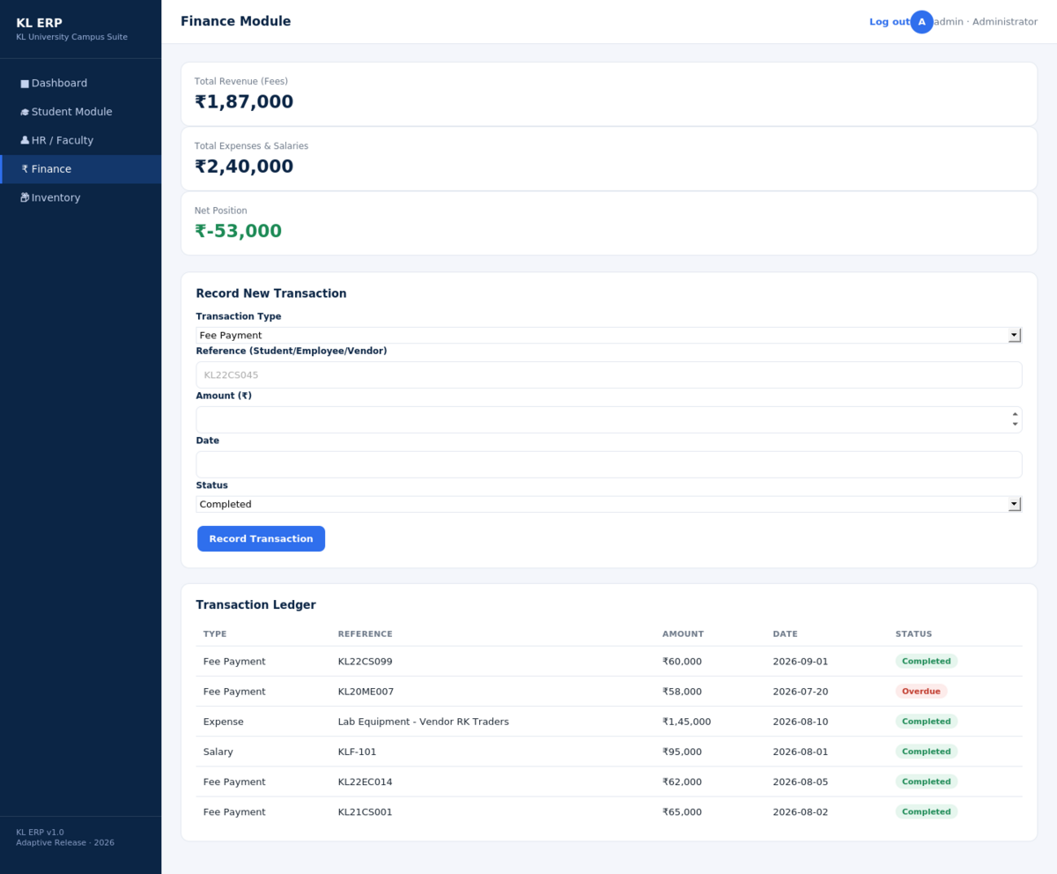
Figure 5. Finance module — revenue/expense summary and transaction ledger.

Step 6 — Inventory Module
The Inventory module (US-15 to US-17) tracks campus assets by category, quantity, location, and condition. Condition is colour-coded (Good / Fair / Needs Repair) so facilities staff can visually triage maintenance priorities directly from the list, satisfying US-17.
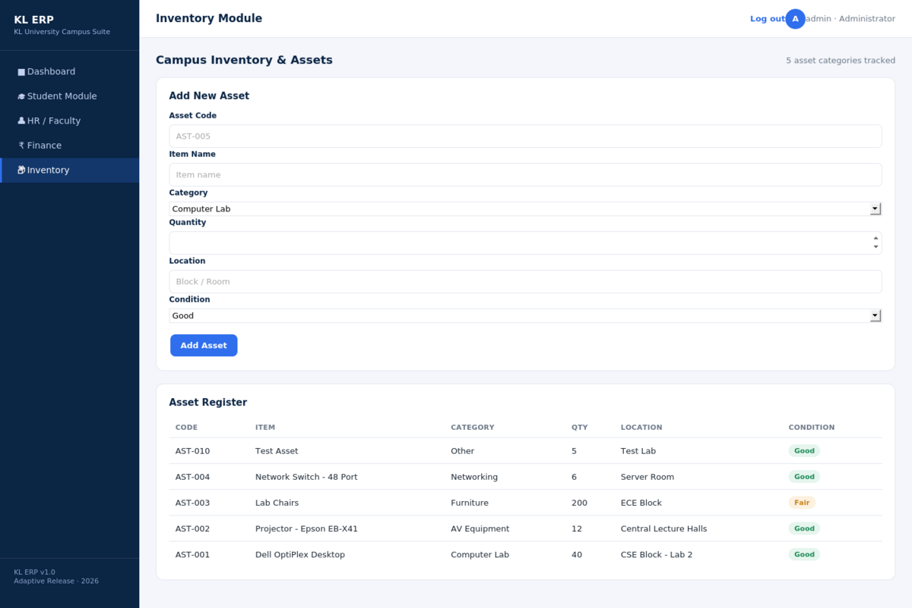
Figure 6. Inventory module — asset register with condition tracking.

Implementation Notes
- Every module follows the same GET (list) / POST (create) pair, guarded by the same requireAuth middleware, which kept the Sprint 1–4 implementation effort roughly constant per module.
- Business keys (reg_no, emp_id, asset_code) are declared UNIQUE at the database layer, so duplicate records are rejected even if application-level validation is bypassed.
- All form inputs are bound via parameterized prepared statements (better-sqlite3’s .prepare().run()), which was a deliberate mitigation against SQL injection from the first sprint onward rather than a later hardening pass.

7. Evaluation Strategy

7.1 Functional Testing (per user story)
Each user story in Section 2 was used directly as an acceptance-test script. For every module, the following cycle was run manually against the live application and is repeatable via the same HTTP routes:
- Submit the "Add" form with valid data → verify the new record appears in the corresponding list (verified for Student, HR, Finance, and Inventory modules in Section 6).
- Attempt to access a module route without an active session → verify the request is redirected to /login (validates US-02).
- Submit a duplicate business key (e.g. an existing reg_no) → verify the database’s UNIQUE constraint rejects the insert.

7.2 Testing Levels Proposed for Continued Development
Level | Approach | Tooling
Unit | Test individual SQL query builders and aggregate calculations (revenue, net position) in isolation | Jest
Integration | Test each Express route (GET/POST) against a temporary in-memory SQLite instance | Jest + Supertest
UAT | Walk each stakeholder role (registrar, HR officer, finance officer, facilities officer) through their module’s user stories | Manual scripted walkthrough, one per sprint review
Regression | Re-run the full user-story checklist after each sprint to confirm earlier modules still function | Manual checklist, automatable with Supertest later

7.3 Non-Functional Evaluation
- Security: parameterized queries throughout (mitigates SQL injection); session cookies are server-side and expire after 60 minutes of inactivity.
- Performance: since each module route issues a small number of indexed SQLite queries per request, response time is expected to stay in the low tens of milliseconds under typical campus-office load; this should be confirmed with a load-testing tool such as autocannon before production use.
- Usability: a consistent sidebar/topbar layout and colour-coded status badges (fee status, employee status, transaction status, asset condition) were used across every module so staff only have to learn the interaction pattern once.

7.4 Success Metrics
- Story completion rate per sprint (target: 100% of that sprint’s user stories demoed and accepted).
- Defect count found during UAT vs. defects found post-release (target: majority caught pre-release).
- Time-on-task for a registrar adding a new student, as a proxy for real-world adoption ease.

8. Conclusion and Future Scope
This case study took the KL ERP System from a set of stakeholder-driven user stories through to a working, database-backed application covering Student, HR, Finance, and Inventory modules, delivered incrementally under a Scrum process and implemented on a Node.js/Express/EJS/SQLite stack chosen specifically for that incremental delivery model.
Future increments identified but out of scope for this case study include: department-wise and year-wise reporting (US-07), role-based access control distinguishing registrar/HR/finance/facilities logins rather than a single administrator account, audit logging of record changes, and migration from SQLite to a networked database (PostgreSQL/MySQL) for multi-instance deployment — a change the parameterized-SQL design was deliberately kept compatible with.

