E-COMMERCE WEB APPLICATION
CASE STUDY – STEP-BY-STEP SCREENSHOTS
Implementation Documentation

Step 1 – Open the E-Commerce Home Page
Open the application and verify that the home page is displayed.
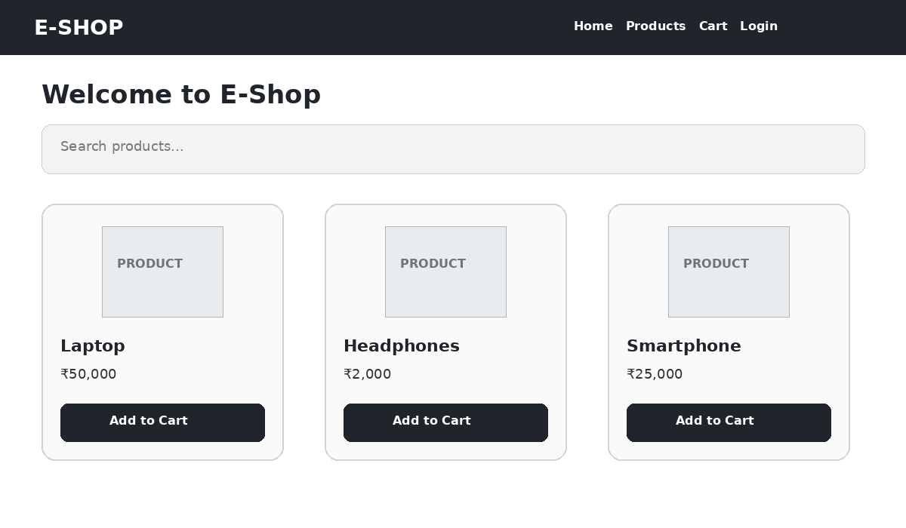
Figure 1: Open the E-Commerce Home Page

Step 2 – Register a New User
Enter the required user details and click Register.
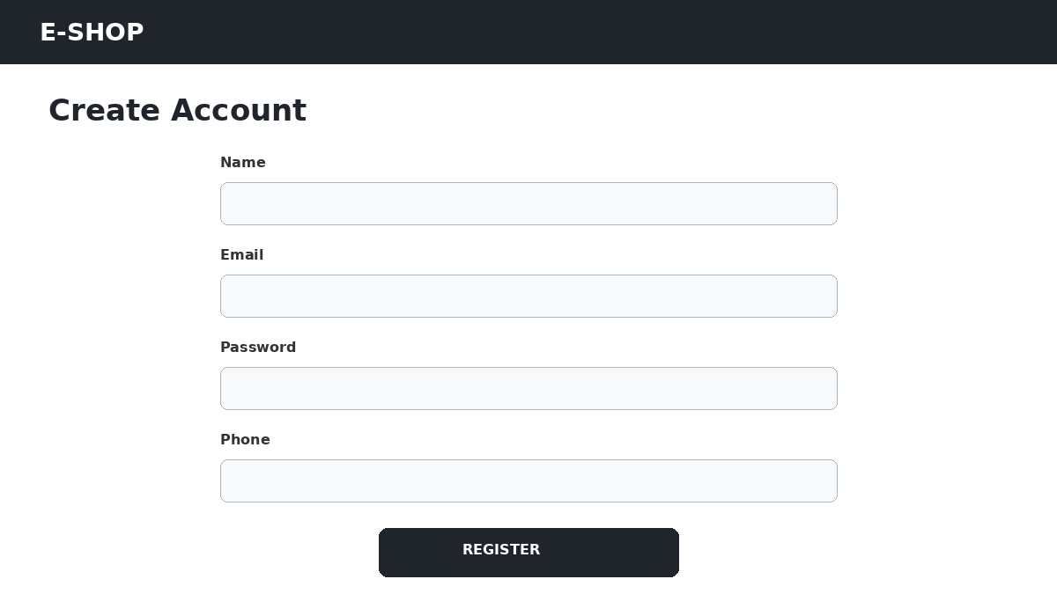
Figure 2: Register a New User

Step 3 – Login to the Application
Enter valid credentials and click Login.
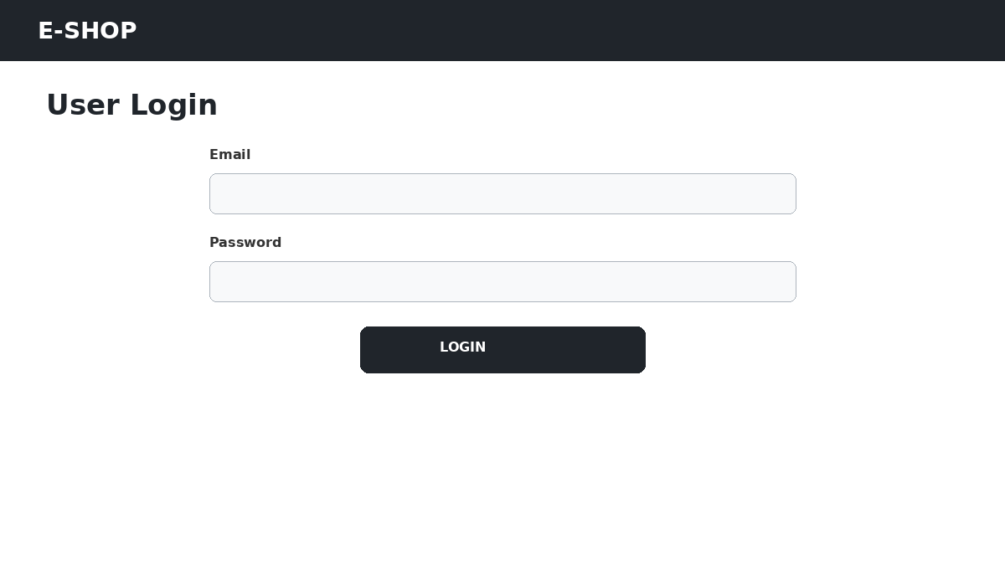
Figure 3: Login to the Application

Step 4 – View Available Products
Open the Products section and verify that available products are displayed.
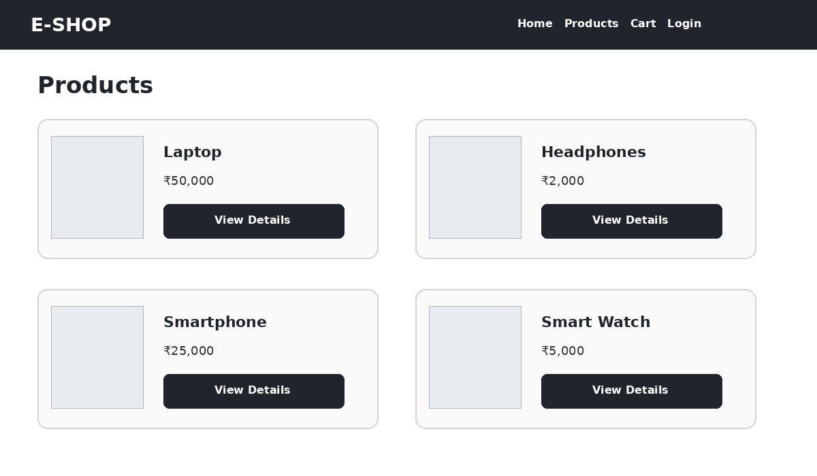
Figure 4: View Available Products

Step 5 – View Product Details
Select a product to view its price, description, and specifications.
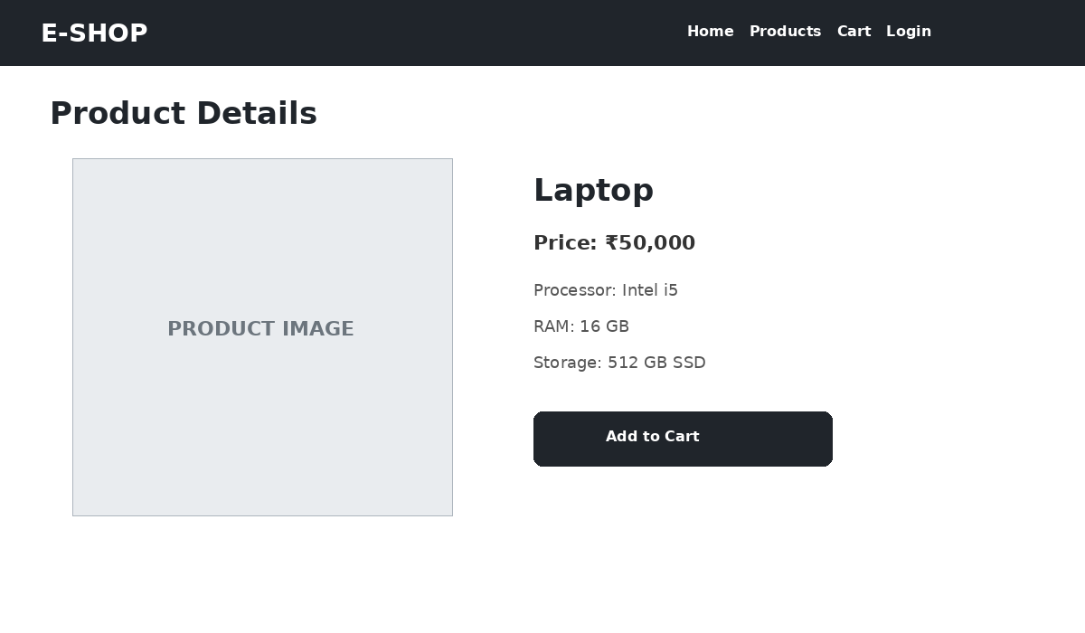
Figure 5: View Product Details

Step 6 – Add Product to Cart
Click Add to Cart for the selected product.
Figure 6: Add Product to Cart

Step 7 – Verify the Shopping Cart
Open the cart and verify the selected products, quantities, and total amount.
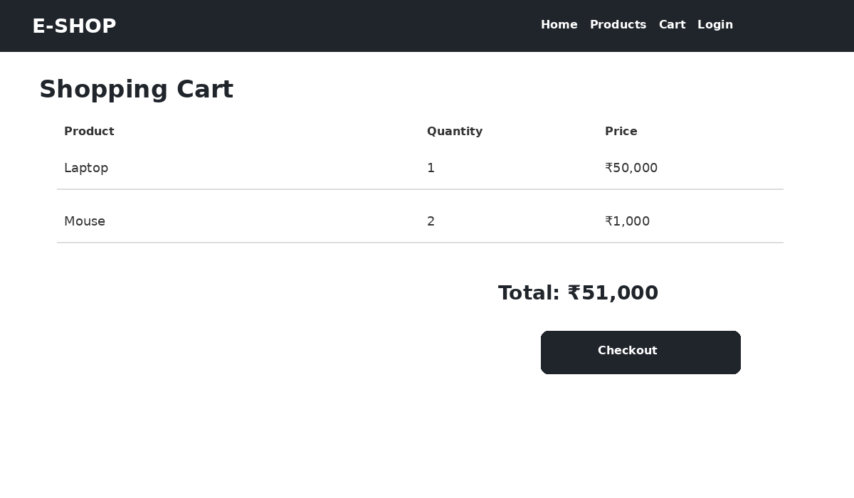
Figure 7: Verify the Shopping Cart

Step 8 – Checkout
Enter the delivery details, select a payment method, and proceed to place the order.
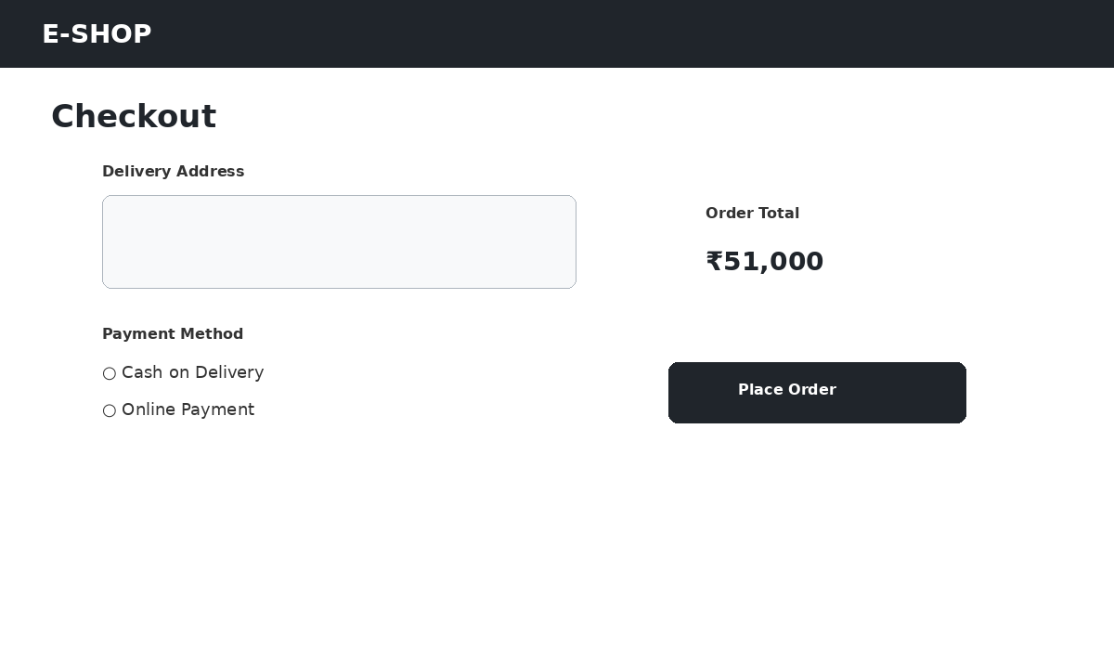
Figure 8: Checkout

Step 9 – Place the Order
Click Place Order and verify that an order confirmation is generated.
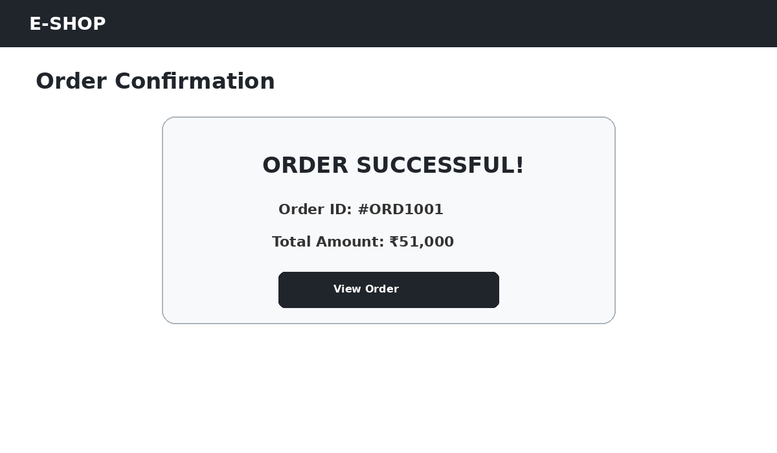
Figure 9: Place the Order

Step 10 – Administrator Dashboard
Log in as administrator and open the dashboard.
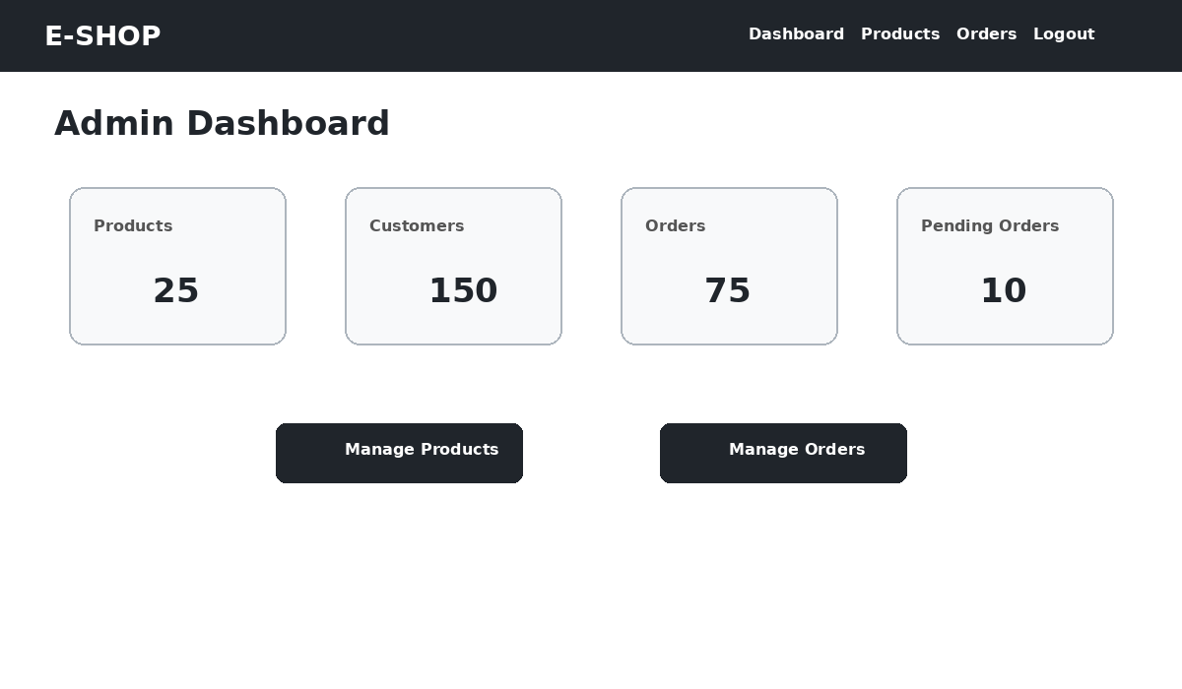
Figure 10: Administrator Dashboard

Step 11 – Manage Products
Use the admin product-management page to view, edit, or delete products.
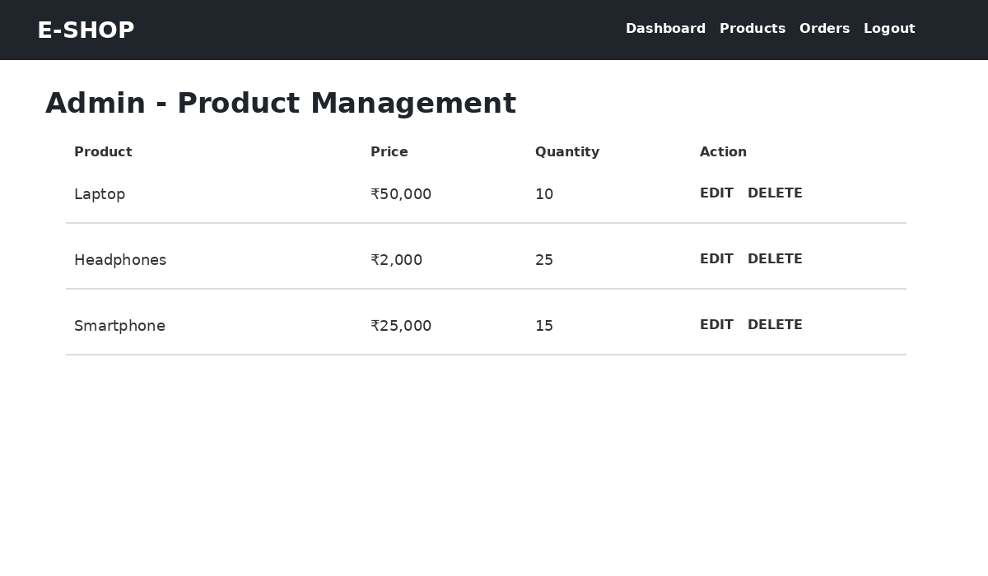
Figure 11: Manage Products

Evaluation
Verify the major functions after implementation: registration, login, product browsing, product details, cart, checkout, order placement, and administrator product management.

