Name: G Harshith Reddy
Roll Number: 2420030527
Experiment 8 Documentation
Step 1: Install SonarQube
Open the browser and type SonarQube installation
https://www.sonarsource.com/products/sonarqube/downloads/
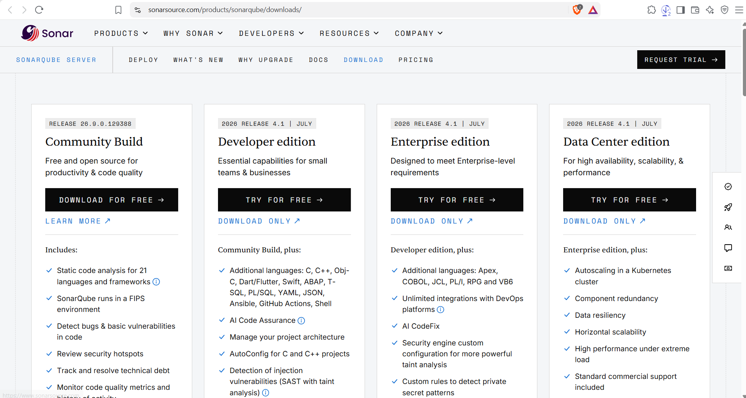
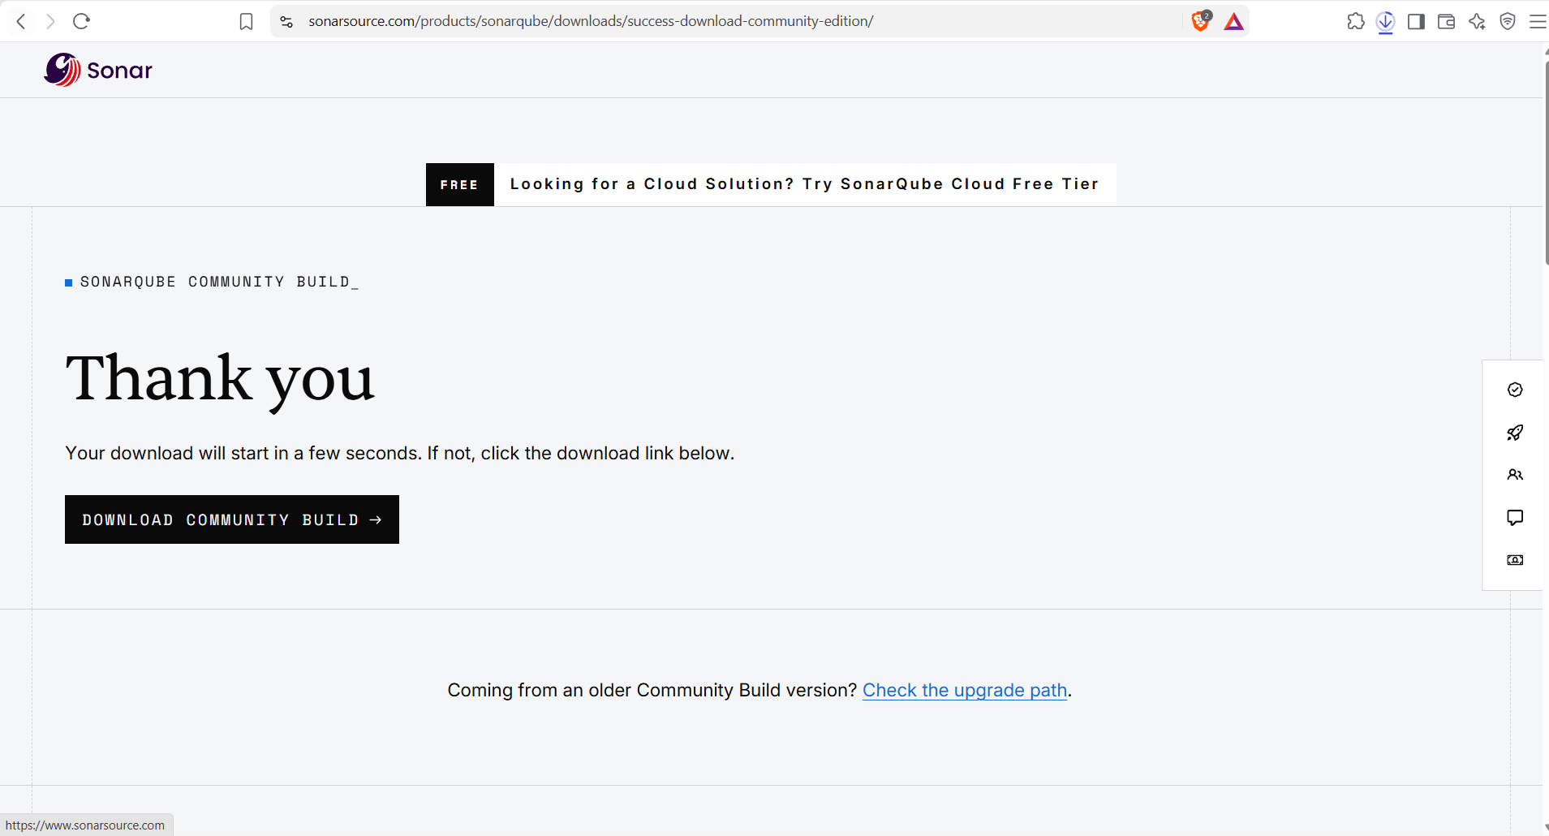
Step 2: After downloading extract the zip folder into the c drive
Screenshot:
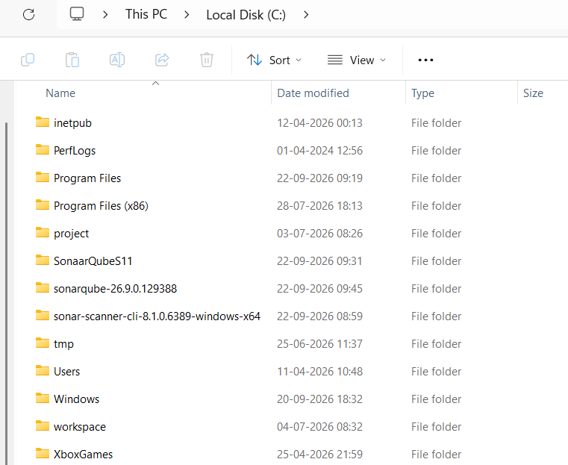
Go to C Drive->Open the Sonar Qube Folder->Open the bin folder-> Open windows -> Choose the OS ->Open windows folder
Here Copy the path
Screenshot:
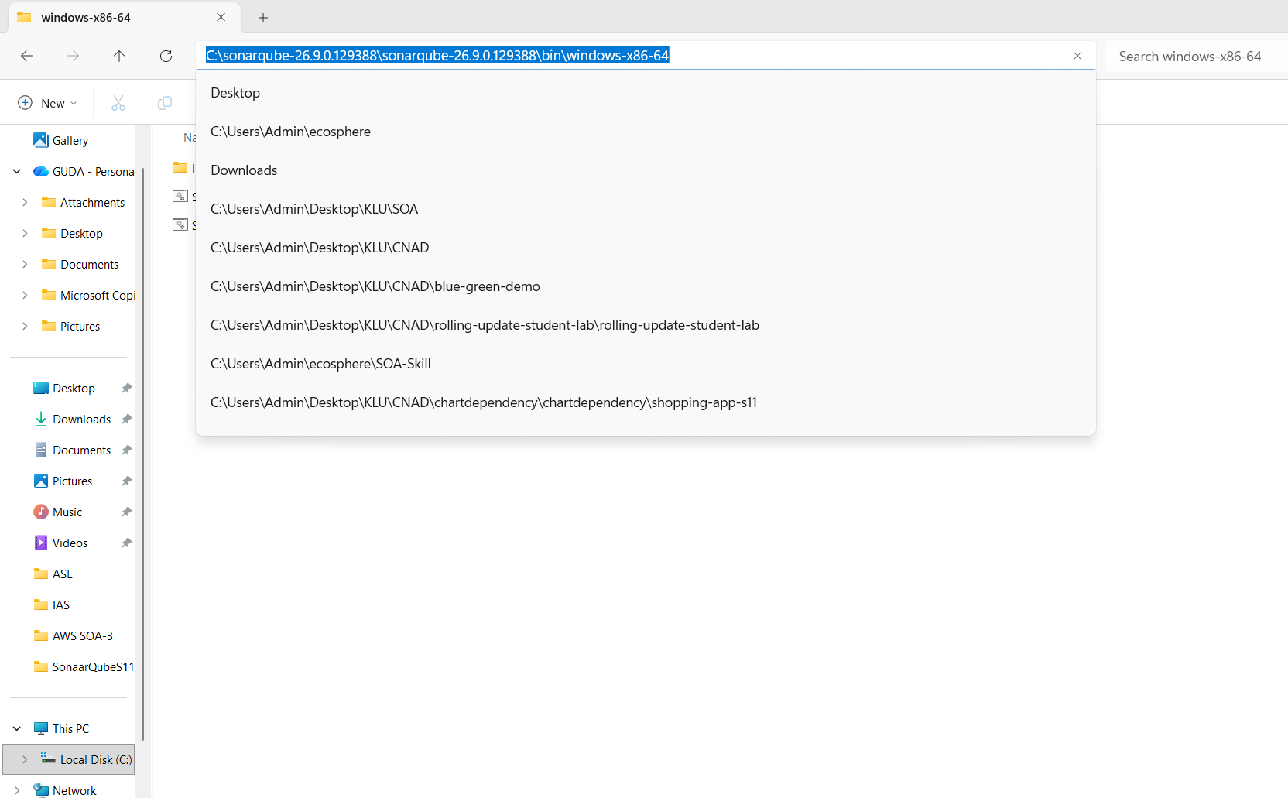
Open edit the system environment variables
Go to windows open the Edit system Environmental variables-Select the path edit -> Edit -> click on new->Paste the path -> Click on Ok, Ok and Ok
Screenshot:
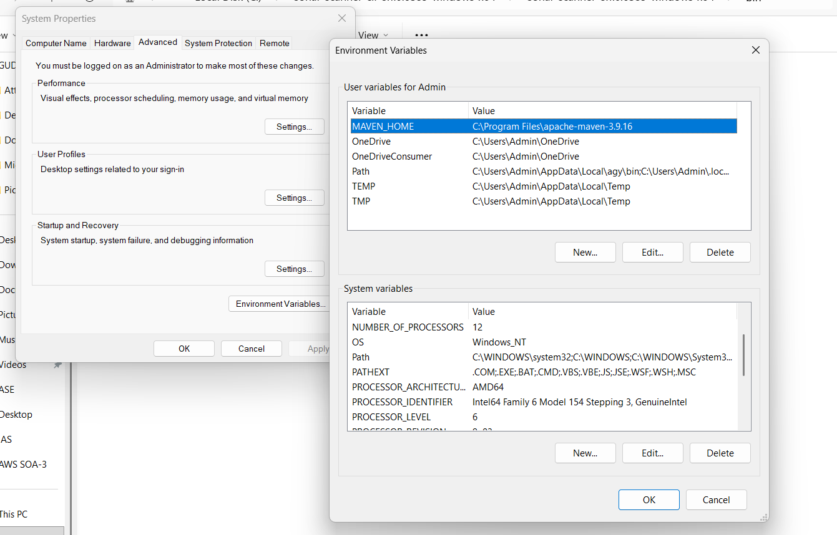
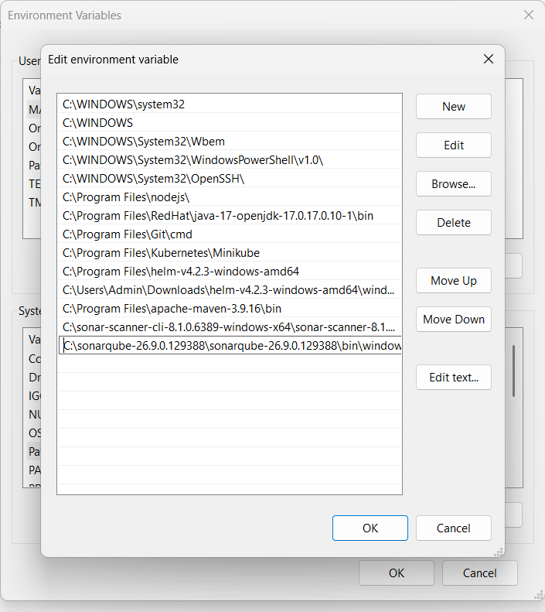

Step 3: Install sonar scanner
Open the web browser and type sonar scanner installation on windows and click on documentation
https://docs.sonarsource.com/sonarqube-server/9.9/analyzing-source-code/scanners/sonarscanner
Click on sonar scanner choose the OS, the zip folder will be downloaded

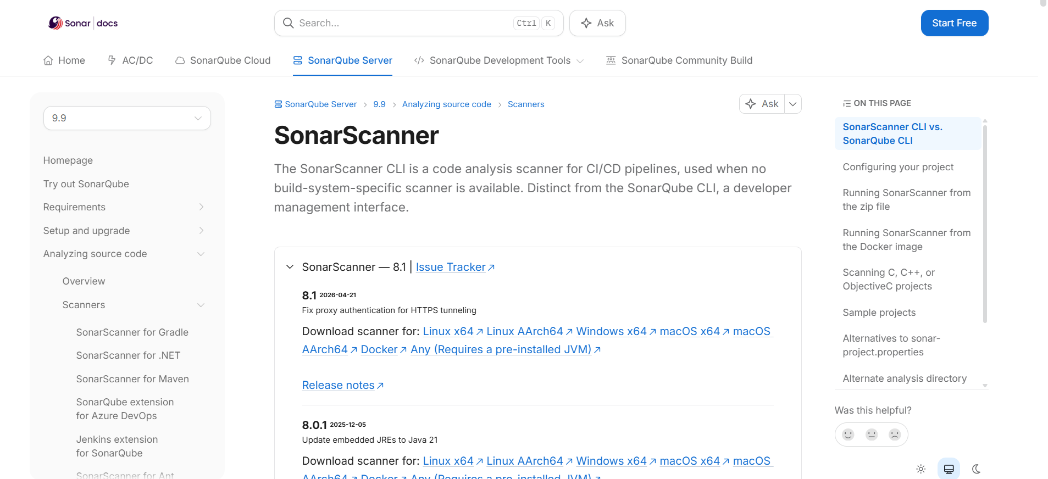
Step 3: After downloading extract the zip folder into the c drive
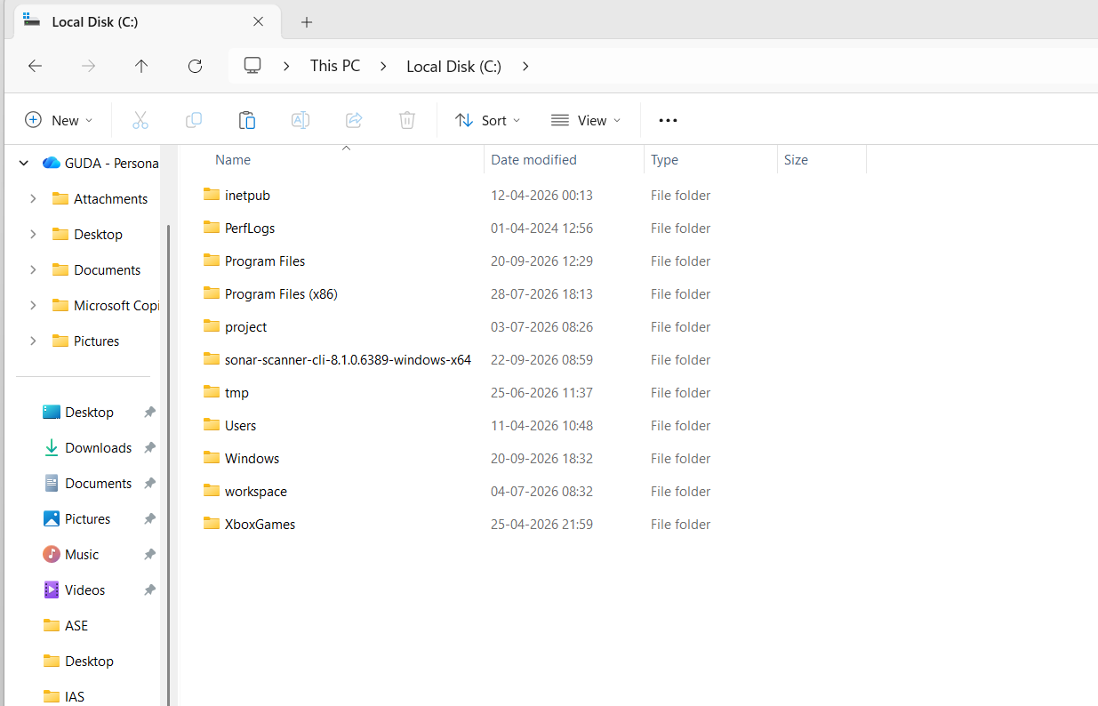
Go to C Drive->Open the Sonar scanner Folder->Open the bin folder-> Copy the path and add the path to system environment variables
Here Copy the path
Screenshot:
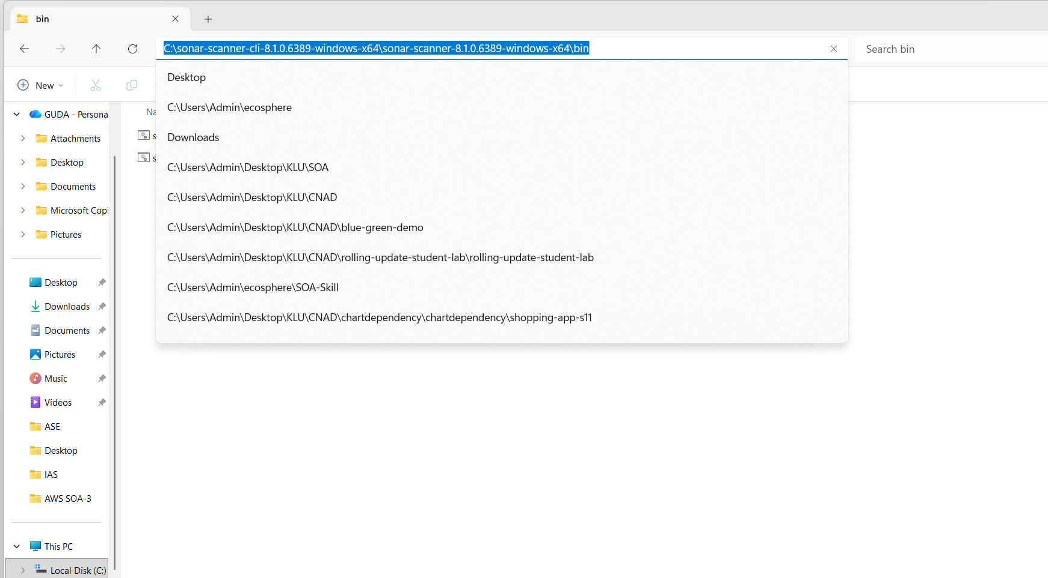
Open edit the environment variables
Go to windows open the Edit system Environmental variables-Select the path edit -> Edit -> click on new->Paste the path -> Click on Ok, Ok and Ok
Screenshot
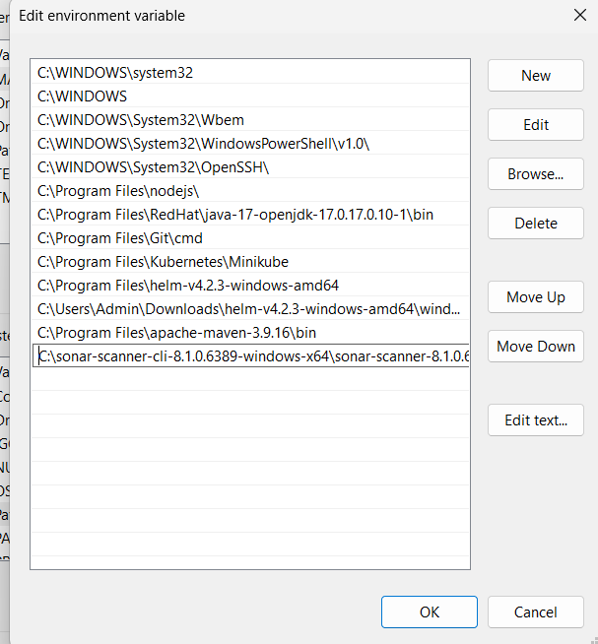
Step 4: Start the server
Open the command prompt and type StartSonar and then click enter
Screenshot:
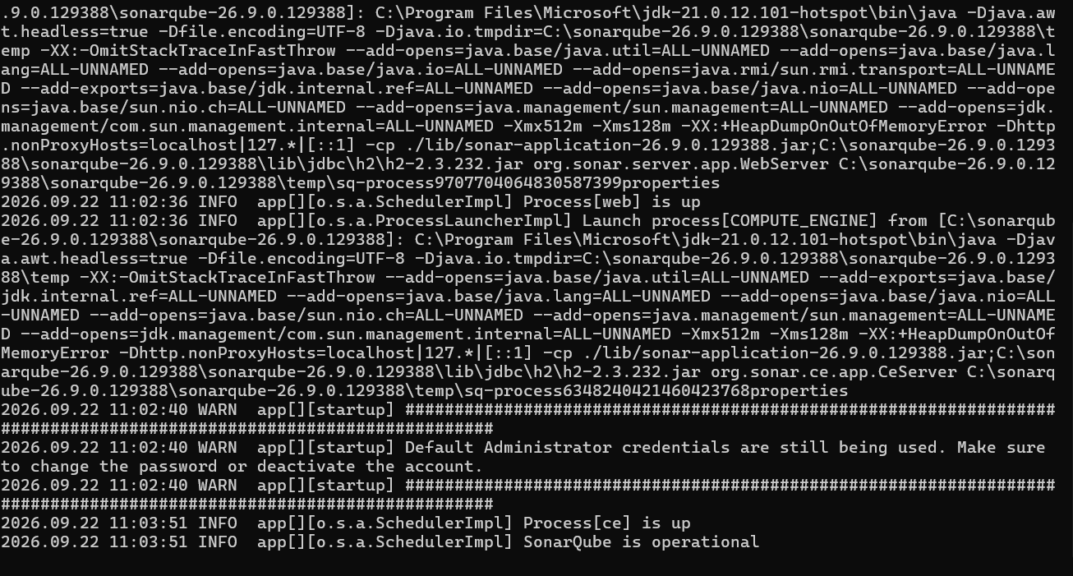

Process[ce] is up
SonarQube is operational
we should not close the command prompt of the SonarQube. We have to minimize. Because it will Shut Down
Step7: Open the browser and type
localhost:9000 and press enter
Username and Password -> “admin”
Screenshot:
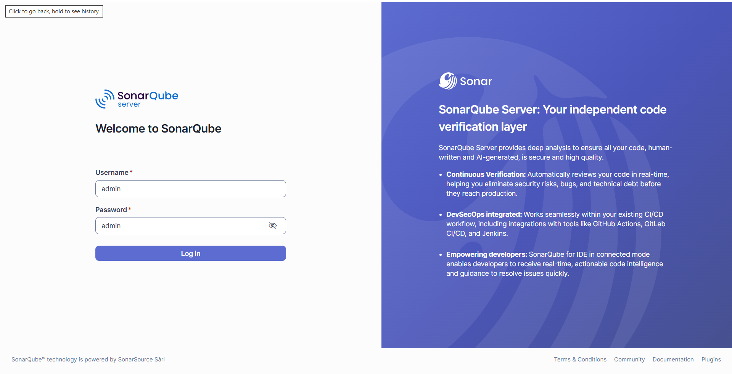
Step 5: Click on Create a local project
Enter the project name and click on next
Screenshot:
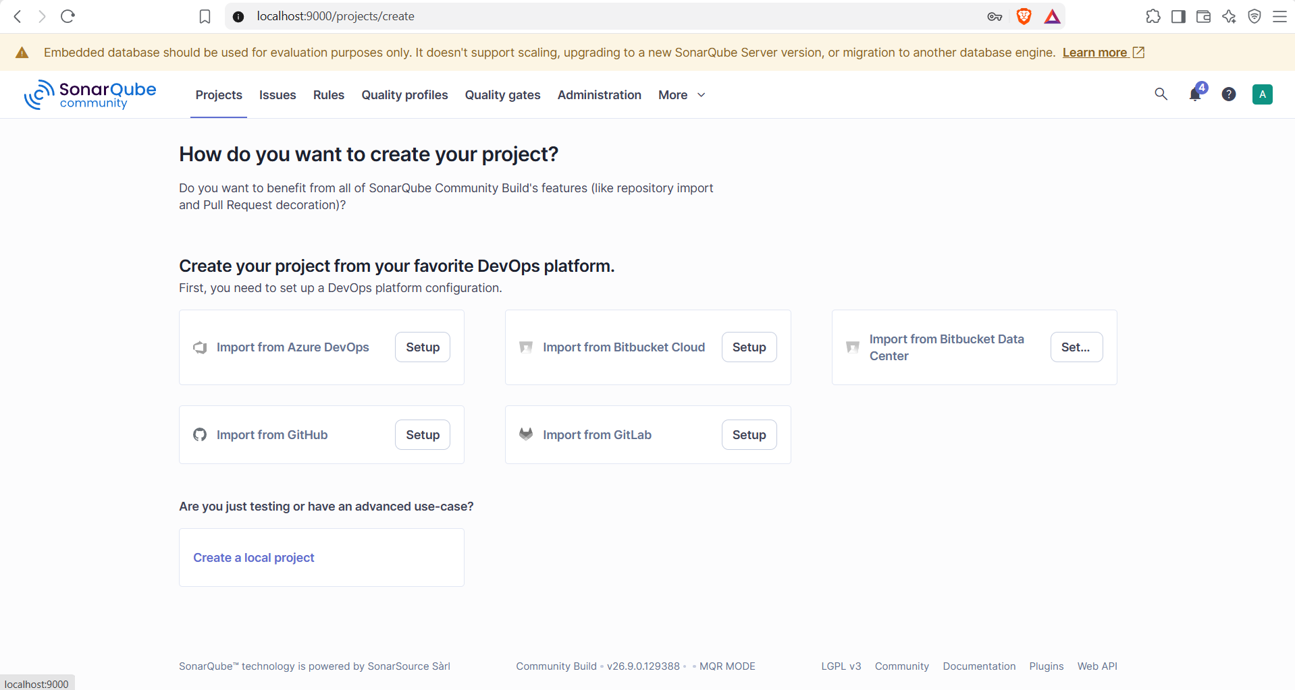
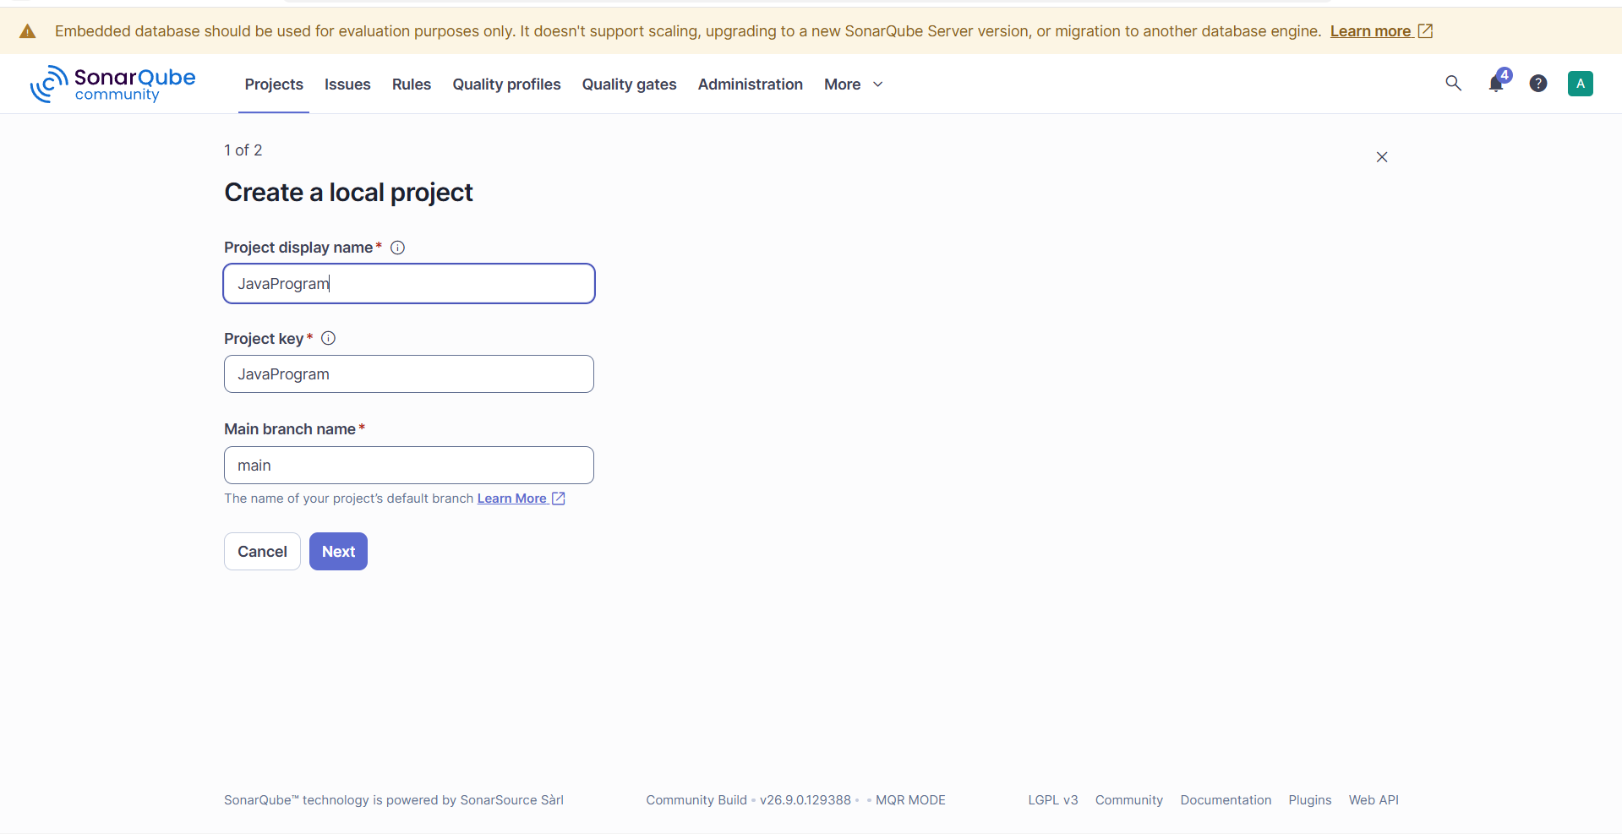
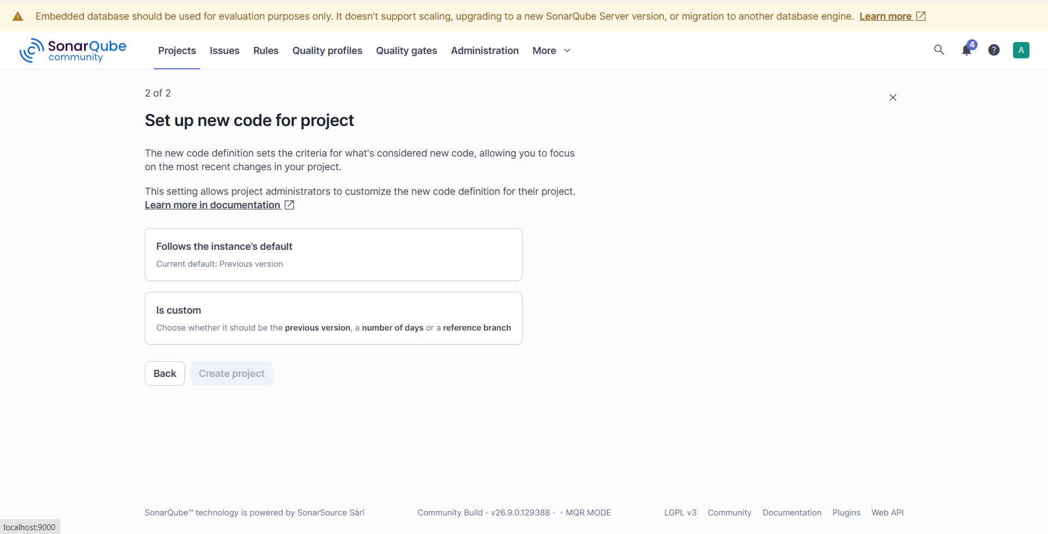

Click on “Follows the Instance’s Default” and click on “create project”
Screenshot:
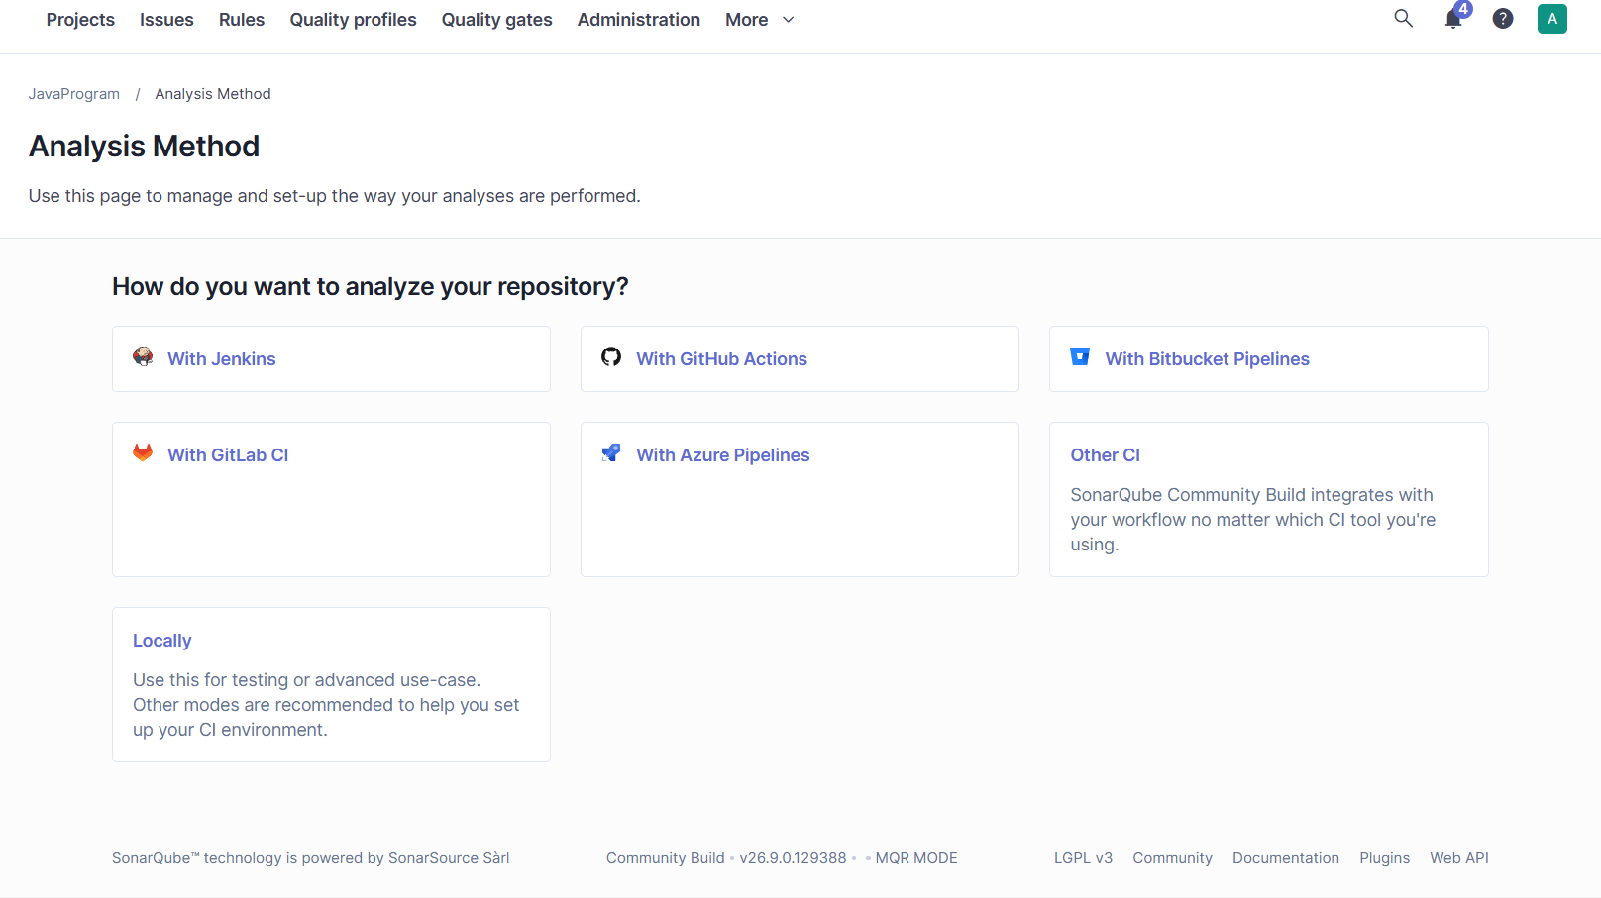
Choose “Locally”
Click on “Generate”
Screenshot:
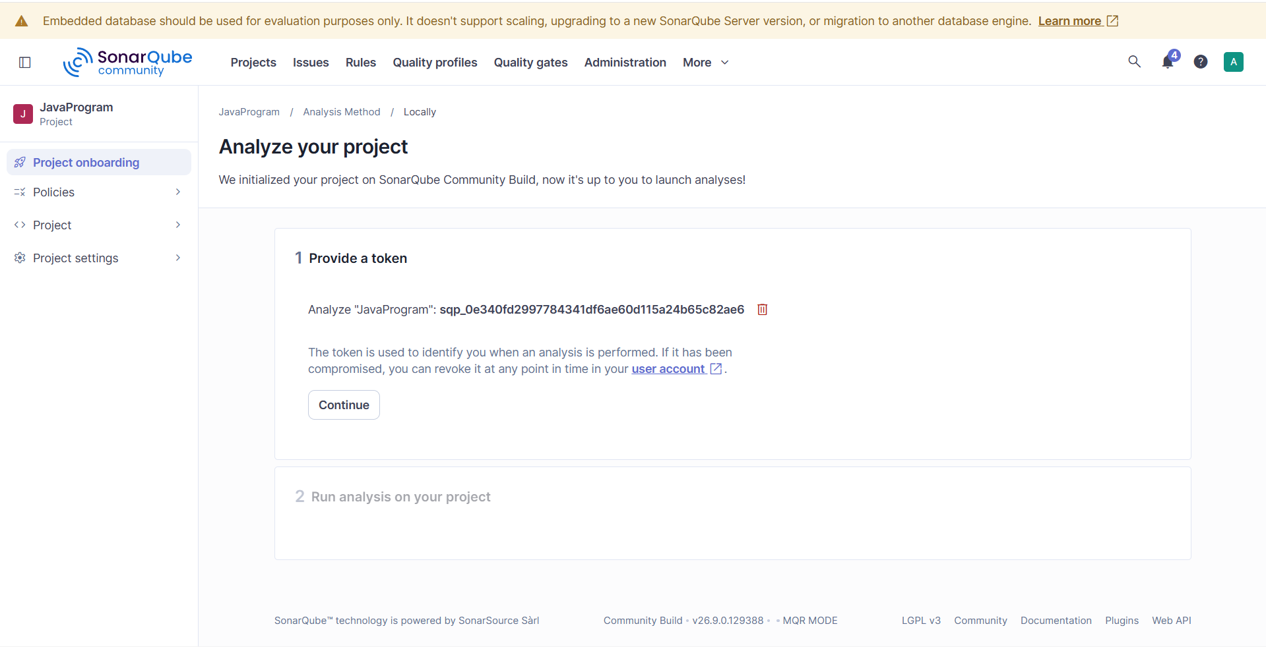
Token will generate, Copy the token and paste somewhere as we need to use this token and click on continue
Screenshot:
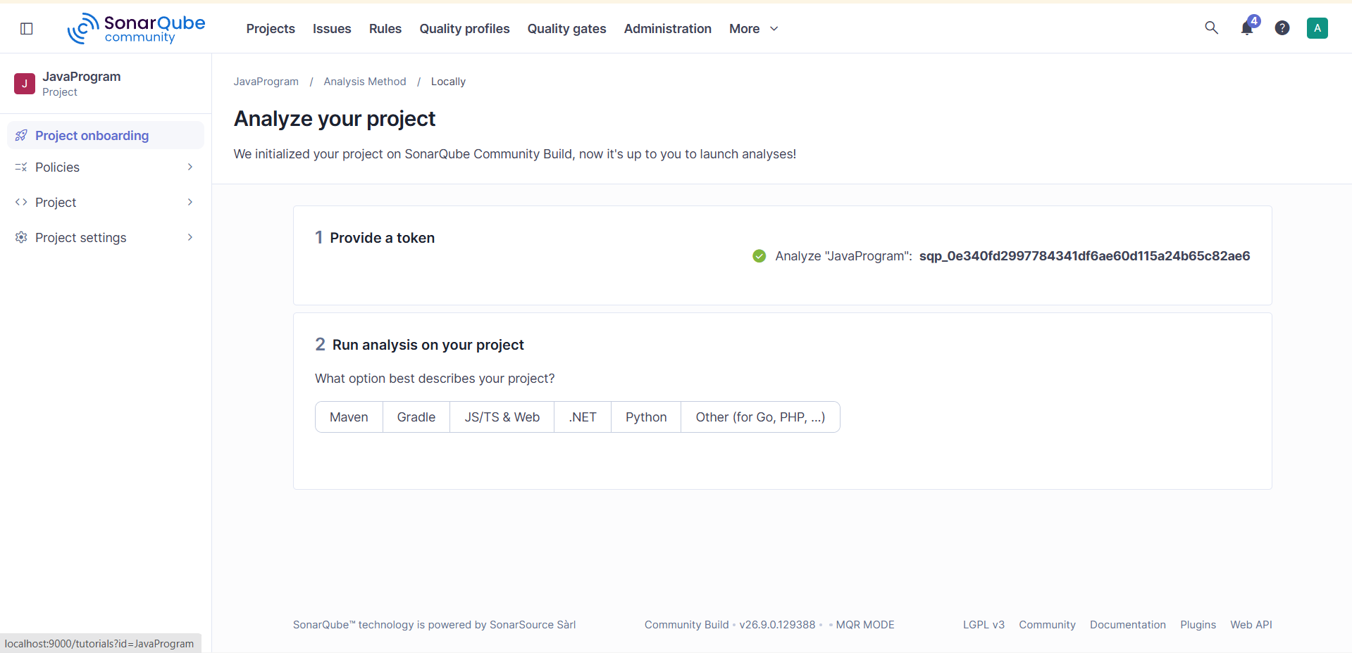
Token: sqp_0e340fd2997784341df6ae60d115a24b65c82ae6
Step6: Check installation of SonarScanner
Open cmd and enter -> sonar-scanner -v
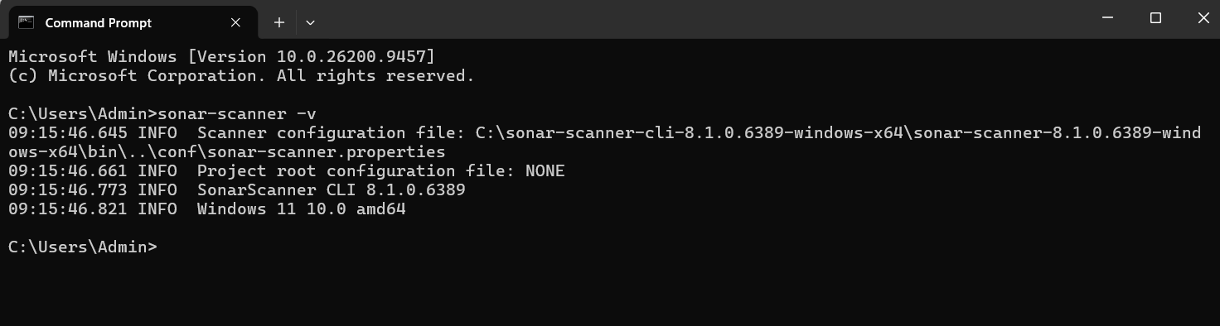
Step7: Create a Folder in C Drive and name it as SonarQubeS11and create a simple java program and name the file as Javaprogram.java and save the file
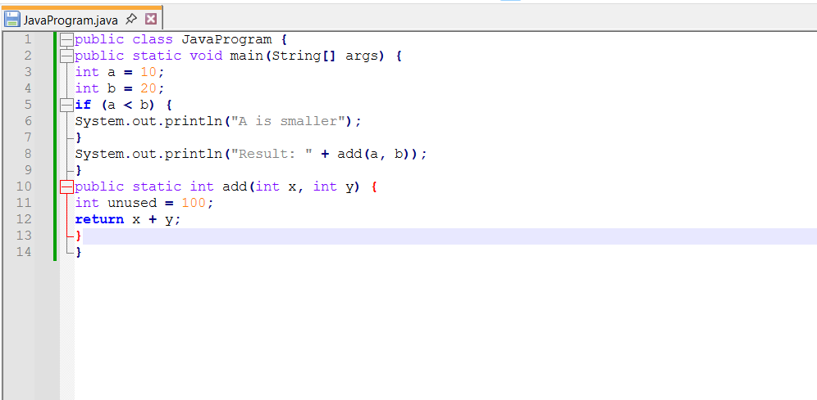

Configuration file should be saved as
sonar-project.properties
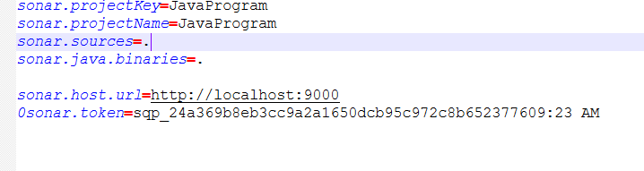
Save the file
Compile the java program to get the class file
Copy the path where java program is saved
Change the directory where the program is there
Goto cmd and change the path
Sc
Compile the program the command is
C:\javac Javaprogram.java

Screenshot:
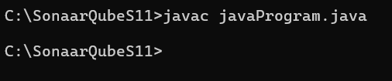
Step8: Scan the program
Command is c:\sonar-scanner
Once the scanning has done you will get as “EXECUTION SUCCESS”
Screenshot:
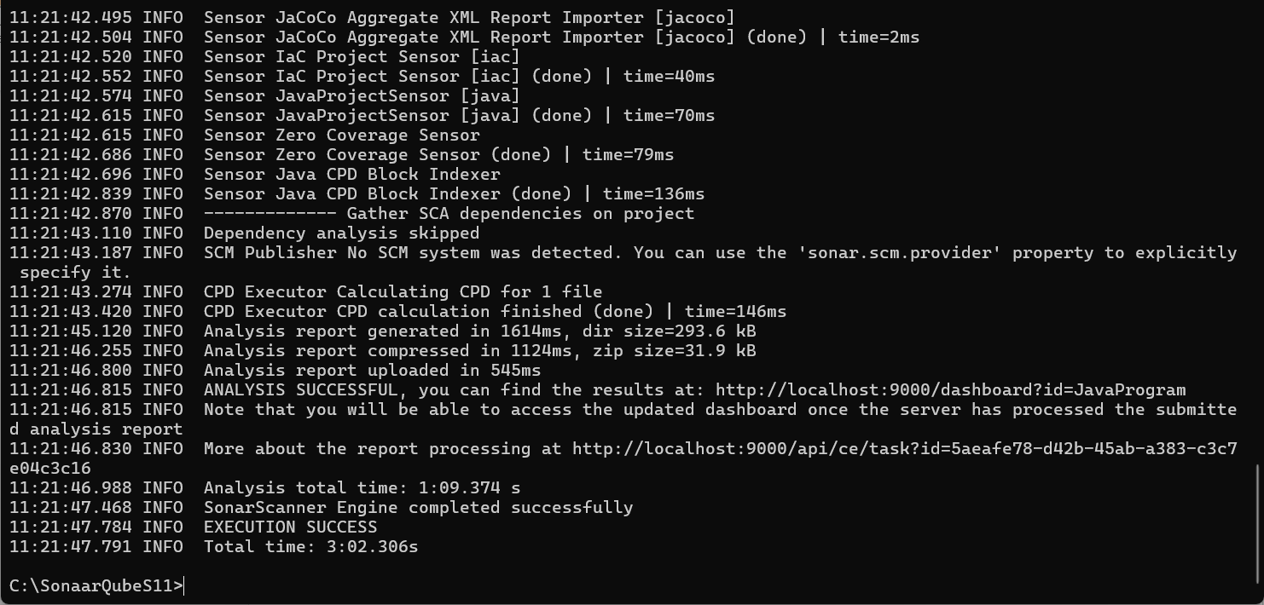
Now go to the server
Click on Projects on top and check the report
Screenshot:
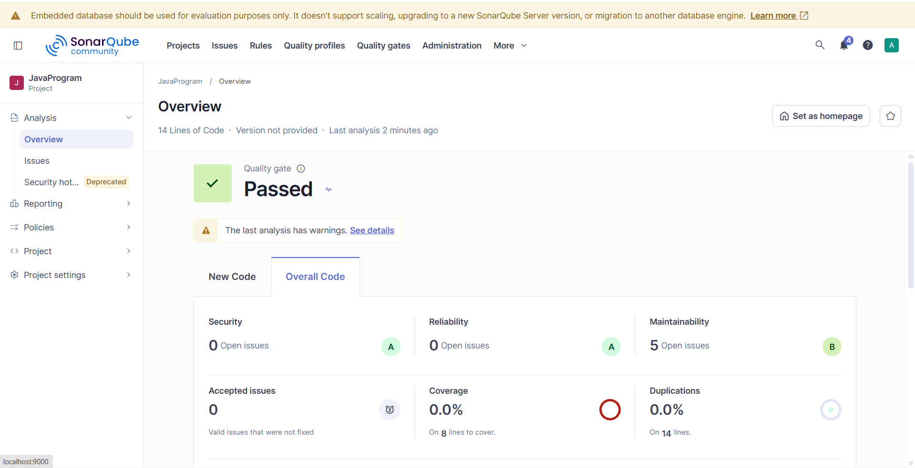

Here 5 Maintainability is showing check those click on issues it will give all the issues
Screenshot:
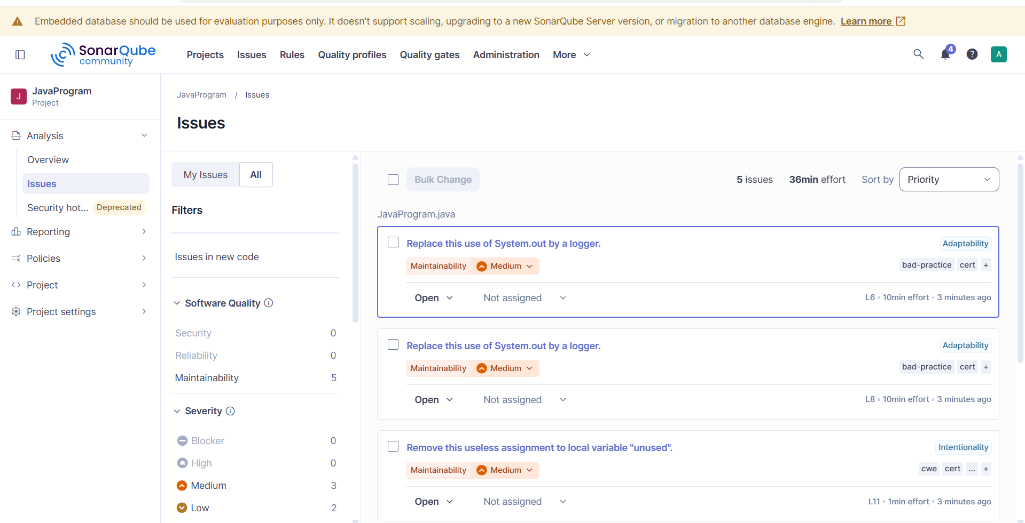
Server is in operational , once the work is done stop the server
Open the cmd where server is in operational
Press ctrl+c
Screenshot:
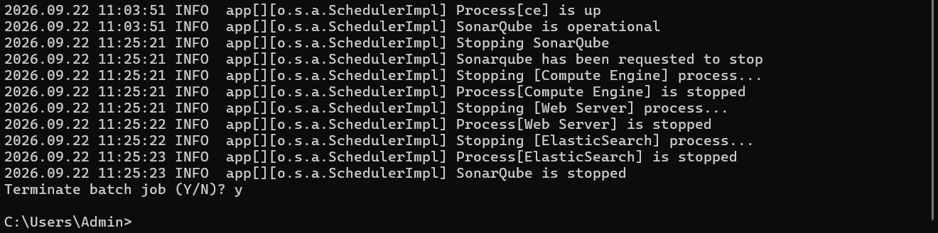

Type exit and y
Screenshot:
To check the server is stopped, open the web browser of SonarQube and refresh
Screenshot: The server is stopped successfully
