# 质量计划

## 项目范围

### 产品名称

AR试衣间

### 目标用户

经常通过淘宝，京东等电商渠道购买衣服的广大消费者

### 需求和价值

需求：

1. 目标用户在线购买衣服时有试穿衣服的需求
2. 现有的一些解决方案效果不好
3. 在线搭配衣服不方便

价值：

解决在线试穿衣服的问题，方便用户生活，弥补线上购衣的先天不足

1. 目标用户在线试衣
2. 更好的试衣效果
3. 在线搭配衣服

### 产品特征

产品特点

1. 试衣效果好
2. 使用方便

概貌

用户在台式机或笔记本电脑前打开软件，并穿上带有marker的上衣，选取要试穿的衣服后，软件即将虚拟衣物叠加在用户身体前，虚拟衣物将随用户移动而移动。

### 竞争对手

#### 试衣搭配导购系统

* 无法各角度观察。
* 给模特试衣，并非给用户自己试衣，没有真实感。
* 真实情况的模拟较差。

#### 打扮他网站

* 系统提供给用户的服装选项是2D图片，效果差
* 使用方法复杂，用户要手动输入24个人体参数
* 虚拟生成模特，与真人试衣效果存在差距

#### 互动虚拟试衣镜

* 价格贵。

### 初步计划

5-13周完成

## Road Map

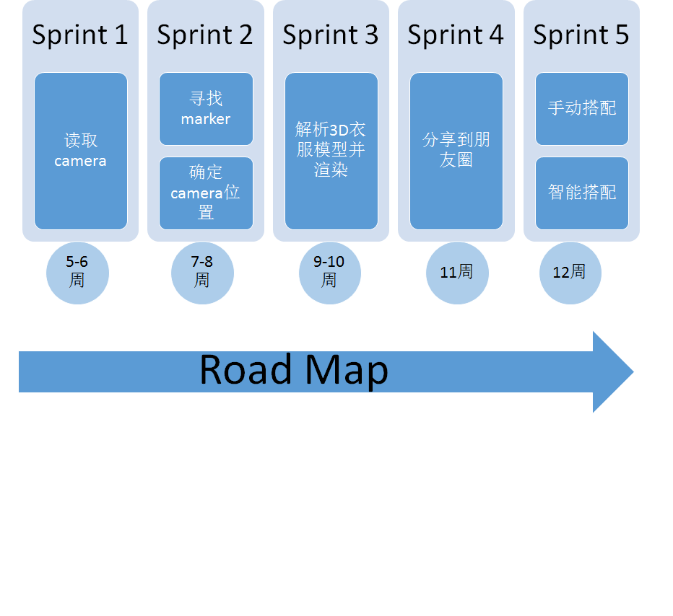

## DoD

* US
  + 源代码和测试脚本提交到配置管理工具
  + 满足user story可接受准则，通过相关的测试用例
  + 每个用例至少被团队中另一个成员评审，并更新测试用例执行结果
  + 标注所有的开源工具
* Iteration
  + 保证Sprint测试计划的执行
  + 根据情况执行压力测试，边界值测试或系统测试
  + 为下一个Sprint准备充足的user story
  + 完成Sprint代码提交和审查
  + 完成Sprint回顾会议
* Field Release
  + 完成用户手册
  + 保证发布版本储存在安全的空间
  + 测试计划已执行

# 质量控制（checklist）

|  |  |  |  |  |  |
| --- | --- | --- | --- | --- | --- |
| **Timing** | **Check item** | **Owner** | **Deliverable** | **Status** | **Comments / Action plan** |
| Grooming | Vertical User Stories are associated to a features | PO | User story | not filled in |  |
| Grooming | Dependencies between stories are identified in Jira | PO | User story | not filled in |  |
| Grooming | User stories are roughly estimated (by scrum masters / architects / technical leaders) | PO | US estimates | not filled in |  |
| Grooming | User stories are prioritised (based on business value, technical criticality and size estimates) | PO | US priority | not filled in |  |
| Grooming | The total estimation is more than the teams velocity | PO | Sprint backlog | not filled in |  |
| Sprint planning | Product Owner has clarified all questions on the user stories to be planned | PO | Sprint backlog | not filled in |  |
| Sprint planning | Acceptance criteria and validation means are defined for each stories | PO | Acceptance criteria | not filled in |  |
| Sprint planning | Definition of Done is reviewed | PO | DoD | not filled in |  |
| Sprint planning | Team capacity is determined (i.e. depending on members availabilities for any reason) | SM | Team capacity | not filled in |  |
| Sprint planning | Big stories have been split in smaller to fit the sprint | PO | User story | not filled in |  |
| Sprint planning | Identify Dependencies & Assumptions | PO | User story | not filled in |  |
| Sprint planning | Team & Product Owner define the sprint goal or theme | PO | Sprint goal | not filled in |  |
| Sprint planning | Team has refined stories estimates and committed on a number of high priority user stories to be developed in the sprint, according to the capacity and the dependencies of the stories | Scrum Team | US estimates | not filled in |  |
| Sprint planning | Product Owner agrees with the work that will be completed | PO | Sprint backlog | not filled in |  |
| Sprint planning | Each user stories are broken into tasks | Scrum Team | US tasks | not filled in |  |
| Sprint planning | Each task is estimated in ideal hours (i.e. actual time dedicated to the task) | Scrum Team | Task estimates | not filled in |  |
| Sprint planning | Total estimated workload is reviewed to ensure it can be completed within the sprint | Scrum Team | Estimated workload | not filled in |  |
| Sprint planning | Jira is updated with all these informations | Scrum Team | Jira update | not filled in |  |
| Sprint Review | Critical Open Software Process (COSP) reviewed by Legal | APC | Open software identification | not filled in |  |
| Sprint Review | BU Representative Approval (if applicable) | APC | Open software identification | not filled in |  |
| Sprint Review | Open Software packages published (if applicable) | APC | Open software identification | not filled in |  |
| Sprint Review | Open Software has been notified in client documentation | APC | Open software identification | not filled in |  |
| Sprint Review | Defect severity thresholds | APC | Defect severity threshholds | not filled in |  |
| Sprint Review | Code peer review level | APC | Code review | not filled in |  |
| Sprint Review | Definition of done is complied to, and meets at least the "Minimum Definition of Done" criteria | APC | Validation approach | not filled in |  |
| Sprint Review | Test coverage on lab test that can be done within the Technicolor environment | PO | Test coverage | not filled in |  |
| Sprint Review | Security vulnerabilities reported by SCC (Security Control Centre) are closed | APC | Security check | not filled in |  |
| Sprint Review | Field tests and customer feedback is taken into account | APC | Customer feedback | not filled in |  |
| Sprint Review | Requirements Traceability through design and test is up to date | APC | Requirement traceability | not filled in |  |
| Sprint Review | Risks are available and clearly identified (owner and mitigation actions are defined) | APC | Risk identification | not filled in |  |
| Sprint Review | Release note is available | PO | Release note | not filled in |  |
| Sprint Review | Software certificates (e.g., HDMi) are available as needed | PO | Software certificates | not filled in |  |
| Sprint Review | ARR data collection complete | APC | ETM actions | not filled in |  |
| Retrospective | Velocity : <sum of accepted points> points | SM | Velocity | not filled in |  |
| Retrospective | Planned Points : <sum of points committed in sprint planning> points | SM | Planned point | not filled in |  |
| Retrospective | Team size : <nb of people in the team during sprint (in order to balance velocity and get a productivity for future planning)> | SM | Team size | not filled in |  |
| Retrospective | Accepted user stories list | SM | Accepted US | not filled in |  |
| Retrospective | Postponed user stories list | SM | Postponed US | not filled in |  |
| Retrospective | Accepted defects | SM | Accepted defects | not filled in |  |
| Retrospective | Postponed defects | SM | Postponed defects | not filled in |  |
| Retrospective | Review of suggestions from previous sprints: <status of actions taken in previous retrospective> | SM | Actions | not filled in |  |
| Retrospective | Things the team should start doing: <New process or enhancement of the Definition of Done to improve quality and velocity> | Scrum Team | Actions | not filled in |  |
| Retrospective | Things the team should manage as well as possible to avoid in decreasing velocity: <List impediments and blockers that occurred in sprint and proposed solution> | Scrum Team | Actions | not filled in |  |
| Retrospective | What went wrong (Name in bold proposes to take action): <Choose a small set of actions (3 actions for instance) to focus on next sprint > | Scrum Team | Actions | not filled in |  |

# 关键绩效指标

* 用户满意度
  + 用户调查
  + 用户数据分析
* 可靠性
  + 千行代码错误数
  + 待办事项接收率
  + 同行评审
* 可靠性