OLIST E-COMMERCE
CLOUD DATA PIPELINE
Technical & Architecture Documentation
Batch ETL Pipeline | Apache Airflow • PySpark • AWS S3 • Docker
Medallion Architecture (Bronze / Silver / Gold)
Version 1.0
Prepared: July 30, 2026

Table of Contents
Table of Contents 1
1. Executive Summary 1
Key Characteristics 1
2. Project Overview 1
2.1 Purpose 1
2.2 Source Dataset 1
2.3 High-Level Data Flow 1
3. Architecture Overview 1
3.1 Architectural Layers 1
3.2 System Architecture Diagram 1
3.3 Core Components 1
4. Technology Stack 1
5. Infrastructure & Deployment 1
5.1 Dockerfile 1
5.2 Docker Compose Services 1
5.3 Volumes & Project Mounts 1
5.4 Required Environment Variables 1
5.5 Startup Sequence 1
6. Orchestration — Airflow DAG 1
6.1 DAG Configuration 1
6.2 DAG Task Flow Diagram 1
6.3 Task Groups 1
start → ingest_to_s3 1
TaskGroup: transformations (Bronze → Silver) 1
TaskGroup: data_modeling (Silver → Gold) 1
TaskGroup: aggregated_tables (Gold → Reporting) 1
end 1
7. Data Ingestion Layer (Bronze) 1
7.1 ingest_to_s3.py 1
7.2 Source → Bronze File Mapping 1
8. Data Transformation Layer (Silver) 1
9. Data Modeling Layer (Gold) — Star Schema 1
9.1 Star Schema Diagram 1
9.2 Dimension: dim_customers 1
9.3 Dimension: dim_sellers 1
9.4 Dimension: dim_products 1
9.5 Dimension: dim_date 1
9.6 Fact Table: fact_order_items 1
Derived Measures 1
Final Fact Columns 1
Fan-out Prevention 1
10. Aggregated Reporting Tables 1
11. Data Quality Framework 1
11.1 Hard Failures (fail-fast gates) 1
11.2 Soft Flags (data_quality_issue column) 1
12. Configuration & Shared Utilities (config.py) 1
12.1 Constants 1
12.2 get_spark_session(app_name) 1
12.3 s3_path(*parts) 1
12.4 write_layer_csv(df, layer, s3_folder, filename) 1
12.5 write_silver_csv / write_gold_csv 1
13. Project File Structure 1
14. Recommendations & Future Enhancements 1
15. Appendix 1
15.1 Glossary 1
15.2 Reviewed Source Files 1

1. Executive Summary
This document describes the design, architecture, and implementation of the Olist E-Commerce Cloud Data Pipeline — a containerized, orchestrated batch ETL system that ingests the public Olist Brazilian e-commerce dataset, cleanses and models it through a Bronze → Silver → Gold medallion architecture, and produces an analytics-ready star schema for business intelligence and reporting.
The pipeline is orchestrated end-to-end by Apache Airflow running in Docker, with all data processing performed using PySpark and persisted to Amazon S3. The system is designed with an emphasis on data quality enforcement, deterministic sequential execution, and a clean separation of ingestion, transformation, and modeling responsibilities.

Key Characteristics
- Fully containerized deployment via Docker Compose (CeleryExecutor-based Airflow cluster)
- Medallion architecture: Bronze (raw), Silver (cleansed), Gold (dimensional model)
- PySpark-based distributed transformation logic with S3 (s3a://) as the storage layer
- Explicit, fail-fast data quality checks embedded in transformation scripts
- Star-schema dimensional model (4 dimensions + 1 fact table) ready for BI consumption
- Deliberately serialized execution (max_active_tasks = 1) for predictability and simplified debugging

2. Project Overview

2.1 Purpose
The project processes the Olist public e-commerce dataset — order, customer, seller, product, payment, review, and geolocation records from a Brazilian online marketplace — into a clean, query-ready analytical model. The end goal is to support downstream analytics such as sales performance by category, seller performance, delivery/logistics metrics, and monthly sales trends by state.

2.2 Source Dataset
Raw data arrives as a set of CSV files (the Olist public dataset) that are uploaded to Amazon S3 as the entry point ('bronze' layer) of the pipeline:
- olist_customers_dataset.csv
- olist_geolocation_dataset.csv
- olist_order_items_dataset.csv
- olist_order_payments_dataset.csv
- olist_order_reviews_dataset.csv
- olist_orders_dataset.csv
- olist_products_dataset.csv
- olist_sellers_dataset.csv
- product_category_name_translation.csv

2.3 High-Level Data Flow
Local Raw_data (CSV) → S3 Bronze (raw landing) → PySpark transformations → S3 Silver (cleansed, standardized) → PySpark dimensional modeling → S3 Gold (star schema: dimensions + fact) → Aggregated reporting tables.

3. Architecture Overview
The system follows a classic Medallion (multi-hop) Lakehouse pattern layered on top of Amazon S3, with Apache Airflow as the single orchestration control plane and PySpark as the sole compute engine for every transformation and modeling step.

3.1 Architectural Layers
Layer | Purpose | Format / Location
Bronze | Raw, untouched source files landed exactly as received from the local Raw_data directory. | s3a://<bucket>/bronze/<entity>/
Silver | Cleansed, trimmed, standardized, deduplicated data with data-quality flags applied. | s3a://<bucket>/silver/<entity>/
Gold | Dimensional star schema (dimensions + fact) and aggregated reporting tables. | s3a://<bucket>/gold/<entity>/

3.2 System Architecture Diagram
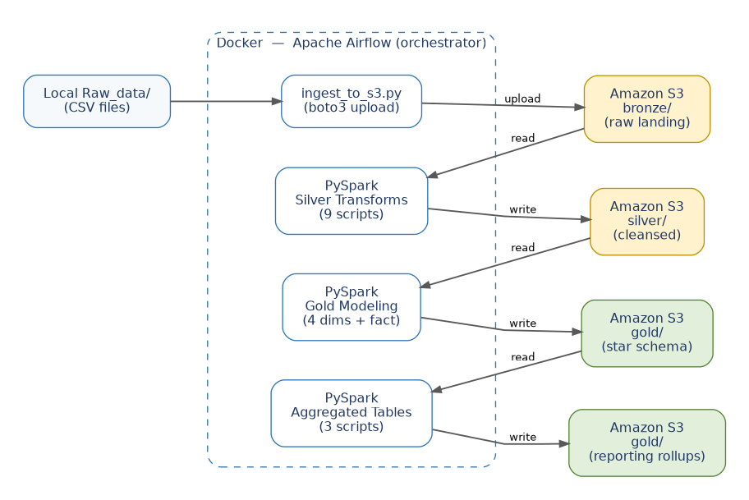
Figure 3.1 — End-to-End System Architecture (Docker / Airflow / PySpark / S3)

3.3 Core Components
Component | Role
Apache Airflow 2.11.0 | Workflow orchestration engine; schedules and sequences every ingestion, transformation, and modeling task via a single DAG.
PySpark 3.5.6 | Distributed data processing engine used for all bronze-to-silver and silver-to-gold transformations.
Amazon S3 | Central data lake storage for all three layers (bronze, silver, gold), accessed via the s3a:// Hadoop connector.
Docker / Docker Compose | Containerizes the entire Airflow cluster (webserver, scheduler, worker, triggerer, Postgres, Redis) for reproducible local/dev deployment.
PostgreSQL | Airflow metadata database (task state, DAG runs, connections).
Redis | Celery message broker for distributing tasks to Airflow workers.
boto3 | AWS SDK for Python; used for direct S3 file operations (upload, list, copy, delete) outside of Spark's own S3 writes.

4. Technology Stack
Layer | Technology | Version / Detail
Orchestration | Apache Airflow | 2.11.0, CeleryExecutor
Base Image | apache/airflow | 2.11.0 (Docker)
Compute Engine | PySpark | 3.5.6
Java Runtime | OpenJDK | 17 (required by Spark)
S3 Connector | hadoop-aws | 3.3.4 (spark.jars.packages)
AWS SDK | boto3 | 1.40.11
Storage | Amazon S3 | Bucket: guhan-cloud-batch-pipeline-2026, Region: eu-north-1
Metadata DB | PostgreSQL | 13
Message Broker | Redis | 7.2-bookworm
Containerization | Docker / Docker Compose | Multi-service cluster (webserver, scheduler, worker, triggerer, flower)
Config / Secrets | python-dotenv | Loads AWS credentials from .env

5. Infrastructure & Deployment

5.1 Dockerfile
The custom image extends the official Airflow base image, adding the Java runtime required by PySpark and the Python packages needed for Spark and S3 access.
FROM apache/airflow:2.11.0
USER root
RUN apt-get update && apt-get install -y openjdk-17-jdk && apt-get clean
ENV JAVA_HOME=/usr/lib/jvm/java-17-openjdk-amd64
USER airflow
RUN pip install --no-cache-dir pyspark==3.5.6 boto3==1.40.11

5.2 Docker Compose Services
The stack is based on the standard Apache Airflow Docker Compose reference architecture, extended with a custom build and mounted project volumes.
Service | Role
postgres | Airflow metadata database (users, DAG runs, task instances).
redis | Celery broker used to dispatch tasks to workers.
airflow-webserver | Web UI, exposed on port 8080.
airflow-scheduler | Parses DAGs and schedules task instances.
airflow-worker | Celery worker(s) that execute the actual BashOperator tasks (ingestion, Spark jobs).
airflow-triggerer | Handles deferrable operators / async triggers.
airflow-init | One-off initialization: DB migration, admin user creation, permission/resource checks.
airflow-cli | Debug-profile helper container for ad-hoc Airflow CLI commands.
flower | Optional Celery monitoring UI, exposed on port 5555 (flower profile).

5.3 Volumes & Project Mounts
- ./dags → /opt/airflow/dags — DAG definition files
- ./logs → /opt/airflow/logs — Task execution logs
- ./plugins → /opt/airflow/plugins — Custom Airflow plugins
- ../scripts → /opt/airflow/project/scripts — All ingestion / transformation / modeling Python scripts
- ../Raw_data → /opt/airflow/project/Raw_data — Local source CSV files

5.4 Required Environment Variables
Credentials and pipeline configuration are supplied via environment variables (an .env file loaded by python-dotenv, and Docker Compose's own environment substitution):
Variable | Purpose
AWS_ACCESS_KEY_ID | AWS credential used by boto3 and Spark's s3a connector.
AWS_SECRET_ACCESS_KEY | AWS credential used by boto3 and Spark's s3a connector.
AWS_DEFAULT_REGION | Default AWS region for boto3 client construction.
AIRFLOW_UID | Host user ID mapped into containers to avoid file permission issues.
_AIRFLOW_WWW_USER_USERNAME / _PASSWORD | Airflow admin UI credentials (default airflow/airflow).

5.5 Startup Sequence
- Create .env with AIRFLOW_UID and AWS credentials.
- docker compose up airflow-init — runs DB migration and creates the admin user.
- docker compose up -d — starts postgres, redis, webserver, scheduler, worker, triggerer.
- Access the Airflow UI at http://localhost:8080 (default: airflow / airflow).
- Trigger the ecommerce_pipeline DAG manually (schedule=None).

6. Orchestration — Airflow DAG

6.1 DAG Configuration
Property | Value
dag_id | ecommerce_pipeline
schedule | None (manually triggered)
catchup | False
max_active_tasks | 1 — enforces fully sequential execution across the entire DAG
tags | ecommerce, data-engineering
The pipeline intentionally caps max_active_tasks at 1. Every task — ingestion, each silver transform, each dimension build, the fact build, and each aggregate — runs strictly one at a time, in a single deterministic order. This trades parallel throughput for simplicity, predictable resource usage, and easier debugging when a step fails.

6.2 DAG Task Flow Diagram
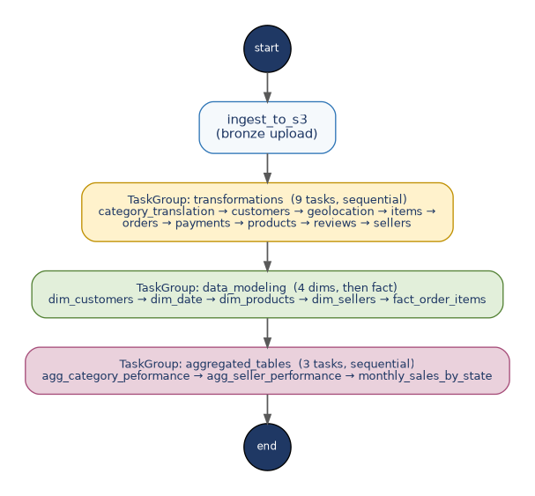
Figure 6.1 — Airflow DAG Task Flow (start → ingest → transformations → data_modeling → aggregated_tables → end)

6.3 Task Groups

start → ingest_to_s3
A BashOperator invokes ingestion/ingest_to_s3.py, uploading all local raw CSV files to their bronze/ locations in S3.

TaskGroup: transformations (Bronze → Silver)
Nine BashOperator tasks, chained one after another (not parallel), each running one transformations/<entity>.py script:
- category_translation → customers → geolocation → items → orders → payments → products → reviews → sellers

TaskGroup: data_modeling (Silver → Gold)
The four dimension builds run first, one at a time, followed by the fact table build, which depends on all four dimensions already existing in Gold:
- dim_customers → dim_date → dim_products → dim_sellers → fact_order_items

TaskGroup: aggregated_tables (Gold → Reporting)
Three reporting/aggregate scripts, run sequentially, that summarize the star schema for direct BI consumption:
- agg_category_peformance
- agg_seller_performance
- monthly_sales_by_state
Note: the source code for these three aggregation scripts was not included in the reviewed project files; this section should be expanded once those scripts are available for review.

end
An EmptyOperator marking successful completion of the full pipeline run.

7. Data Ingestion Layer (Bronze)

7.1 ingest_to_s3.py
Reads every file listed in FILE_MAPPING from the local RAW_DATA_PATH directory and uploads each one to its corresponding bronze/ key in the target S3 bucket using boto3. Missing local files are skipped with a warning rather than failing the whole run; upload failures are caught and logged per-file.

7.2 Source → Bronze File Mapping
Local File | S3 Bronze Key
olist_customers_dataset.csv | bronze/customers/olist_customers_dataset.csv
olist_geolocation_dataset.csv | bronze/geolocation/olist_geolocation_dataset.csv
olist_order_items_dataset.csv | bronze/order_items/olist_order_items_dataset.csv
olist_order_payments_dataset.csv | bronze/order_payments/olist_order_payments_dataset.csv
olist_order_reviews_dataset.csv | bronze/order_reviews/olist_order_reviews_dataset.csv
olist_orders_dataset.csv | bronze/orders/olist_orders_dataset.csv
olist_products_dataset.csv | bronze/products/olist_products_dataset.csv
olist_sellers_dataset.csv | bronze/sellers/olist_sellers_dataset.csv
product_category_name_translation.csv | bronze/category_translation/product_category_name_translation.csv

8. Data Transformation Layer (Silver)
Every transformation script follows the same pattern: create a Spark session (config.get_spark_session), read the relevant bronze CSV via config.s3_path(), apply cleansing/standardization logic (and, where relevant, hard data-quality gates), then persist the result to Silver via config.write_silver_csv(), which writes a single, cleanly-named CSV directly to S3 (no local disk hop).
Script | Source (Bronze) | Key Transformations | Silver Output | Data Quality Checks
category_translation.py | product_category_name_translation.csv | Trims category name and English translation columns. | silver/products_cat/product_cat.csv | None
customers.py | olist_customers_dataset.csv | Trims IDs; lowercases city; maps 2-letter state codes to full Brazilian state names. | silver/customers/customers.csv | None
geolocation.py | olist_geolocation_dataset.csv | Drops duplicate rows; lowercases and trims city name. | silver/geolocation/geolocation.csv | None
items.py | olist_order_items_dataset.csv | Trims order/product/seller IDs. | silver/orders/order_items.csv | Fails the run if any negative price or negative freight_value is found.
orders.py | olist_orders_dataset.csv | Trims order/customer IDs and status. | silver/orders/orders.csv | Flags data_quality_issue = MISSING_DELIVERY_INFORMATION when a 'delivered' order is missing approval/carrier/customer delivery timestamps.
payments.py | olist_order_payments_dataset.csv | Defaults credit_card installments of 0 to 1; trims order ID and payment type. | silver/orders/payments.csv | Fails the run if any negative payment_value is found.
products.py | olist_products_dataset.csv | Fixes misspelled source column names (lenght → length); lowercases/trims category; nulls → 'Unknown'. | silver/products/products.csv | Flags data_quality_issue = MISSING_WEIGHT when product_weight_g is null.
reviews.py | olist_order_reviews_dataset.csv | Multi-line/quoted CSV parsing; trims review/order IDs and comment text. | silver/orders/reviews.csv | Fails the run if any review_score falls outside the 1–5 range.
sellers.py | olist_sellers_dataset.csv | Replaces known bad sentinel city value ('04482255') with 'Unknown'; maps state code to full state name; trims fields. | silver/sellers/sellers.csv | None

Design note: order_items, payments, and reviews are all written under the silver/orders/ prefix (rather than their own top-level folders) by deliberate convention, since they are all order-grain tables consumed together downstream by fact_order_items.

9. Data Modeling Layer (Gold) — Star Schema
The Gold layer implements a classic star schema: four conformed dimension tables surrounding a single fact table at the order-item grain. Each dimension is built with a Spark Window function (row_number() ordered by the natural key) to generate a stable surrogate key.

9.1 Star Schema Diagram
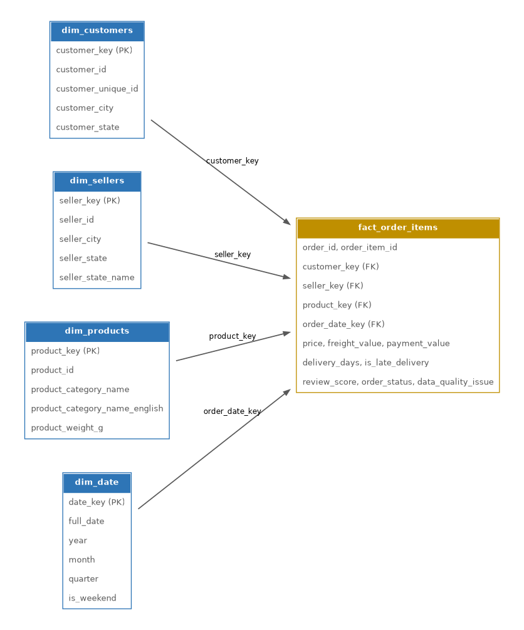
Figure 9.1 — Star Schema (dim_customers, dim_sellers, dim_products, dim_date → fact_order_items)

9.2 Dimension: dim_customers
Built from silver/customers/customers.csv. Selects only identifying/descriptive attributes (no measures) and assigns a surrogate customer_key.
- Columns: customer_key, customer_id, customer_unique_id, customer_city, customer_state

9.3 Dimension: dim_sellers
Built from silver/sellers/sellers.csv, assigning a surrogate seller_key.
- Columns: seller_key, seller_id, seller_city, seller_state, seller_state_name

9.4 Dimension: dim_products
Joins silver products with the silver category-translation table on product_category_name (left join, so every product is retained even without a translation match), then assigns a surrogate product_key.
- Columns: product_key, product_id, product_category_name, product_category_name_english, product_weight_g

9.5 Dimension: dim_date
A fully generated calendar dimension spanning 2016-09-01 to 2018-12-31 (matching the dataset's date range), with year, month, quarter, day_of_week, an is_weekend flag, and an integer date_key (yyyyMMdd format) used to join against the fact table.
- Columns: full_date, year, month, quarter, day_of_week, is_weekend, date_key

9.6 Fact Table: fact_order_items
Grain: one row per order line item (order_id + order_item_id). Built by joining silver order_items with orders, a payments-collapsed-per-order aggregate (summed payment_value), and a reviews-collapsed-per-order aggregate (first review_score), then enriching with surrogate keys from all three business dimensions.

Derived Measures
- delivery_days — datediff between order_delivered_customer_date and order_purchase_timestamp
- is_late_delivery — boolean, true when the customer delivery date is after the estimated delivery date
- order_date_key — yyyyMMdd integer key for joining to dim_date

Final Fact Columns
- order_id, order_item_id
- customer_key, seller_key, product_key, order_date_key (foreign keys to the four dimensions)
- price, freight_value, payment_value (measures)
- delivery_days, is_late_delivery (derived logistics measures)
- review_score, order_status, data_quality_issue

Fan-out Prevention
Payments and reviews are pre-aggregated to one row per order_id before joining, explicitly to avoid fan-out / row duplication in the final fact table — a common pitfall when an order can legitimately have multiple payment installments or more than one review.

10. Aggregated Reporting Tables
The DAG defines an aggregated_tables TaskGroup that runs three summary scripts against the Gold star schema, intended for direct consumption by dashboards / BI tools:
Script | Likely Purpose (inferred from name / DAG position)
agg_category_peformance | Sales / performance metrics rolled up by product category, using dim_products and fact_order_items.
agg_seller_performance | Seller-level KPIs (revenue, order volume, review scores, late-delivery rate) using dim_sellers and fact_order_items.
monthly_sales_by_state | Time-series sales rolled up by customer state and month, using dim_customers, dim_date, and fact_order_items.
The source code for these three scripts was not part of the files reviewed for this documentation. Their logic, output schema, and S3 destinations should be documented here once available.

11. Data Quality Framework
Rather than a separate validation stage, data quality is enforced inline within the relevant transformation script, using two strategies:

11.1 Hard Failures (fail-fast gates)
These checks raise a ValueError and stop the pipeline run immediately if violated:
Script | Rule
items.py | No negative price or freight_value values are allowed in order items.
payments.py | No negative payment_value values are allowed.
reviews.py | review_score must fall within the 1–5 range.

11.2 Soft Flags (data_quality_issue column)
These checks tag affected rows with a descriptive flag rather than blocking the run, so downstream consumers can filter or report on them:
Script | Flag Value | Condition
orders.py | MISSING_DELIVERY_INFORMATION | Order status is 'delivered' but approval, carrier-dispatch, or customer-delivery timestamps are null.
products.py | MISSING_WEIGHT | product_weight_g is null (impacts freight/shipping calculations downstream).
Both flags are carried forward and surfaced on the final fact_order_items table (data_quality_issue), making data quality visible at the analytics layer rather than hidden inside the pipeline.

12. Configuration & Shared Utilities (config.py)
A single shared module centralizes AWS/S3 configuration, Spark session creation, and the S3 write pattern used by every transformation and modeling script.

12.1 Constants
Name | Value / Purpose
BUCKET_NAME | "guhan-cloud-batch-pipeline-2026" — target S3 bucket for all three layers.
AWS_REGION | "eu-north-1"
RAW_DATA_PATH | PROJECT_ROOT / "Raw_data" — local source of the raw CSV files.

12.2 get_spark_session(app_name)
Builds a SparkSession configured with the hadoop-aws package and s3a credentials/endpoint/region, using SimpleAWSCredentialsProvider so Spark can read/write directly to S3 without a local Hadoop install.

12.3 s3_path(*parts)
Small helper that joins path segments into an s3a:// URI, e.g. s3_path('bronze','customers','file.csv') → s3a://<bucket>/bronze/customers/file.csv.

12.4 write_layer_csv(df, layer, s3_folder, filename)
The core write utility used by both write_silver_csv and write_gold_csv. It coalesces the DataFrame to a single partition, writes it to a temporary S3 prefix, locates the resulting Spark part-file via boto3, copies it to the final, cleanly-named key, and then deletes all temporary Spark output (part files, _SUCCESS, .crc files) — avoiding messy multi-part Spark output and local disk hops entirely.

12.5 write_silver_csv / write_gold_csv
Thin, backward-compatible wrappers around write_layer_csv for the silver and gold layers respectively, used consistently across every transformation and modeling script.

13. Project File Structure
Based on the reviewed files, the project is organized as follows (paths inferred from imports and volume mounts):
project-root/
├── Dockerfile
├── docker-compose.yml
├── .env (AWS credentials — not committed)
├── dags/
│ └── ecommerce_pipeline.py (Airflow DAG definition)
├── Raw_data/ (local source CSV files)
└── scripts/
├── config.py (shared Spark/S3 utilities)
├── ingestion/
│ └── ingest_to_s3.py
├── transformations/
│ ├── category_translation.py
│ ├── customers.py
│ ├── geolocation.py
│ ├── items.py
│ ├── orders.py
│ ├── payments.py
│ ├── products.py
│ ├── reviews.py
│ └── sellers.py
├── data_modeling/
│ ├── dim_customers.py
│ ├── dim_date.py
│ ├── dim_products.py
│ ├── dim_sellers.py
│ └── fact_order_items.py
└── aggregated_tables/
├── agg_category_peformance.py
├── agg_seller_performance.py
└── monthly_sales_by_state.py

14. Recommendations & Future Enhancements
- Replace inferSchema=True with explicit schemas on read to guarantee stable types across runs and avoid costly schema-inference passes over large files.
- Move hard-coded values (BUCKET_NAME, AWS_REGION) into environment variables for cleaner separation between code and environment-specific configuration.
- Consider writing Silver/Gold outputs in Parquet rather than CSV for compression, columnar performance, and schema enforcement, once downstream consumers support it.
- Introduce parallelism where dependencies genuinely allow it (e.g. independent silver transforms could run concurrently) if pipeline runtime becomes a concern, revisiting the current max_active_tasks = 1 constraint.
- Add automated data-quality reporting (e.g. row counts, null rates, DQ flag summaries) surfaced in Airflow logs or a dedicated dashboard, rather than only inline flags/failures.
- Document and version the three aggregated_tables scripts, which are referenced by the DAG but were not available for this review.
- Add unit tests for transformation logic (e.g. state-code mapping, DQ flag conditions) to guard against regressions.

15. Appendix

15.1 Glossary
Term | Definition
Medallion Architecture | A data design pattern organizing data into progressively refined layers: Bronze (raw), Silver (cleansed), Gold (modeled/aggregated).
Surrogate Key | A system-generated, meaningless integer key (e.g. via row_number()) used as the primary key of a dimension table, independent of the natural/business key.
Grain | The level of detail represented by a single row in a fact table — here, one order line item.
Fan-out | Unwanted row duplication caused by joining to a table with multiple matching rows per key (mitigated here via pre-aggregation of payments and reviews).
s3a:// | The Hadoop-compatible URI scheme used by Spark to read/write Amazon S3 objects.

15.2 Reviewed Source Files
This documentation was generated from a review of the following project files: Dockerfile, docker-compose.yml, ecommerce_pipeline.py, ingest_to_s3.py, config.py, category_translation.py, customers.py, geolocation.py, items.py, orders.py, payments.py, products.py, reviews.py, sellers.py, dim_customers.py, dim_date.py, dim_products.py, dim_sellers.py, fact_order_items.py.

