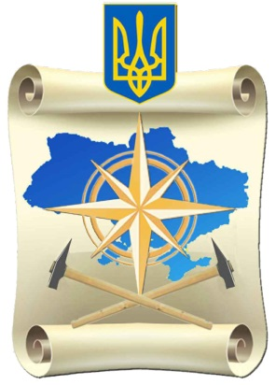
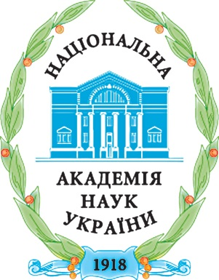
National Academy of Science of Ukraine
M.P. Semenenko Institute of Geochemistry, Mineralogy and Ore Formation
Institute of Geological Sciences
S.I. Subbotin Institute of Geophysics
State Service of Geology and Mineral Resources
State Enterprise “Ukrainian Geological Company”
All-Ukrainian Public Organization “Ukrainian Association of Geologists”
Institute of Geology of Taras Shevchenko National University of Kyiv
Ivan Franko National University of Lviv
___________________________________________________________________

Second circular

Scientific Conference, dedicated to the Centenaries of
National Academy of Sciences and Geological Survey of Ukraine
“Geology and minerals of Ukraine”
Kyiv, 2 - 4 October, 2018

Venue
M.P. Semenenko Institute of Geochemistry, Mineralogy and Ore Formation, National Academy of Sciences of Ukraine (IGMOF NAS of Ukraine), Acad. Palladina ave. 34, Kyiv, Ukraine, 03680

Main sections of the Conference
- Precambrian of the Ukrainian Shield
- Phanerozoic of Ukraine
- geophysics methods and results
- education and personnel training

Important dates
31 July 2018 – abstract submission deadline
15 September 2018 – circulation of the Conference Programme for participants
2 October 2018 – starting of registration for a conference
3–4 October 2018 – plenary talks

Preparation of Abstracts
The Organizing Committee accepts the abstracts by the e-mail 100nas.ukr@gmail.com not exceeding 2 pages in Ukrainian, Russian or English as attached *.doc or *.docx files and named by the Surname of the first author in English. In the case of sending more than one abstracts to subjoin a number of abstract. To design abstracts you can use this template:
https://drive.google.com/open?id=1ztF49z-KpW7iWyQD4lTKPLnB0EtUelrF
Languages
Ukrainian, English, Russian. Translation is not provided. Oral presentation – 15 minutes and 5 minutes for questions-answers.

Note
For application submission, please, before 1 June 2018 fill out and send the application form using the link: https://goo.gl/forms/wJSKVrcHffz9U3ig1.
Organizing committee

Organizing Committee Co-Chairmen
Ponomarenko O.M. – Academician of NAS of Ukraine, Director, IGMOF NAS of Ukraine
Gozhyk P.F. – Academician of NAS of Ukraine, Director, Institute of Geological Sciences of the NAS of Ukraine (IGS NAS of Ukraine)
Starostenko V.I. – Academician of NAS of Ukraine, Director, S.I. Subbotin Institute of Geophysics of the NAS of Ukraine (IGP NAS of Ukraine)
Zagorodnyuk P.O. – Candidate of Geological and Mineralogical Sciences, Chairman of Board of Directors, TUTKOVSKY PLC
Foshchiy M.V. – First Deputy Chairman, State Service of Geology and Mineral Resources of Ukraine
Organizing Committee Members
Artemenko G.V. – Doctor of Geological Sciences, Head of the Department of Precambrian Geology and Chronostratigraphy, IGMOF NAS of Ukraine
Gintov O.B. – Corresponding Member of the NAS of Ukraine, IGP NAS of Ukraine
Goshovskiy S.V. – Doctor of Technical Sciences, Director, Ukrainian State Geological Research Institute
Zagnitko V.M. – Doctor of Geological and Mineralogical Sciences, Professor, Institute of Geology of the Taras Shevchenko National University of Kyiv
Kendzera O.V. – Corresponding Member of NAS of Ukraine, Deputy Director,IGP NAS of Ukraine
Kryvdik S.G. – Doctor of Geological and Mineralogical Sciences, Head of the Department of Petrology, IGMOF NAS of Ukraine
Kutas R.I. – Corresponding Member of NAS of Ukraine, Head of the Department of Geothermal and Modern Geodynamics, IGP NAS of Ukraine
Liventseva G.A. – Chairman of the Board, All-Ukrainian Public Organization “Ukrainian Association of Geologists”
Machulina S.O. – Doctor of Geological Sciences, Leading Researcher, IGS NAS of Ukraine
Mikhailov V.A. – Doctor of Geological Sciences, Professor, Institute of Geology of the Taras Shevchenko National University of Kyiv
Olshtynska O.P. – Doctor of Geological Sciences, Head of the Department of Modern Marine Sedimentogenesis, IGS NAS of Ukraine
Pavlun M.M. – Doctor of Geological Sciences, Dean of the Faculty of Geology, Ivan Franko National University of Lviv
Poletaev V.I. – Doctor of Geological and Mineralogical Sciences, Acting Head of the Department of Palaeontology and Stratigraphy of Paleozoic Sediments, IGS NAS of Ukraine
Slobodian B.I. – General Director, State Enterprise “Ukrainian Geological Company”
Stepanyuk L.M. – Corresponding Member of the NAS of Ukraine, Deputy Director, IGMOF NAS of Ukraine
Syomka V.O. – Doctor of Geological Sciences, Geology and Geochemistry of Ore Deposits, IGMOF NAS of Ukraine
Academic secretary of the Organizing Committee
Sukach V.V. – Doctor of Geological Sciences, Senior Researcher, IGMOF NAS of Ukraine
Working Group of the Organizing Committee
Amashukeli T.A. – Junior Researcher, IGP NAS of Ukraine
Donskyi M.O. – Candidate of Geological Sciences, Senior Researcher, IGMOF NAS of Ukraine
Lisovyi Yu.V. – Junior Researcher, IGP NAS of Ukraine
Semenova Yu.V. – Candidate of Physical and Mathematical Sciences, Researcher, IGP NAS of Ukraine
Skobin V.T. – Junior Researcher, IGMOF NAS of Ukraine
Farfulyak L.V. – Candidate of Geological Sciences, Researcher, IGP NAS of Ukraine
Technical support
A multimedia projector will be used to demonstrate presentations. The presentations should be saved in *.ppt extension. Poster reports will be placed on stands with dimensions (cm): 89×89.
Organizing fee
The conference fee as a partial reimbursement of organization expenses (book of abstracts, Conference programme, coffee breaks, welcome reception) is 200 UAH. For postgraduate students the contribution is 100 UAH, for students – free of charge.
The registration fee will be accepted in cash (UAH) at the registration desk.
Accommodation
You can use the website https://www.booking.com/city/ua/kiev.html to search, compare and book hotel rooms. The Organizing Committee can book a limited number of rooms at the Feofaniya Academic Hotel (http://www.feofaniya.net.ua/). In that case it is recommended to notify us in advance not late than the 10August, 2018.
If you have any question, please contact
tel.: +(38) 050-453-87-18, 068-751-69-90 (Sukach Vitaliy)
e-mail: 100nas.ukr@gmail.com (Donskyi Mykola). If you need a formal invitation to the Conference, please inform us.

On-line information: web-site of the IGMOF NAS of Ukraine http://igmof.org.ua/ within “Conferences”.

