**DEPARTMENT OF CS & AI**

**SUBJECT: DBMS Assignment-6 BATCH 1**

**h.no:2203a51238**

**Task 1:**

**Consider the schema for Movie Database:**

**ACTOR (Act_id, Act_Name, Act_Gender)**

**Output:**

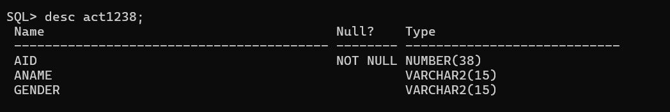

**DIRECTOR (Dir_id, Dir_Name, Dir_Phone)**

**Output:**

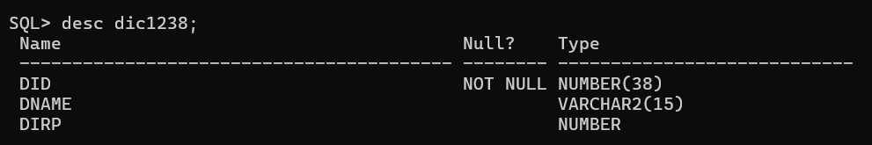

**MOVIES (Mov_id, Mov_Title, Mov_Year, Mov_Lang, Dir_id)**

**Output:**

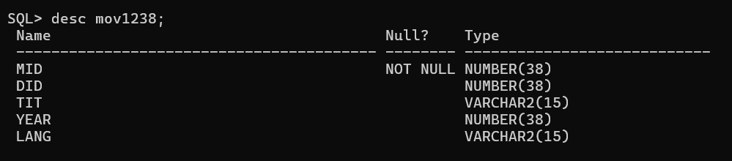

**MOVIE_CAST (Act_id, Mov_id, Role)**

**Output:**

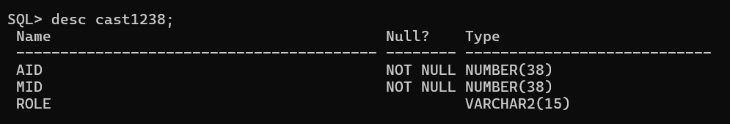

**RATING (Mov_id, Rev_Stars)**

**Output:**

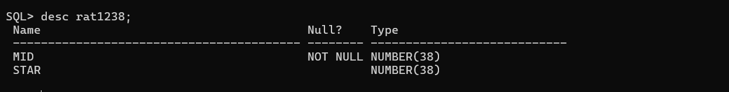

Create the above tables by properly specifying the primary keys and the foreign keys.

Enter at least five tuples for eachrelation.

**List the titles of all movies directed by ‘Hitchcock’ and ‘Spielberg’**

**Output:**

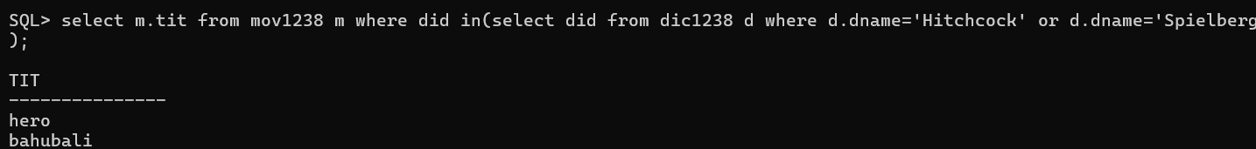

**Find the names of the actors who acted in two or more movies.**

**Output:**

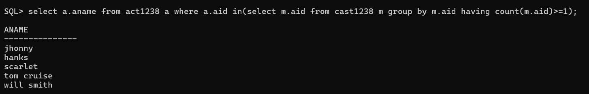

**List all actors who acted in a movie before 2000**

**Output:**

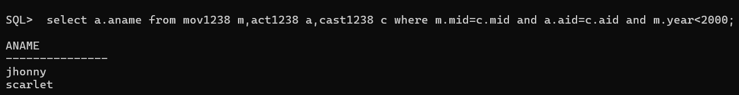

**Find the title of movies and number of stars for each movie directed by RGV.**

**Output:**

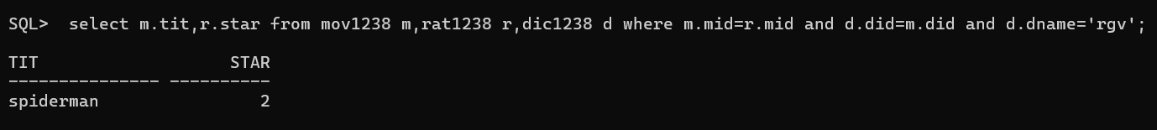

**Update rating of all movies directed by ‘Steven Spielberg’ to** 5.

**Output:**

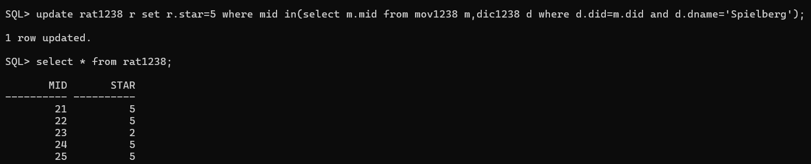

**List all the movies directed by any director which have four star rating**

**Output:**

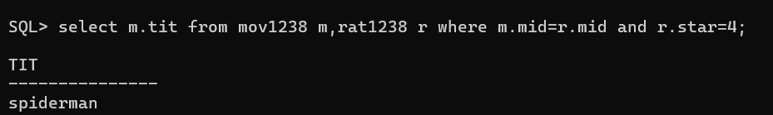

**List the names of the movies with five star rating**

**Output:** 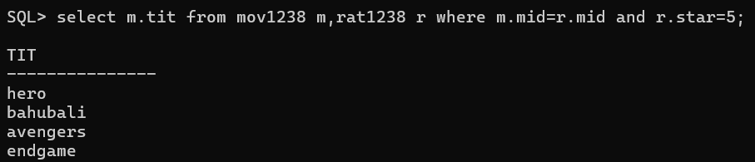

**List the names of the directors who directed five star rating movies**

**Output:**

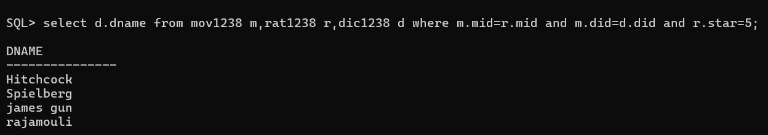

**List the names of the movies acted by tom hanks and Johnny depp**

**Output:**

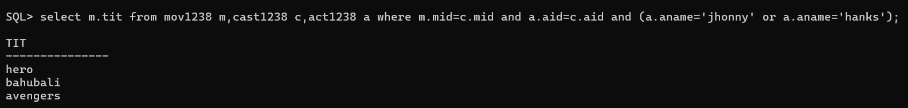

**Display the review star rating of movies directed by Spielberg**

**Output:**

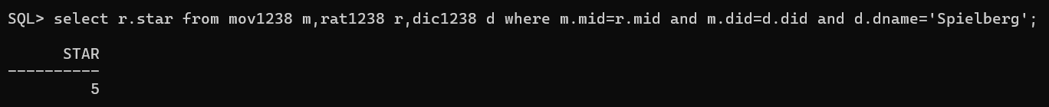

**Task 3:**

**Consider the following schema for a Library Database:**

**BOOK (Book_id, Title, Publisher_Name, Pub_Year)**

**Output:**

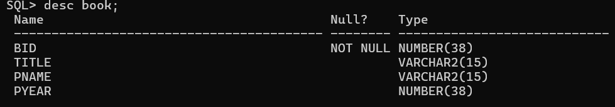

**BOOK_AUTHORS (Book_id, Author_Name)**

**Output:**

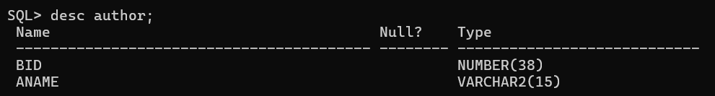

**PUBLISHER** (Publisher_Name, Address, Phone)

**Output:**

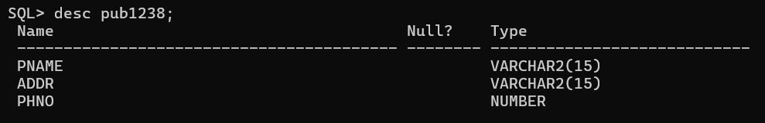

**BOOK_COPIES (Book_id, Branch_id, No_of_Copies)**

**Output:**

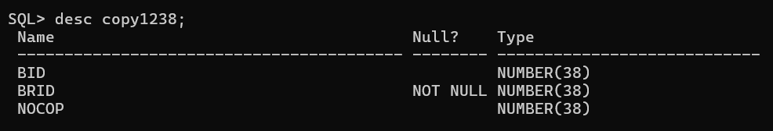

**BOOK_LENDING (Book_id, Branch_id, Card_No, Issued_Date, Due_Date)**

**Output:**

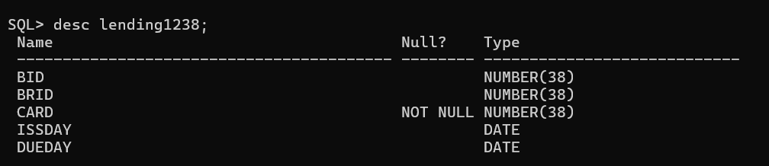

**LIBRARY_BRANCH (Branch_id, Branch_Name, Address)**

**Output:**

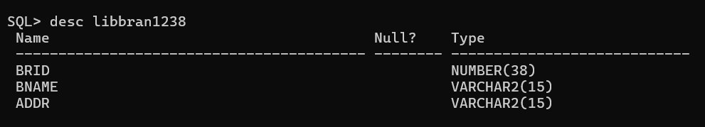

**Create the above tables by properly specifying the primary keys and the foreign keys.**

**Enter at least five tuples for eachrelation.**

1.**Retrieve details of all books in the library – id, title, name of publisher etc.**

**Query:**select b.bid,b.title,b.pname,b.pyear,a.aname,c.brid from book b,author a,copy1238 c,lending1238 l where a.bid=b.bid and c.brid=l.brid;

**Output:**

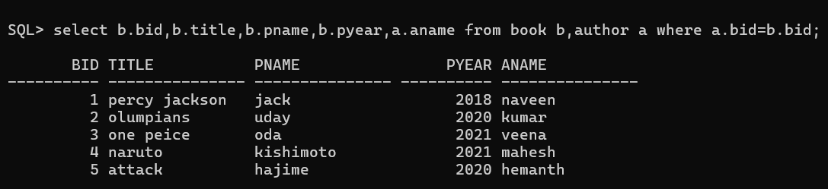

**2. Get the particulars of borrowers who have borrowed more than 3 books**

**Query**

select .card from lending1238 l GROUP BY(l.card) HAVING COUNT(l.card)>=1;

**Output:**

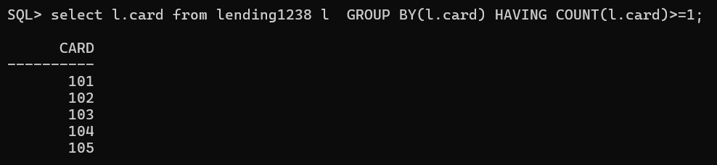

**3. Delete a book in BOOK table.**

**Query:**

**delete books where bid =1;**

**Output:**

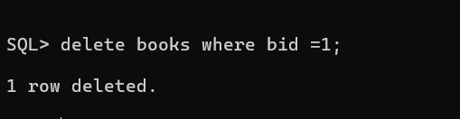

**4. Display the names of the books that have more than 100 copies in the library**

**Query:**

**Output:**

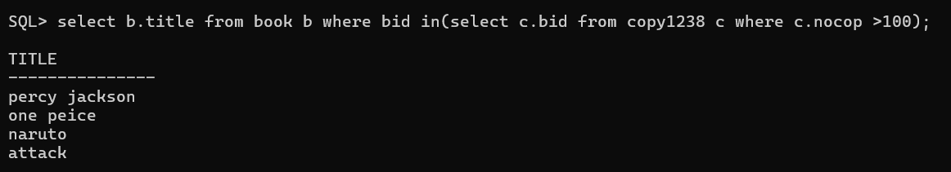

5**. Display the list of all books and its number of copies that are currently available in the Library.**

**Query:**

select b.title,c.nocop from book b,copy1238 c where b.bid=c.bid;

**Output:**

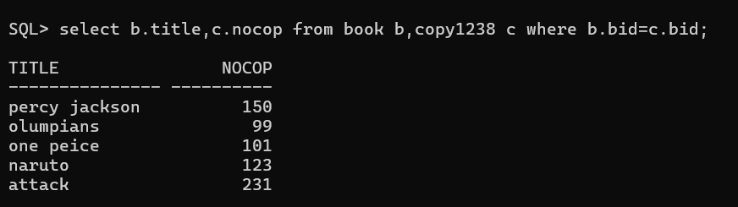

6**. List the names of the books that are barrowed with a publisher name Naveen**

**Query:**

**select b.title from book b where bid in(select a.bid from author a where a.aname='naveen');**

**Output:**

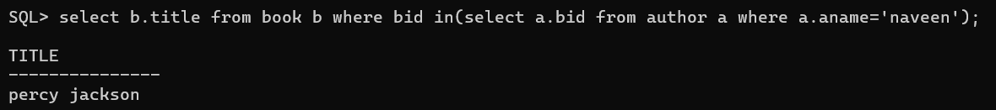

**7. List the authors of the books published in year 2020 and 2021**

**Query:**

**select a.aname from author a where bid in(select b.bid from book b where b.pyear between 2020 and 2021);**

**Output:**

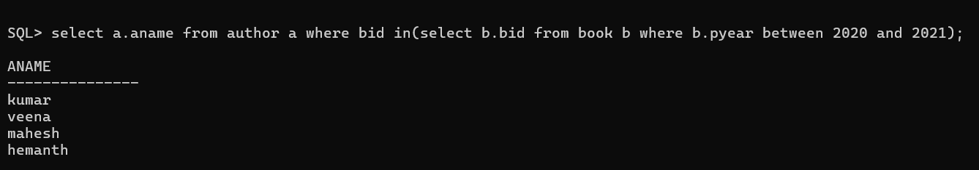

**8. List the titles of the books borrowed between 01/06/2021 and 10/06/2021**

**Query:**

**select b.title from book b where bid in(select l.bid from lending1238 l where l.issday between '01-jun-21' and '11-jun-21');**

**Output:**



**9. Display the names of the books that have at least one copy in the library**

**Query:**

**select b.title from book b where bid in(select c.bid from copy1238 c where c.nocop>1);**

**Output:**

