School of Computer Science and Artificial Intelligence

NAME: G. uday kiran H.NO:2203A51238

Batch - 1

**Consider the following schemas:**

**1.Flowers(**Unique ID, name, color, and price)

**Query:**

Create table flower(fid int primary key, fname varchar(15),color varchar(15), price int);

**Output:**

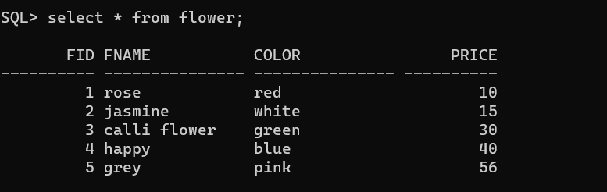

**2.Bouquets(** bouquet ID, name, description, and price)

**Query:**

Create table bon(bid int primary key, bname varchar(15), dis varchar(15), int bprice);

**Output:**

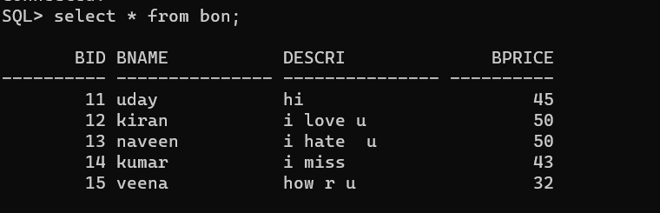

**3.Customers(**Customer ID, name, phone, and valid email)

**Query:**

Create table cust(cid int primary key,phno int,email varchar(15));

**Output:**

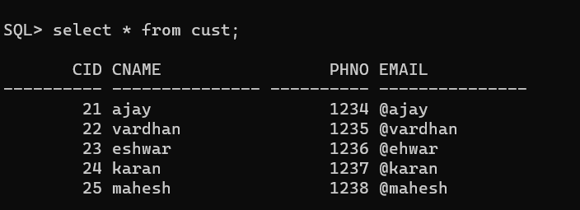

**4.Orders(**Unique ID, customer ID, bouquet ID, address ID, delivery date, and status)

**Query:**

Create table ord (fid int, cid int, bid int,addr varchar(15) , delivery date, stat

Varchar(15) ,primary key(fid,cid,bid,delivey),foreign key(fid) references flower(fid), foreign key(bi) references bon(bid), foreign key(cid) references cust(cid));

**Output:**

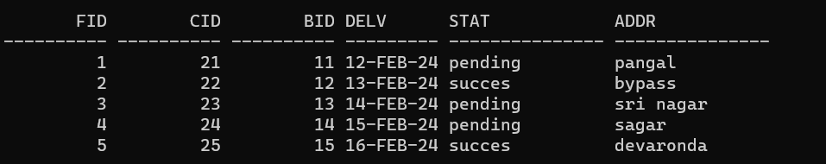

5.**Addresses(**Unique ID, customer ID, street, city, state, and postal code)

**Query:**

**Create table deliver( did int,cid,street varchar(15),state varchar(15),**

**Post int, primary key(did,cid), foreign key(did) references cust(c**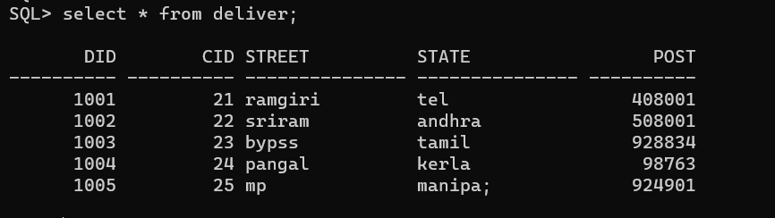

**Queries:**

6.Find the names of the flowers having name starting with ‘r’ and having maximum length of four characters.

**Query:**

Select fname from flower color=’red’ and length(fname)=4;

**Output:**

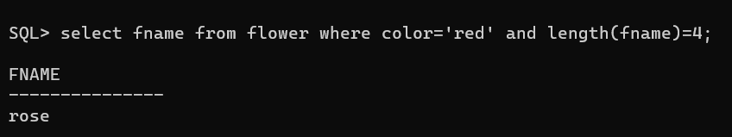

7.Find all the names of the flowers whose order status is ‘pending’;

**Query:**

Select c.cname from cust c,ord o where c.cid=o.cid and o.stat=’pending’;

**Output:**

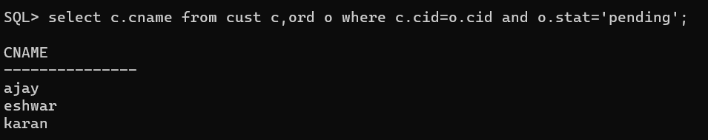

8.Find the average price of bouquets ordered by customers from a specific city.

**Query:**

**Select avg(b.bprice) from bon b ,ord o, deliver d, cust c where o.cid=c.cid and d.city=’nal’;**

**Output:**

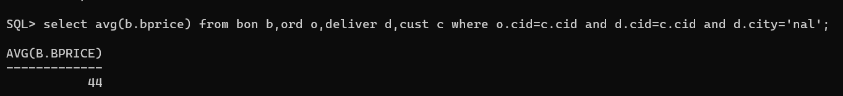

9.Find all the names of the customers who didn’t order on a particular date.

**Query:**

Select c.cname from cust c,ord o where c.cid=o.cid and delv !=’12-feb-24’;

**Output:**

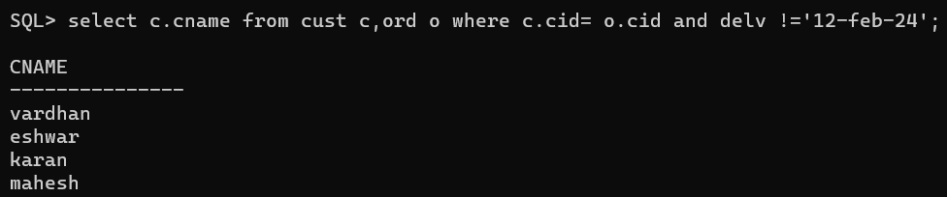

10.Retrieve all delivery addresses with a postal code starting with '92':

**Query:**

Select o.addr from ord o,cust c,deliver d where o.cid=c.cid and d.cid=c.cid and d.post like’92%;

**Output;**

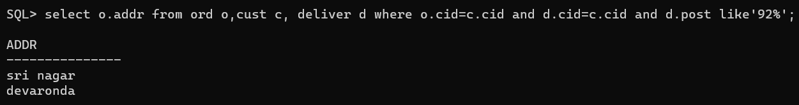

11.Find the customer details that were delivered to city ‘warangal’.

**Query:**

Select c.cname from cust c and ord o,deliver d where c.cid=o.cid and c.cid=d.did and city =’khm’;

**Output:**

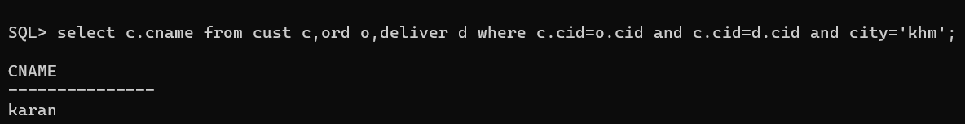

12.Find the maximum orders placed by the customers for a particular bouquet id.

Find the orders details whose delivery date is after ‘21-feb-2024’ and delivery status as pending flowers

**Query:**

Select cid,bid from ord where delv between’12-feb-24 and ’15-feb-24’ and stat=’pending’;

**Output:**

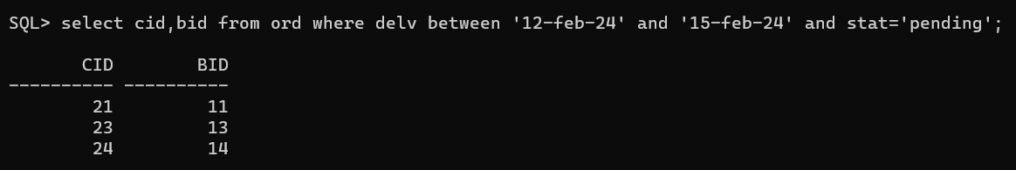

13. Find the id’s of customers who ordered white color and red color flower

