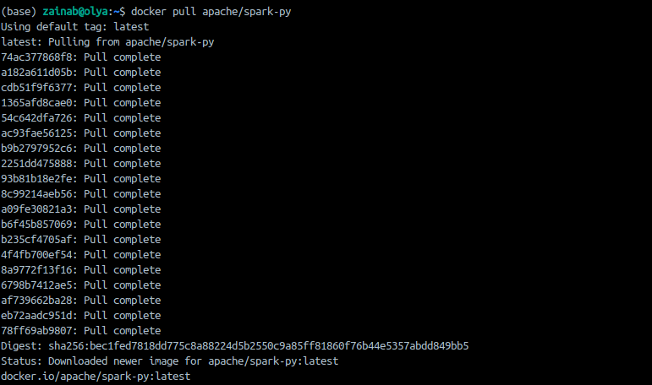
2021173_408_running python script on pyspark using docker

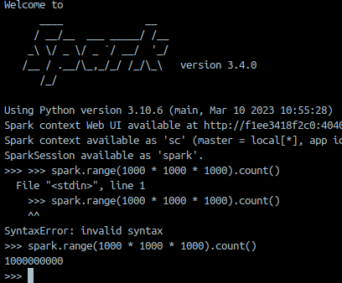
Mounting the directory and testing if my downloaded dataset is in the data
df = spark.read.csv("/data/netflix_titles.csv", header=True, inferSchema=True)
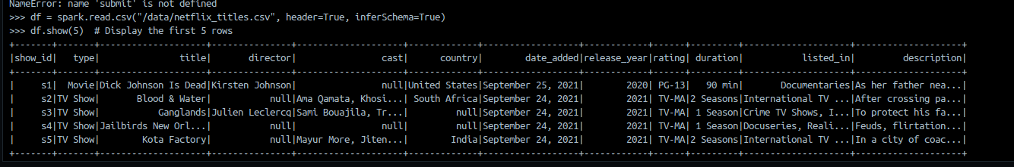
df.show(5) # Display the first 5 rows
# Print Schema
df.printSchema()

# Show basic statistics
df.describe().show()

# Count rows
print(f"Row count: {df.count()}")

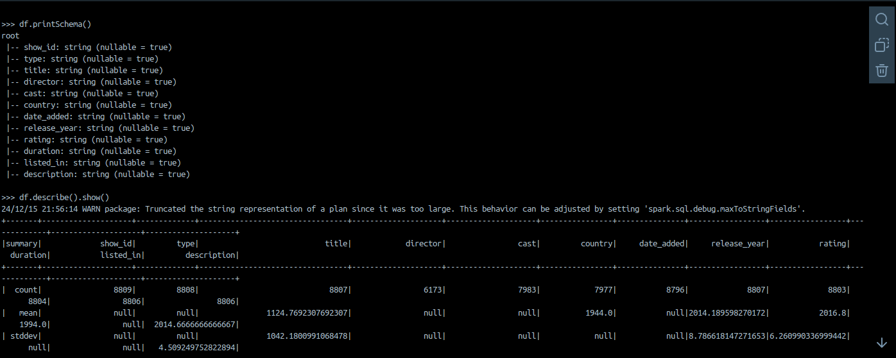

from pyspark.sql.functions import col, sum

# Check for missing values in each column
missing_data = df.select([sum(col(c).isNull().cast("int")).alias(c) for c in df.columns])
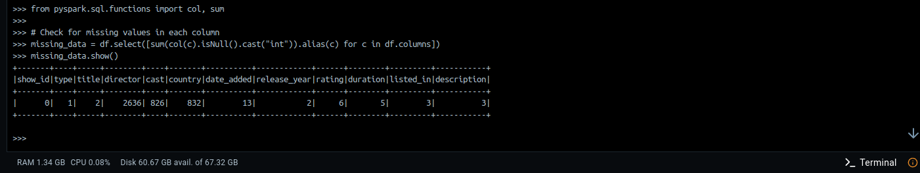
missing_data.show()

# Group by Genre
df.groupBy("listed_in").count().orderBy("count", ascending=False).show()
df.groupBy("release_year").count().orderBy("release_year").show()




