MATS ENGINEERING (SAVEETHA SCHOOL OF ENGINEERING)
Department of Artificial Intelligence and Data Science
ASSESSMENT TOOL 1 – APPLICATION BASED QUESTIONS

Course Code: | DSA03 | Course Title: | Natural Language Processing
CO Assessed: | CO1 – Imitation (L1) | Assessment: | Assessment Tool 1 – Application Based Questions
Weightage: | 40% of CIA
CO1 Statement: | Analyse NLP models, regular expression patterns, finite state automata, morphological processing techniques and to interpret language processing. (BL-3)
Student Name: | GUNALAN V | Reg. No.: | 192325038
Section / Batch: | AI & ML | Date:

Code of Conduct
I __________________________ (Name / Reg No) certify that this submission is my original work and that I have adhered to the guidelines specified for this assessment. I understand that any violation of academic integrity rules will result in disciplinary action.
Signature of the Student: _________________________

Instructions
- Develop a modular and efficient Python program that satisfies all the functional requirements specified in the problem statement.
- Demonstrate the correctness of the implementation using suitable test cases and justify the output obtained.
- Follow good programming practices, including meaningful variable names, proper code indentation, comments, and error handling wherever applicable.
- Duration: 30 minutes.

Section / Topic | Focus | Q Nos
Information Extraction | Regex-Based Information Extraction | 1
Pattern Matching | Regex Pattern Matching | 2
Regular Expression Patterns | Regex-Based Input Validation | 3

Annexure A – Application Based Questions

Section 1: Regular Expressions – Resume Information Extraction
- A multinational recruitment company receives thousands of resumes every day in text format. The HR department requires an automated system to extract candidate information for shortlisting.

Design and implement a Python-based resume information extraction system using Regular Expressions that performs the following tasks:

Extract the candidate's name.
Identify email addresses.
Extract mobile numbers.
Detect technical skills (Python, Java, SQL, Machine Learning, NLP).
Extract years of experience.
Generate a structured summary of the candidate's profile.
Display candidates who satisfy the minimum eligibility criteria (minimum 2 years of experience and Python skill).

Section 2: Regular Expressions – Product Search System
- An e-commerce company plans to enhance its product search engine to improve customer experience through flexible keyword matching.

Design and implement a Python-based product search system using Regular Expressions that performs the following tasks:

Search products using an exact keyword.
Perform prefix-based searches.
Perform suffix-based searches.
Search using partial keywords.
Perform case-insensitive searches.
Display all matching product names.
Generate a report showing the total number of matching products for each search.
Section 3: Regular Expressions – University Registration System
A university is developing an automated online registration portal to verify student information before course enrollment.

Design and implement a Python-based validation system using Regular Expressions that performs the following tasks:

Validate the student register number.
Validate the institutional email address.
Validate the course code.
Validate the semester information.
Validate the student's mobile number.
Display appropriate validation messages for each field.
Generate a final registration status report indicating whether the registration is successful.

1.A multinational recruitment company receives thousands of resumes every day in text format. The HR department requires an automated system to extract candidate information for shortlisting.

Design and implement a Python-based resume information extraction system using Regular Expressions that performs the following tasks:

Extract the candidate's name.
Identify email addresses.
Extract mobile numbers.
Detect technical skills (Python, Java, SQL, Machine Learning, NLP).
Extract years of experience.
Generate a structured summary of the candidate's profile.
Display candidates who satisfy the minimum eligibility criteria (minimum 2 years of experience and Python skill)

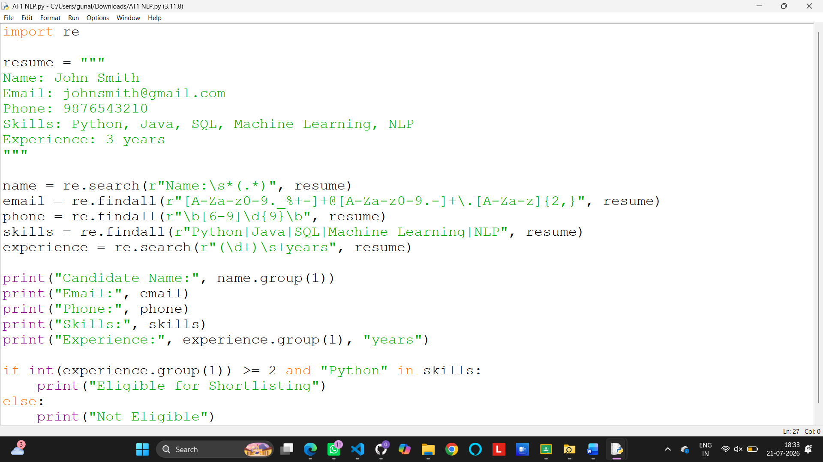

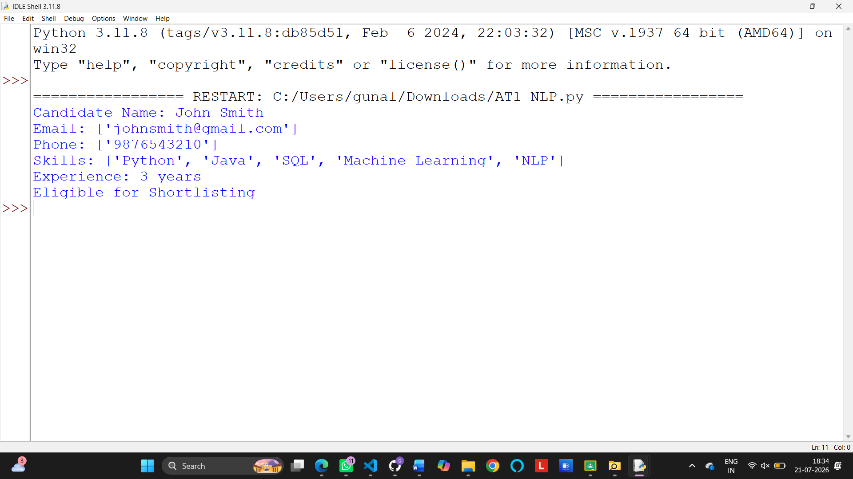
2.An e-commerce company plans to enhance its product search engine to improve customer experience through flexible keyword matching.

Design and implement a Python-based product search system using Regular Expressions that performs the following tasks:

Search products using an exact keyword.
Perform prefix-based searches.
Perform suffix-based searches.
Search using partial keywords.
Perform case-insensitive searches.
Display all matching product names.
Generate a report showing the total number of matching products for each search.

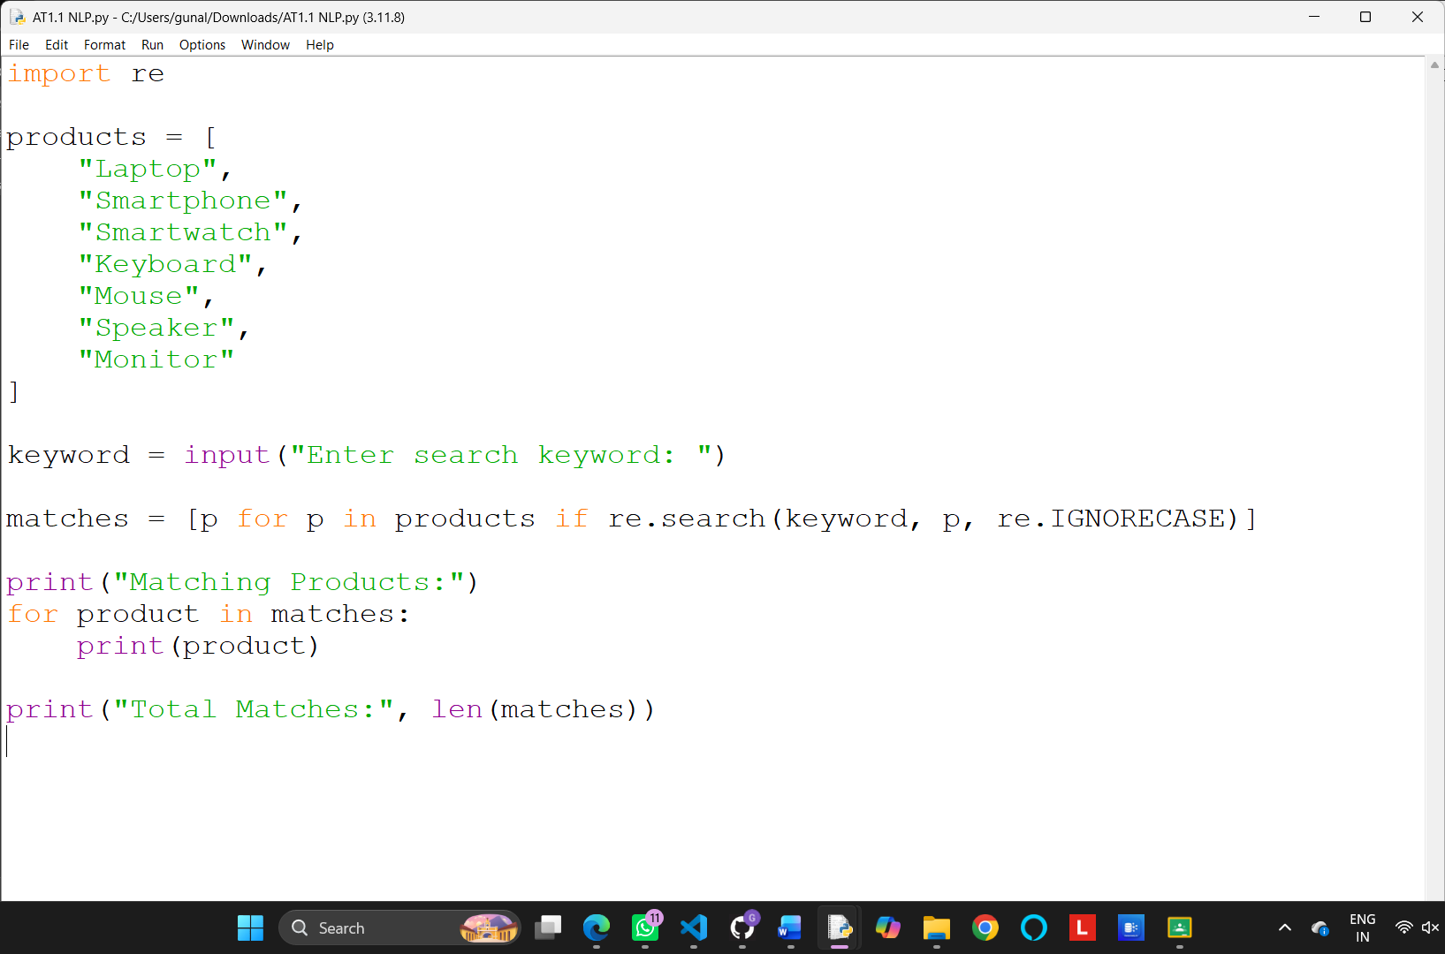

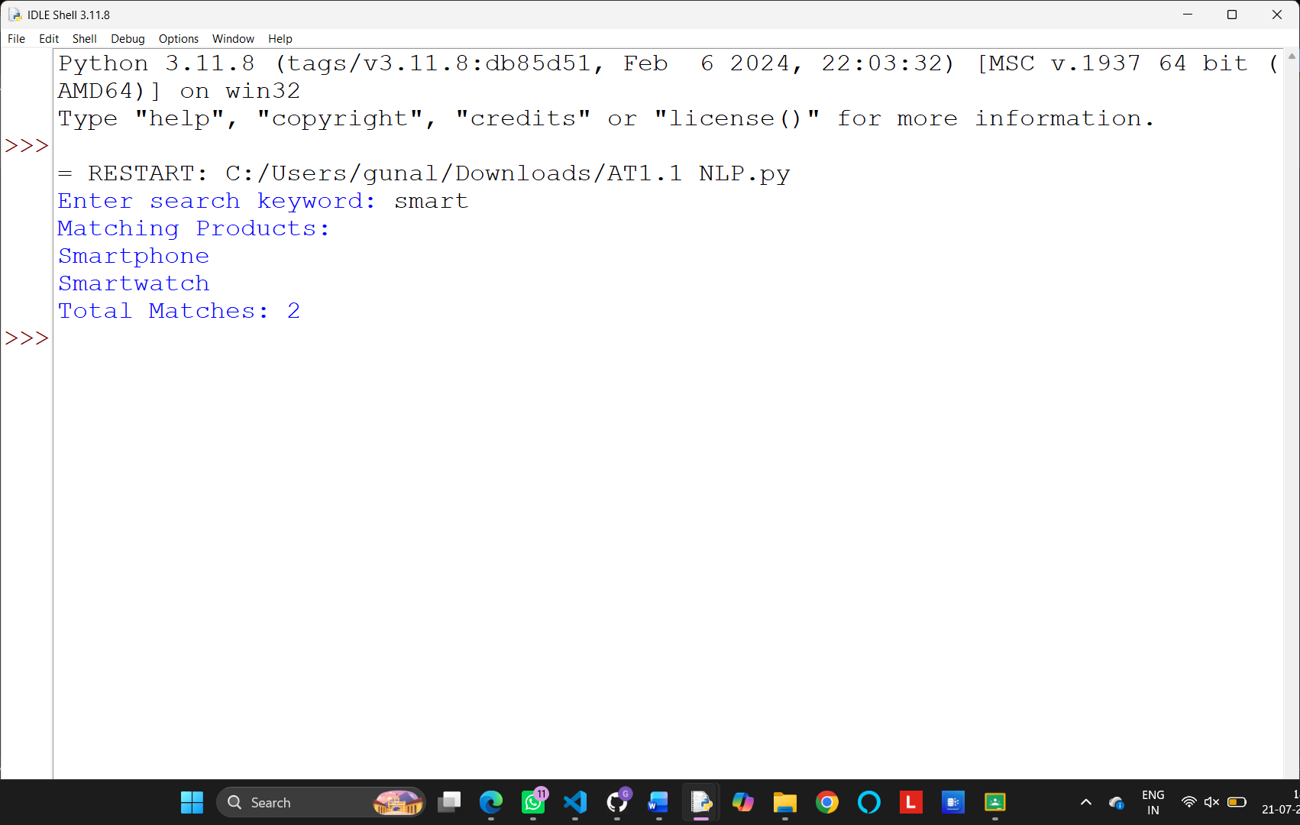

3.A university is developing an automated online registration portal to verify student information before course enrollment.

Design and implement a Python-based validation system using Regular Expressions that performs the following tasks:

Validate the student register number.
Validate the institutional email address.
Validate the course code.
Validate the semester information.
Validate the student's mobile number.
Display appropriate validation messages for each field.
Generate a final registration status report indicating whether the registration is successful.

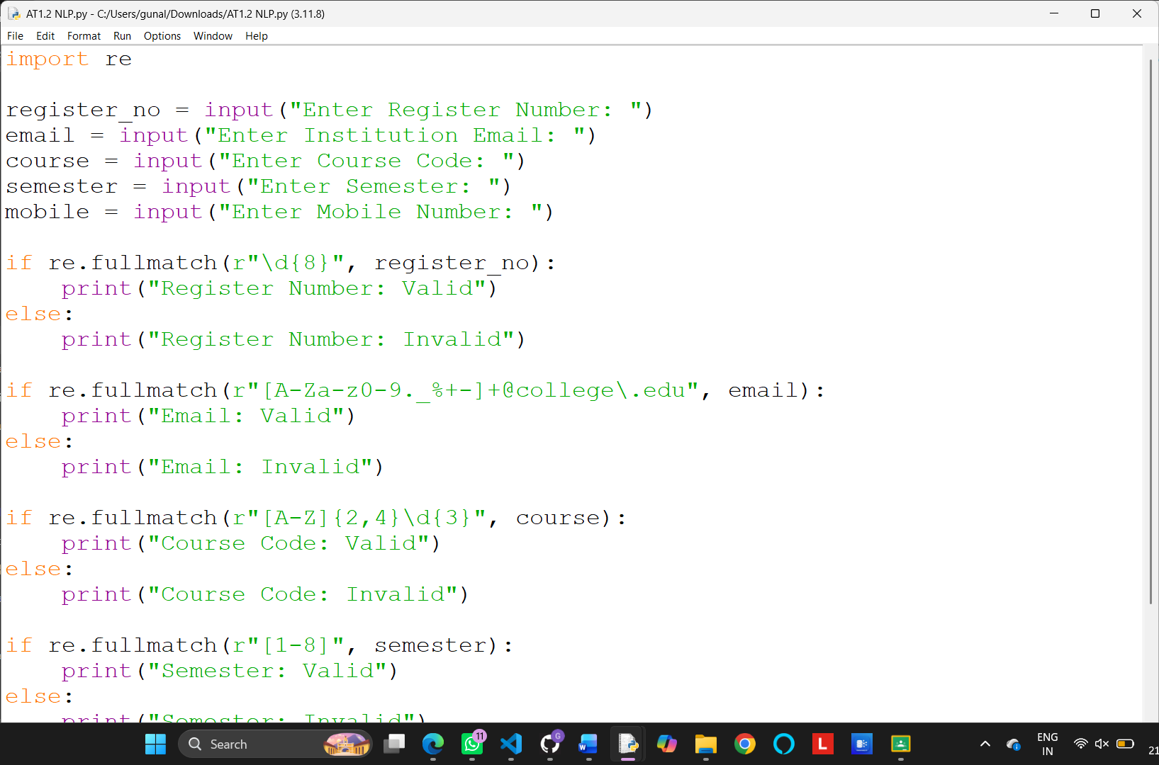

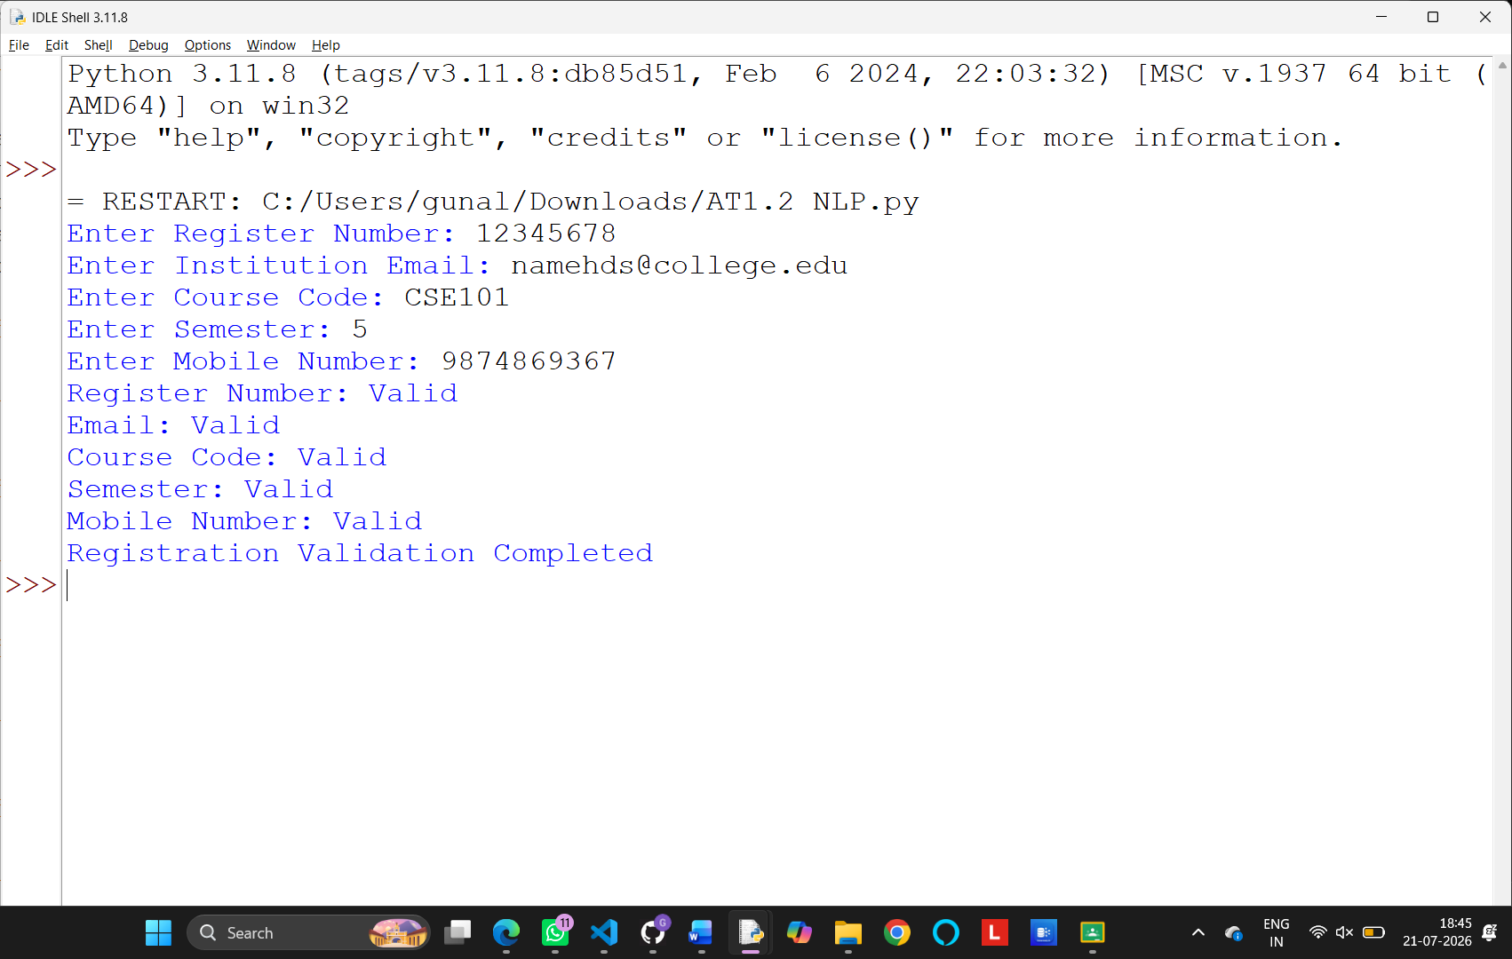

Rubrics for Calculation
Criteria | Weightage | Level 4 – Exemplary | Level 3 – Proficient | Level 2 – Developing | Level 1 – Beginning
Understanding of Problem Context | 20 | Clearly understands the problem and accurately identifies all requirements | Good understanding with minor gaps | Basic understanding; some requirements unclear | Poor understanding or misinterpretation of the problem
Application of Concepts | 30 | Accurately applies appropriate concepts to solve complex problems | Applies relevant concepts correctly with minor errors | Applies basic concepts with limited accuracy | Fails to apply appropriate concepts
Problem-Solving Approach | 20 | Logical, well-structured, and efficient approach | Mostly logical approach with minor gaps | Basic approach with some inconsistencies | Illogical or unclear approach
Accuracy of Solution | 20 | Completely correct solution with proper justification | Mostly correct with minor errors | Partially correct solution | Incorrect or incomplete solution
Clarity | 10 | Clear, well-organized, and properly explained solution | Understandable with minor clarity issues | Limited clarity and explanation | Poorly presented and difficult to understand

Q. No. / Criteria | Understanding of Problem Context | Application of Concepts | Problem-Solving Approach | Accuracy of Solution | Clarity | Sub. Total | Total %
1
2
3

Faculty In-charge | Course Coordinator | Program Director
Signature: _______________ | Signature: _______________ | Signature: _______________
Date: ___________________ | Date: ___________________ | Date: ___________________

