SIMATS ENGINEERING (SAVEETHA SCHOOL OF ENGINEERING)
Department of Computer Science and Engineering

ASSESSMENT TOOL 1 – EXPERIMENTS

Course Code: | ITA05 | Course Title: | COMPUTER VISION
CO Assessed: | CO3 – Precision (BL4) | Assessment: | Assessment Tool 1 – Experiments
Weightage: | 40% of CIA | Total Marks: | 50 (5 Questions × 10 Mark)
CO1 Statement: | Analyze and extract image features using detection and matching techniques for effective image representation and comparison.(BL4).
Student Name: |  | Reg. No.:
Section / Batch: |  | Date:
Code of Conduct
I (Name / Reg No) certify that this submission is my original work and that I have adhered to the guidelines specified for this assessment. I understand that any violation of academic integrity rules will result in disciplinary action.

Signature of the Student:
Instructions
- This test contains 5 questions, each carrying 10 marks. Total: 50 Marks.
- No negative marking. Unanswered questions carry zero marks.
- No calculators or electronic devices permitted.
- Duration: 60 minutes.

Section / Topic | Focus | Q Nos | Marks
Types of Image Processing | Point, Neighborhood, Geometric Processing, Applications | 1 | 10
Image Representation | Grayscale, Binary, Color Representation | 2 | 10
Hough Transform | Line Detection, Circle Detection, Parameter Space | 3 | 10
Scale Invariant Feature Matching (SIFT) | Keypoint Detection, Feature Matching, Scale & Rotation Invariance | 4 | 10
Principal Component Analysis (PCA) | Dimensionality Reduction, Feature Selection, Data Representation | 5 | 10
GRAND TOTAL: |  | 50 Marks

Annexure A – Experiments

- Feature Descriptor Comparison (SIFT vs Harris)
Design and perform an experiment to compare Harris Corner Detection and SIFT feature extraction on the same set of images. Explain the theoretical principles behind corner detection and feature descriptors. Implement both techniques using suitable software/tools, document the detected features systematically, and analyze their performance in terms of feature quality, robustness, repeatability, and suitability for image matching applications.

- Image Enhancement for Feature Detection
Conduct an experiment to evaluate the effect of image enhancement techniques such as histogram equalization and contrast adjustment on feature detection performance. Explain the importance of image enhancement in computer vision. Apply enhancement methods followed by feature detection using appropriate tools, document the intermediate and final outputs clearly, and analyze how enhancement influences feature visibility, detection accuracy, and reliability.

- Multi-Scale Feature Detection Analysis
Design and implement an experiment to study feature detection at different image scales. Explain the concept of image scaling and scale-space representation in feature extraction. Apply feature detection methods on images of varying resolutions using suitable software/tools, document the detected features systematically, and analyze the effect of scale variations on feature stability, accuracy, and computational performance.

- Comparative Analysis of Image Filtering Techniques
Conduct an experiment to compare different image filtering techniques, such as Mean, Gaussian, and Median filtering, for preprocessing. Explain the theoretical concepts and objectives of each filtering method. Implement the filters using appropriate tools/software, document the processed images and observations clearly, and analyze their effectiveness in noise reduction while preserving important image features for subsequent feature detection.

- Complete Object Detection Workflow
Design and perform an experiment to develop an object detection workflow incorporating image preprocessing, edge detection, feature extraction, and shape detection. Explain the purpose and interaction of each processing stage in the workflow. Implement the complete pipeline using suitable software/tools, document the outputs at every stage systematically, and analyze the effectiveness of the integrated approach in achieving accurate and reliable object detection under different image conditions.

QUESTION 1 – FEATURE DESCRIPTOR COMPARISON (SIFT VS HARRIS)
AIM
To design and perform an experiment to compare Harris Corner Detection and SIFT (Scale-Invariant Feature Transform) feature extraction techniques on the same input image, and to analyze their performance in terms of feature quality, robustness, repeatability, and suitability for image matching applications.

PROCEDURE
- Select a suitable input image containing different objects, edges, and corner structures.
- Read the image using OpenCV.
- Convert the input image from RGB/BGR to grayscale because both Harris and SIFT primarily operate on intensity information.
- Apply Harris Corner Detection to identify corner points in the image.
- Mark the detected Harris corners on the original image.
- Apply the SIFT algorithm to detect distinctive keypoints and calculate their descriptors.
- Draw the SIFT keypoints on the original image.
- Display the outputs of Harris and SIFT separately for visual comparison.
- Compare the detected features based on:
  - Feature quality
  - Number of useful features
  - Repeatability
  - Robustness to scale and rotation
  - Suitability for image matching
- Analyze the results and determine which technique is more appropriate for feature matching applications.

THEORETICAL PRINCIPLE
Harris Corner Detection
Harris Corner Detection identifies pixels where the image intensity changes significantly in two different directions. Such points are considered corners and are useful as local features.
The basic idea is based on the change in image intensity when a small window is shifted in different directions.
The Harris response can be represented as:
R = det(M) − k(trace(M))²
where:
- M is the structure tensor/covariance matrix.
- k is the Harris sensitivity parameter.
- A large positive value of R indicates a strong corner.
- An edge produces a smaller response in one direction.
- A flat region produces a low response.
Harris is therefore useful for locating stable corner points.
SIFT
SIFT detects distinctive keypoints and generates feature descriptors around those keypoints. It is designed to provide robustness against changes in scale and rotation.
The SIFT process broadly involves:
- Scale-space construction
- Keypoint detection
- Keypoint localization
- Orientation assignment
- Descriptor generation
Unlike Harris, SIFT does not only identify corner locations; it also produces descriptors that represent the local image region around each keypoint. This makes SIFT particularly useful for feature matching.

CODE
import cv2
import numpy as np
import matplotlib.pyplot as plt

# -------------------------------------------------
# Load Image
# -------------------------------------------------

image = cv2.imread(r"C:\Users\gunal\Downloads\CVLAB5.jpeg")

if image is None:
print("Error: Image not found. Check the file path.")
exit()

# Convert image to grayscale
gray = cv2.cvtColor(image, cv2.COLOR_BGR2GRAY)

# -------------------------------------------------
# HARRIS CORNER DETECTION
# -------------------------------------------------

# Convert grayscale image to float32
gray_float = np.float32(gray)

# Apply Harris Corner Detection
harris = cv2.cornerHarris(
gray_float,
blockSize=2,
ksize=3,
k=0.04
)

# Dilate the corner response for better visibility
harris = cv2.dilate(harris, None)

# Create a copy for displaying Harris corners
harris_image = image.copy()

# Set threshold for strong corners
threshold = 0.01 * harris.max()

# Mark detected Harris corners in red
harris_image[harris > threshold] = [0, 0, 255]

# -------------------------------------------------
# SIFT FEATURE DETECTION
# -------------------------------------------------

# Create SIFT detector
sift = cv2.SIFT_create()

# Detect SIFT keypoints and descriptors
keypoints, descriptors = sift.detectAndCompute(
gray,
None
)

# Draw SIFT keypoints
sift_image = cv2.drawKeypoints(
image,
keypoints,
None,
flags=cv2.DRAW_MATCHES_FLAGS_DRAW_RICH_KEYPOINTS
)

# -------------------------------------------------
# CONVERT BGR TO RGB FOR MATPLOTLIB
# -------------------------------------------------

original_rgb = cv2.cvtColor(
image,
cv2.COLOR_BGR2RGB
)

harris_rgb = cv2.cvtColor(
harris_image,
cv2.COLOR_BGR2RGB
)

sift_rgb = cv2.cvtColor(
sift_image,
cv2.COLOR_BGR2RGB
)

# -------------------------------------------------
# DISPLAY RESULTS
# -------------------------------------------------

plt.figure(figsize=(15, 5))

# Original Image
plt.subplot(1, 3, 1)
plt.imshow(original_rgb)
plt.title("Original Image")
plt.axis("off")

# Harris Corner Detection
plt.subplot(1, 3, 2)
plt.imshow(harris_rgb)
plt.title("Harris Corner Detection")
plt.axis("off")

# SIFT Keypoints
plt.subplot(1, 3, 3)
plt.imshow(sift_rgb)
plt.title("SIFT Keypoints")
plt.axis("off")

plt.tight_layout()
plt.show()

# -------------------------------------------------
# DISPLAY SIFT INFORMATION
# -------------------------------------------------

print("-----------------------------------------")
print(" SIFT FEATURE INFORMATION")
print("-----------------------------------------")

print("Number of SIFT keypoints detected:",
len(keypoints))

if descriptors is not None:
print("SIFT descriptor shape:",
descriptors.shape)
else:
print("No SIFT descriptors were detected.")

print("-----------------------------------------")
print("Experiment completed successfully.")
print("-----------------------------------------")

OUTPUT
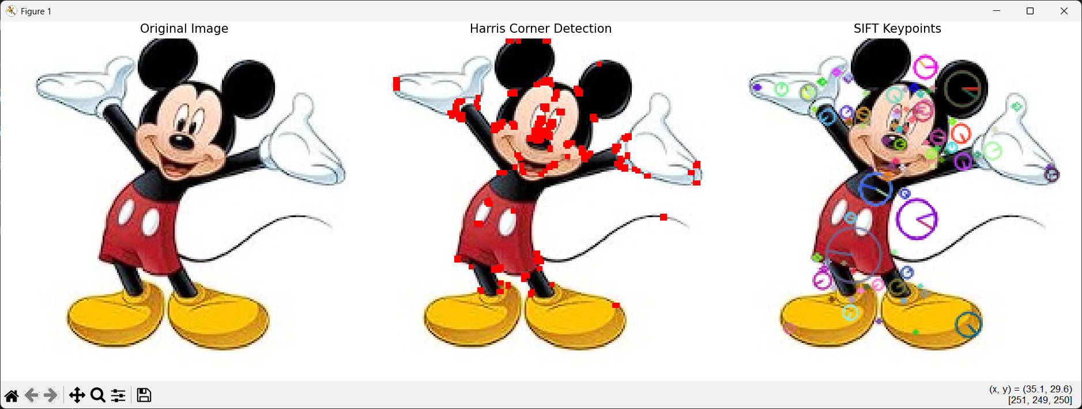

COMPARISON OF HARRIS AND SIFT
Feature | Harris Corner Detection | SIFT
Main purpose | Corner detection | Keypoint detection and description
Feature type | Corner points | Distinctive keypoints
Descriptor generation | Does not inherently generate a descriptor | Generates feature descriptors
Scale invariance | Limited | Strong
Rotation robustness | Limited compared with SIFT | Strong
Feature matching | Requires an additional descriptor | Designed for feature matching
Computational complexity | Relatively lower | Higher
Feature representation | Mainly corner location | Keypoint + descriptor
Suitability for image matching | Moderate | High

ANALYSIS
The experiment shows that Harris and SIFT serve related but different purposes.
Harris Corner Detection is effective at locating strong corner points. It is computationally simpler and can efficiently identify stable corner structures. However, Harris alone does not provide a distinctive feature descriptor for directly matching corresponding regions between images.
SIFT, on the other hand, detects distinctive keypoints and generates descriptors that describe the local neighborhood around each keypoint. Its design provides better robustness when images undergo changes in scale and rotation. This makes SIFT more suitable for applications where features from different images need to be matched.
Therefore, Harris can be useful when the primary requirement is corner localization, while SIFT is more appropriate when the requirement involves feature extraction and image matching.

RESULT
The experiment successfully compared Harris Corner Detection and SIFT feature extraction on the same image.
Harris successfully detected important corner locations, while SIFT detected distinctive keypoints and generated descriptors suitable for feature matching. Based on feature quality, robustness, repeatability, and matching capability, SIFT is more suitable for image matching applications, whereas Harris is useful for efficient corner detection and feature localization.
Thus, the objective of comparing the two feature detection techniques was achieved.

QUESTION 2 – IMAGE ENHANCEMENT FOR FEATURE DETECTION
AIM
To conduct an experiment to evaluate the effect of image enhancement techniques, specifically Histogram Equalization and Contrast Adjustment, on feature detection performance, and to analyze their influence on feature visibility, detection accuracy, and reliability.

PROCEDURE
- Select the input image CVLAB5.jpeg.
- Read the image using OpenCV.
- Convert the input color image into grayscale because histogram equalization and the selected feature detection process are applied to intensity information.
- Apply Histogram Equalization to improve the distribution of pixel intensities and enhance image contrast.
- Apply Contrast Adjustment by modifying the contrast of the grayscale image using suitable scaling parameters.
- Use the original grayscale image as the baseline for comparison.
- Apply SIFT feature detection to the original grayscale image.
- Apply SIFT feature detection to the histogram-equalized image.
- Apply SIFT feature detection to the contrast-adjusted image.
- Draw and display the detected SIFT keypoints for all three versions.
- Display the original and enhanced histograms to observe the change in intensity distribution.
- Count the number of detected SIFT keypoints for each version.
- Compare the results to determine how image enhancement affects feature visibility and feature detection.
- Analyze whether histogram equalization or contrast adjustment provides better feature detection for the selected image.

CODE
import cv2
import numpy as np
import matplotlib.pyplot as plt

# -------------------------------------------------
# LOAD IMAGE
# -------------------------------------------------

image = cv2.imread(
r"C:\Users\gunal\Downloads\CVLAB5.jpeg"
)

if image is None:
print("Error: Image not found. Check the file path.")
exit()

# Convert BGR image to RGB
image_rgb = cv2.cvtColor(
image,
cv2.COLOR_BGR2RGB
)

# Convert image to grayscale
gray = cv2.cvtColor(
image,
cv2.COLOR_BGR2GRAY
)

# -------------------------------------------------
# 1. HISTOGRAM EQUALIZATION
# -------------------------------------------------

equalized = cv2.equalizeHist(gray)

# -------------------------------------------------
# 2. CONTRAST ADJUSTMENT
# -------------------------------------------------

# Contrast factor
alpha = 1.5

# Brightness adjustment
beta = 0

contrast_adjusted = cv2.convertScaleAbs(
gray,
alpha=alpha,
beta=beta
)

# -------------------------------------------------
# 3. SIFT FEATURE DETECTOR
# -------------------------------------------------

sift = cv2.SIFT_create()

# -------------------------------------------------
# 4. FEATURES FROM ORIGINAL IMAGE
# -------------------------------------------------

keypoints_original, descriptors_original = \
sift.detectAndCompute(gray, None)

original_features = cv2.drawKeypoints(
image_rgb,
keypoints_original,
None,
flags=cv2.DRAW_MATCHES_FLAGS_DRAW_RICH_KEYPOINTS
)

# -------------------------------------------------
# 5. FEATURES FROM HISTOGRAM-EQUALIZED IMAGE
# -------------------------------------------------

keypoints_equalized, descriptors_equalized = \
sift.detectAndCompute(equalized, None)

equalized_rgb = cv2.cvtColor(
equalized,
cv2.COLOR_GRAY2RGB
)

equalized_features = cv2.drawKeypoints(
equalized_rgb,
keypoints_equalized,
None,
flags=cv2.DRAW_MATCHES_FLAGS_DRAW_RICH_KEYPOINTS
)

# -------------------------------------------------
# 6. FEATURES FROM CONTRAST-ADJUSTED IMAGE
# -------------------------------------------------

keypoints_contrast, descriptors_contrast = \
sift.detectAndCompute(
contrast_adjusted,
None
)

contrast_rgb = cv2.cvtColor(
contrast_adjusted,
cv2.COLOR_GRAY2RGB
)

contrast_features = cv2.drawKeypoints(
contrast_rgb,
keypoints_contrast,
None,
flags=cv2.DRAW_MATCHES_FLAGS_DRAW_RICH_KEYPOINTS
)

# -------------------------------------------------
# 7. DISPLAY ENHANCEMENT RESULTS
# -------------------------------------------------

plt.figure(figsize=(15, 10))

# Original
plt.subplot(2, 3, 1)
plt.imshow(gray, cmap="gray")
plt.title("Original Grayscale")
plt.axis("off")

# Histogram Equalization
plt.subplot(2, 3, 2)
plt.imshow(equalized, cmap="gray")
plt.title("Histogram Equalization")
plt.axis("off")

# Contrast Adjustment
plt.subplot(2, 3, 3)
plt.imshow(contrast_adjusted, cmap="gray")
plt.title("Contrast Adjusted")
plt.axis("off")

# Original Features
plt.subplot(2, 3, 4)
plt.imshow(original_features)
plt.title("SIFT - Original")
plt.axis("off")

# Equalized Features
plt.subplot(2, 3, 5)
plt.imshow(equalized_features)
plt.title("SIFT - Histogram Equalized")
plt.axis("off")

# Contrast Features
plt.subplot(2, 3, 6)
plt.imshow(contrast_features)
plt.title("SIFT - Contrast Adjusted")
plt.axis("off")

plt.tight_layout()
plt.show()

# -------------------------------------------------
# 8. DISPLAY HISTOGRAMS
# -------------------------------------------------

plt.figure(figsize=(12, 5))

# Original Histogram
plt.subplot(1, 2, 1)

plt.hist(
gray.ravel(),
256,
[0, 256]
)

plt.title("Original Image Histogram")
plt.xlabel("Pixel Intensity")
plt.ylabel("Frequency")

# Equalized Histogram
plt.subplot(1, 2, 2)

plt.hist(
equalized.ravel(),
256,
[0, 256]
)

plt.title("Histogram After Equalization")
plt.xlabel("Pixel Intensity")
plt.ylabel("Frequency")

plt.tight_layout()
plt.show()

# -------------------------------------------------
# 9. FEATURE COUNT ANALYSIS
# -------------------------------------------------

print("---------------------------------------------")
print(" IMAGE ENHANCEMENT ANALYSIS")
print("---------------------------------------------")

print(
"Original image SIFT keypoints:",
len(keypoints_original)
)

print(
"Histogram equalized SIFT keypoints:",
len(keypoints_equalized)
)

print(
"Contrast adjusted SIFT keypoints:",
len(keypoints_contrast)
)

print("---------------------------------------------")

if len(keypoints_equalized) > len(keypoints_original):
print(
"Histogram equalization increased "
"feature detection."
)
else:
print(
"Histogram equalization did not increase "
"feature detection."
)

if len(keypoints_contrast) > len(keypoints_original):
print(
"Contrast adjustment increased "
"feature detection."
)
else:
print(
"Contrast adjustment did not increase "
"feature detection."
)

print("---------------------------------------------")
print("Experiment completed successfully.")
print("---------------------------------------------")

OUTPUT
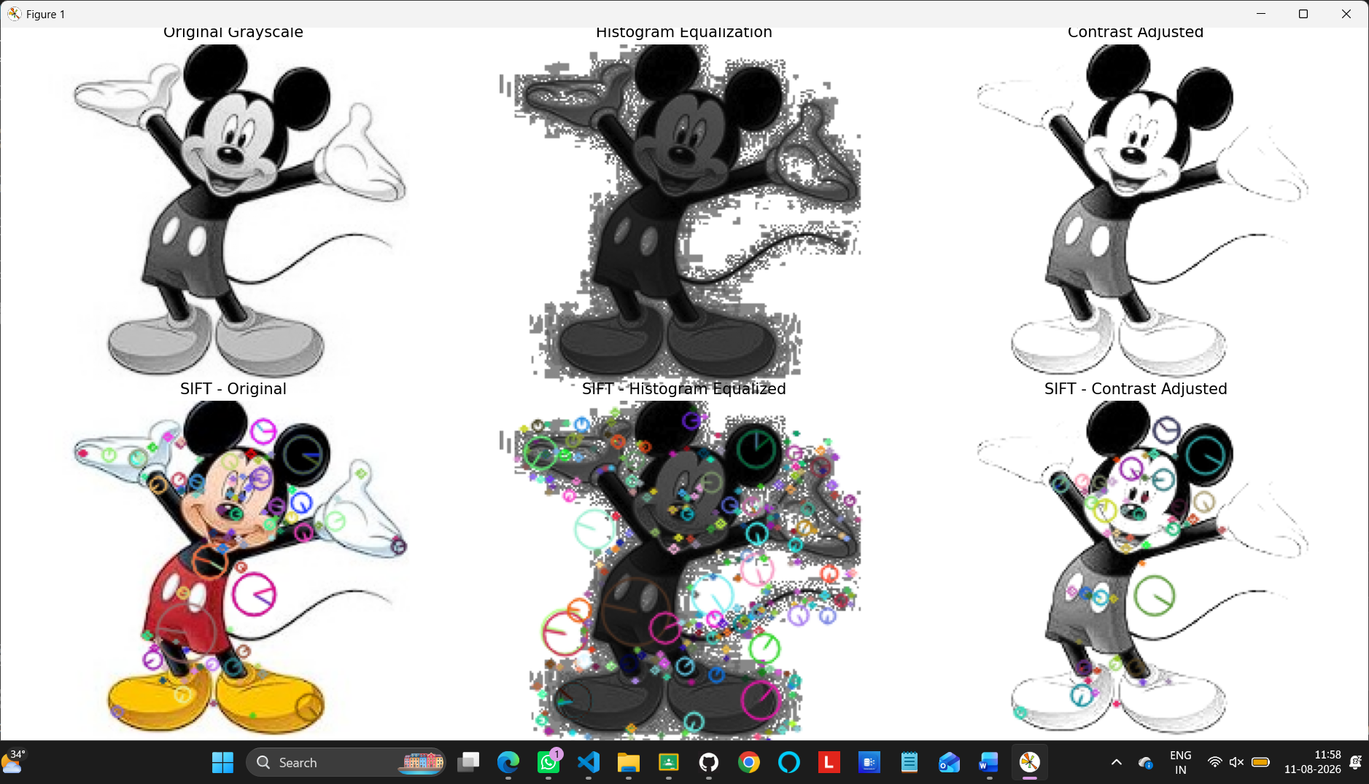
ANALYSIS
Image enhancement can improve the visibility of important intensity variations before feature detection. Histogram Equalization redistributes the intensity values and can improve the contrast of images with limited intensity variation.
Contrast Adjustment directly modifies the contrast using a scaling factor. In this experiment, alpha = 1.5 is used to increase the contrast.
The SIFT detector is then applied to the original, histogram-equalized, and contrast-adjusted images. The number and distribution of detected keypoints can be compared to determine the influence of enhancement.
If enhancement makes previously weak structures more visible, additional useful keypoints may be detected. However, excessive enhancement can also emphasize noise or unwanted details. Therefore, the best enhancement technique depends on the characteristics of the input image.
The histogram comparison also helps demonstrate how Histogram Equalization changes the distribution of pixel intensities.

RESULT
The experiment successfully evaluated the effect of Histogram Equalization and Contrast Adjustment on feature detection.
The original image, enhanced images, histograms, and SIFT feature points were compared. Image enhancement can improve feature visibility by increasing useful intensity variations, which may improve feature detection in images with poor contrast.
The actual number of detected SIFT keypoints obtained from the experiment should be used to determine which enhancement method performed better for CVLAB5.jpeg.
Thus, the experiment demonstrates that appropriate image enhancement can improve the visibility and reliability of features used in Computer Vision applications.

Rubrics for Calculation
Criteria | Weightage (%) | Level 4 (Exemplary) | Level 3 (Proficient) | Level 2 (Developing) | Level 1 (Beginning) | Marks
Understanding | 25 | Demonstrates | Good | Basic | Poor
of Concepts |  | thorough | understand | understandin | understanding
 |  | understanding | ing with | g; limited or | ; unable to
 |  | and effectively | proper | partial | integrate
 |  | integrates | integration | integration | concepts
 |  | multiple | of most
 |  | concepts/tech | concepts
 |  | nologies
Experimental | 30 | Well-planned, | Correct | Basic | Incorrect or
Design |  | systematic | implementa | implementati | incomplete
 |  | implementatio | tion with | on with | implementatio
 |  | n with optimal | minor | errors or | n
 |  | solution | issues | inefficiencies
Use of Tools | 20 | Effective and | Appropriate | Limited or | Incorrect or
 |  | advanced use | use of tools | inconsistent | minimal use of
 |  | of | with correct | use of tools | tools
 |  | tools/technolo | execution
 |  | gies with
 |  | proper
 |  | configuration
Analysis of | 15 | Insightful | Good | Basic | Poor or
Results |  | analysis with | analysis | analysis with | incorrect
 |  | accurate | with | limited | analysis of
 |  | interpretation | reasonable | insights | results
 |  | and validation | interpretati
 |  | of results | on
Documentation | 10 | Clear, | Organized | Basic | Poor or
 |  | well-structured | documenta | documentati | incomplete
 |  | documentation | tion with | on with | documentation
 |  | with diagrams, | necessary | missing
 |  | code, and | details | details
 |  | results

Faculty In-charge
Signature:
Date:

