BUILD 3
DEFECT REPORT
Appointment Booking Application
Web Application • WhatsApp • Chatbot
Reported Date: 01-Oct-2026
DEFECT SUMMARY
Build 3 defects identified during functional testing. Each defect contains its reproduction steps, expected result, actual result, test data, and the evidence associated with that defect.
Area | Defects | Priority | Severity
Web Application | 9 | P1 / P2 | Critical / High / Medium
HMS Core API | 0 | P1 / P2 | High
Chatbot / WhatsApp | 0 | P1 / P2 | High / Medium
Total | 9 | P1 / P2 | Critical / High / Medium

WEB APPLICATION DEFECTS
BUG-001
Build | Build 3
Module | Appointment Booking
Sub Module | New Patient Booking
Feature | DOC-001: Open schedule screen and verify doctor filter list loads
Priority | P2 - High
Severity | Medium
Status | New
Reported Date | 01-Oct-2026
Assigned To | Development Team
Issue Description
Error: expect(received).toBeGreaterThan(expected)
Steps to Reproduce
1. Step 1: Complete intake and tier selection
2. Step 2: Verify doctor filter list is populated
Expected Result
> 0
Actual Result
0
Test Data
• Patient Type: New Patient / Existing Patient
• Environment: UAT (https://awh-website-booking-form.vercel.app/)
• Browser: Google Chrome (Chromium Engine)
• Test Data Artifact: sample/booking.json
Testing Evidence
Screenshot showing the state of the application at the point of assertion failure for BUG-001.
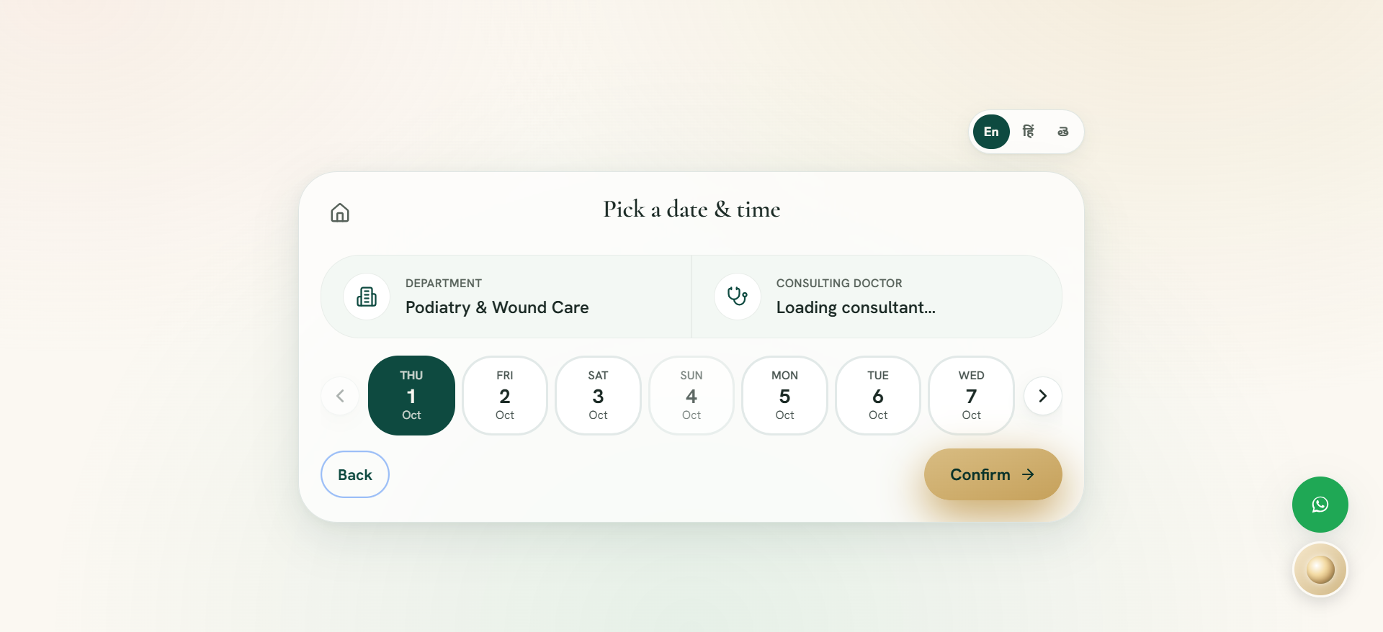

BUG-002
Build | Build 3
Module | Appointment Booking
Sub Module | New Patient Booking
Feature | DT-003: Navigate across calendar weeks smoothly
Priority | P2 - High
Severity | Medium
Status | New
Reported Date | 01-Oct-2026
Assigned To | Development Team
Issue Description
LocatorError: [Navigating to 'Next week'] locator.click: Error: strict mode violation: locator('//div[button[contains(@class, \'flex-col\')]]/button[preceding-sibling::button[contains(@class, \'flex-col\')]] | //button[@aria-label=\'Next week\' or @title=\'Next week\']') resolved to 7 elements:
Steps to Reproduce
1. Step 1: Reach Date & Time screen
2. Step 2: Click next week and previous week
Expected Result
The system should process the workflow successfully as per requirements without error or timeout.
Actual Result
Application encountered an assertion timeout or unexpected UI state during step execution.
Test Data
• Patient Type: New Patient / Existing Patient
• Environment: UAT (https://awh-website-booking-form.vercel.app/)
• Browser: Google Chrome (Chromium Engine)
• Test Data Artifact: sample/booking.json
Testing Evidence
Screenshot showing the state of the application at the point of assertion failure for BUG-002.

BUG-003
Build | Build 3
Module | Appointment Booking
Sub Module | Existing Patient Booking
Feature | EP-003: Existing patient booking with Silver Tier
Priority | P2 - High
Severity | Medium
Status | New
Reported Date | 01-Oct-2026
Assigned To | Development Team
Issue Description
FrameworkError: [Selecting care package: Silver] [Selecting care package: Silver] Element with identifier "Silver" not found in collection.
Steps to Reproduce
1. Step 1: Authenticate existing patient
2. Step 2: Complete Silver booking and verify confirmation
Expected Result
The system should process the workflow successfully as per requirements without error or timeout.
Actual Result
Application encountered an assertion timeout or unexpected UI state during step execution.
Test Data
• Patient Type: New Patient / Existing Patient
• Environment: UAT (https://awh-website-booking-form.vercel.app/)
• Browser: Google Chrome (Chromium Engine)
• Test Data Artifact: sample/booking.json
Testing Evidence
Screenshot showing the state of the application at the point of assertion failure for BUG-003.
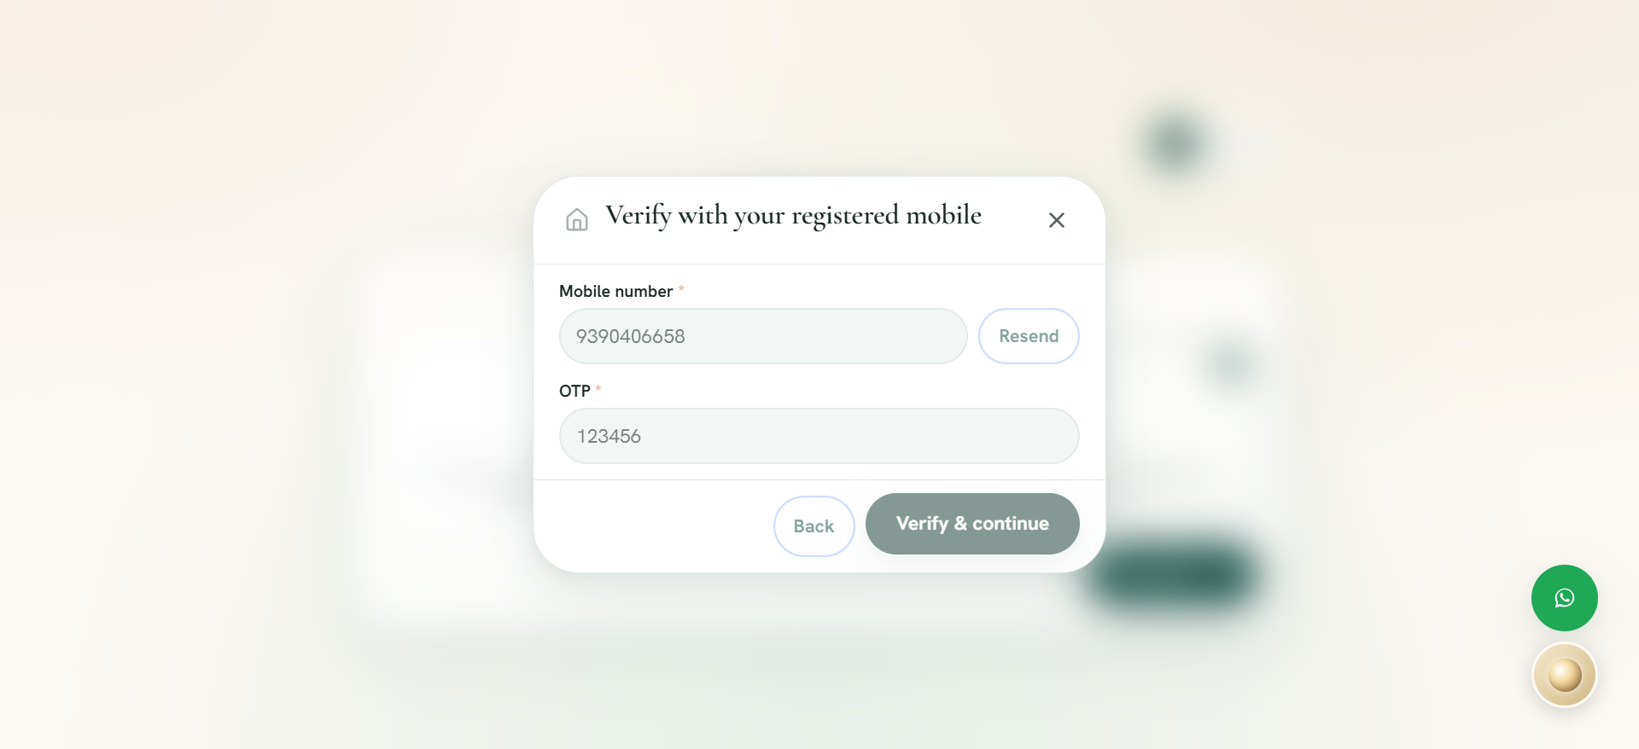

BUG-004
Build | Build 3
Module | Appointment Booking
Sub Module | Existing Patient Booking
Feature | EP-004: Existing patient booking with Gold Tier
Priority | P2 - High
Severity | Medium
Status | New
Reported Date | 01-Oct-2026
Assigned To | Development Team
Issue Description
FrameworkError: [Selecting care package: Gold] [Selecting care package: Gold] Element with identifier "Gold" not found in collection.
Steps to Reproduce
1. Step 1: Authenticate existing patient
2. Step 2: Complete Gold booking and verify confirmation
Expected Result
The system should process the workflow successfully as per requirements without error or timeout.
Actual Result
Application encountered an assertion timeout or unexpected UI state during step execution.
Test Data
• Patient Type: New Patient / Existing Patient
• Environment: UAT (https://awh-website-booking-form.vercel.app/)
• Browser: Google Chrome (Chromium Engine)
• Test Data Artifact: sample/booking.json
Testing Evidence
Screenshot showing the state of the application at the point of assertion failure for BUG-004.
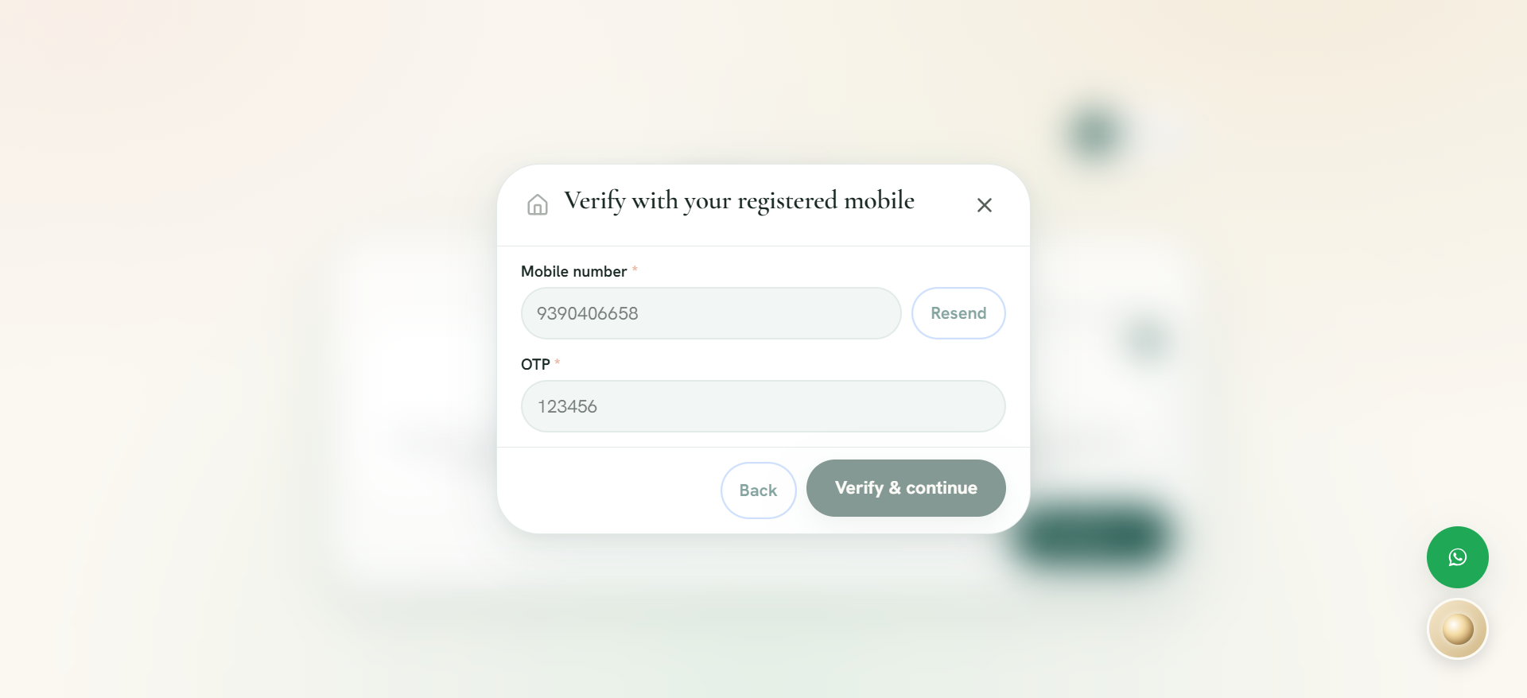

BUG-005
Build | Build 3
Module | Appointment Booking
Sub Module | New Patient Booking
Feature | RES-001: Reschedule appointment to replacement date and time slot
Priority | P2 - High
Severity | Medium
Status | New
Reported Date | 01-Oct-2026
Assigned To | Development Team
Issue Description
LocatorError: [Navigating to 'Next week'] locator.click: Error: strict mode violation: locator('//div[button[contains(@class, \'flex-col\')]]/button[preceding-sibling::button[contains(@class, \'flex-col\')]] | //button[@aria-label=\'Next week\' or @title=\'Next week\']') resolved to 7 elements:
Steps to Reproduce
1. Step 1: Book initial appointment
2. Step 2: Reschedule to another slot and confirm
Expected Result
The system should process the workflow successfully as per requirements without error or timeout.
Actual Result
Application encountered an assertion timeout or unexpected UI state during step execution.
Test Data
• Patient Type: New Patient / Existing Patient
• Environment: UAT (https://awh-website-booking-form.vercel.app/)
• Browser: Google Chrome (Chromium Engine)
• Test Data Artifact: sample/booking.json
Testing Evidence
Screenshot showing the state of the application at the point of assertion failure for BUG-005.
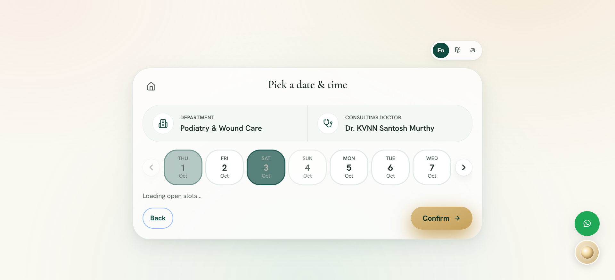

BUG-006
Build | Build 3
Module | Appointment Booking
Sub Module | New Patient Booking
Feature | CAN-001: Cancel active appointment via modal dialog
Priority | P1 - Immediate
Severity | High
Status | New
Reported Date | 01-Oct-2026
Assigned To | Development Team
Issue Description
TimeoutError: [Clicking 'Cancel' appointment button] locator.click: Timeout 15000ms exceeded.
Steps to Reproduce
1. Step 1: Book initial appointment
2. Step 2: Open cancel modal and confirm cancellation
Expected Result
The system should process the workflow successfully as per requirements without error or timeout.
Actual Result
Application encountered an assertion timeout or unexpected UI state during step execution.
Test Data
• Patient Type: New Patient / Existing Patient
• Environment: UAT (https://awh-website-booking-form.vercel.app/)
• Browser: Google Chrome (Chromium Engine)
• Test Data Artifact: sample/booking.json
Testing Evidence
Screenshot showing the state of the application at the point of assertion failure for BUG-006.
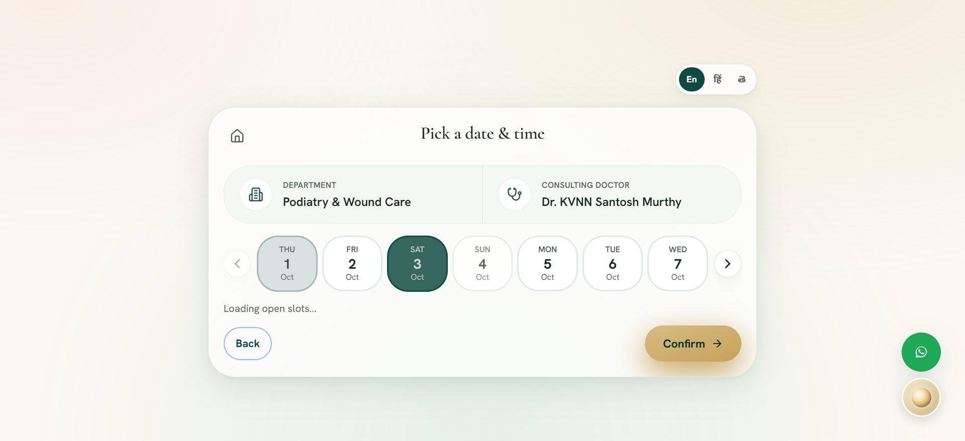

BUG-007
Build | Build 3
Module | Appointment Booking
Sub Module | New Patient Booking
Feature | CAN-002: Decline cancellation modal keeps appointment active
Priority | P1 - Immediate
Severity | High
Status | New
Reported Date | 01-Oct-2026
Assigned To | Development Team
Issue Description
TimeoutError: [Clicking 'Cancel' appointment button] locator.click: Timeout 15000ms exceeded.
Steps to Reproduce
1. Step 1: Book initial appointment
2. Step 2: Open cancel modal and dismiss with Back
Expected Result
The system should process the workflow successfully as per requirements without error or timeout.
Actual Result
Application encountered an assertion timeout or unexpected UI state during step execution.
Test Data
• Patient Type: New Patient / Existing Patient
• Environment: UAT (https://awh-website-booking-form.vercel.app/)
• Browser: Google Chrome (Chromium Engine)
• Test Data Artifact: sample/booking.json
Testing Evidence
Screenshot showing the state of the application at the point of assertion failure for BUG-007.
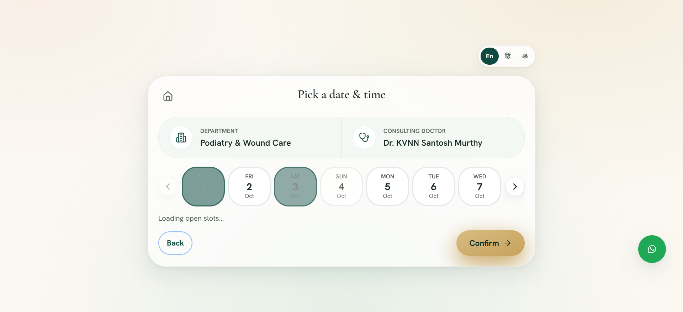

BUG-008
Build | Build 3
Module | Appointment Booking
Sub Module | New Patient Booking
Feature | LIFE-001: Complete Lifecycle: Book -> Reschedule -> Cancel
Priority | P2 - High
Severity | Medium
Status | New
Reported Date | 01-Oct-2026
Assigned To | Development Team
Issue Description
LocatorError: [Navigating to 'Next week'] locator.click: Error: strict mode violation: locator('//div[button[contains(@class, \'flex-col\')]]/button[preceding-sibling::button[contains(@class, \'flex-col\')]] | //button[@aria-label=\'Next week\' or @title=\'Next week\']') resolved to 7 elements:
Steps to Reproduce
1. Step 1: Book initial visit
2. Step 2: Reschedule visit
Expected Result
The system should process the workflow successfully as per requirements without error or timeout.
Actual Result
Application encountered an assertion timeout or unexpected UI state during step execution.
Test Data
• Patient Type: New Patient / Existing Patient
• Environment: UAT (https://awh-website-booking-form.vercel.app/)
• Browser: Google Chrome (Chromium Engine)
• Test Data Artifact: sample/booking.json
Testing Evidence
Screenshot showing the state of the application at the point of assertion failure for BUG-008.
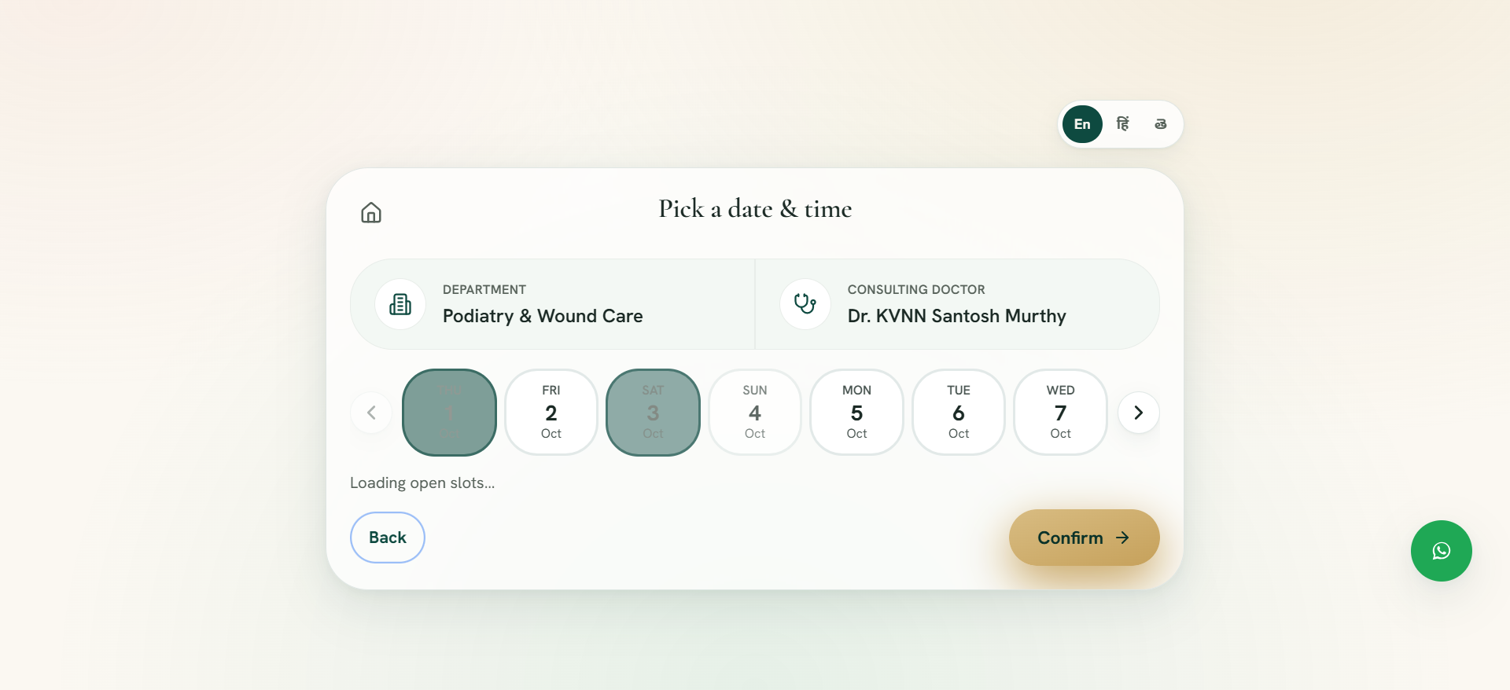

BUG-009
Build | Build 3
Module | Appointment Booking
Sub Module | New Patient Booking
Feature | CON-002: Released slot behavior after appointment cancellation
Priority | P1 - Immediate
Severity | High
Status | New
Reported Date | 01-Oct-2026
Assigned To | Development Team
Issue Description
TimeoutError: [Clicking 'Cancel' appointment button] locator.click: Timeout 15000ms exceeded.
Steps to Reproduce
1. Step 1: Book appointment and cancel
Expected Result
The system should process the workflow successfully as per requirements without error or timeout.
Actual Result
Application encountered an assertion timeout or unexpected UI state during step execution.
Test Data
• Patient Type: New Patient / Existing Patient
• Environment: UAT (https://awh-website-booking-form.vercel.app/)
• Browser: Google Chrome (Chromium Engine)
• Test Data Artifact: sample/booking.json
Testing Evidence
Screenshot showing the state of the application at the point of assertion failure for BUG-009.
