To clone a GitHub repository to your local computer, follow these steps:

**1. Open GitHub Repository**

* Go to the GitHub repository you want to clone.
* You should see a page like this:

**2. Find the Clone Button**

* On the repository page, find the **"Code"** button on the right side (above the file list).

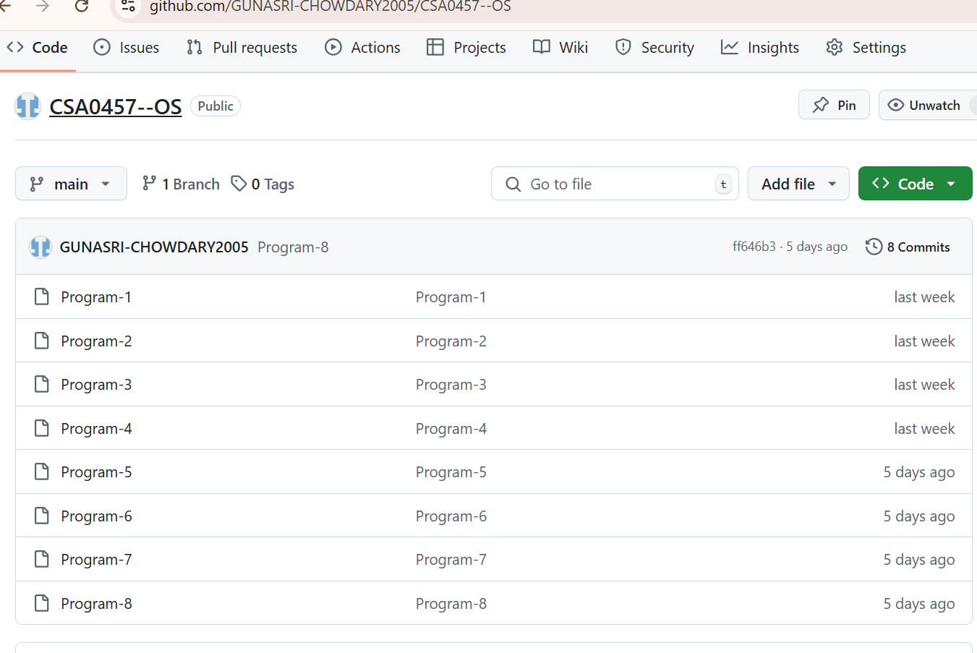

**3. Copy the Clone URL**

* + After clicking the "Code" button, you'll see the clone options. You can clone using HTTPS, SSH, or GitHub CLI.
  + For now, copy the **HTTPS URL** (it will look like https://github.com/username/repository.git). Click the copy button next to the URL:

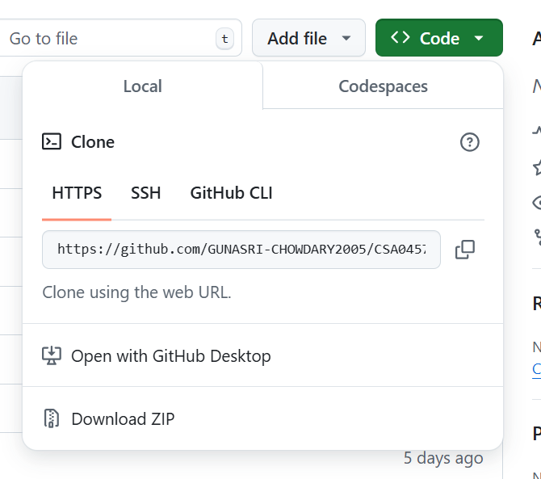

**4. Open Your Terminal/Command Prompt**

* Open your **Terminal** on macOS or Linux, or **Command Prompt** on Windows.
* You can also use **Git Bash** (a terminal that comes with Git).

**5. Navigate to the Folder Where You Want to Clone the Repo**

* Use the cd command to navigate to the directory where you want to clone the repo.
* For example, to go to the "Documents" directory, use:
* cd Documents

**6. Run the Clone Command :**

* In your terminal, type the following command:
* git clone https://github.com/username/repository.git
* Replace https://github.com/username/repository.git with the URL you copied earlier.

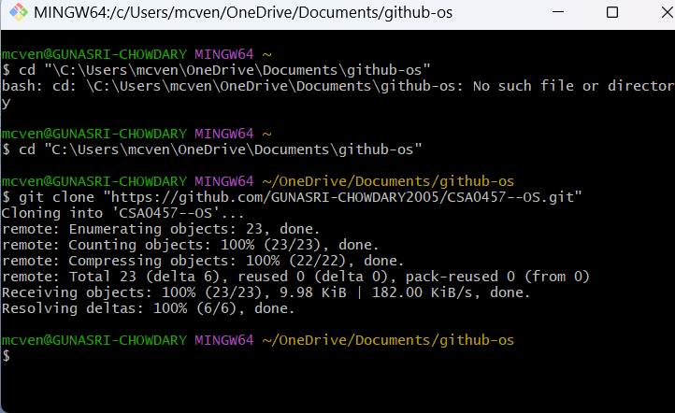

**7. Press Enter**

* Press **Enter** after typing the command. Git will now clone the repository to your local machine.
* You will see output like this:
* Cloning into 'repository'...
* remote: Enumerating objects: 10, done.
* remote: Counting objects: 100% (10/10), done.
* remote: Compressing objects: 100% (8/8), done.
* Receiving objects: 100% (10/10), done.

**8. Navigate into the Cloned Repository**

* After cloning, you need to navigate into the repository directory:
  1. cd repository Replace repository with the actual name of the repository.

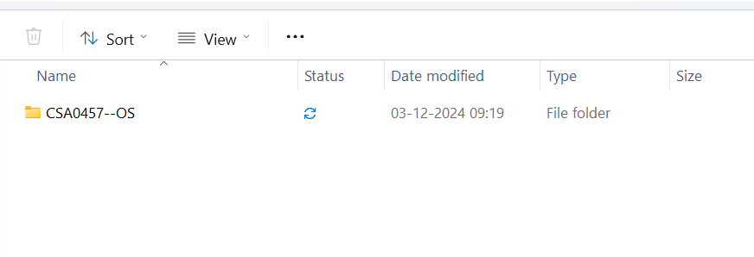

**9. Check the Repository Files**

* List the files in the repository with:
* ls
* You should see the files from the repository on your local machine.

That's it! You've successfully cloned a repository from GitHub to your local machine. You can now work with the files, make changes, and push them back to GitHub when you're ready.