**EXP 2:**

## Create a simple cloud software application for Flight Reservation System using any Cloud Service Provider to demonstrate SaaS

**AIM:** To create a simple cloud software application for Flight

Reservation System using any Cloud Service Provider to demonstrate SaaS

**PROCEDURE:**

### STEP1: GOTO ZOHO.COM .

**STEP 2: LOGIN TO THE ZOHO.COM**

### STEP 3: SELECT ONE APPLICATION

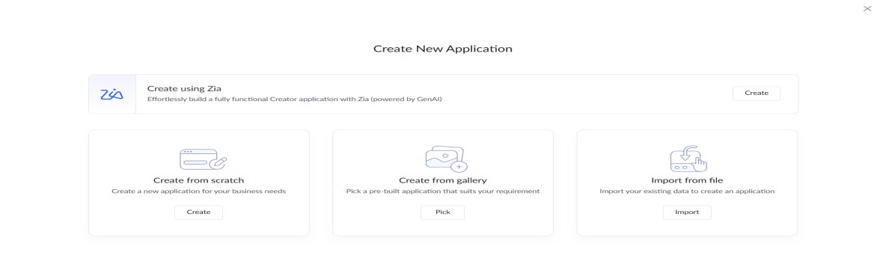

### STEP 4: ENTER APPLICATION NAME(“Flight Reservation System)

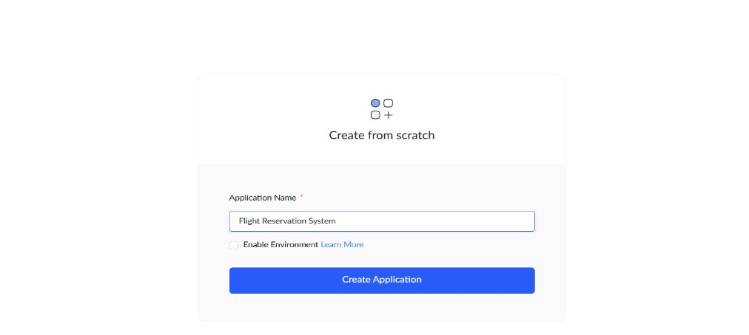

### STEP 5: CREATED NEW APPLICATION

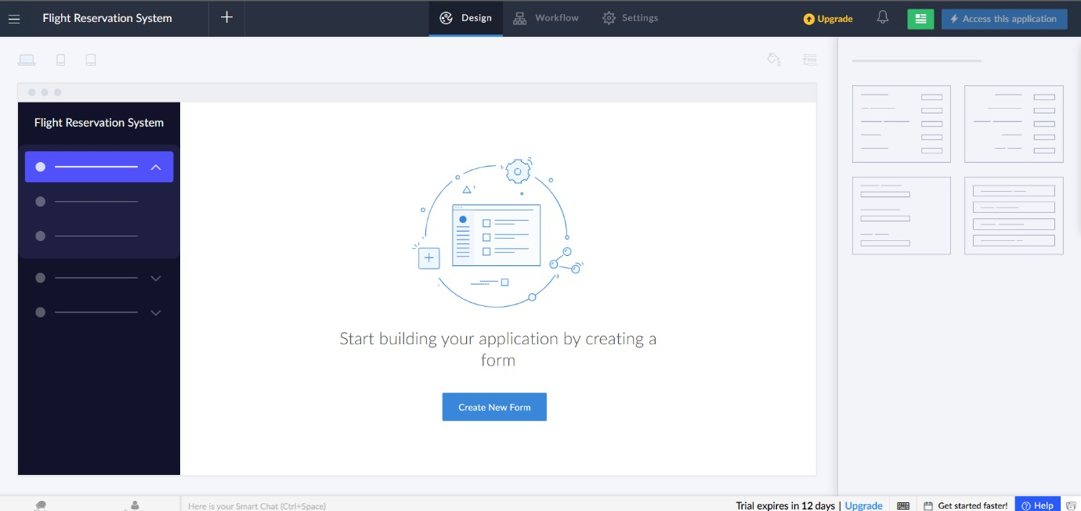

### STEP 6: SELECT ONE FORM

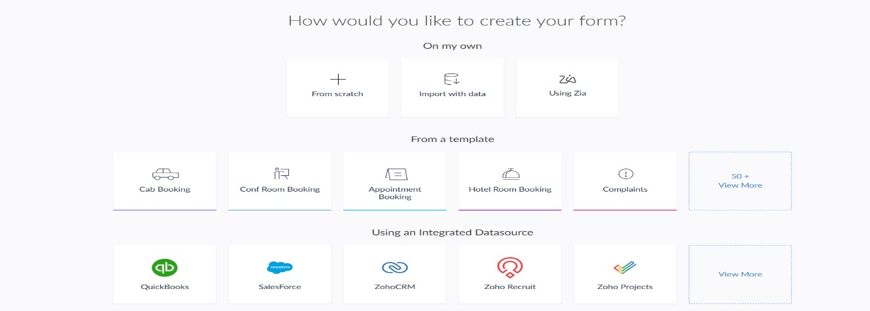

### STEP 7 : CREATE FROM SCRATCH (Flights form)

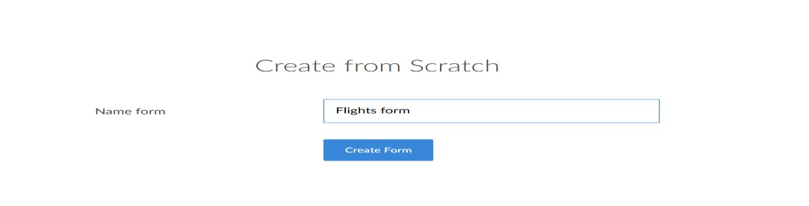

### STEP 8: CREATE FLIGHTS FORM

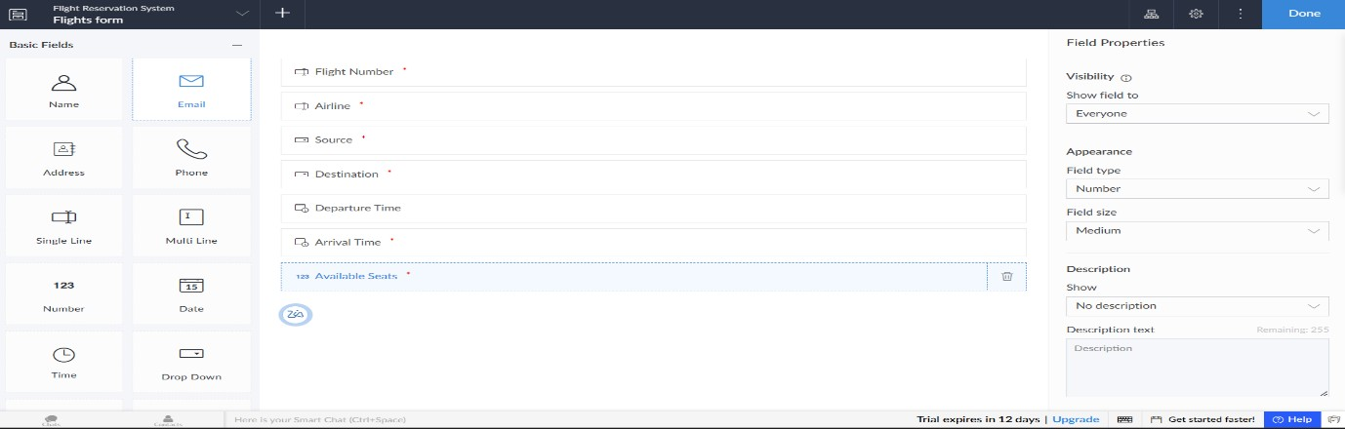

### STEP 9: CREATE PASSENGERS FORM

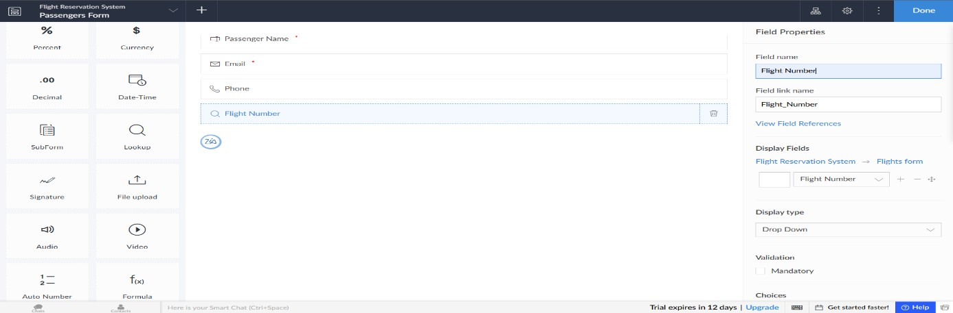

### STEP 10 : CRAETE BOOKING FORM

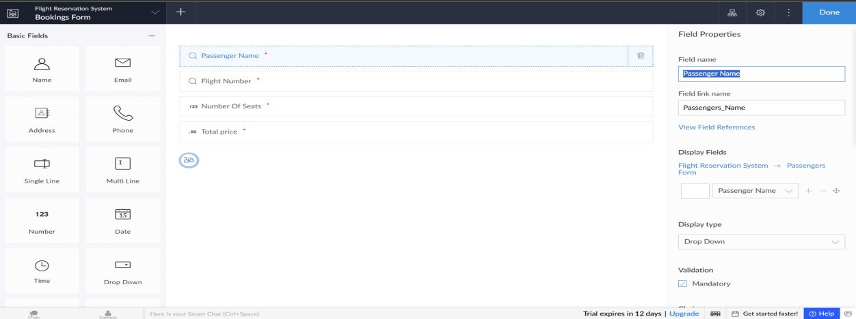

**STEP 11: FILL THE FLIGHTS FORM, PASSENGERS FORM, BOOKING FORM**

**STEP 12:**

### FLIGHT REPORT

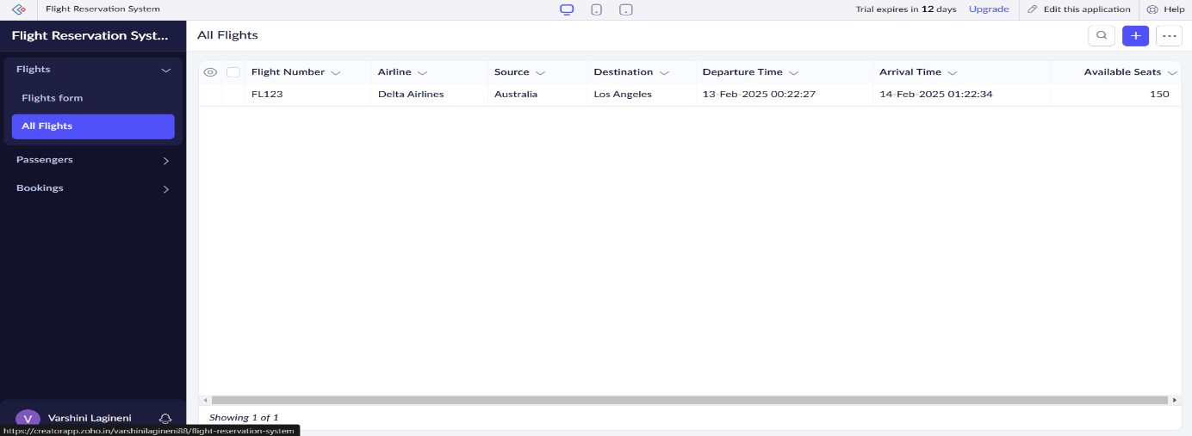

### PASSENGERS REPORT

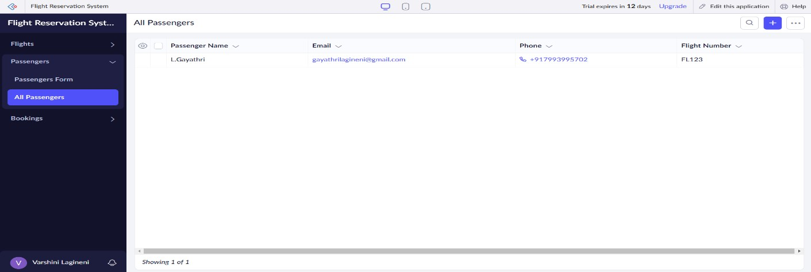

### BOOKING REPORT

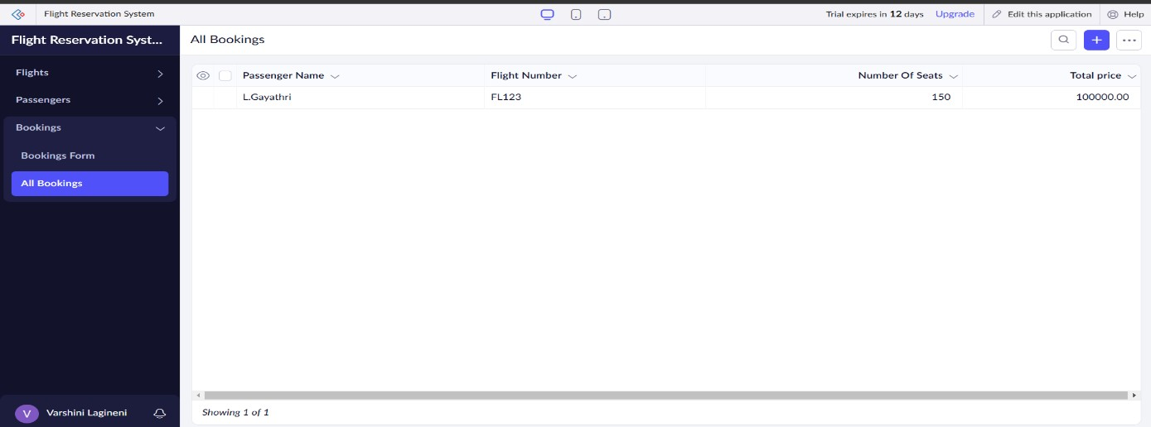

**RESULT:**

A simple cloud software application for Flight Reservation System using any Cloud Service Provider to demonstrate SaaS has successfully created.