**COURSE CODE:** CSA1523

**CPOURSE NAME:** CLOUD COMPUTING AND BIG

DATA ANALYTICS

**NAME:** PUNUGUPATI GUNASRI

**REG NO:** 192324103

**EXP NO 3:**

# CREATE A SIMPLE CLOUD SOFTWARE APPLICATION

**FOR PROPERTY BUYING & RENTAL PROCESS (IN CHENNAI CITY) USING ANY CLOUD SERVICE PROVIDER TO DEMONSTRATE SAAS.**

**AIM:** To Create a simple cloud software application for Property Buying & Rental process (In Chennai city) using any Cloud Service Provider to demonstrate SaaS.

**PROCEDURE**:

**STEP 1: Go to zoho.com.**

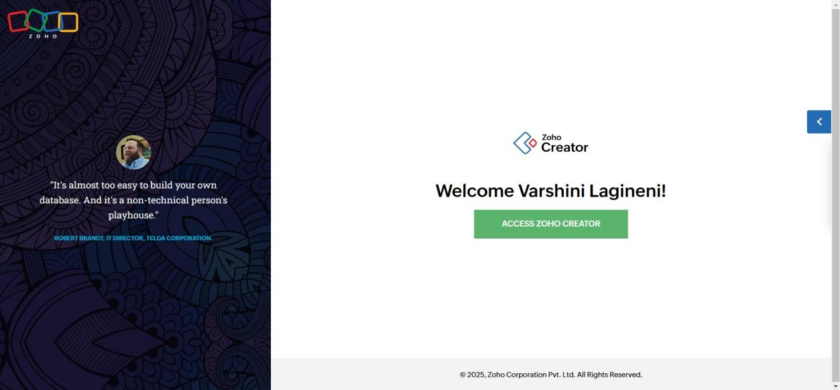

**STEP 2: LOGIN TO THE ZOHO.COM**

# STEP 3: SELECT ONE APPLICATION

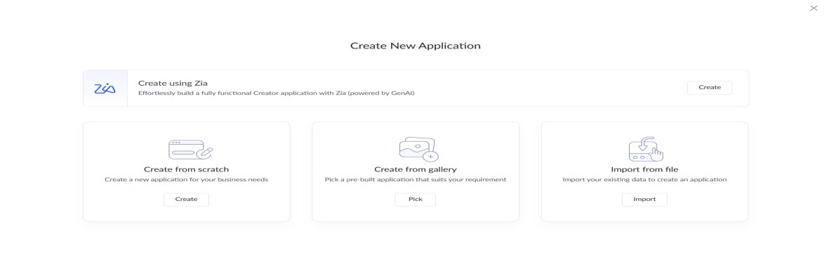

# STEP 4: ENTER APPLICATION NAME (“Chennai Property Hub”)

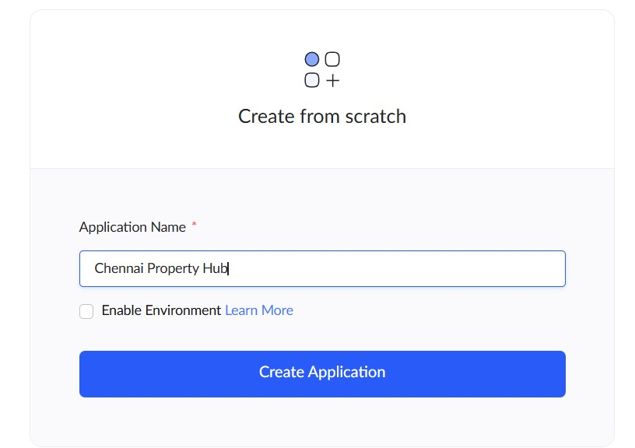

# STEP 5: CREATED NEW APPLICATION

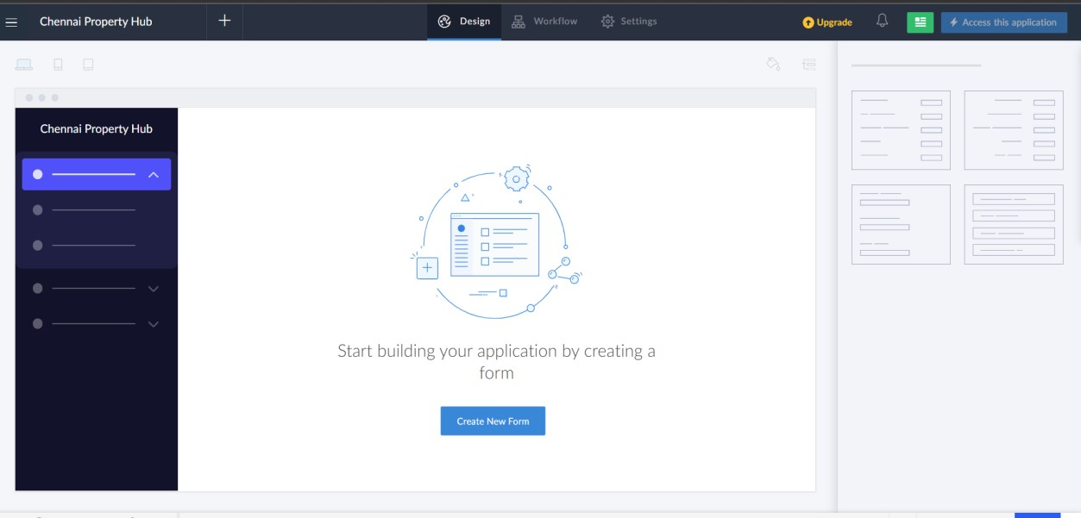

# STEP 6: CREATE FROM SCRATCH (Property Listings Form)

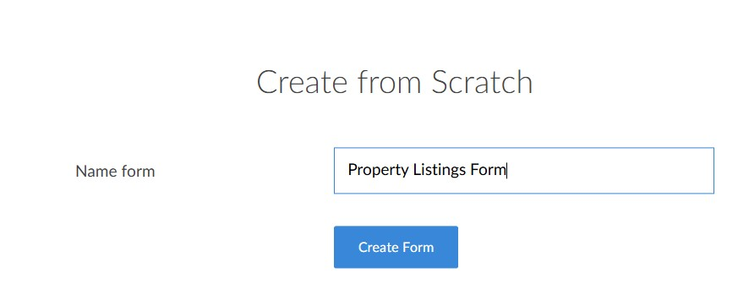

# STEP 7: CREATE PROPERTY LISTINGS FORM

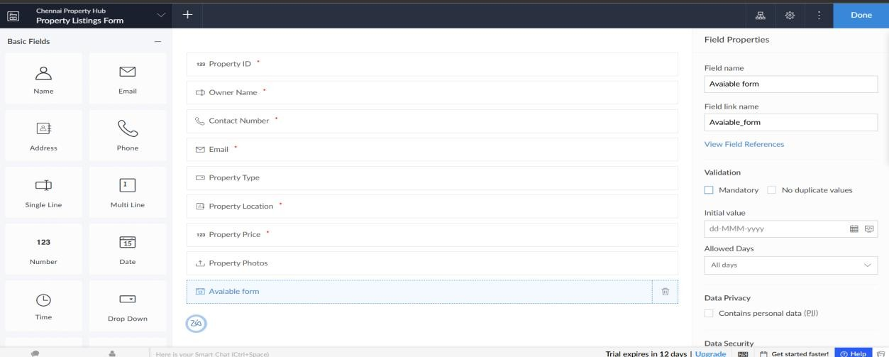

# STEP 8: CREATE BUYER/RENTER REQUESTS FORM

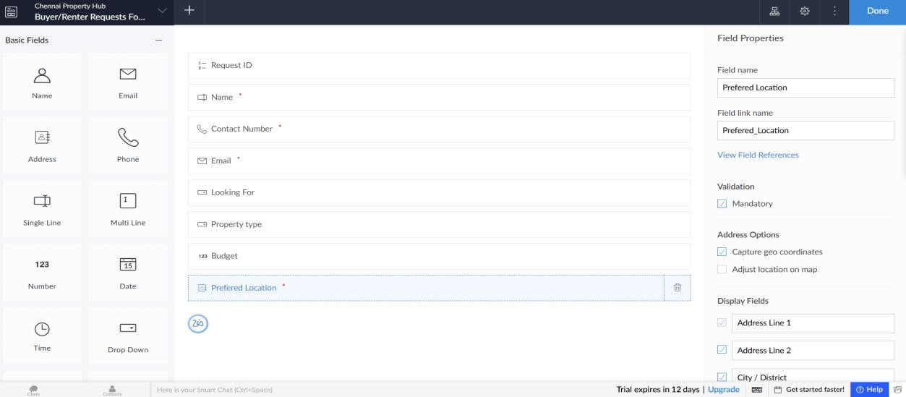

# STEP 9: CREATE BOOKINGS FORM

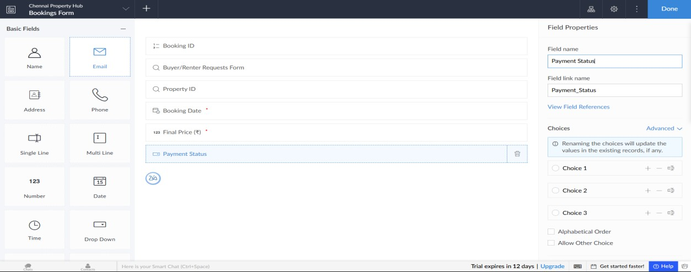

# STEP 10: ALL PROPERTY LISTINGS

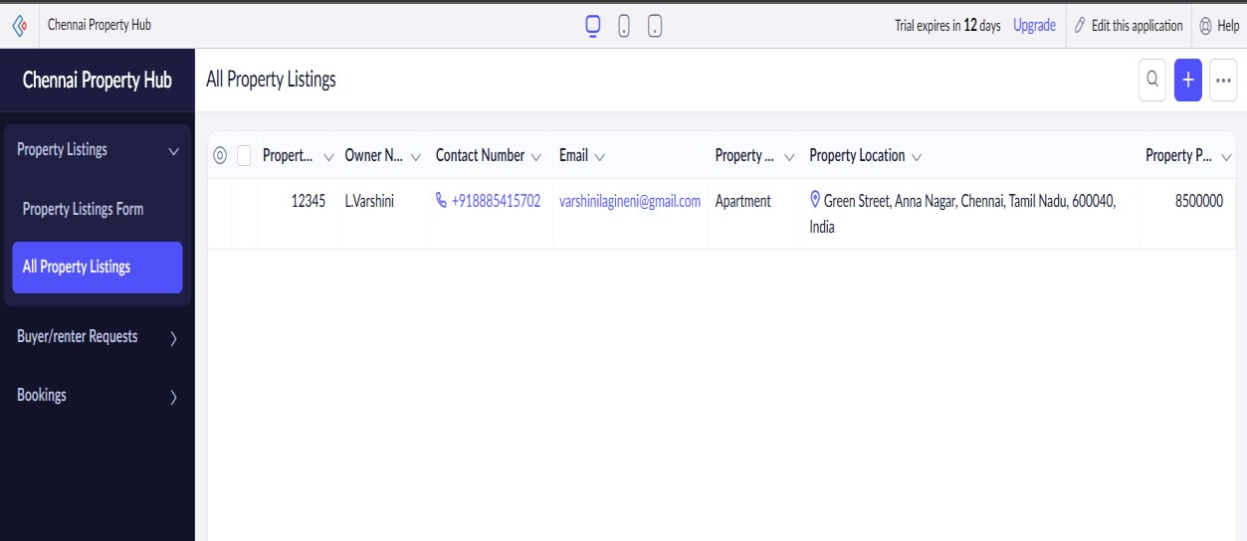

# ALL BUYER/RENTER REQUESTS

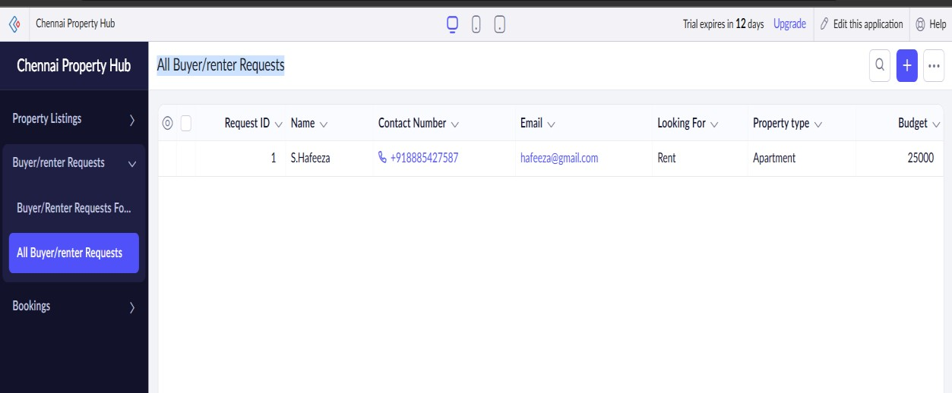

# ALL BOOKINGS

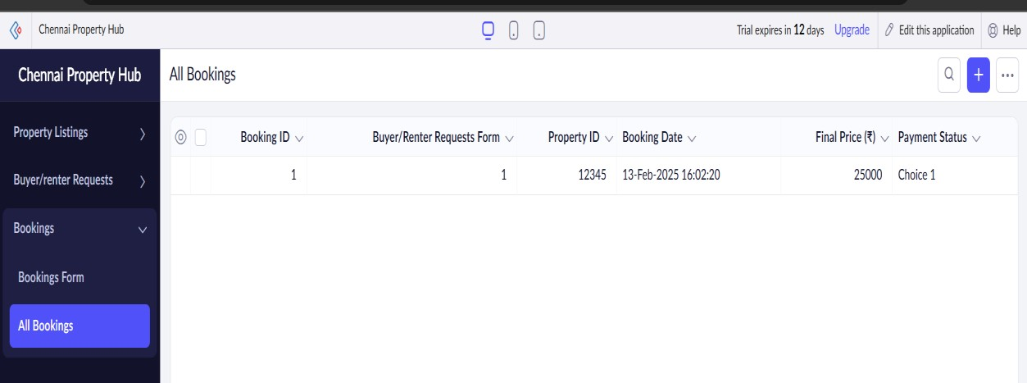

**RESULT:**

A simple cloud software application for Property Buying & Rental process (In Chennai city) using any Cloud Service Provider to demonstrate SaaS (Chennai Property Hub) has successfully created