**CSA1523- CLOUD COMPUTING AND BIG DATA ANALYTICS FOR HEALTHCARE INDUSTRIES**

**P.Gunasri**

**192324103**

**EXP 5. Create a simple cloud software application for the Library book reservation system for the SIMATS library using any Cloud Service Provider to demonstrate SaaS.**

**AIM:**

To create a simple cloud software application for a Library book reservation system for SIMATS library using any Cloud Service Provider to demonstrate SaaS.

**PROCEDURE:**

STEP 1: Log in to ZOHO Creators and click Create a new application.

STEP 2: Choose from scratch and name the application (Ex-Library book reservation system)

STEP 3: Create a new form as per the requirements. (Ex- User Registration form, Book Listing Form, Book Reservation Form, etc)

STEP 4: Drag and place the required fields and click DONE.

STEP 5: Now open each module and give the required details to store it in the report.

STEP 6: Verify the entries of the User Registration form, Book Listing Form, Book Registration Form, etc from Module Reports.

STEP 7: The software has been created successfully.

**IMPLEMENTATION:**

STEP1: Login to ZOHO Creators and click Create a new application.

STEP 2: Choose from scratch and name the application (Ex-Library book reservation system)

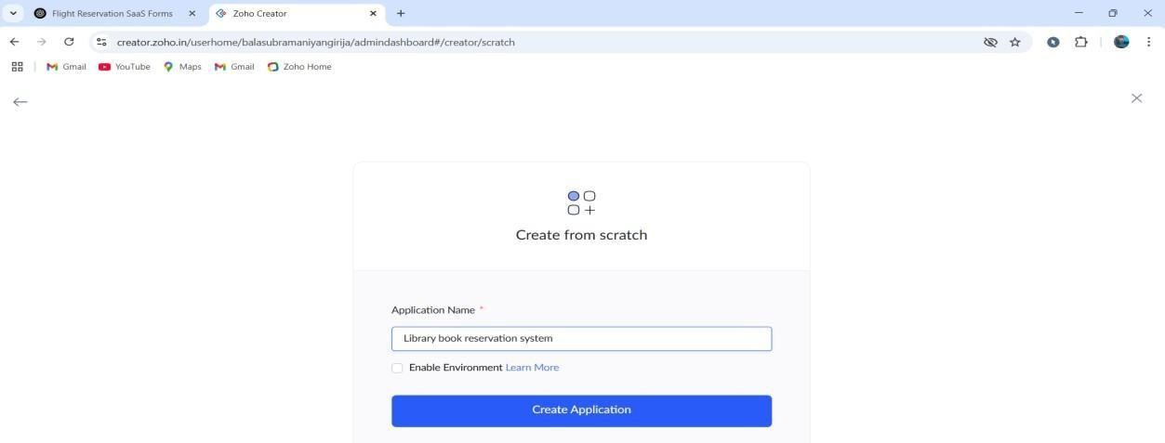

STEP 3: Create a new form as per the requirements. (Ex- User Registration form, Book Listing Form, Book Reservation Form, etc)

User Registration form:

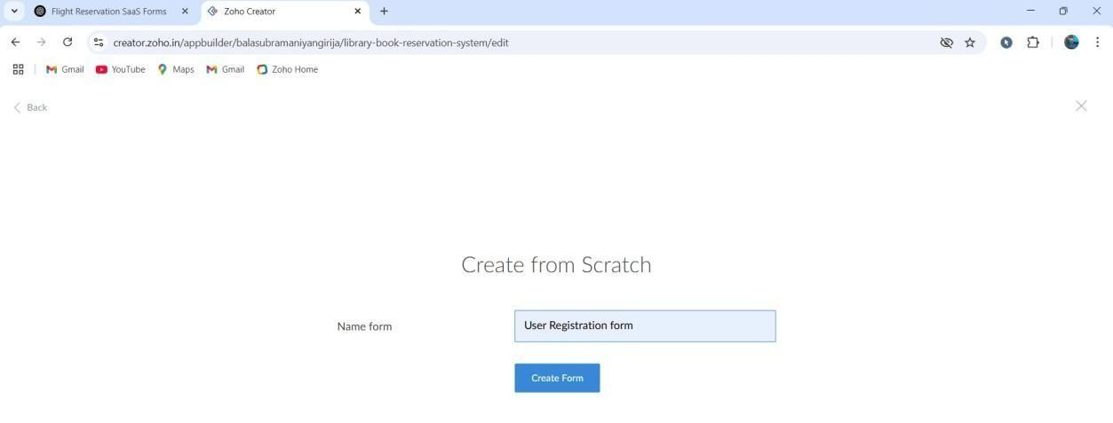

STEP 4: Drag and place the required fields and click DONE.

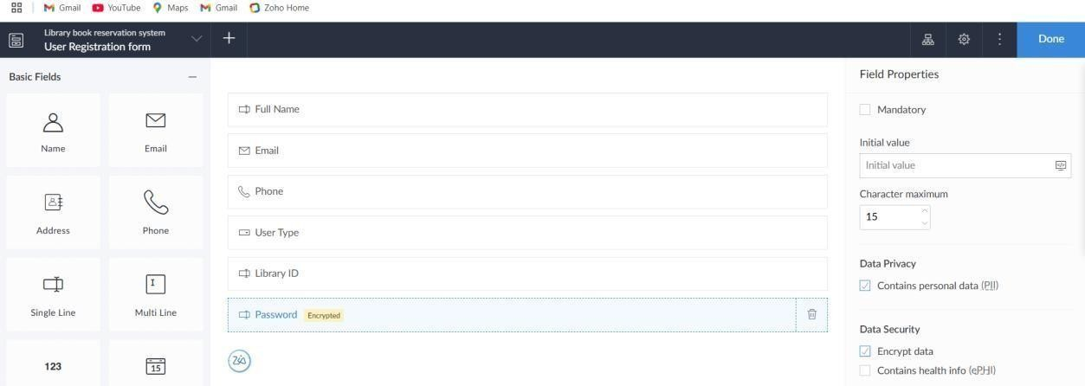

Book Listing Form:

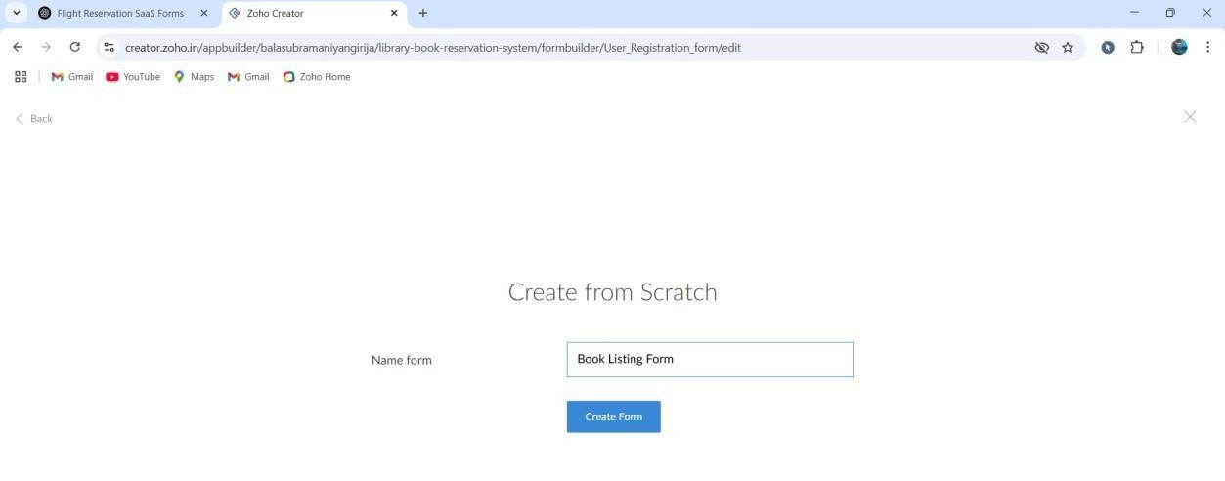

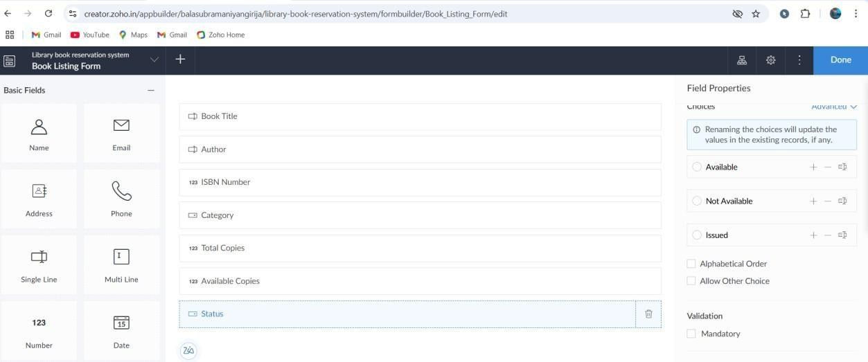

Book Reservation Form:

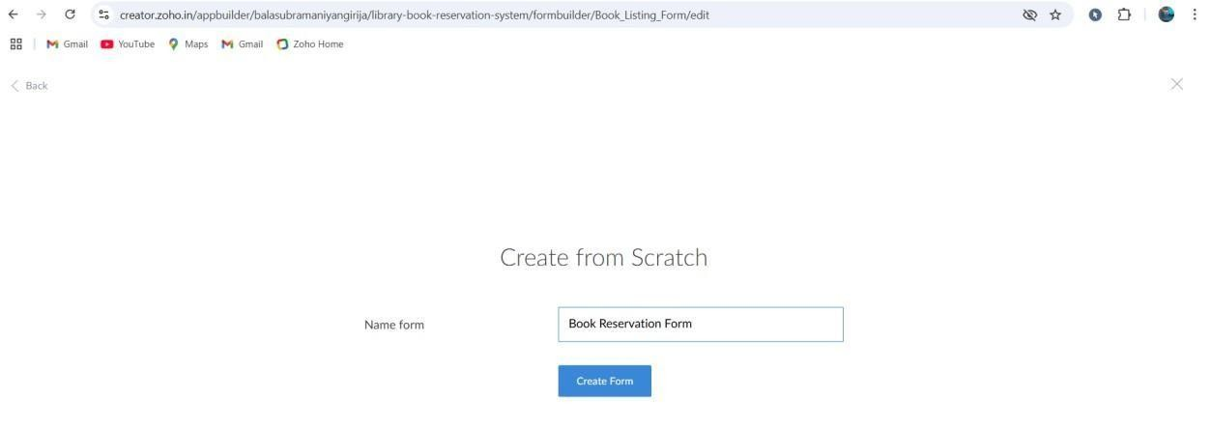

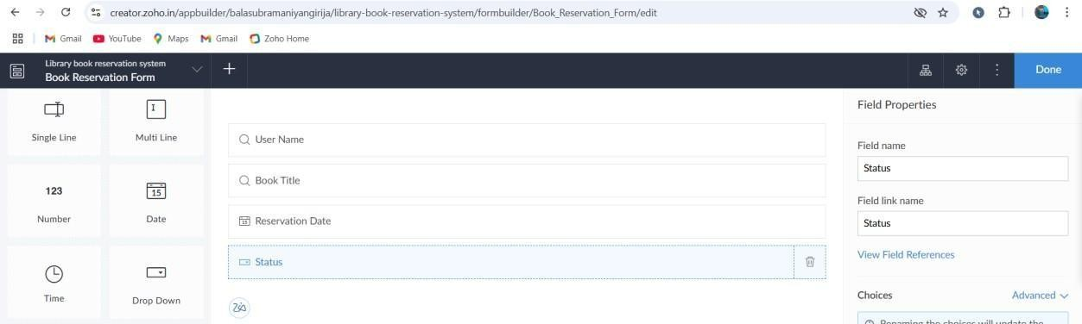

STEP 5: Now open each module and give required details to store it in the report.

User Registration form:

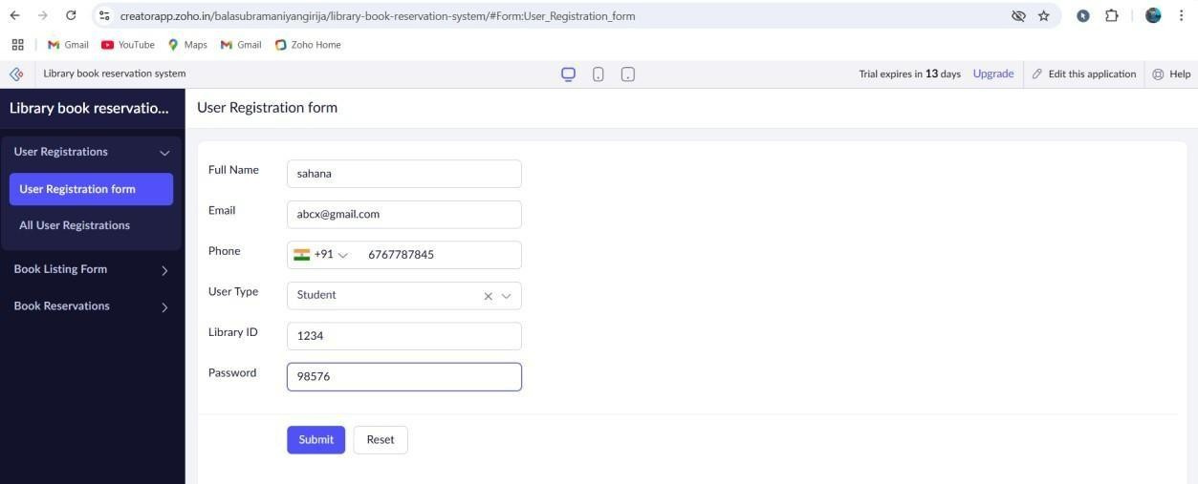

Book Listing Form:

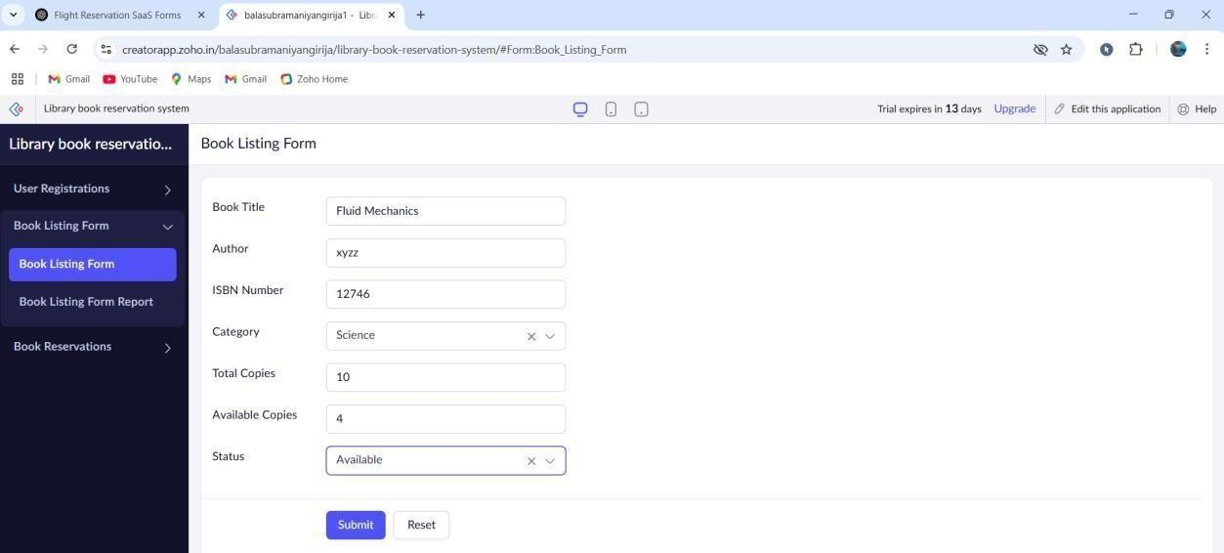

Book Reservation Form:

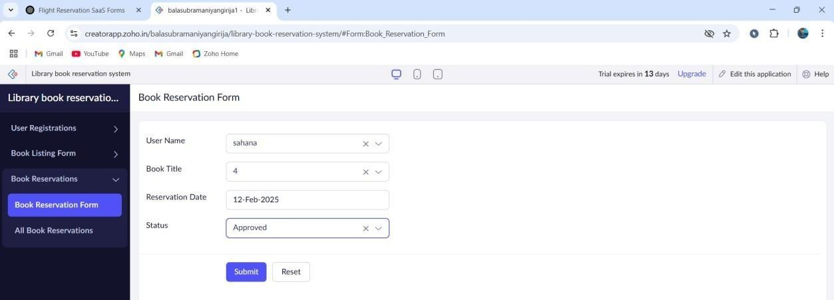

STEP 6: Verify the entries of the User Registration form, Book Listing Form, Book Registration Form, etc from Module Reports.

User Registration form:

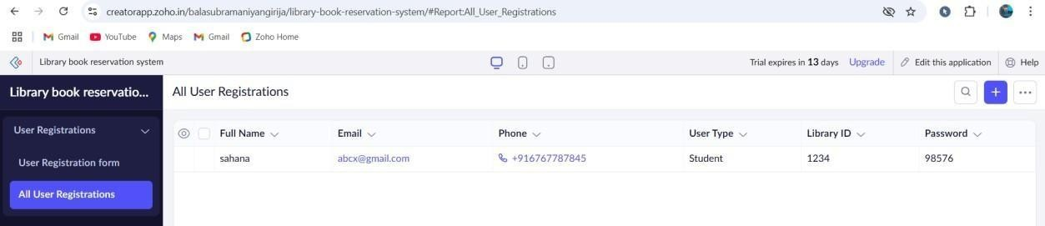

Book Listing Form:

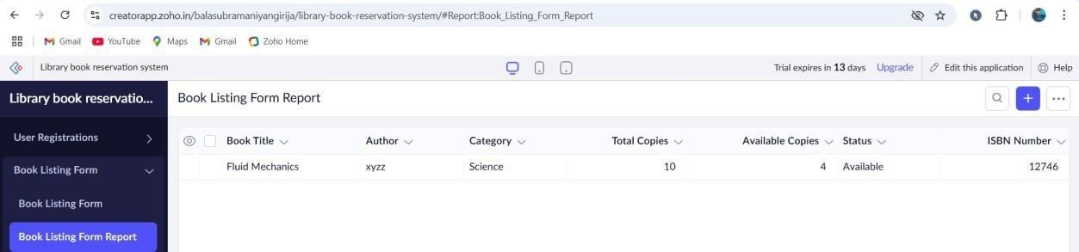

Book Reservation Form:

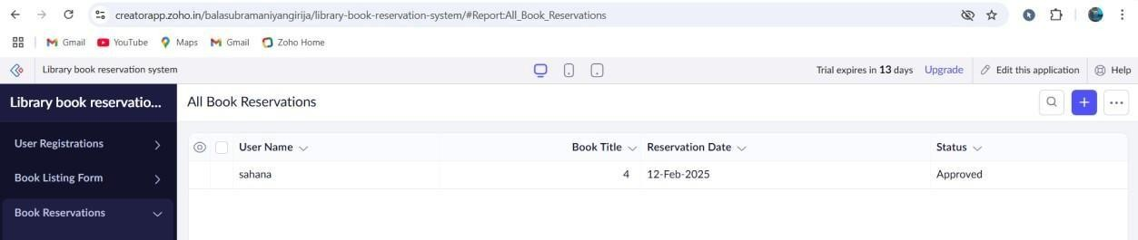

**RESULT:**

The software has been created successfully.