**ASSIGNMENT-7 DATE-22/7/24**

1. Write a program to count all the prime and composite numbers entered by the user.

Sample Input:

Enter the numbers

4

54

29

71

7

59

98

23

Sample Output:

Composite number:3

Prime number:5

CODE:

import java.util.Scanner;

public class PrimeCompositeCounter {

public static void main(String[] args) {

Scanner input = new Scanner(System.in);

int primeCount = 0;

int compositeCount = 0;

System.out.println("Enter the numbers:");

while (input.hasNextInt()) {

int num = input.nextInt();

if (isPrime(num)) {

primeCount++;

} else {

compositeCount++;

}

}

System.out.println("Composite number: " + compositeCount);

System.out.println("Prime number: " + primeCount);

}

public static boolean isPrime(int num) {

if (num <= 1) {

return false;

}

for (int i = 2; i <= Math.sqrt(num); i++) {

if (num % i == 0) {

return false;

}

}

return true;

}

}

OUPUT:

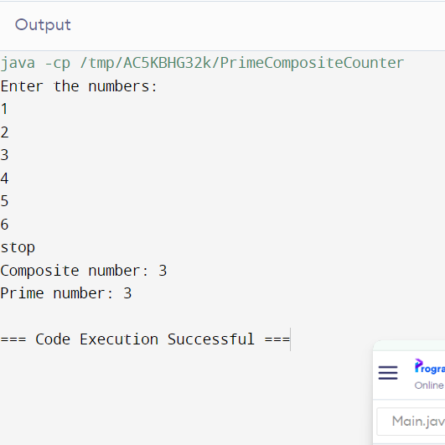

2. Find the Mth maximum number and Nth minimum number in an array and then find the sum of it and difference of it.

Sample Input:

Array of elements = {14, 16, 87, 36, 25, 89, 34}

M = 1

N = 3

Sample Output:

1stMaximum Number = 89

3rdMinimum Number = 25

Sum = 114

Difference = 64

CODE:

import java.util.Arrays;

public class Main {

public static void main(String[] args) {

int[] arr = {14, 16, 87, 36, 25, 89, 34};

int M = 1;

int N = 3;

Arrays.sort(arr);

int mthMax = arr[arr.length - M];

int nthMin = arr[N - 1];

int sum = mthMax + nthMin;

int diff = Math.abs(mthMax - nthMin);

System.out.println(M + "st Maximum Number = " + mthMax);

System.out.println(N + "rd Minimum Number = " + nthMin);

System.out.println("Sum = " + sum);

System.out.println("Difference = " + diff);

}

}

OUTPUT:

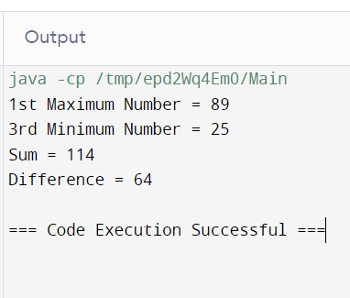

3.Write a program to print the total amount available in the ATM machine with the conditions applied.

Total denominations are 2000, 500, 200, 100, get the denomination priority from the user and the total number of notes from the user to display the total available balance to the user

Sample Input:

Enter the 1st Denomination: 500

Enter the 1st Denomination number of notes: 4

Enter the 2nd Denomination: 100

Enter the 2nd Denomination number of notes: 20

Enter the 3rd Denomination: 200

Enter the 3rd Denomination number of notes: 32

Enter the 4th Denomination: 2000

Enter the 4th Denomination number of notes: 1

Sample Output:

Total Available Balance in ATM: 12400

CODE:

import java.util.Scanner;

public class ATM {

public static void main(String[] args) {

Scanner input = new Scanner(System.in);

System.out.print("Enter the 1st Denomi: ");

int denomination1 = input.nextInt();

System.out.print("Enter the 1st Denomi number of notes: ");

int notes1 = input.nextInt();

System.out.print("Enter the 2nd Denomi: ");

int denomination2 = input.nextInt();

System.out.print("Enter the 2nd Denomi number of notes: ");

int notes2 = input.nextInt();

int totalBalance = (denomination1 * notes1) + (denomination2 * notes2);

System.out.println("Total Available Balance in ATM: " + totalBalance);

}

}

OUTPUT:

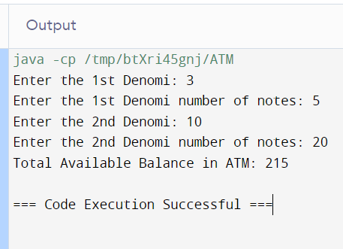

4.Write a program using choice to check

Case 1: Given string is palindrome or not

Case 2: Given number is palindrome or not

Sample Input:

Case = 1

String = MADAM

Sample Output:

Palindrome

CODE:

import java.util.Scanner;

public class PalindromeChecker {

public static void main(String[] args) {

Scanner input = new Scanner(System.in);

System.out.println("Enter 1 to check if a string is a palindrome or 2 to check if a number is a palindrome:");

int choice = input.nextInt();

switch (choice) {

case 1:

System.out.println("Enter a string:");

String str = input.next();

if (isPalindrome(str))

System.out.println("Palindrome");

else

System.out.println("Not a Palindrome");

break;

case 2:

System.out.println("Enter a number:");

int num = input.nextInt();

if (isPalindrome(Integer.toString(num)))

System.out.println("Palindrome");

else

System.out.println("Not a Palindrome");

break;

default:

System.out.println("Invalid choice");

}

input.close();

}

public static boolean isPalindrome(String str) {

int left = 0;

int right = str.length() - 1;

while (left < right) {

if (str.charAt(left) != str.charAt(right))

return false;

left++;

right--;

}

return true;

}

}

OUTPUT:

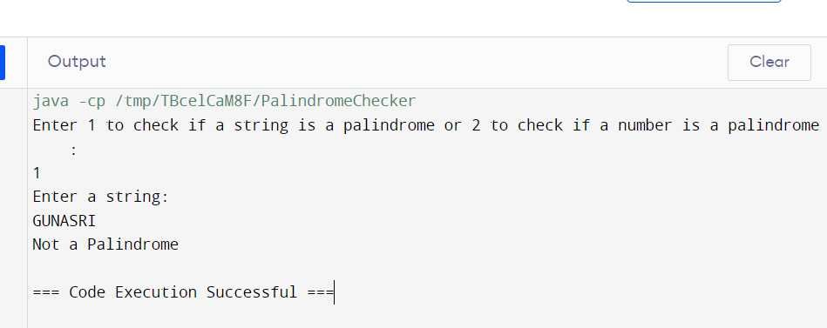

5.Write a program to convert Decimal number equivalent to Binary number and octal numbers?

Sample Input:

Decimal Number: 15

Sample Output:

Binary Number = 1111

Octal = 17

CODE:

import java.util.Scanner;

public class DecimalToBinaryOctal {

public static void main(String[] args) {

Scanner scanner = new Scanner(System.in);

System.out.print("Enter a decimal number: ");

int decimal = scanner.nextInt();

String binary = Integer.toBinaryString(decimal);

String octal = Integer.toOctalString(decimal);

System.out.println("Binary Number = " + binary);

System.out.println("Octal Number = " + octal);

}

}

OUTPUT:

