**ASSIGNMENT-8 DATE-23/7/24**

1.Write a program to calculate the factorial of number using recursive function.

Sample Input & Output:

Enter the value of n: 6

Sample Input & Output:

The factorial of 6 is: 720

CODE:

import java.util.Scanner;

public class FactorialCalculator {

public static void main(String[] args) {

Scanner scanner = new Scanner(System.in);

System.out.print("Enter the value of n: ");

int n = scanner.nextInt();

int factorial = calculateFactorial(n);

System.out.println("The factorial of " + n + " is: " + factorial);

}

public static int calculateFactorial(int n) {

if (n == 0) {

return 1;

} else {

return n * calculateFactorial(n - 1);

}

}

}

OUTPUT:

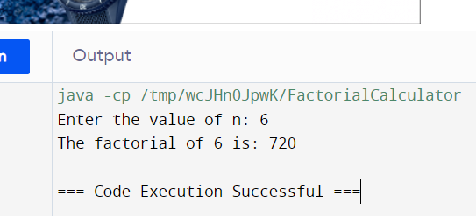

2.Write a Program to Find the Nth Largest Number in a array.

Sample Input:

List : {14, 67, 48, 23, 5, 62}

N = 4

Sample Output:

4th Largest number: 23

CODE:

import java.util.Arrays;

public class NthLargestNumber {

public static void main(String[] args) {

int[] arr = {14, 67, 48, 23, 5, 62};

int n = 4;

Arrays.sort(arr);

System.out.println(n + "th Largest number: " + arr[arr.length - n]);

}

}

OUTPUT:

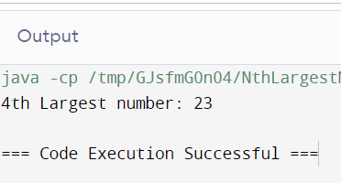

3. Write a program to convert the Binary to Decimal, Octal

Sample Input:

Given Number: 1101

Sample Output:

Decimal Number: 13

CODE:

import java.util.Scanner;

public class BinaryToDecimalOctal {

public static void main(String[] args) {

Scanner scanner = new Scanner(System.in);

System.out.print("Enter a binary number: ");

String binaryString = scanner.nextLine();

int decimal = Integer.parseInt(binaryString, 2);

System.out.println("Decimal Number: " + decimal);

int decimalForOctal = Integer.parseInt(binaryString, 2);

String octalString = Integer.toOctalString(decimalForOctal);

System.out.println("Octal Number: " + octalString)

scanner.close();

}

}

OUTPUT:

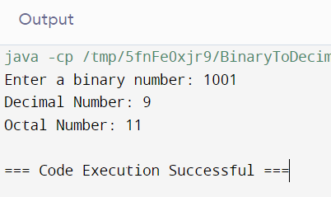

4. Write a program to find the number of special characters in the given statement

Sample Input:

Given statement: Modi Birthday @ September 17, #&$% is the wishes code for him.

Sample Output:

Number of special Characters: 5

CODE:

public class SpecialCharactersCounter {

public static void main(String[] args) {

String statement = "Modi Birthday @ September 17, #&$% is the wishes code for him.";

int specialCharCount = 0;

for (int i = 0; i < statement.length(); i++) {

if (!Character.isLetterOrDigit(statement.charAt(i)) && !Character.isWhitespace(statement.charAt(i))) {

specialCharCount++;

}

}

System.out.println("Number of Special Characters: " + specialCharCount);

}

}

OUTPUT:  
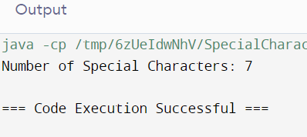

1. 5. Write a Program to Remove the Duplicate Items from a array.

Sample Input:

Enter the number of elements in array:7

Enter element1:10

Enter element2:20

Enter element3:20

Enter element4:30

Enter element5:40

Enter element6:40

Enter element7:50

Sample Output:

Non-duplicate items:

[10, 20, 30, 40, 50]

CODE:

import java.util.*;

public class RemoveDuplicatesFromArray {

public static void main(String[] args) {

Scanner scanner = new Scanner(System.in);

System.out.print("Enter the number of elements in the array: ");

int n = scanner.nextInt();

int[] arr = new int[n];

Set<Integer> uniqueElements = new HashSet<>();

for (int i = 0; i < n; i++) {

System.out.print("Enter element" + (i + 1) + ": ");

int num = scanner.nextInt();

arr[i] = num;

uniqueElements.add(num);

}

System.out.println("Non-duplicate items:");

System.out.println(uniqueElements);

}

}

OUTPUT:

