## Loanalytic- Web

## Purpose

The purpose of this document is to describe the objective of an online application- Loanalytic-Web for bank loans.

## Scope

The purpose of Loanalytic-Web is to make the life of the borrower easy by simply registering to an online portal and get a loan approved. The application deals with 3 kinds of loans as of now: Mortgage, Personal and Education loan. The user can quickly choose the kind of loan he wants and the amount he wants to borrow. Loan request would be validated by the application automatically as soon as the user answers few questions based on the kind of loan. The feasibility of loan approval would be displayed immediately. If the criteria is not met the user would be notified immediately else a background check is performed by the admin and a manual notification is sent to the user by the admin. The application gives an opportunity to the admin to verify the user by validating the documents he has uploaded and doing some criminal/background check. Above all, we hope to provide a comfortable user experience along with the best pricing available. The company might keep the collateral before approving a loan in the real world. We would simple ask the users to provide the scanned copies of collateral here in our application.

There are a number of operation performed by the financial institutions in the real world. However we do not include all those features in Loanalytic. To make it easy, we consider the total liquid assets of a hypothetical company (Loanalytic) is 100 billion in the beginning. With the available assets, Loanalytic runs its business by providing loans to the people who wish to acquire them. Based on the credit rate, user income, previous bankruptcy and Collateral provided, the risk is validated and the loan is approved. As soon as a loan is sanctioned, the amount is deducted from the companies’ assets and is shown under user’s portfolio. Every time the user pays back the interest and principle, the company’s assets keep increasing. Automatic emails are sent to the users who missed to pay loan dues. Additional fines are also charged due on late payments.

## Project Objective:

This section of the document lists each component of the application along with a screenshot.

* User login
* Admin login
* Registration page
* Forgot password
* User home page
* Admin home page
* Loan calculator
* Contact us
* Chat
* View applications
* Manage user Installments Payments
* Edit Profile

**Landing Page:**

Any user trying to access the application can view the home page and select the kind of loan he would like to apply. By clicking on the available options, as shown in the below home page. Chart assistance is provided in every component of the application. In case the user is stuck in any part of the application he/she can quickly click on the chart icon to communicate with the admin.

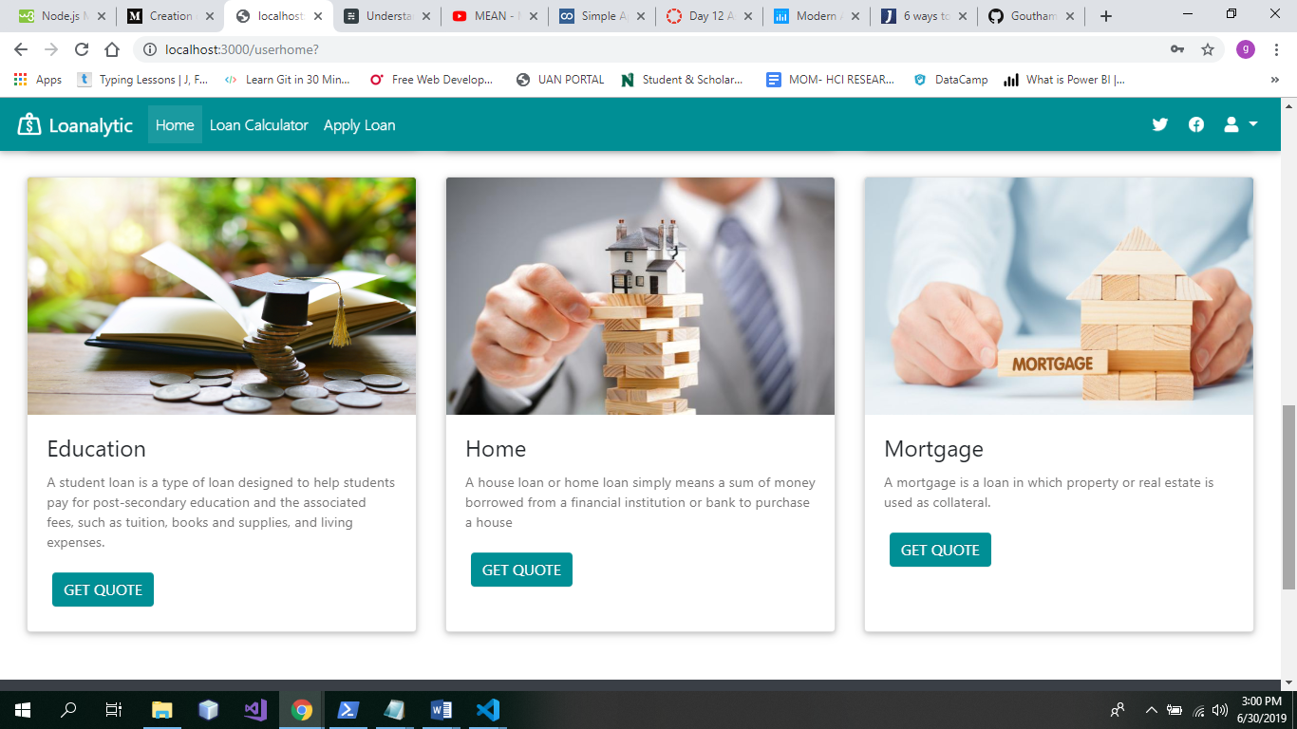

**User Module:**

If the customer is already registered with the application. He/she can login into the system to view the status of the application or view the payment information and make payments.

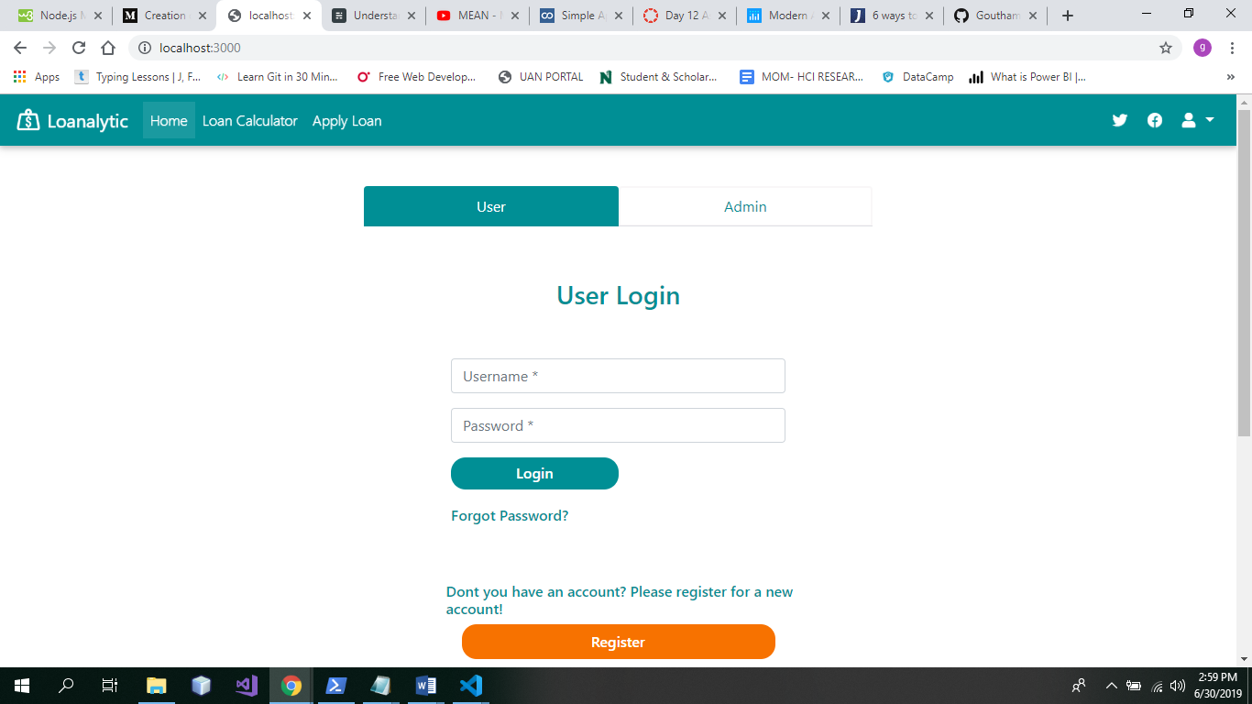

**User can perform the below operations:**

* Choose the loan type.
* Use the loan calculator to find an estimate.
* Fill in the required details.
* Chat with the admin in case of any issues.
* View all his applications and status. (To reduce complexity, only one person/customer is accountable for an application)
* View/Edit his profile.
* Pay his loans amount on or before the due date.
* Check his balance and due dates graphically and in a table format.

**Admin Module:**

The admin can use the Admin login page to login in to the application. As soon as the admin is logged into the application he/she can perform admin related functionalities.

**Admin can do the following operations:**

* View all the Applications:
* Approve and reject Applications.
* Click on approved application and monitor the payments.
* Respond to the clients/Users on Chat window.

