**Project Proposal**

**Team Name:** Tech Riders

**Application Name:** PartyFun

**Team Members:**

1. Sharadruthi Beerkuri
2. Chaitra Vemula
3. Deepak Sai Krishna Jayanthi
4. Sowmya Reddy Kumbham

**Scope:**

To brighten the boring party time here is the application to create fun in the party. A traditional game of truth or dare turning in to digital application which is simple and fun.

**Activities:**

Activity 1:Welcome page: Here we can add player names.

Activity 2: Pick a person: This is a simple game to pick a person who can add truth or dare questions.

Activity 3: Adding questions (Truth and dare): These are two pages where questions are added.

Activity 4: Select image: The players who are playing will select images given or select image from the gallery of mobile.

Activity 5: Play area: The images selected by the players represent them and the images will be blinking randomly one after the other and is operated by a button to stop.

Activity 6: Select truth or dare: A page will be displayed with the options “Truth” or “Dare”.

Activity 7: Question: As per the selection the questions are displayed with two buttons done or forfeit to continue the game.

**Persist:**

Truth or dare questions and player names are saved in the game temporarily till the game exit called cache memory and the inbuilt questions are stored in the app data.

**Share across different users** of the app:

The app memory consists of 40 truth and dare questions and will be within the app and randomly given to the users on clicking truth or dare. This memory will be carried by the application to all the app users.

**Description:**

Application opens with welcome page where we can add player names and click on next with that it redirects to next page where a special person is picked through a button game who has the privilege to add custom questions of truth and dare, if not we have an option to continue with the questions in our app data. Truth questions and dare questions are added and saved. Players other than privileged person will be selecting given images or can browse from the gallery. On clicking start button the page redirects to truth or dare game where images will be blinking randomly one after the other and is operated by a button to stop. On clicking stop button image is displayed and on clicking next the page is redirected to page where the player must opt truth or dare option, once opted as per the selection the questions are displayed with two buttons “done” or “forfeit” to continue the game.

**Prototypes:**

1. Welcome page 2. Pick a person

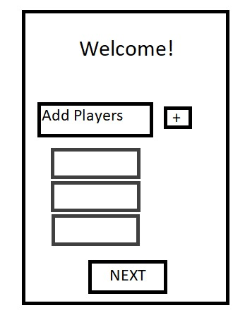 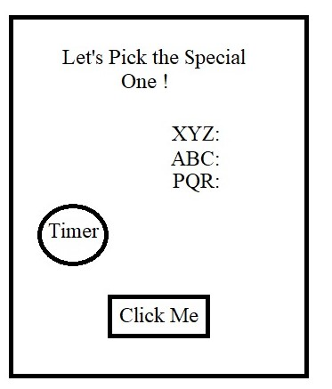

3. Adding questions:

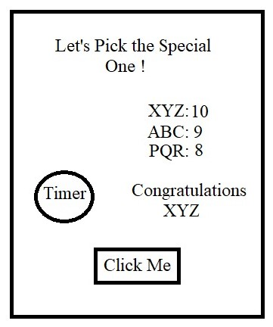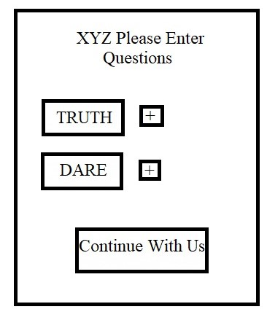

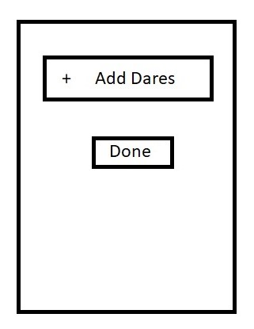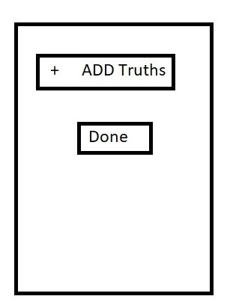

4. Select image 5.Playarea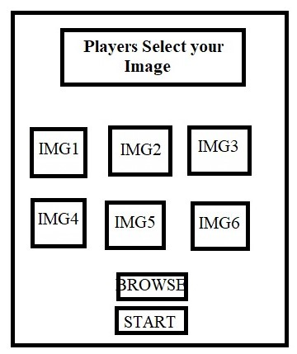 

6. Select Truth or Dare 7. Question

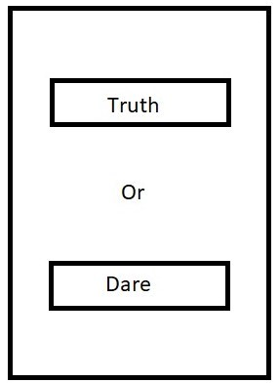

Risky components:

* Connecting the mobile gallery with the app so that the app can select the picture from the mobile storage.
* Animation in picking the image to select truth or dare in the game.
* Saving the names and special person adding questions in the cache data temporarily and removing as the closes.
* Saving the default questions in the database and connecting with the application.
* Special Effects and animations in the application.

Git repo: <https://github.com/SOWMYAREDDY97/Tech_Riders_PartyFun_App>