This Question is a guess – estimation problem , and it requires complex market analysis to solve.

QA)

* The current population of **India** is **1,406,717,605 (1.4 billion approx)**  as of Thursday, June 23, 2022, based on Worldometer elaboration of the latest United Nations data.
* In 2011-2012 , Over 22 % of the country’s population lived below poverty line **(below $1.90 mark )** as per the data provided by the RBI , It has not been updated since.
* 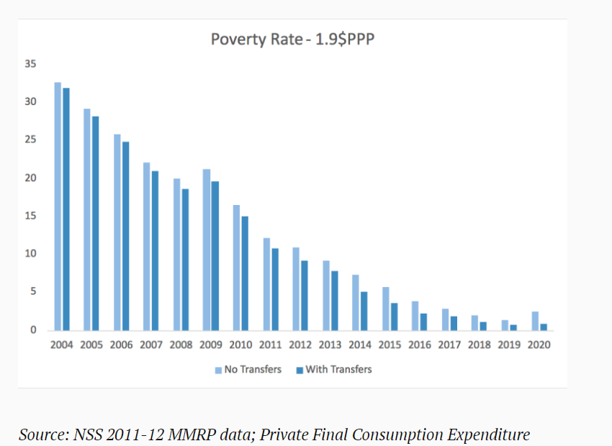

According to NSS , the Extreme poverty rate went down steeply after 2004 and as of 2020 , it stands to be at less than 5 % .

This is the Statistics provided by the “World Poverty Clock” on India’s poverty rate .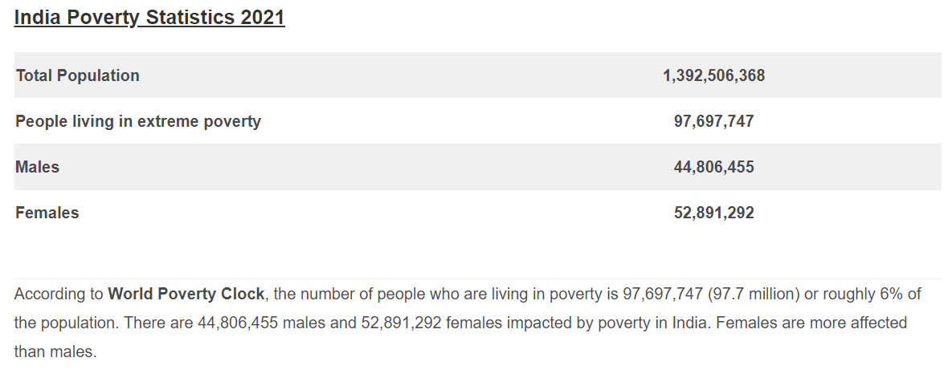

**Extreme poverty is defined as people who are living below the $1.25 benchmark.**

**SO , as of Today , 6% of Total Indian Population lives under extreme Poverty**

If we talk about distributing the covid kitbags over the hotspot areas only , then the states are Delhi , Gujarat ,UP ,Maharashtra ,Kerala and Rajasthan.

**The Total population living in the hotspot States is around 57.2 crores .**

This information is backed by PopulationU.com .

Considering that the extreme poverty is somewhat evenly distributed over all states , **then No . of KIT BAGS = 6 % of 57.2 crores = 3.43 crores** , Taking a perfect looking number **, The number of Kitbags required will be Around 5 CRORES .**

QB) Total cost can be broken down into **(Production cost + Delivery cost)**

A standard Covid Kitbag would take at most **INR 800 for production**.( INR 100 for masks , INR 200 for sanitizer (200 ml ) , INR 500 for Medicines and testing kit ) . considering that the medicines that will be provided are of standard quality .

The delivery cost is a variable quantity across different states and cities, as it depends on the fuel price , which in turn depends on the fuel type **. The govt of India has to accommodate this delivery cost after The kits have been delivered.**

So the **immediate total cost would be No. of (Kit bags x Production cost) = 5 crores x 800 =INR 4000 crores**

QC) Govt of India Started its Vaccination drive On 16th January 2021 , as of today , over 1.9 billion vaccines have been given , **over 93 % people have received their first shot and 83% have received both shots.** This data is backed by Mohfw (Ministry of Health and Family welfare ) website and Wikipedia.

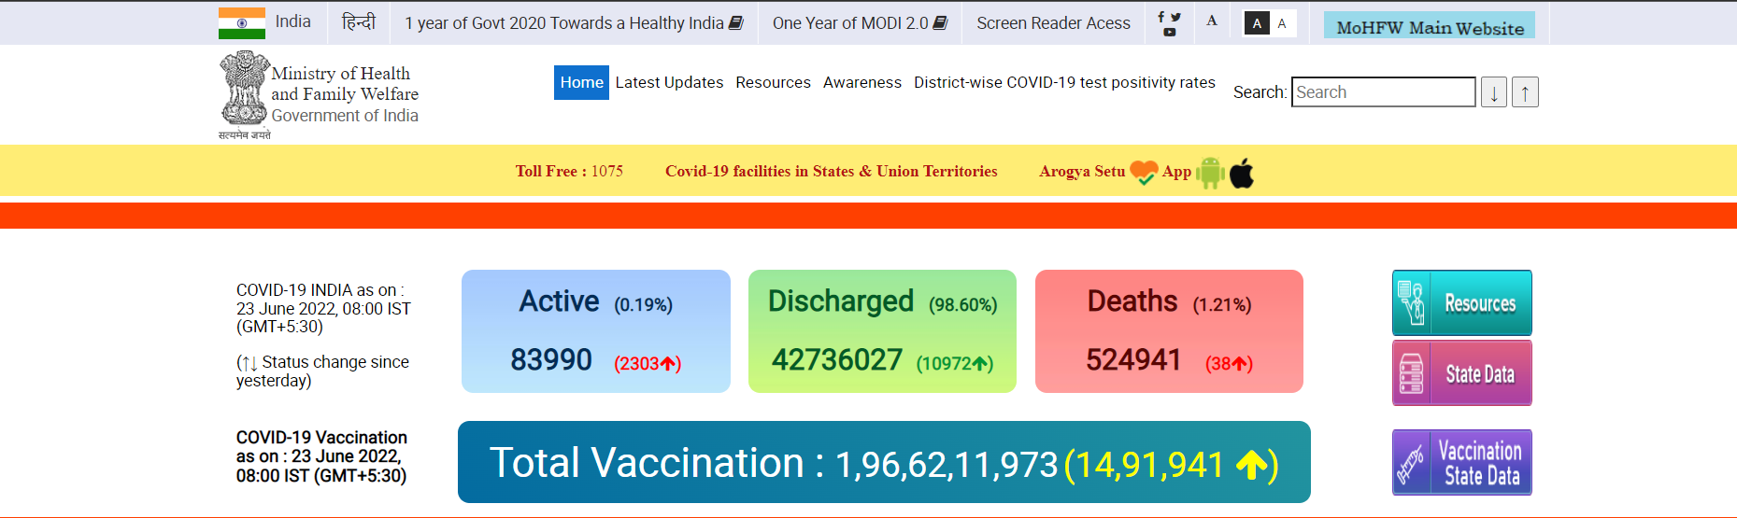

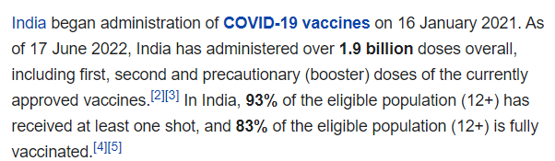

So , it has taken the govt 1 year 5 months(17-18 months approx) to deliver over 1.96 billion Covid Vaccine doses to people across India .

In our case , To deliver 5 Crore kitbags , using unitary method , 5 crore x (18/196 crore) = 0.45 months

This is not just it , The production and assembly of the kit bags will also take time .

A simple factory takes 3 months to produce just 8 L kit bags . India has 5 major Pharmaceutical factories located in Karnataka(KAPL) , Bengal(BPCL) , Rajasthan(RDPL) , Pune(HAL) and Gurgaon(IDPL).

Production value in crores of these factories are given below

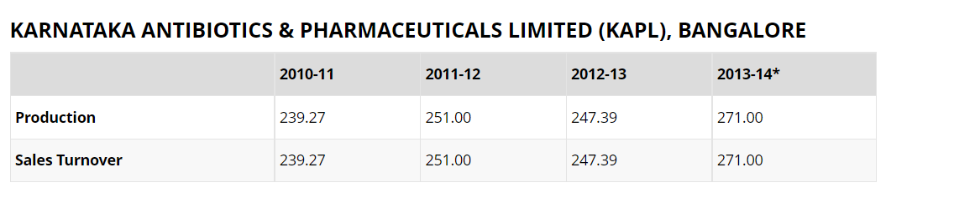

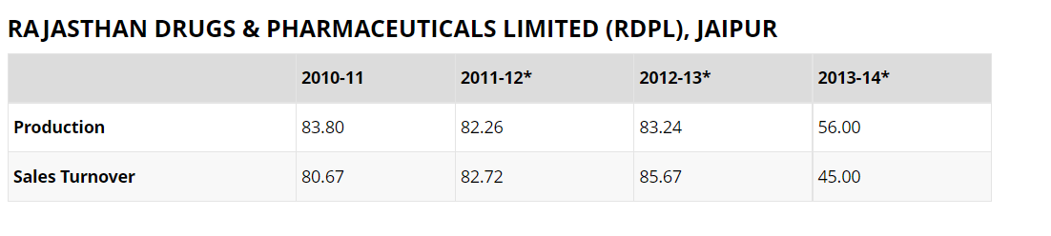

For HAL – PUNE:

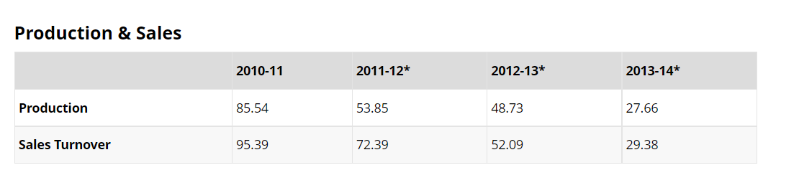

FOR BCPL – BENGAL -

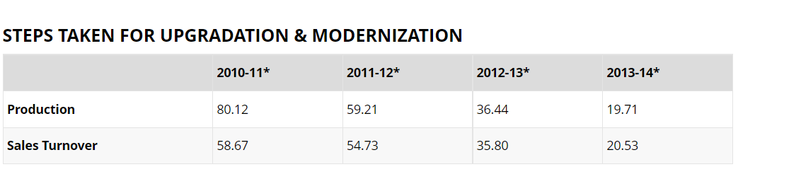

FOR IDPL -GURGAON

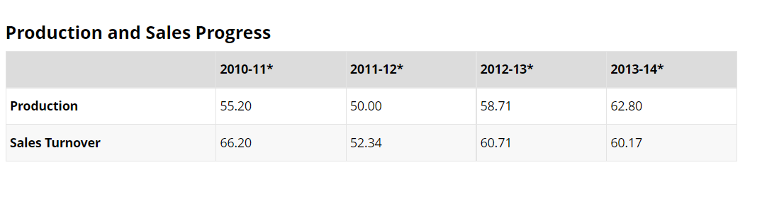

The current data being unavailable .

If we add all the production costs for 2013-2014 , we get 435 crores worth of production value. **Along with few other firms, we can go up to 600 crores production value in a year .**

If we had to estimate , the same value for 2022 , it should increase due to the pandemic situation . According to https://pharmaceuticals.gov.in/ Records , The Pharmaceutical companies more than doubled their production value during the pandemic .

**Which means the current production value per year stands out to be 2.5x of 600 crores = 3000 crores per year .**

This is all done by the Govt firms , If we start to include the major private pharmaceutical firms , **then the combined production value will go over 4800 crores per year**.

**With this rate we can achieve To deliver the kit bags in 5000crores/4800crores = 1 year approx .**