Q)Please produce a brief write up on your last project in the field of Data science in less than 200 words.

I am currently a 3rd year student pursuing btech in Vellore Institute Of technology in the field of Artificial Intelligence and Machine Learning. Our college provided credits for completing projects . One such project I would like to talk about is “**Face Mask Detection , using cascade classifier , If found not wearing a mask , then a warning message is sent through whats app .** “ Here is the overall system architecture of this project

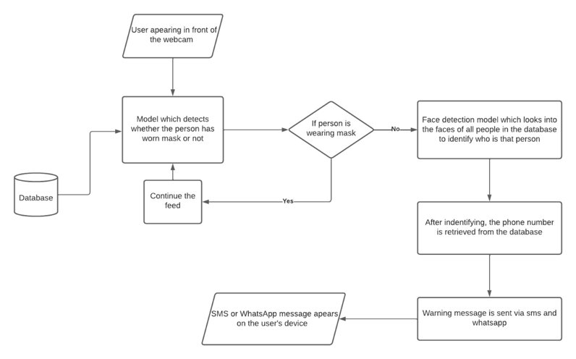

Firstly it was required to Detect mask in faces , for this **Custom made cascade classifiers** were used , these classifiers were trainer on thousands of images of masks .

**-Opencv-python** was used to access the video camera

-Each frame of camera was fed to the **Mask cascade classifier**

-If **frame had a face AND the face had a mask** , then the feed would continue

Otherwise ,

-If the **frame had a face , but the face had no mask** , then the following procedure would involve.

For this , we also needed to recognize the faces that were found not wearing the mask.

To achieve face recognition, The following 3 Methods were Thought of

* **CNN ( convolutional neural network )**
* **Structural similarity**
* **Face recognition module**

All 3 methods were applied ,

- **CNN** gave pretty good results in recognizing faces (92%),

**-Structural similarity** gave the least desired result in recognizing faces ( about 50-65 %),

-**Face recognition module** had the highest accuracy ( 99%) .

After detecting the face , we need to search the database and find out the phone number of the person whose face was detected , for doing this , **Nosql extension in python** was used to make the database . the database was a dummy database

After retrieving the phone number a WhatsApp warning message was sent using the **pywhatkit module in python** .

**Conclusion –**

To conclude I would like to say that this system has many real-world applications like using it in malls to check and fine people depending on if they follow the SOP or not.​ I was encouraged by my college mentors to write a research paper on this project as they were quite impressed by my work.