Comparing Text Representations for Document Clustering

Abstract
This project compares TF-IDF, pretrained sentence embeddings, an autoencoder (AE), and a variational autoencoder (VAE) as inputs to K-means. All methods use the same 3,295 nonempty documents. Sentence Transformer provides the strongest agreement with category labels (ARI 0.5025; NMI 0.5306), followed by AE and TF-IDF. VAE obtains the largest silhouette score but almost no category agreement. Additional diagnostics associate its latent representation with the number of retained distinct word types. The findings distinguish geometric separation from semantic usefulness and show why reconstruction loss alone cannot determine clustering quality.

1 Research question and data
The research question is whether learned document representations improve category-aligned clustering over a lexical baseline, and how their objectives explain successes and failures. The four categories contain overlapping discussions, especially atheism and religion, so category labels are useful reference annotations rather than a perfect definition of every topic.
Category | Documents
alt.atheism | 779
comp.graphics | 955
sci.space | 955
talk.religion.misc | 606
Total | 3295
The all-subset 20 Newsgroups loader returns 3,387 documents for these categories. Headers, footers and quotations are removed; 92 whitespace-empty documents are discarded. Original document IDs are retained and reused across every representation. Category labels are used only for post-hoc scoring and visualization.
Scope: unsupervised fitting and evaluation take place on the same corpus. No held-out classification or generalization result is claimed. Source runs use seed 42, a CPU and one numerical-computation thread.

2 Representations and evaluation protocol
Representation | Input and output | Objective / preparation
TF-IDF | 5,000 lexical features | English stop words; min_df=2; max_df=0.95; L2 rows
Sentence Transformer | all-MiniLM-L6-v2; 384 dimensions | Pretrained encoder; sequence length 256; L2 rows
AE latent | TF-IDF → 512 → 128 → 32 | Squared reconstruction error; L2 latent rows
VAE latent (mu) | Binary BoW 2,000 → 512 → 128 → 20 | Bernoulli reconstruction + KL; L2 mean rows
TF-IDF captures weighted lexical overlap. Sentence Transformer encodes text using a pretrained model [2, 3]; its maximum sequence length means some long documents are truncated. Both neural models trained here use fully connected ReLU hidden layers and mirrored decoders. The AE has a linear output. The VAE has separate mean and log-variance outputs, samples a latent vector by reparameterization, and uses a sigmoid decoder [4]. Clustering uses the deterministic VAE mean, not a random sample.
AE loss is the sum of squared feature errors, averaged over documents. VAE loss is binary cross-entropy summed over vocabulary entries plus the Gaussian posterior-to-standard-normal KL divergence, averaged over documents; the KL coefficient is 1. Both use Adam with learning rate 0.001, batch size 128 and 30 epochs. These losses have different units and must not be compared directly.
Every representation is clustered with K=4, k-means++ initialization, 20 initializations, Lloyd updates, at most 300 iterations and seed 42. ARI and NMI measure agreement with reference categories. Silhouette uses Euclidean distances and the same seed for a 2,000-document sample. It measures separation within each representation space; differing spaces limit comparisons of its absolute magnitude.
Zero rows are retained: 15 in TF-IDF and LDA counts, and 21 in binary BoW. Biased neural encoders can produce nonzero vectors for these rows, but cannot recover words absent from the selected vocabulary. PCA is fitted separately to each actual clustering input for visualization [5].
LDA is an additional interpretability analysis, using raw counts with the TF-IDF vocabulary, 10 topics, batch learning, 20 iterations, and document-topic and topic-word priors of 0.1. It represents documents as topic mixtures rather than the single cluster assignments produced by K-means [6].

3 Quantitative results and training behavior
Representation | Dim. | ARI | NMI | Silhouette
TF-IDF | 5,000 | 0.1765 | 0.3602 | 0.0050
Sentence Transformer | 384 | 0.5025 | 0.5306 | 0.0421
AE latent | 32 | 0.3193 | 0.3995 | 0.0741
VAE latent (mu) | 20 | 0.0066 | 0.0085 | 0.4072
Table 1. Single-seed corpus-level results. All four metric rows were independently reproduced from the saved arrays and labels.
Sentence Transformer has the highest ARI and NMI. Its graphics cluster contains 826 of 955 graphics documents and its space cluster contains 731 of 955 space documents. AE improves category agreement over TF-IDF while compressing 5,000 features to 32 dimensions. Atheism and religion remain mixed, reflecting substantial semantic overlap.
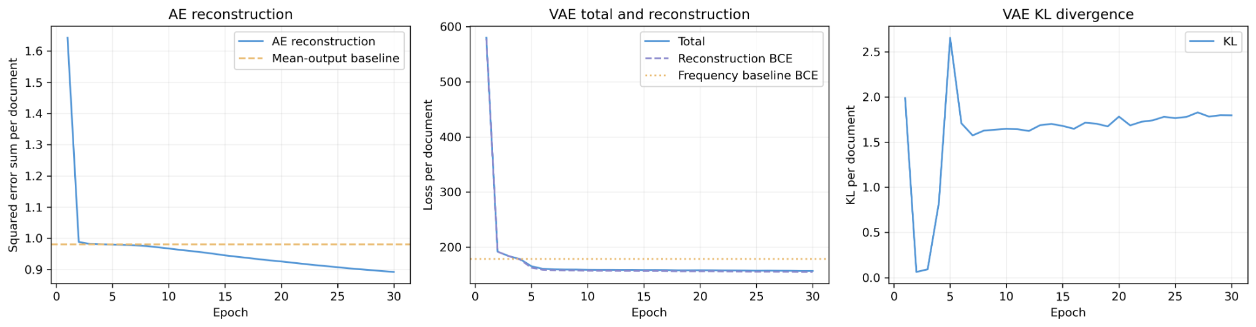
Figure 1. Original training curves. AE uses squared error; VAE uses BCE plus KL. The scales are not directly comparable.
AE final whole-corpus reconstruction error is 0.8882, compared with 0.9805 for a mean-output baseline, a relative reduction of about 9.4%. Its epoch-average loss continues to decline through epoch 30; the result does not establish convergence to an optimum.
VAE final whole-corpus BCE is 154.4293 versus a frequency baseline of 178.6654, a reduction of about 13.6%. Its final KL is 1.8179 and total loss is 156.2473. The early KL dip is followed by recovery and a stable nonzero value. These observations do not justify declaring complete posterior collapse. Better reconstruction than a frequency baseline also does not guarantee category-aligned latent features.
Final whole-corpus values are evaluated after training and need not equal the last epoch average, which aggregates batches while parameters are changing. VAE evaluation also depends on latent sampling.

4 Visual inspection of representation geometry
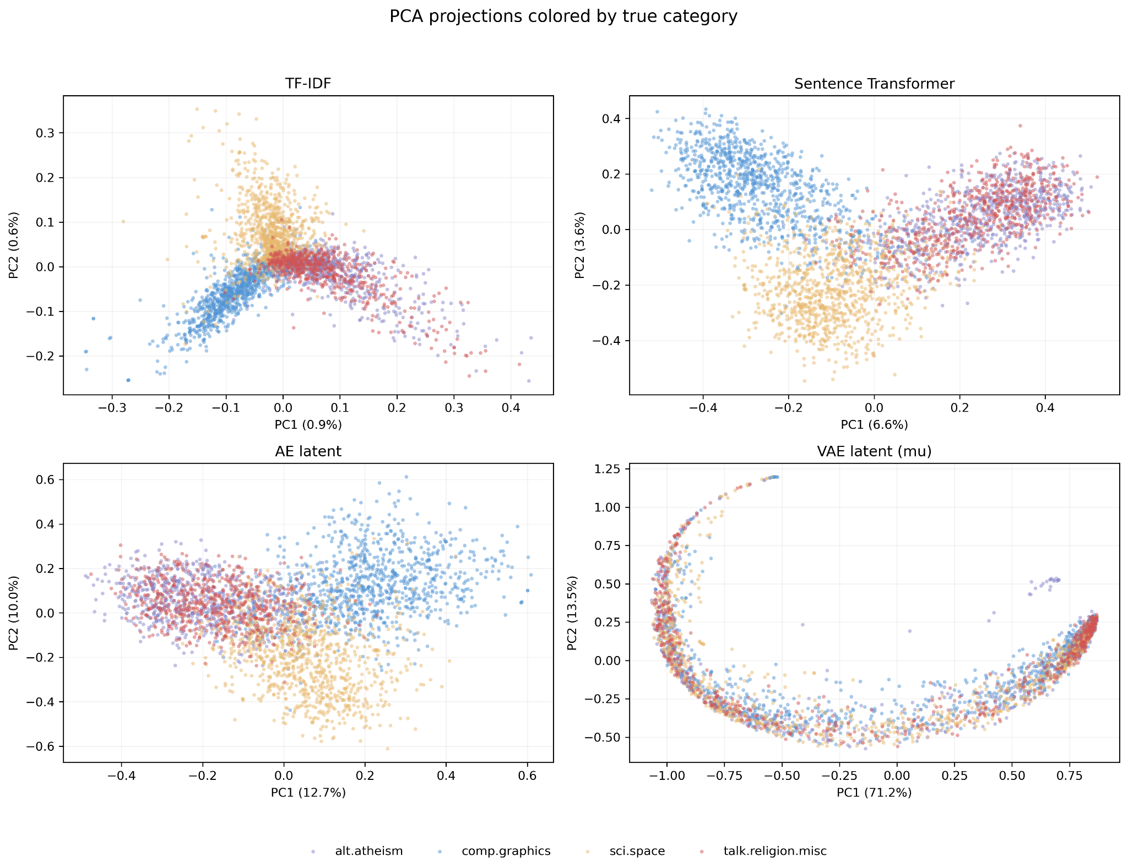
Figure 2. PCA projections colored by reference category. Purple: atheism; blue: graphics; gold: space; red: religion. Each panel uses its own fitted PCA and coordinate scale.
The first two components explain 1.45% of TF-IDF variance, 10.28% of sentence-embedding variance, 22.70% of AE variance and 84.67% of VAE variance. The lexical panel shows broad arms but substantial central overlap. Sentence embeddings provide clearer graphics and space regions, while atheism and religion overlap. AE retains moderate category structure.
The VAE forms a curved structure whose category colors are heavily mixed. A high two-component variance fraction describes concentration of variance, not semantic quality. PCA can hide distinctions outside the displayed dimensions, particularly for TF-IDF, so the two-dimensional plot supports interpretation rather than replacing full-space metrics.

5 Diagnosing the VAE result
VAE silhouette is 0.4072, yet ARI is 0.0066 and NMI is 0.0085. To investigate this discrepancy, the number of retained distinct word types is computed from binary BoW. This count is vocabulary coverage within 2,000 selected terms, not the raw document length or the number of word occurrences.
VAE cluster | Documents | Mean retained types | Median retained types
0 | 640 | 117.83 | 80
1 | 1,368 | 10.27 | 10
2 | 542 | 21.46 | 21
3 | 745 | 36.03 | 34
Raw mean coordinate 9 has Pearson correlation 0.9412 with log(1 + retained type count). Several other mean coordinates also show large absolute correlations. Together with mixed category colors and the count distributions above, this supports a quantity-related explanation for the VAE geometry. Count ranges overlap, and correlation does not prove that this is the only encoded factor or establish a causal mechanism.

6 Topics and representative documents
LDA topic | Selected keywords | Representative document
0 | space, nasa, launch, satellite, shuttle | NASA astronaut FAQ; original ID 1750
3 | jpeg, image, file, gif, format | JPEG compression FAQ; original ID 2239
8 | god, people, jesus, believe, bible | Bible / Mormon doctrine debate; original ID 1823
These three documents have topic proportions of approximately 0.9990, 0.9998 and 0.9997. TF-IDF, Sentence Transformer and AE assign them to separate space, graphics and religion-related clusters. VAE assigns all three to cluster 0, which has the highest mean retained-type count. This case study is consistent with the quantitative diagnosis, although three selected examples are not a general performance estimate.
Other LDA topics contain overlapping or generic words; they should not all receive confident semantic names. Topic numbers and K-means cluster IDs are arbitrary identifiers, and the 10-topic LDA model is an interpretability aid rather than a directly matched four-cluster competitor.

7 Discussion, limitations and next experiments
The main lesson is that representation objectives shape what becomes separable. Pretrained sentence embeddings yield the best reference-category agreement in this run. Reconstruction-based compression can preserve useful lexical structure, as the AE demonstrates, but it can also emphasize nuisance variation, as the VAE count diagnostics suggest. Strong internal separation and low reconstruction error answer different questions from semantic category agreement.
The comparison is descriptive rather than architecture-controlled: AE and VAE differ in vocabulary size, weighting, dimensionality and reconstruction likelihood. Sentence Transformer also benefits from external pretraining. Results come from one seed on one small corpus, without uncertainty estimates or an unseen-data evaluation. Vocabulary filtering, retained zero rows, encoder truncation and overlap between the reference categories are additional limits.
The next experiments should repeat runs across seeds and report means and dispersion; test sensitivity to zero-row exclusion while preserving a common document subset; compare AE and VAE with matched inputs and latent dimensions; and inspect count effects before and after normalization. A stronger semantic text-VAE objective can be explored only after these controls. Hyperparameters should be selected without optimizing against the same final category scores.

8 Reproducibility and audit
The submission preserves the original notebook, environment snapshot, aligned features, model weights, tables and figures. Independent metric recomputation matches all saved results. NumPy forward passes from the weights reproduce AE latents and VAE means within 0.000001; AE reconstruction and VAE KL also match. Full training and the stochastic VAE reconstruction BCE were not rerun during this audit. The exported pipeline passed syntax checks and the offline verification script passed on the packaged data.

