实验7 内容提供者

**学号： 1920502127 班级：19计算机外包（1）班 姓名： 郭铠东**

实验要求：

* 掌握使用内容解析器读取其他应用程序的数据
* 创建自己的内容提供器
* 把项目使用git进行版本管理并上传到自己的git账号

实验内容：

1. 读取手机联系人信息，并用ListView显示。显示界面布局如下所示。（给出读取联系人列表的实现）。

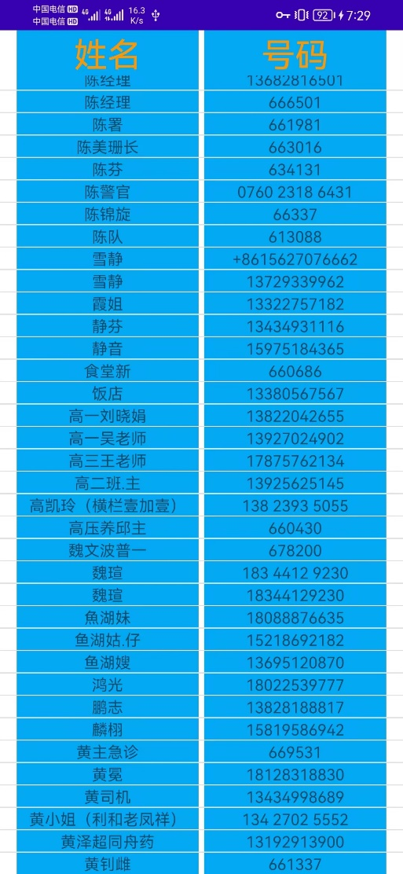

姓名 1 电话1

姓名2 电话2

**activity_main.xml**

<LinearLayout xmlns:android="http://schemas.android.com/apk/res/android"  
 android:layout_width="match_parent"  
 android:layout_height="match_parent"  
 android:orientation="vertical">  
 <LinearLayout  
 android:layout_width="match_parent"  
 android:layout_height="match_parent"  
 android:orientation="vertical">  
 <LinearLayout  
 android:layout_width="match_parent"  
 android:layout_height="wrap_content"  
 android:orientation="horizontal">  
 <TextView  
 android:layout_width="0dp"  
 android:layout_height="match_parent"  
 android:layout_weight="1"  
 android:text="姓名"  
 android:textSize="30dp"  
 android:gravity="center"  
 android:background="#03A9F4"  
 android:textColor="#FF9800"  
 android:layout_marginLeft="15dp"/>  
 <TextView  
 android:layout_width="0dp"  
 android:layout_height="match_parent"  
 android:layout_weight="1"  
 android:background="#03A9F4"  
 android:gravity="center"  
 android:text="号码"  
 android:textSize="30dp"  
 android:textColor="#FF9800"  
 android:layout_marginLeft="5dp"  
 android:layout_marginRight="15dp"/>  
 </LinearLayout>  
 <ListView  
 android:id="@+id/contacts_view"  
 android:layout_width="match_parent"  
 android:layout_height="match_parent">  
 </ListView>  
 </LinearLayout>  
  
  
</LinearLayout>

**Item.xml**

<?xml version="1.0" encoding="utf-8"?>  
<LinearLayout xmlns:android="http://schemas.android.com/apk/res/android"  
 android:orientation="horizontal"  
 android:layout_width="match_parent"  
 android:layout_height="match_parent">  
  
 <TextView  
 android:id="@+id/c_name"  
 android:layout_width="0dp"  
 android:layout_height="wrap_content"  
 android:layout_weight="1"  
 android:background="#03A9F4"  
 android:gravity="center"  
 android:layout_marginLeft="15dp"/>  
  
 <TextView  
 android:id="@+id/c_phone"  
 android:layout_width="0dp"  
 android:layout_height="wrap_content"  
 android:layout_weight="1"  
 android:background="#03A9F4"  
 android:gravity="center"  
 android:layout_marginLeft="5dp"  
 android:layout_marginRight="15dp"/>  
</LinearLayout>

**MainActivity.java**

package com.example.contactstest;  
  
import androidx.appcompat.app.ActionBar;  
import androidx.appcompat.app.AppCompatActivity;  
import androidx.core.app.ActivityCompat;  
import androidx.core.content.ContextCompat;  
  
import android.Manifest;  
import android.annotation.SuppressLint;  
import android.app.Activity;  
import android.content.pm.PackageManager;  
import android.database.Cursor;  
import android.os.Bundle;  
import android.provider.ContactsContract;  
import android.util.Log;  
import android.widget.ArrayAdapter;  
import android.widget.ListView;  
import android.widget.TextView;  
import android.widget.Toast;  
  
import java.util.ArrayList;  
import java.util.List;  
  
public class MainActivity extends AppCompatActivity {  
 private ContactsAdapter adapter;  
 private List<Contact> contactsList = new ArrayList<>();  
 private List<String> list = new ArrayList<>();  
 private ArrayAdapter<String> ada;  
  
 @Override  
 protected void onCreate(Bundle savedInstanceState) {  
 super.onCreate(savedInstanceState);  
 setContentView(R.layout.*activity_main*);  
  
 ActionBar actionBar = getSupportActionBar();  
 if(actionBar!=null){  
 actionBar.hide();  
 }  
  
 ListView contactsView = (ListView)findViewById(R.id.*contacts_view*);  
 adapter = new ContactsAdapter(this,R.layout.*item*,contactsList);  
 contactsView.setAdapter(adapter);  
 if(ContextCompat.*checkSelfPermission*(this, Manifest.permission.*READ_CONTACTS*)!=  
 PackageManager.*PERMISSION_GRANTED*){  
 ActivityCompat.*requestPermissions*(this,new String[]{Manifest.permission.*READ_CONTACTS*},  
 1);  
 }else {  
 readContacts();  
 }  
  
 }  
  
 private void readContacts() {  
 Cursor cursor = null;  
 try{  
 /*查询联系人数据*/  
 cursor = getContentResolver().query(ContactsContract.CommonDataKinds.Phone.*CONTENT_URI*,  
 null,null,null,ContactsContract.CommonDataKinds.Phone.*DISPLAY_NAME*);  
 if(cursor.moveToFirst()){  
 while(cursor.moveToNext()){  
 /*获取联系人姓名*/  
 @SuppressLint("Range") String displayName = cursor.getString(cursor.getColumnIndex(  
 ContactsContract.CommonDataKinds.Phone.*DISPLAY_NAME*));  
 /*获取联系人手机号*/  
 @SuppressLint("Range") String number = cursor.getString(cursor.getColumnIndex(  
 ContactsContract.CommonDataKinds.Phone.*NUMBER*));  
  
 Contact contact = new Contact();  
 contact.setName(displayName);  
 contact.setPhone(number);  
 contactsList.add(contact);  
 list.add(displayName+""+number);  
 }  
 adapter.notifyDataSetChanged();  
 }  
 }catch (Exception e){  
 e.printStackTrace();  
 }finally {  
 if(cursor!=null){  
 cursor.close();  
 }  
 }  
 }  
  
 @Override  
 public void onRequestPermissionsResult(int requestCode, String[] permissions,int[] grantResults) {  
 super.onRequestPermissionsResult(requestCode, permissions, grantResults);  
 switch (requestCode){  
 case 1:  
 if(grantResults.length > 0 && grantResults[0] == PackageManager.*PERMISSION_GRANTED*){  
 readContacts();  
 }else{  
 Toast.*makeText*(this, "取消", Toast.*LENGTH_SHORT*).show();  
 }  
 break;  
 }  
 }  
}

**ConstactsAdapter.java(自定义适配器)**

package com.example.contactstest;  
  
import android.content.Context;  
import android.util.Log;  
import android.view.LayoutInflater;  
import android.view.View;  
import android.view.ViewGroup;  
import android.widget.ArrayAdapter;  
import android.widget.TextView;  
  
import androidx.annotation.NonNull;  
  
import java.util.List;  
  
public class ContactsAdapter extends ArrayAdapter<Contact> {  
 private int resourceId;  
 public ContactsAdapter( Context context, int resource, List<Contact> objects) {  
 super(context, resource, objects);  
 resourceId = resource;  
 }  
  
 @Override  
 public View getView(int position, View convertView, ViewGroup parent){  
 Contact contact = getItem(position);//获取当前项的Rank实例  
 View view = LayoutInflater.*from*(getContext()).inflate(resourceId,parent,false);  
 TextView name = (TextView) view.findViewById(R.id.*c_name*);  
 TextView phone = (TextView) view.findViewById(R.id.*c_phone*);  
 name.setText(contact.getName());  
 phone.setText(contact.getPhone());  
 return view;  
 }  
}

**界面如图**

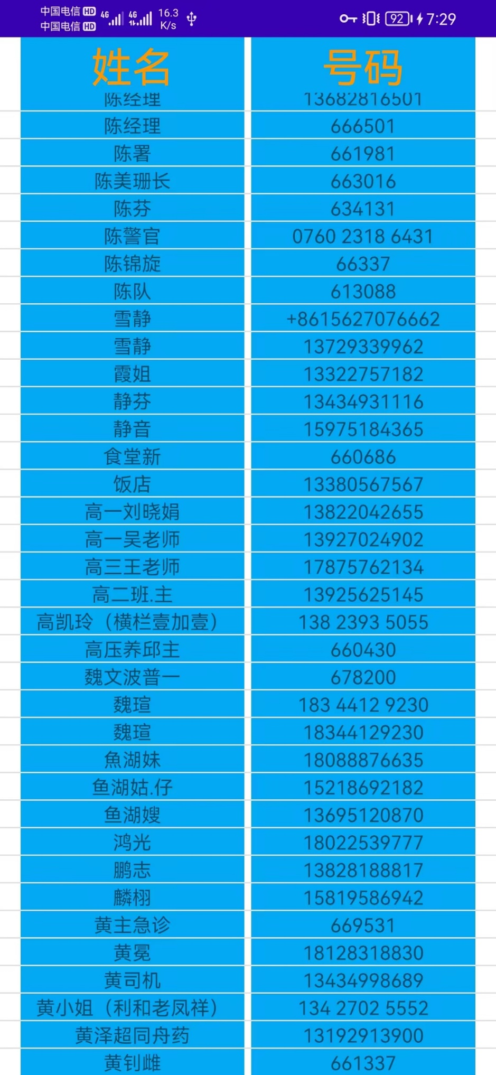

1. 应用中有一个使用Sqllite保存的数据库db。里面有一个表contacts用于保存联系人的基本信息，这些信息包括姓名，联系电话，性别。要求你创建一个内容提供者，给其他app提供contacts中数据的查询。其他app能够查询contacts表中的所有信息，也可以查询单条联系人的信息。（实验报告给出你自定义的内容提供者的实现）

**主界面如图：**

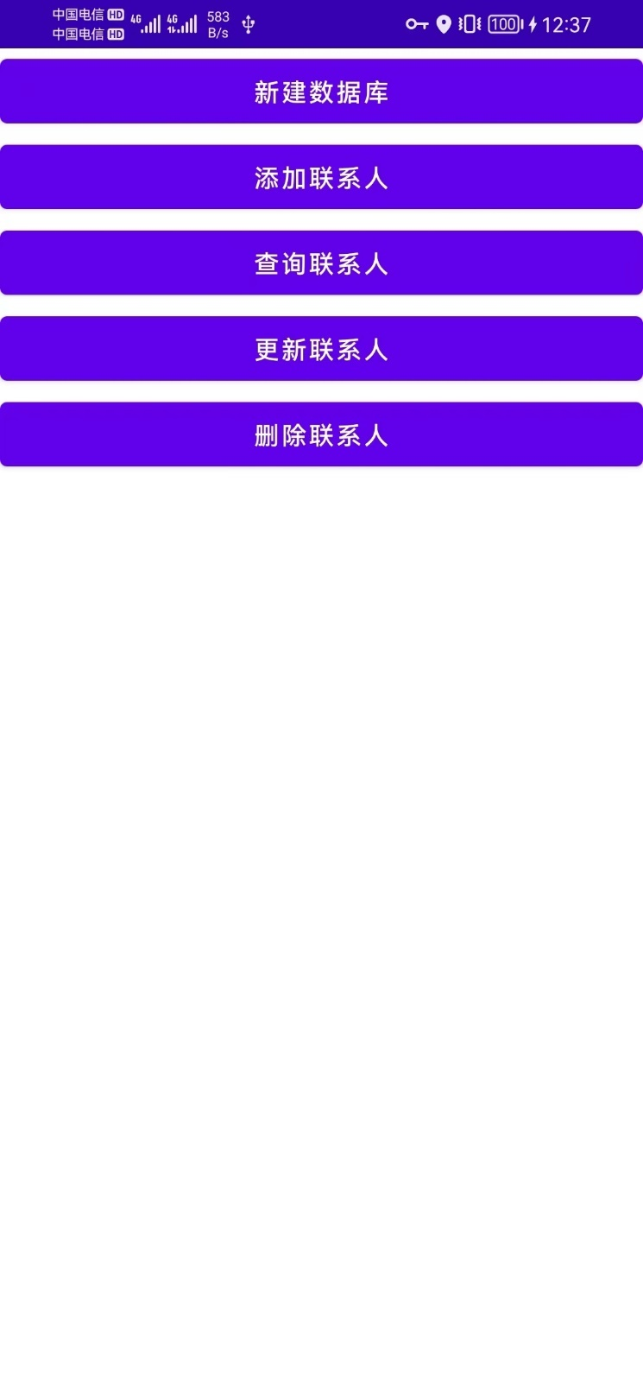

**点击新建数据库生成Contact.db数据库**

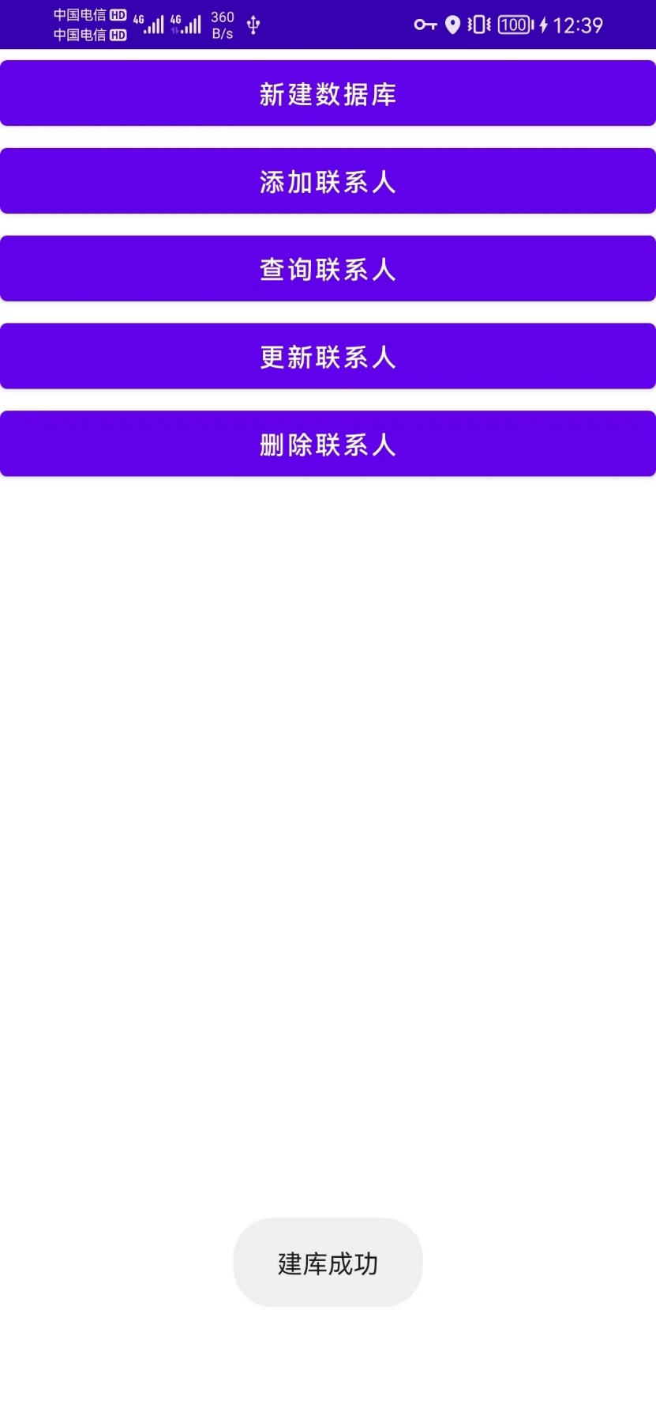

**点击添加联系人，则读取系统里储存的联系人并插入Contact.db数据库**

**中的contact表，查询得：**

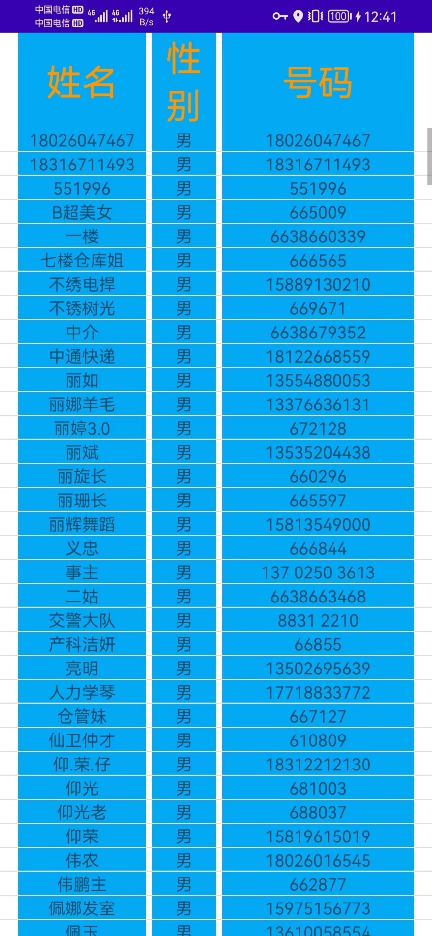

**代码如下：**

**FirstActivity.java**

package com.example.contactstest;  
  
import androidx.appcompat.app.ActionBar;  
import androidx.appcompat.app.AppCompatActivity;  
  
import android.annotation.SuppressLint;  
import android.content.ContentValues;  
import android.content.Intent;  
import android.content.pm.PackageManager;  
import android.database.Cursor;  
import android.database.sqlite.SQLiteDatabase;  
import android.net.Uri;  
import android.os.Bundle;  
import android.provider.ContactsContract;  
import android.util.Log;  
import android.view.View;  
import android.widget.Button;  
import android.widget.Toast;  
  
import java.util.ArrayList;  
import java.util.List;  
  
public class FirstActivity extends AppCompatActivity {  
 private MyDatabaseHelper dbHelper;  
  
 @Override  
 protected void onCreate(Bundle savedInstanceState) {  
 super.onCreate(savedInstanceState);  
 setContentView(R.layout.*activity_first*);  
 ActionBar actionBar = getSupportActionBar();  
 if(actionBar!=null){  
 actionBar.hide();  
 }  
  
 dbHelper = new MyDatabaseHelper(this,"Contacts.db",null,2);  
 Button createDatabase = (Button) findViewById(R.id.*create_database*);  
 createDatabase.setOnClickListener(new View.OnClickListener() {  
 @Override  
 public void onClick(View view) {  
 /*创建数据库*/  
 dbHelper.getWritableDatabase();  
 Toast.*makeText*(FirstActivity.this, "建库成功", Toast.*LENGTH_SHORT*).show();  
 }  
 });  
  
 Button add_data = (Button) findViewById(R.id.*add_data*);  
 add_data.setOnClickListener(new View.OnClickListener() {  
 @Override  
 public void onClick(View view) {  
 /*添加联系人*/  
 SQLiteDatabase db = dbHelper.getWritableDatabase();  
// ContentValues values = new ContentValues();  
 Cursor cursor = getContentResolver().query(ContactsContract.CommonDataKinds.Phone.*CONTENT_URI*, null,  
 null,null,ContactsContract.CommonDataKinds.Phone.*DISPLAY_NAME*);  
 if(cursor!=null){  
 int n = 0;  
 String sex;  
 while (cursor.moveToNext()){  
// Contact contact = new Contact();  
 /*获取系统联系人姓名、性别、号码，插入到应用的Contact数据库*/  
 @SuppressLint("Range") String displayName = cursor.getString(cursor.getColumnIndex(ContactsContract.CommonDataKinds.Phone.*DISPLAY_NAME*));  
 @SuppressLint("Range") String number = cursor.getString(cursor.getColumnIndex(ContactsContract.CommonDataKinds.Phone.*NUMBER*));  
  
 if(n%2==0)  
 sex = "男";  
 else  
 sex = "女";  
//  
// values.put("name",displayName);  
// values.put("phone",number);  
// values.put("sex",sex);  
// db.insert("contact",null,values);  
// values.clear();  
// n++;  
  
 Uri uri = Uri.*parse*("content://com.example.contactstest.provider/contact");  
 ContentValues values = new ContentValues();  
 values.put("name",displayName);  
 values.put("phone",number);  
 values.put("sex",sex);  
 getContentResolver().insert(uri,values);  
 }  
 }  
 cursor.close();  
 Toast.*makeText*(FirstActivity.this, "添加成功", Toast.*LENGTH_SHORT*).show();  
 }  
 });  
  
  
 Button query_data = (Button) findViewById(R.id.*query_data*);  
 query_data.setOnClickListener(new View.OnClickListener() {  
 @Override  
 public void onClick(View view) {  
 /*查询应用的数据库所有联系人*/  
 Intent intent = new Intent(FirstActivity.this,ShowList.class);  
 startActivity(intent);  
 }  
 });  
  
// Button add_data = (Button) findViewById(R.id.add_data);  
// Button add_data = (Button) findViewById(R.id.add_data);  
  
 }  
  
 @Override  
 public void onRequestPermissionsResult(int requestCode, String[] permissions,int[] grantResults) {  
 super.onRequestPermissionsResult(requestCode, permissions, grantResults);  
 switch (requestCode){  
 case 1:  
 if(grantResults.length > 0 && grantResults[0] == PackageManager.*PERMISSION_GRANTED*){  
 }else{  
 Toast.*makeText*(this, "取消", Toast.*LENGTH_SHORT*).show();  
 }  
 break;  
 }  
 }  
}

**ContactProvider.java**

package com.example.contactstest;  
  
import android.content.ContentProvider;  
import android.content.ContentValues;  
import android.content.UriMatcher;  
import android.database.Cursor;  
import android.database.sqlite.SQLiteDatabase;  
import android.net.Uri;  
  
import com.example.contactstest.MyDatabaseHelper;  
  
public class ContactProvider extends ContentProvider {  
 public ContactProvider() {  
 }  
 public static final int *CONTACT_DIR*=0;  
 public static final int *CONTACT_ITEM*=1;  
 public static final String *AUTHORITY* = "com.example.contactstest.provider";  
 private static UriMatcher *uriMatcher*;  
 private MyDatabaseHelper dbHelper;  
  
 static {  
 *uriMatcher* = new UriMatcher(UriMatcher.*NO_MATCH*);  
 *uriMatcher*.addURI(*AUTHORITY*,"contact",*CONTACT_DIR*);  
 *uriMatcher*.addURI(*AUTHORITY*,"contact/#",*CONTACT_ITEM*);  
  
 }  
  
 @Override  
 public int delete(Uri uri, String selection, String[] selectionArgs) {  
 // 删除数据  
 SQLiteDatabase db = dbHelper.getWritableDatabase();  
 int deleteRows = 0;  
 switch (*uriMatcher*.match(uri)){  
 case *CONTACT_DIR*:  
 deleteRows = db.delete("contact",selection,selectionArgs);  
 break;  
 case *CONTACT_ITEM*:  
 String contactId = uri.getPathSegments().get(1);  
 deleteRows = db.delete("contact","id = ?",new String[]{contactId});  
 break;  
 default:  
 break;  
 }  
 return deleteRows;  
 }  
  
 @Override  
 public String getType(Uri uri) {  
 switch (*uriMatcher*.match(uri)){  
 case *CONTACT_DIR*:  
 return "vnd.android.cursor.dir/vnd.com.example.databasetest.provider.contact";  
 case *CONTACT_ITEM*:  
 return "vnd.android.cursor.item/vnd.com.example.databasetest.provider.contact";  
 }  
 return null;  
 }  
  
 @Override  
 public Uri insert(Uri uri, ContentValues values) {  
 /*添加数据*/  
 SQLiteDatabase db = dbHelper.getWritableDatabase();  
 Uri uriReturn = null;  
 switch (*uriMatcher*.match(uri)){  
 case *CONTACT_DIR*:  
 case *CONTACT_ITEM*:  
 long newContactId = db.insert("contact",null,values);  
 uriReturn = Uri.*parse*("content://"+*AUTHORITY*+"/contact/"+newContactId);  
 break;  
 default:  
 break;  
 }  
 return uriReturn;  
 }  
  
 @Override  
 public boolean onCreate() {  
 dbHelper = new MyDatabaseHelper(getContext(),"Contact.db",null,2);  
 return true;  
 }  
  
 @Override  
 public Cursor query(Uri uri, String[] projection, String selection,  
 String[] selectionArgs, String sortOrder) {  
 /*查询数据 */  
 SQLiteDatabase db = dbHelper.getReadableDatabase();  
 Cursor cursor = null;  
 switch (*uriMatcher*.match(uri)){  
 case *CONTACT_DIR*:  
 cursor = db.query("contact",projection,selection,  
 selectionArgs,null,null,sortOrder);  
 break;  
 case *CONTACT_ITEM*:  
 String contactId = uri.getPathSegments().get(1);  
 cursor = db.query("contact",projection,"id=?",new String[]{contactId},  
 null,null,sortOrder);  
 break;  
 }  
 return cursor;  
 }  
  
 @Override  
 public int update(Uri uri, ContentValues values, String selection,  
 String[] selectionArgs) {  
 // 更新数据  
 SQLiteDatabase db = dbHelper.getWritableDatabase();  
 int updateRows = 0;  
 switch (*uriMatcher*.match(uri)){  
 case *CONTACT_DIR*:  
 updateRows = db.update("contact",values,selection,selectionArgs);  
 break;  
 case *CONTACT_ITEM*:  
 String contactId = uri.getPathSegments().get(1);  
 updateRows = db.update("contact",values,"id = ?",new String[]{contactId});  
 break;  
 default:  
 break;  
 }  
 return updateRows;  
 }  
}

**activity_show_list.layout**

<LinearLayout xmlns:android="http://schemas.android.com/apk/res/android"  
 android:layout_width="match_parent"  
 android:layout_height="match_parent"  
 android:orientation="vertical">  
 <LinearLayout  
 android:layout_width="match_parent"  
 android:layout_height="match_parent"  
 android:orientation="vertical">  
 <LinearLayout  
 android:layout_width="match_parent"  
 android:layout_height="wrap_content"  
 android:orientation="horizontal">  
 <TextView  
 android:layout_width="0dp"  
 android:layout_height="match_parent"  
 android:layout_weight="2"  
 android:text="姓名"  
 android:textSize="30dp"  
 android:gravity="center"  
 android:background="#03A9F4"  
 android:textColor="#FF9800"  
 android:layout_marginLeft="15dp"/>  
 <TextView  
 android:layout_width="0dp"  
 android:layout_height="match_parent"  
 android:layout_weight="1"  
 android:text="性别"  
 android:textSize="30dp"  
 android:gravity="center"  
 android:background="#03A9F4"  
 android:textColor="#FF9800"  
 android:layout_marginLeft="5dp"/>  
 <TextView  
 android:layout_width="0dp"  
 android:layout_height="match_parent"  
 android:layout_weight="3"  
 android:background="#03A9F4"  
 android:gravity="center"  
 android:text="号码"  
 android:textSize="30dp"  
 android:textColor="#FF9800"  
 android:layout_marginLeft="5dp"  
 android:layout_marginRight="15dp"/>  
 </LinearLayout>  
 <ListView  
 android:id="@+id/contacts"  
 android:layout_width="match_parent"  
 android:layout_height="match_parent">  
 </ListView>  
 </LinearLayout>  
  
  
</LinearLayout>

**然后新建一个项目来检验内容提供者**

**新项目主界面如图：(主界面就是查询contact表的所有信息)**

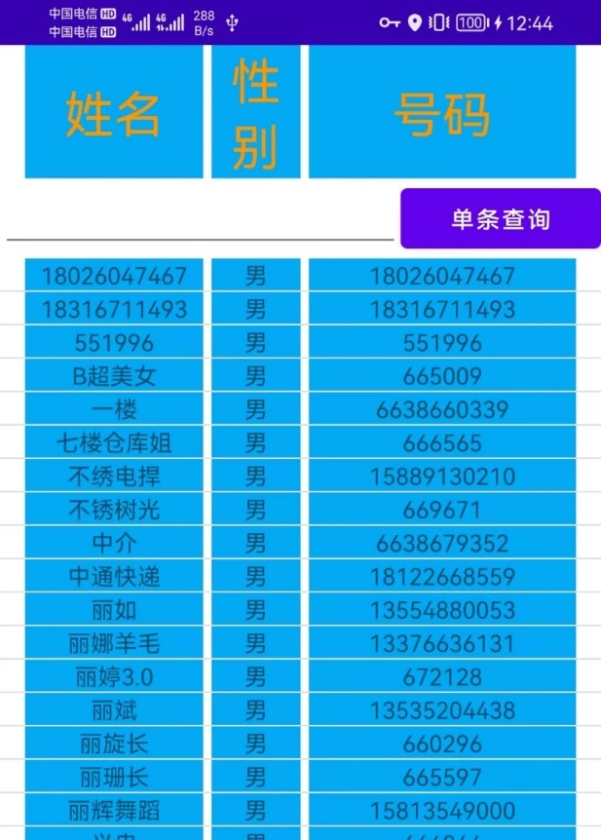

**在输入框输入id，点击按钮根据联系人id来查询单条信息：**

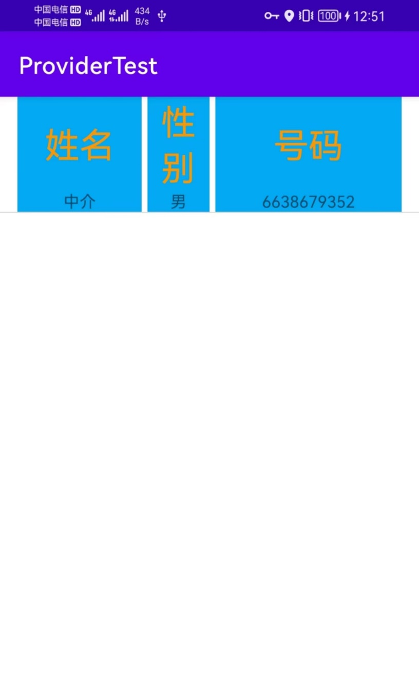

**代码如下：**

**Activity_show_list.layout**

<LinearLayout xmlns:android="http://schemas.android.com/apk/res/android"  
 android:layout_width="match_parent"  
 android:layout_height="match_parent"  
 android:orientation="vertical">  
 <LinearLayout  
 android:layout_width="match_parent"  
 android:layout_height="match_parent"  
 android:orientation="vertical">  
 <LinearLayout  
 android:layout_width="match_parent"  
 android:layout_height="wrap_content"  
 android:orientation="horizontal">  
 <TextView  
 android:layout_width="0dp"  
 android:layout_height="match_parent"  
 android:layout_weight="2"  
 android:text="姓名"  
 android:textSize="30dp"  
 android:gravity="center"  
 android:background="#03A9F4"  
 android:textColor="#FF9800"  
 android:layout_marginLeft="15dp"/>  
 <TextView  
 android:layout_width="0dp"  
 android:layout_height="match_parent"  
 android:layout_weight="1"  
 android:text="性别"  
 android:textSize="30dp"  
 android:gravity="center"  
 android:background="#03A9F4"  
 android:textColor="#FF9800"  
 android:layout_marginLeft="5dp"/>  
 <TextView  
 android:layout_width="0dp"  
 android:layout_height="match_parent"  
 android:layout_weight="3"  
 android:background="#03A9F4"  
 android:gravity="center"  
 android:text="号码"  
 android:textSize="30dp"  
 android:textColor="#FF9800"  
 android:layout_marginLeft="5dp"  
 android:layout_marginRight="15dp"/>  
 </LinearLayout>  
 <LinearLayout  
 android:layout_width="match_parent"  
 android:layout_height="wrap_content"  
 android:orientation="horizontal">  
 <EditText  
 android:id="@+id/singleData"  
 android:layout_width="0dp"  
 android:layout_height="wrap_content"  
 android:layout_weight="2"  
 android:lines="1" />  
 <Button  
 android:layout_width="0dp"  
 android:layout_height="wrap_content"  
 android:id="@+id/single"  
 android:text="单条查询"  
 android:layout_weight="1"/>  
 </LinearLayout>  
  
 <ListView  
 android:id="@+id/contacts"  
 android:layout_width="match_parent"  
 android:layout_height="match_parent">  
 </ListView>  
 </LinearLayout>  
</LinearLayout>

**ShowList.java**

package com.example.providertest;  
  
import android.annotation.SuppressLint;  
import android.content.Intent;  
import android.database.Cursor;  
import android.database.sqlite.SQLiteDatabase;  
import android.net.Uri;  
import android.os.Bundle;  
import android.util.Log;  
import android.view.View;  
import android.widget.Button;  
import android.widget.EditText;  
import android.widget.ListView;  
  
import androidx.appcompat.app.ActionBar;  
import androidx.appcompat.app.AppCompatActivity;  
  
import java.util.ArrayList;  
import java.util.List;  
  
public class ShowList extends AppCompatActivity {  
 private List<Contact> list = new ArrayList<>();  
 ContactsAdapter contactsAdapter;  
  
 @Override  
 protected void onCreate(Bundle savedInstanceState) {  
 super.onCreate(savedInstanceState);  
 setContentView(R.layout.*activity_show_list*);  
  
 ActionBar actionBar = getSupportActionBar();  
 if(actionBar!=null){  
 actionBar.hide();  
 }  
  
 initData();  
 ListView listView = (ListView) findViewById(R.id.*contacts*);  
 contactsAdapter = new ContactsAdapter(this,R.layout.*item*,list);  
 listView.setAdapter(contactsAdapter);  
  
 Button bt = (Button) findViewById(R.id.*single*);  
 bt.setOnClickListener(new View.OnClickListener() {  
 @Override  
 public void onClick(View view) {  
 EditText data = (EditText) findViewById(R.id.*singleData*);  
 String id = data.getText().toString();  
 Log.*d*("testId",id);  
 Intent intent = new Intent(ShowList.this,SingleActivity.class);  
 intent.putExtra("id",id);  
  
 startActivity(intent);  
 }  
 });  
  
 }  
  
 private void initData() {  
 Uri uri = Uri.*parse*("content://com.example.contactstest.provider/contact");  
 Cursor cursor = getContentResolver().query(uri,null,null,null,null);  
 if(cursor.moveToFirst()){  
 while(cursor.moveToNext()){  
 Contact contact = new Contact();  
 @SuppressLint("Range") String name = cursor.getString(cursor.getColumnIndex("name"));  
 @SuppressLint("Range") String sex = cursor.getString(cursor.getColumnIndex("sex"));  
 @SuppressLint("Range") String phone = cursor.getString(cursor.getColumnIndex("phone"));  
  
 contact.setName(name);  
 contact.setSex(sex);  
 contact.setPhone(phone);  
 Log.*d*("FirstActivity",contact.toString());  
 list.add(contact);  
 }  
 }else {  
 Log.*d*("FirstActivity","空");  
 }  
 if (cursor!=null){  
 cursor.close();  
 }  
 }  
}

**ShowList.java跳转到SingleActivity.java(显示单条查询结果)**

package com.example.providertest;  
  
import androidx.appcompat.app.AppCompatActivity;  
  
import android.annotation.SuppressLint;  
import android.content.Intent;  
import android.database.Cursor;  
import android.net.Uri;  
import android.os.Bundle;  
import android.util.Log;  
import android.widget.EditText;  
import android.widget.ListView;  
  
import java.util.ArrayList;  
import java.util.List;  
  
public class SingleActivity extends AppCompatActivity {  
 private List<Contact> list = new ArrayList<>();  
 ContactsAdapter adapter;  
 @Override  
 protected void onCreate(Bundle savedInstanceState) {  
 super.onCreate(savedInstanceState);  
 setContentView(R.layout.*activity_single*);  
  
 Intent intent = getIntent();  
 int id = Integer.*parseInt*(intent.getStringExtra("id"));  
 Log.*d*("testId",String.*valueOf*(id));  
  
 ListView listView = (ListView) findViewById(R.id.*singleContact*);  
 adapter = new ContactsAdapter(this,R.layout.*item*,list);  
 listView.setAdapter(adapter);  
  
  
 Uri uri = Uri.*parse*("content://com.example.contactstest.provider/contact/"+id);  
 Cursor cursor;  
 cursor = getContentResolver().query(uri,null,null,null,null);  
 if (cursor.moveToFirst()){  
 @SuppressLint("Range") String name = cursor.getString(cursor.getColumnIndex("name"));  
 @SuppressLint("Range") String sex = cursor.getString(cursor.getColumnIndex("sex"));  
 @SuppressLint("Range") String phone = cursor.getString(cursor.getColumnIndex("phone"));  
  
 Contact contact = new Contact();  
 contact.setName(name);  
 contact.setSex(sex);  
 contact.setPhone(phone);  
 list.add(contact);  
 }  
 if (cursor!=null){  
 cursor.close();  
 }  
 }  
}

1. 在github上申请一个账户，把以上的项目保存到自己申请的git账户上。（实验报告中给出你的github上项目的连接）