JBoss启动和关闭 1

1 JBoss脚本启动 1

1.1 JBOSS7 启动： 1

1.2 JBOSS7 关闭： 2

2 JBoss启动（eclipse中启动） 3

2.1 启动方式 3

2.2 JBoss启动日志 （eclipse中启动） 3

JBoss日志 4

JBoss管理平台 4

1配置管理员 4

2访问管理平台： 5

JBoss启动和关闭

1 JBoss脚本启动

1.1 JBOSS7 启动：

**以standalone模式运行服务器：**

<JBOSS_HOME>/bin/standalone.sh (Unix / Linux)

<JBOSS_HOME>/bin/standalone.sh & (Unix / Linux 后台启动)

<JBOSS_HOME>\bin\standalone.bat (Windows)

<JBOSS_HOME>\bin\start/b standalone.bat (Windows 后台启动)

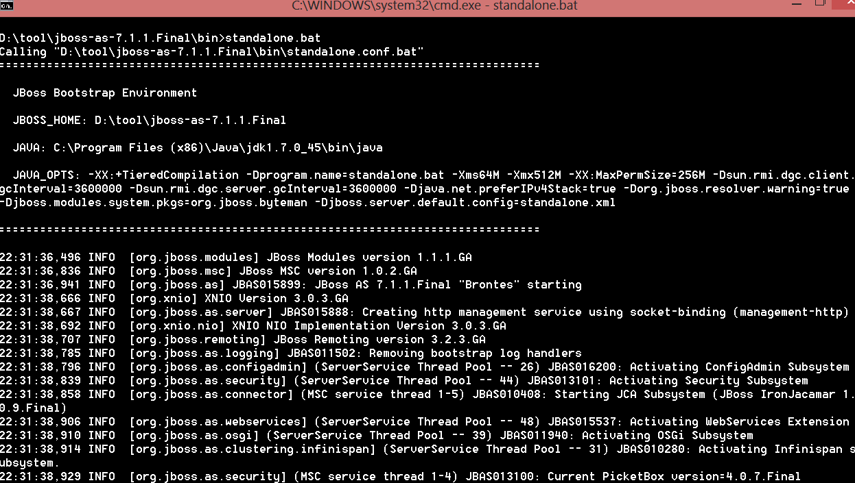

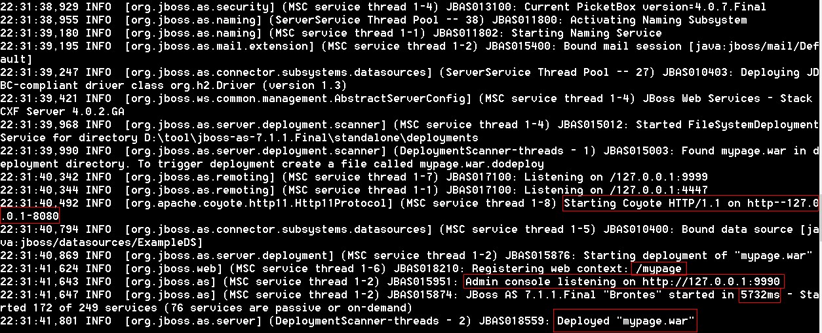

**以domain模式运行服务器：**

<JBOSS_HOME>/bin/domain.sh (Unix / Linux)

<JBOSS_HOME>\bin\domain.bat (Windows)

1.2 JBOSS7 关闭：

执行： jboss-admin.bat --connect command=:shutdown //对jboss7.0.x (Windows)

<JBOSS_HOME>/bin/jboss-cli.bat --connect --command=:shutdown //对jboss7.1.x (Windows)

<JBOSS_HOME>/bin/jboss-cli.sh --connect --command=:shutdown //对jboss7.1.x (Unix / Linux)

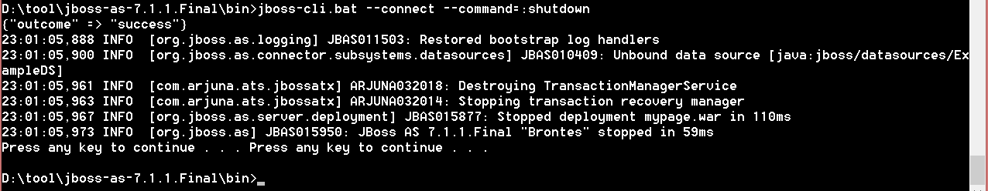

2 JBoss启动（eclipse中启动）

2.1 启动方式

在Servers视图下，右键点击JBoss项（需事先配好），选择start即可启动。

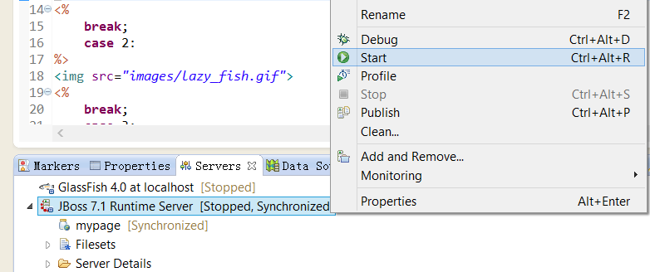

2.2 JBoss启动日志 （eclipse中启动）

21:32:10,494 INFO [org.jboss.modules] JBoss Modules version 1.1.1.GA

21:32:11,083 INFO [org.jboss.msc] JBoss MSC version 1.0.2.GA

21:32:11,199 INFO [org.jboss.as] JBAS015899: JBoss AS 7.1.1.Final "Brontes" starting

21:32:13,304 INFO [org.xnio] XNIO Version 3.0.3.GA

21:32:13,304 INFO [org.jboss.as.server] JBAS015888: Creating http management service using socket-binding (management-h

ttp)

21:32:13,330 INFO [org.xnio.nio] XNIO NIO Implementation Version 3.0.3.GA

21:32:13,351 INFO [org.jboss.remoting] JBoss Remoting version 3.2.3.GA

21:32:13,444 INFO [org.jboss.as.logging] JBAS011502: Removing bootstrap log handlers

21:32:13,452 INFO [org.jboss.as.configadmin] (ServerService Thread Pool -- 26) JBAS016200: Activating ConfigAdmin Subsy

stem

21:32:13,495 INFO [org.jboss.as.clustering.infinispan] (ServerService Thread Pool -- 31) JBAS010280: Activating Infinis

pan subsystem.

21:32:13,520 INFO [org.jboss.as.osgi] (ServerService Thread Pool -- 39) JBAS011940: Activating OSGi Subsystem

21:32:13,565 INFO [org.jboss.as.naming] (ServerService Thread Pool -- 38) JBAS011800: Activating Naming Subsystem

21:32:13,665 INFO [org.jboss.as.security] (ServerService Thread Pool -- 44) JBAS013101: Activating Security Subsystem

21:32:13,667 INFO [org.jboss.as.connector] (MSC service thread 1-5) JBAS010408: Starting JCA Subsystem (JBoss IronJacam

ar 1.0.9.Final)

21:32:13,681 INFO [org.jboss.as.security] (MSC service thread 1-3) JBAS013100: Current PicketBox version=4.0.7.Final

21:32:13,700 INFO [org.jboss.as.webservices] (ServerService Thread Pool -- 48) JBAS015537: Activating WebServices Exten

sion

21:32:13,849 INFO [org.jboss.as.naming] (MSC service thread 1-5) JBAS011802: Starting Naming Service

21:32:13,972 INFO [org.jboss.as.mail.extension] (MSC service thread 1-1) JBAS015400: Bound mail session [java:jboss/mai

l/Default]

21:32:14,125 INFO [org.jboss.as.connector.subsystems.datasources] (ServerService Thread Pool -- 27) JBAS010403: Deployi

ng JDBC-compliant driver class org.h2.Driver (version 1.3)

21:32:14,128 INFO [org.jboss.ws.common.management.AbstractServerConfig] (MSC service thread 1-4) JBoss Web Services - S

tack CXF Server 4.0.2.GA

21:32:15,298 INFO [org.jboss.as.server.deployment.scanner] (MSC service thread 1-1) JBAS015012: Started FileSystemDeplo

ymentService for directory D:\tool\jboss-as-7.1.1.Final\standalone\deployments

21:32:15,316 INFO [org.jboss.as.server.deployment.scanner] (DeploymentScanner-threads - 1) JBAS015003: Found mypage.war

in deployment directory. To trigger deployment create a file called mypage.war.dodeploy

21:32:15,521 INFO [org.jboss.as.remoting] (MSC service thread 1-5) JBAS017100: Listening on localhost/127.0.0.1:4447

21:32:15,524 INFO [org.jboss.as.remoting] (MSC service thread 1-4) JBAS017100: Listening on /127.0.0.1:9999

21:32:15,548 INFO [org.apache.coyote.http11.Http11Protocol] (MSC service thread 1-3) Starting Coyote HTTP/1.1 on http-l

ocalhost-127.0.0.1-8080

21:32:15,979 INFO [org.jboss.as.connector.subsystems.datasources] (MSC service thread 1-8) JBAS010400: Bound data sourc

e [java:jboss/datasources/ExampleDS]

21:32:16,081 INFO [org.jboss.as.server.deployment] (MSC service thread 1-5) JBAS015876: Starting deployment of "mypage.

war"

21:32:17,125 INFO [org.jboss.web] (MSC service thread 1-7) JBAS018210: Registering web context: /mypage

21:32:17,143 INFO [org.jboss.as] (MSC service thread 1-7) JBAS015951: Admin console listening on http://127.0.0.1:9990

21:32:17,145 INFO [org.jboss.as] (MSC service thread 1-7) JBAS015874: JBoss AS 7.1.1.Final "Brontes" started in 7341ms

- Started 172 of 249 services (76 services are passive or on-demand)

21:32:17,426 INFO [org.jboss.as.server] (DeploymentScanner-threads - 2) JBAS018559: Deployed "mypage.war"

JBoss日志

D:\tool\app_server\jboss-as-7.1.1.Final\standalone\log

JBoss管理平台

1配置管理员

访问管理平台，需输入<http://127.0.0.1:9990>后（若是7.1.0，则需要输入<http://127.0.0.1:9990/console>才会出现如下页面。而且奇怪的是，在server启动日志中看不到admin console的9990端口在listening。而7.1.1则有，怀疑是7.1.0的bug），弹出如下出错页面。访问管理平台先要遵照提示配置用户

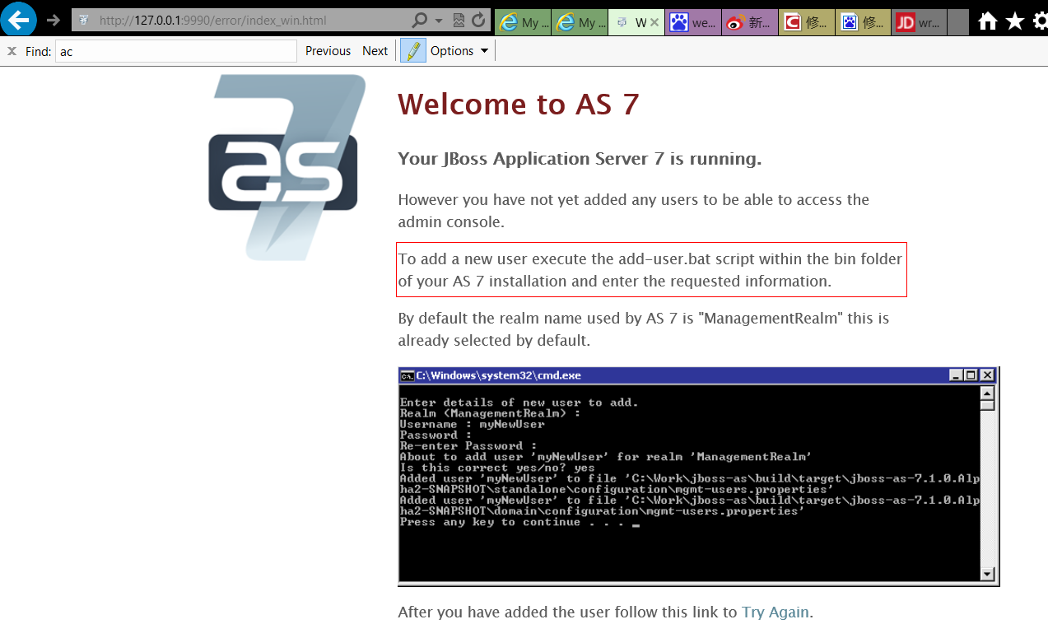

以下执行bin内的add-user.bat（以7.1.0为例，7.1.1类似）

d:\tool\app_server\jboss-as-7.1.0.Final>cd bin

d:\tool\app_server\jboss-as-7.1.0.Final\bin>add-user.bat

What type of user do you wish to add?

a) Management User (mgmt-users.properties)

b) Application User (application-users.properties)

(a):

Enter the details of the new user to add.

Realm (ManagementRealm) :

Username : admin

Password :

Re-enter Password :

The username 'admin' is easy to guess

Are you sure you want to add user 'admin' yes/no? yes

About to add user 'admin' for realm 'ManagementRealm'

Is this correct yes/no? yes

Added user 'admin' to file 'D:\tool\app_server\jboss-as-7.1.0.Final\standalone\configurati

on\mgmt-users.properties'

Added user 'admin' to file 'D:\tool\app_server\jboss-as-7.1.0.Final\domain\configuration\m

gmt-users.properties'

Press any key to continue . . .

d:\tool\app_server\jboss-as-7.1.0.Final\bin>

2访问管理平台：

以7.1.0为例，7.1.1类似

>输入管理员用户密码

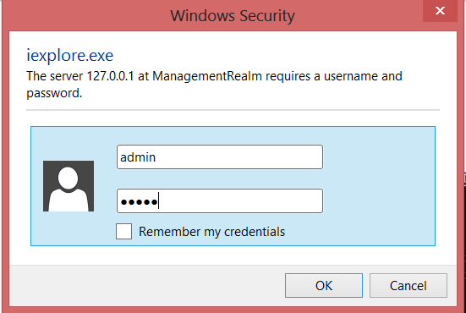

> 就可进入管理平台页面如下，在这可以部署应用，查看服务器状态，配置服务器等。

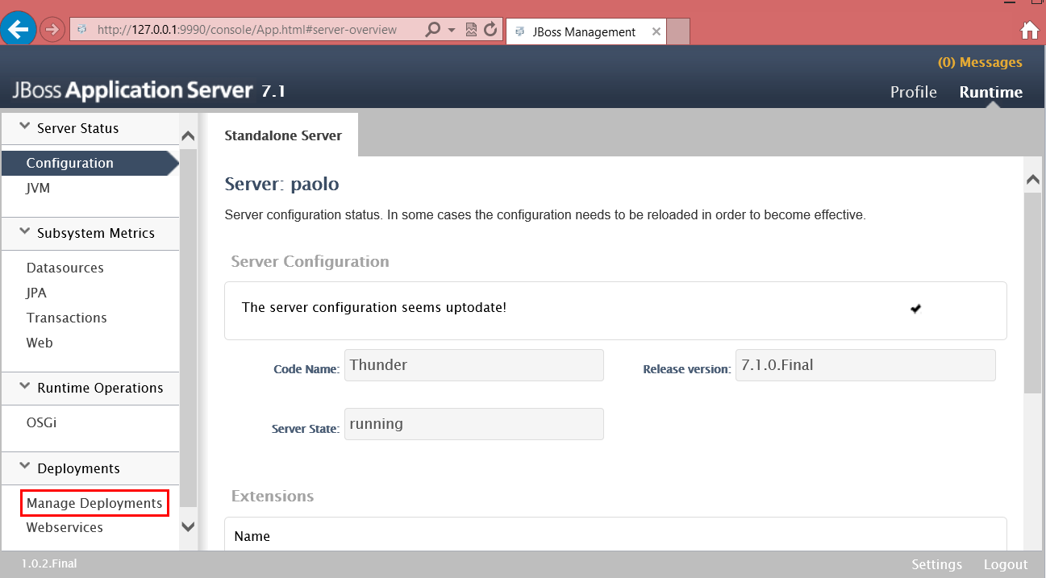

> 若要部署应用，则点击上图的Manage Deployments，出现页面如下：

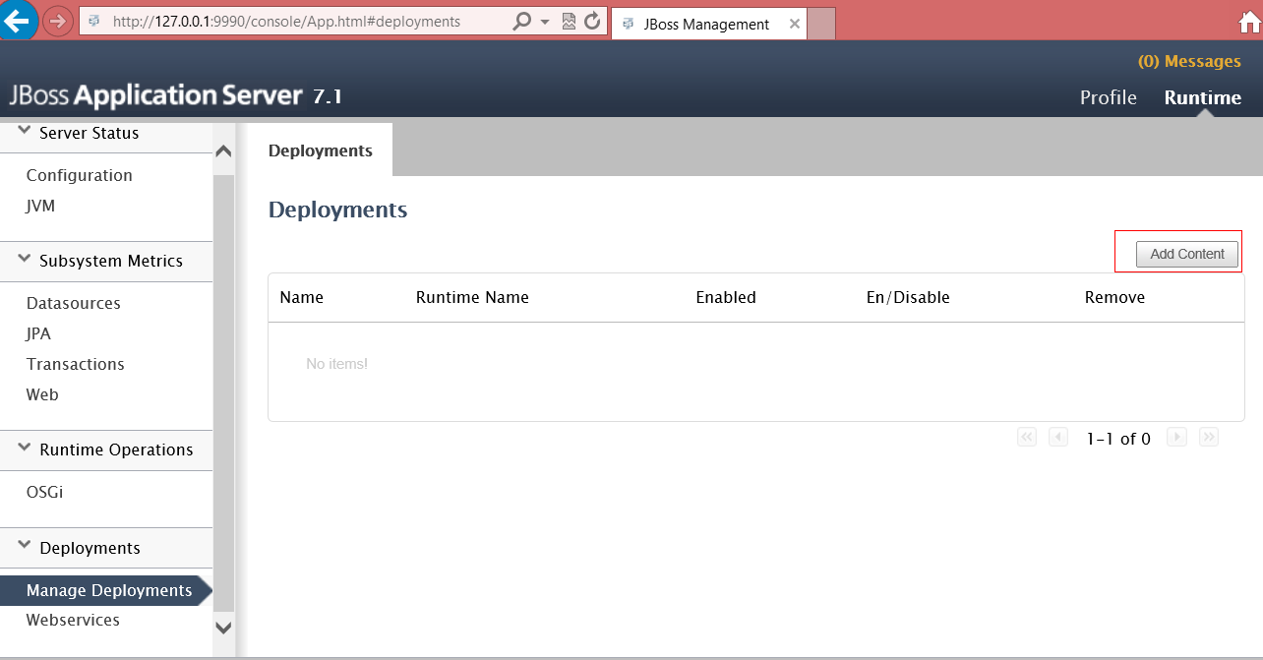

> 在上图中点击“Add Content”，出现页面如下：

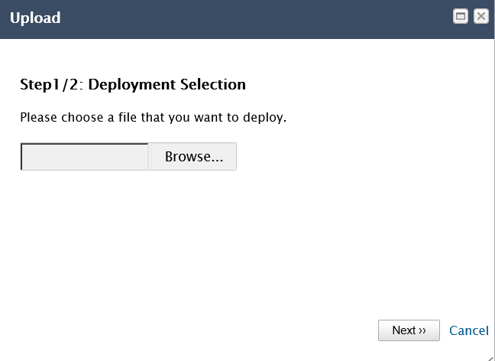

> 选择要上传的应用，如myface2.war

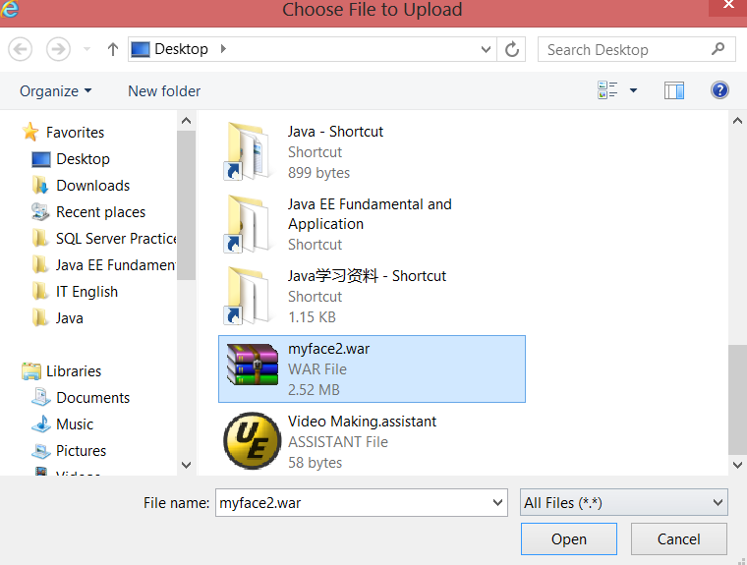

> 点Next

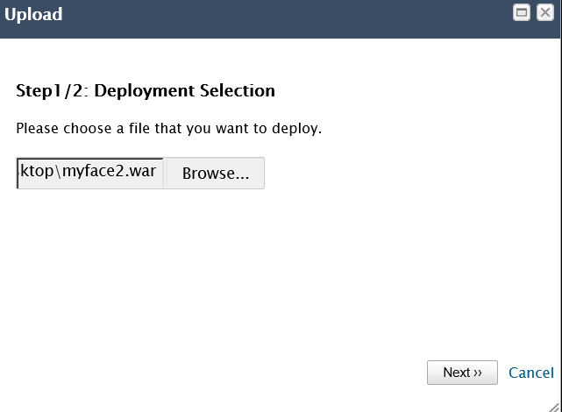

> 点Save

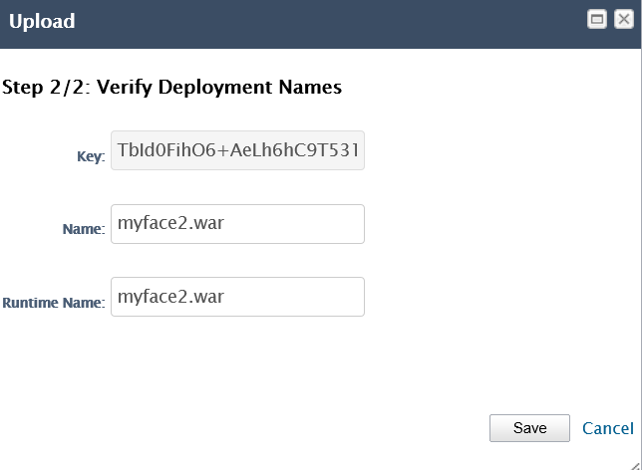

> 点Enable

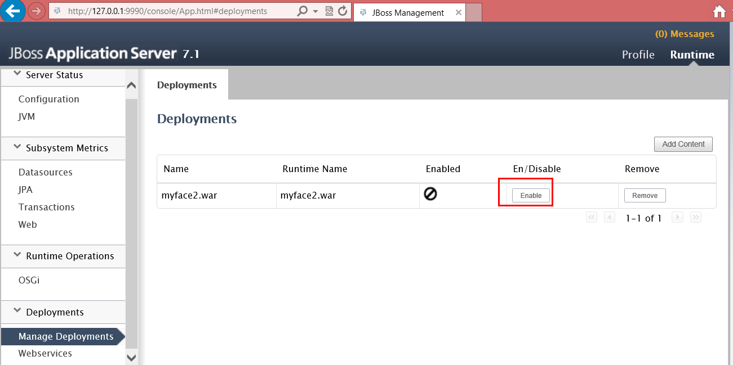

> 点confirm

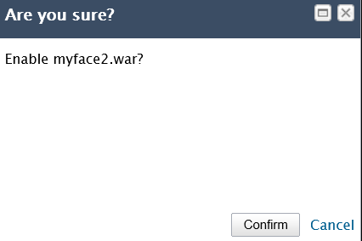

> 状态为enabled，则表示部署成功，如下

