

**NAME – RAHUL KUMAR GUPTA**

**ENROLLMENT NO – 18UEC079**

**Registration Number-1810082**

**wireless LABORATORY REPORT.**

**Semester- 7th.**

**Date :23.11.2021**

**List of experiments:**

|  |  |  |
| --- | --- | --- |
| SL NO | Name of experiments | Pages |
| 1. | To determine the free-space loss and the power received using MATLAB program. | 3 – 5. |
| 2. | To determine the path loss in 2-ray ground reflection model and the power received using MATLAB program. | 6 – 8. |
| 3. | To write a MATLAB program to calculate the median path loss for Okumura model for outdoor propagation. | 9 – 11. |
| 4. | To write a MATLAB program to calculate the median path loss for Hata model for outdoor propagation. | 12 – 15. |
| 5. | To generate Rayleigh random variables for slowly varying frequency non-selective channels using MATLAB program. | 16 - 18. |

**EXPERIMENT:1**

**Aim:**To determine the free-space loss and the power received using MATLAB program.

**Apparatus Required:**

|  |  |  |  |
| --- | --- | --- | --- |
| SL No | Equipment/Device | Specification | Quantity |
| 1 | Computer | Min 2 Ghz,250 Gb, Win 7 | 1 |
| 2 | MATLAB | 2021 | 1 user |

**Theory:**

The free space path loss (FSPL) , is the loss in signal strength that occurs when an electromagnetic wave travels over a line of sight (LOS) path in free space. In these circumstances there are no obstacles that might cause the signal to be reflected, refracted or even scattered.

To understand the reasons for the free space path loss, it is possible to imagine a signal spreading out from a transmitter. It will move away from the source spreading out in the form of a sphere. As it does so , the surface area of the sphere increases. As this will follow the law of the conservation of energy, as the surface area of the sphere increases, so the intensity of the signal must decrease.

As a result of this it is found that the signal decreases in a way that is inversely proportional to the square of the distance from the source of the radio signal.

**Free space path loss formula**

Free space path loss PL=Pt/Pr=(4πd)2/α2GtxGrx

Where d is the distance of the receiver from the transmitter(metres)

α =C/f is the signal wavelength(metres)

f is the signal frequency(Hertz)

C is the speed of light in a vacuum(metres per second)

Gtx  is the gain of the transmitter antenna

Grx is the gain of receiver antenna

The free space path loss formula is applicable to situations where only the electromagnetic wave is present, i.e., for far field situations. It does not hold true for near field situations.

**Decibel version of free space path loss equation:**

Most RF comparisons and measurements are performed in decibels. This gives an easy and consistent method to compare the signal levels present at various points. Accordingly it is very convenient to express the free space path loss formula, FSPL, in terms of decibels.

FSPL(dB)=20log10(d) + 20log10(f) + 32.44- Gtx - Gtx

Where Gtx  is the gain of the transmitter antenna relative to an isotropic source(dBi)

Grx is the gain of receiver antenna relative to an isotropic source(dBi)

**Program:**

f=6*10^6;

c=300;

lambda=c/f;

D=1;

df=(2*D^2)/lambda;

d=1*df:0.1*df:5*df;

Gtx=15;

Grx=12;

Wt=90;

PI=20*log10(d)+20*log10(f)+20*log10(4*pi/c)-Gtx-Grx;

Wr=Wt-PI;

subplot(2,1,1);

plot(log10(d),Wr);

xlabel('log10(d)');

ylabel('recieved power in dbm');

Wr=10.^(Wr/10);

subplot(2,1,2);

plot(d,Wr);

xlabel('Distance in meter');

ylabel('Recieved power in Watts');

**Result:** The program for power received by an antenna and path loss in free space propagation has been performed successfully.

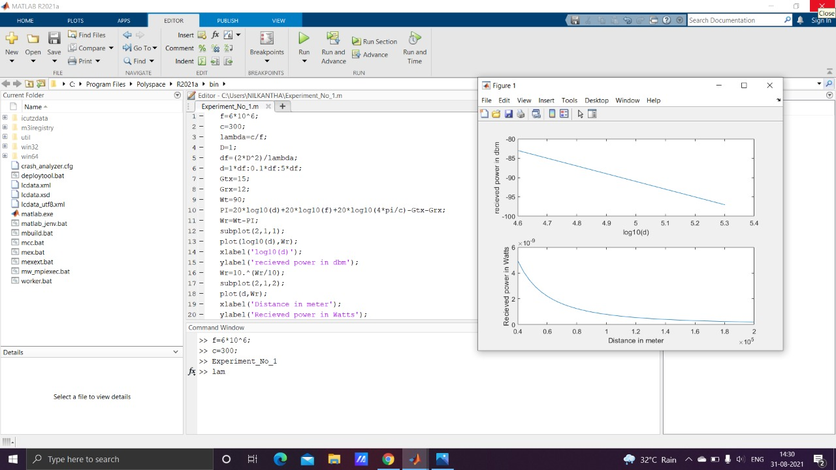

**EXPERIMENT:2**

**Aim:**To determine the path loss in 2-ray ground reflection model and the power received using MATLAB program.

**Apparatus Required:**

|  |  |  |  |
| --- | --- | --- | --- |
| SL No | Equipment/Device | Specification | Quantity |
| 1 | Computer | Min 2 Ghz,250 Gb, Win 7 | 1 |
| 2 | MATLAB | 2021 | 1 user |

**Theory:**

The ground reflection model assumes an additional reflected path apart from the LOS one and it gives us the received power when antenna gains and antenna heights are given with transmitter receiver separation. The transmitter-receiver separation distance(d) should be greater than a critical distance(dc) where, dc=4hthr/α. Also, we assume grazing incidence , for which reflection coefficient is -1.

**2-ray ground reflection model**

Path loss PL=Pt/Pr = d4/ht2hr2GtxGrx

Where d is the distance of the receiver from the transmitter(metres)

α =C/f is the signal wavelength(metres)

f is the signal frequency(Hertz)

C is the speed of light in a vacuum(metres per second)

Gtx  is the gain of the transmitter antenna

Grx is the gain of receiver antenna

ht is the transmitter antenna height

hr is the receiver antenna height

**Decibel version of free space path loss equation:**

Most RF comparisons and measurements are performed in decibels. This gives an easy and consistent method to compare the signal levels present at various points. Accordingly it is very convenient to express the free space path loss formula, PL, in terms of decibels.

PL(dB)= 40log10(d) + 20log10(ht) + 20log10(hr) - Gtx - Grx

Where Gtx  is the gain of the transmitter antenna relative to an isotropic source(dBi)

Grx is the gain of receiver antenna relative to an isotropic source(dBi)

**Program:**

f=6*10^6;

L=300/f;

ht=50;

hr=40;

Gt=25;

Gr=20;

Wt=100;

dc=(4*ht*hr)/L;

d=1.6*dc:0.1*dc:5*dc;

PI=40*log10(d)-20*log10(ht)-20*log10(hr)-Gt-Gr;

fprintf('%s %d %s','the path loss is:',PI,'db');

Wr=Wt-PI;

fprintf('%s %d %s','the recieved power is:',Wr,'db');

subplot(2,1,1)

plot(log10(d),Wr)

xlabel('log(d)')

ylabel('recieved power in dbm')

wr=10.^(Wr/10);

fprintf('%s %d %s','the recieved power is:',wr,'watts');

subplot(2,1,2)

plot(d,wr)

xlabel('distance in mt')

ylabel('recieved power in watts')

**Result:** The program for power received by ground reflection ray tracing technique has been performed successfully.

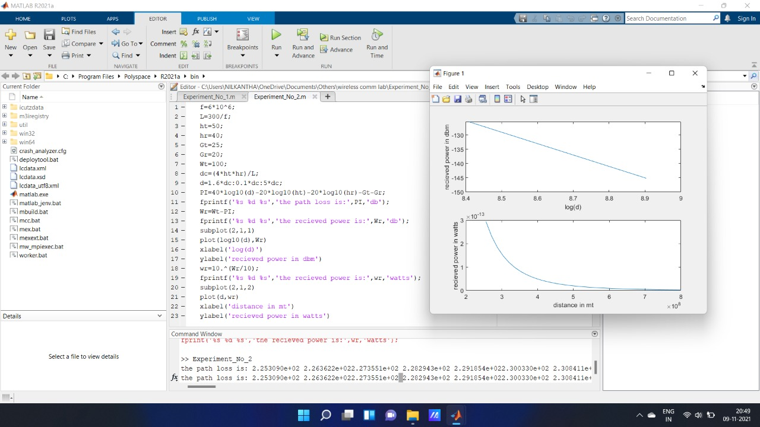

**EXPERIMENT:3**

**Aim:**To write a MATLAB program to calculate the median path loss for Okumura model for outdoor propagation.

**Apparatus Required:**

|  |  |  |  |
| --- | --- | --- | --- |
| SL No | Equipment/Device | Specification | Quantity |
| 1 | Computer | Min 2 Ghz,250 Gb, Win 7 | 1 |
| 2 | MATLAB | 2021 | 1 user |

**Theory:**

The Okumura model for Urban Areas is a Radio propagation model that was built using the data collected in the city of Tokyo, Japan. The model is ideal for using in cities with many urban structures but not many tall blocking structures. The model served as a base for the Hata model. Okumura model was built into three modes viz. urban, suburban and open areas. The model for urban areas was built first and used as base for others.

**Coverage:**

Frequency=150MHz to 1920 MHz(typically extended up to 3GHz)

Mobile station Antenna Height: Between 1m and 10m

Base station Antenna Height : Between 30m and 1000m

Link distance : Between 1km and 100km

**Mathematical formulation:**

The Okumura model is formally expressed as:

L50(dB)=LFSPL(fc, d) + Amu(fc, d) - G(hte) - G(hre) – GAREA

Where,

L50(dB)= The median (50th  percentile) path loss.

LFSPL(fc, d)= Thre free space path loss.

Amu(fc, d) = The median attenuation relative to free space(obtained from curve)

**Program:**

clc;

clear all;

close all;

f=input('Enter the frequency in MHz:');

d=input('Enter the distance between transmitter and reciever in km:');

Gt=input('Enter the transmitting antenna gain in dbs:');

Gr=input('Enter the receiving antenna gain in dbs:');

Lfsp1=32.45+20*log10(d)+20*log10(f)-Gt-Gr;

fprintf('%s%d%s','the free space path loss is:',Lfsp1,'dB');

Amu=input('\nEnter the median attenuation value from curves:');

G_area=input('Enter the Correction factor gain from curves:');

hte=input('Enter the Base Station Antenna height in mt:');

if 30<hte && hte<1000

G(hte)=20*log10(hte/200);

elseif hte<30

G(hte)=10*log10(hte/200);

else G(hte)=0;

end

fprintf('%s%d%s','The Base Station Antenna Height gain factor:',G(hte),'dB');

hre=input('\nEnter the Mobile Station Antenna height in mt:');

if hre<3

G(hre)=10*log10(hre/3);

elseif 3<hre && hre<=10

G(hre)=20*log10(hre/3);

else G(hre)=0;

end

fprintf('%s%d%s','The Mobile Station Antenna Height gain factors:',G(hre),'dB');

L=Lfsp1+Amu-G(hte)-G(hre)-G_area;

fprintf('\n%s%f%s','The median path loss:',L,'dB');

**Result:**The program for Okumura Model for outdoor propagation was simulated successfully.

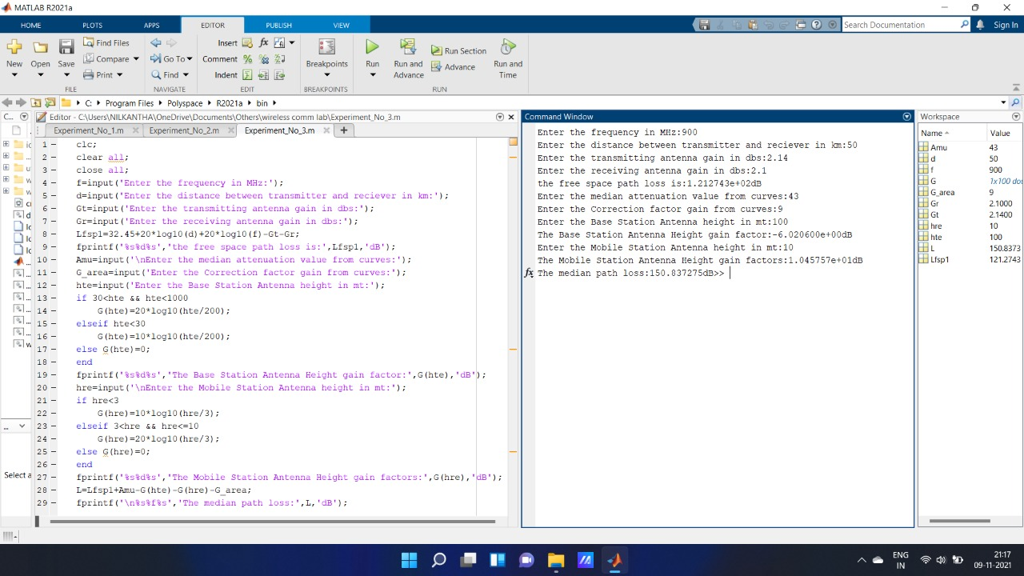

**EXPERIMENT:4**

**Aim:**To write a MATLAB program to calculate the median path loss for Hata model for outdoor propagation.

**Apparatus Required:**

|  |  |  |  |
| --- | --- | --- | --- |
| SL No | Equipment/Device | Specification | Quantity |
| 1 | Computer | Min 2 Ghz,250 Gb, Win 7 | 1 |
| 2 | MATLAB | 2021 | 1 user |

**Theory:**

In wireless communication , the Hata Model for Urban Areas, also known as the Okumura-Hata model for being a developed version of the Okumura Model, is the most widely used radio frequency propagation model for predicting the behavior of cellular transmissions in built up areas. This model incorporates the graphical information from Okumura model and develops it further to realize the effects of diffraction, reflection and scattering caused by city structures. This model also has two more varieties for transmission in suburban areas and open areas. Hata Model predicts the total path loss along a link of terrestrial microwave or other type of cellular communications.

This particular version of the Hata model is applicable to the radio propagation within urban areas. This model is suited for both point-to-point and broadcast transmissions and it is based on extensive empirical measurements taken.

**Coverage:**

Frequency=150MHz to 1500MHz

Mobile station Antenna Height: Between 1m and 10m

Base station Antenna Height : Between 30m and 200m

Link distance : Between 1km and 20km

**Mathematical Formulation**

Hata Model for Urban areas is formulated as:

PL,Urban=69.55 + 26.16log f – 13.82log ht – a(hr)+[44.9-6.55log ht] log d.

For small or medium sized city,

a(hr) = 0.8+ (1.1 log f - 0.7) hr - 1.56 log f

and for large cities,

a(hr) = 8.29(log 1.54 hr)2 – 1.1, if 150<= f<= 200

a(hr) = 3.2(log 11.75 hr)2 – 4.97, if 200<= f<= 1500

where,

PL,Urban=Path loss in urban areas(dB)

ht = Height of base station Antenna(m)

hr = Height of mobile station Antenna(m)

f = Frequency of Transmission(MHz)

a(hr) = Antenna height correction factor

d= Distance between the base and mobile stations(km)

The term “small city” means a city where the mobile antenna height is not more than 10meters i.e., 1<=hr<=10m

**Program:**

clc;

clear all;

close all;

f=input('Enter the frequency in MHz:');

ht=input('Enter the height of base station Antenna in meter:');

hr=input('Enter the height of mobile station Antenna in meter');

d=input('Enter the distance between the base and mobile stations:');

n=input('Enter 0 for small city and 1 for large city:');

if n==0

a_hr=0.8+(1.1*log10(f)-0.7)*hr-1.56*log10(f);

else

if f>=150 && f<=200

a_hr=8.29*(log10(1.54*hr))^.2-1.1;

else

if f>=200 && f<=1500

a_hr=3.2*log10(11.75*hr)^.2-4.97;

end;

end;

end;

PL_U=69.55+26.26*log10(f)-13.82*log10(ht)-a_hr+(44.9-6.55*log10(ht))*log10(d);

fprintf('%s%f%s','Path loss is Urban Areas =',PL_U,'dB');

**Result:**The program for Hata Model for outdoor propagation was simulated successfully.

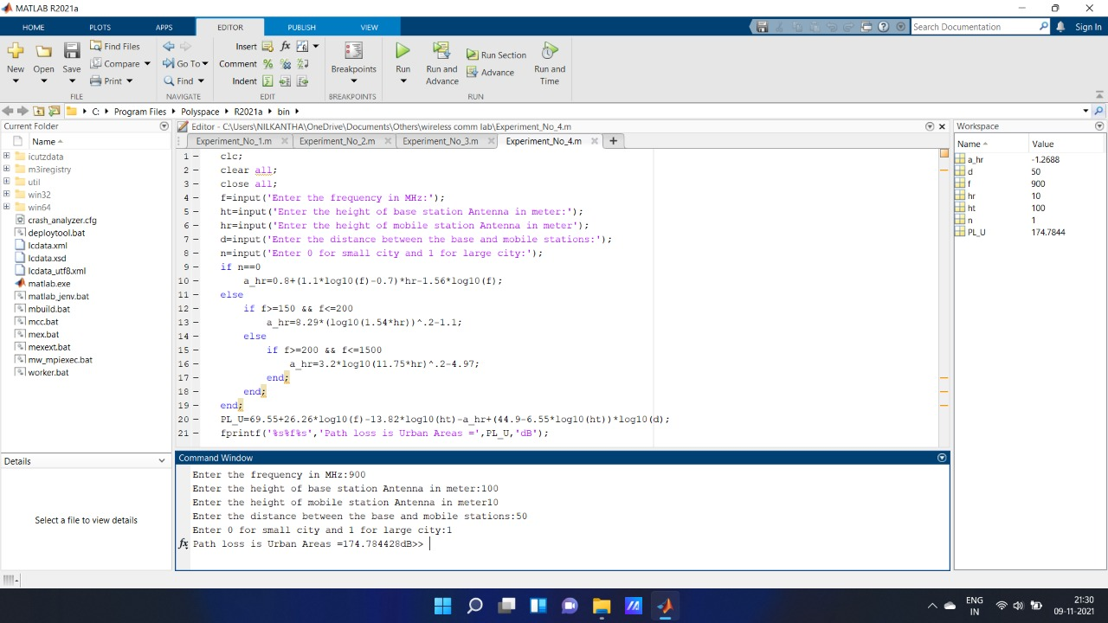

**EXPERIMENT - 5**

Aim: To generate Rayleigh random variables for slowly varying frequency non-selective channels using MATLAB program.

Apparatus Required:

|  |  |  |  |
| --- | --- | --- | --- |
| Sl.No. | Equipment/Device | Specification | Quantity |
| 1 | Computer | Min 2 Ghz,250 Gb, Win 7 | 1 |
| 2 | Matlab | 2014 | 1 user |

Theory:

There are basically two distinct characteristics of the radio channels.First, the transmittted signal arrives at the reciever via multiple propagation paths, each of which has an associated propagation time delay.Second, the time variation can occur either in the structure of the medium, such as the ionosphere, or the motion and position of the transmitter and reciever relative to the terrain between them.

To obtain a statistical description of the channel, consider the transmission of an un-modulated carrier

s(t)=cos(2)

The recieved signal in the absence of noise may be expressed as:

x(t)=-

Where  are the multipath attenuation factors and  are multipath delays.

Using the complex baseband formulation, the complex channel response is given by

c(t)=)=exp(-j

The frequency non-selective channel model applies when the transmitted signal bandwidth W satiesfies the condition W<< Bcb, where Bcb is coherence bandwidth.A further simplification occurs when the coherence time Tct of the channel is much larger than the signal time duration T (i.e , Tct>> T). In this case, the channel characteristic c(t) may be treated as a constant over the signal duration T and may be expressed as

c(t)=

The real and imaginary part of c(t) are usually modeled as zero-mean, Gaussian random processes with zero cross-correlation. Therefore  is chacterized statistically by the Rayleigh probability distribution and  is uniformly distributed over the interval (0, 2 The Rayleigh fading signal amplitude is described by the Probability Density Function(PDF).



Program:

N=200000;

x=0:0.05:5;

sigma=1;

u=rand(1,N);

u=rand(1,N);

r=sigma*sqrt(-2*log(u));

r_ac=x/sigma^2.*exp(-(x/sigma).^2/2);

subplot(2,1,1);

hist(r,x);

xlabel('(a)Histogram for N=200000 samples');

axis([0 5 0 7500]);

subplot(2,1,2);

plot(x,r_ac);

xlabel('(b)Rayleigh PDF');

Observed Ouput:

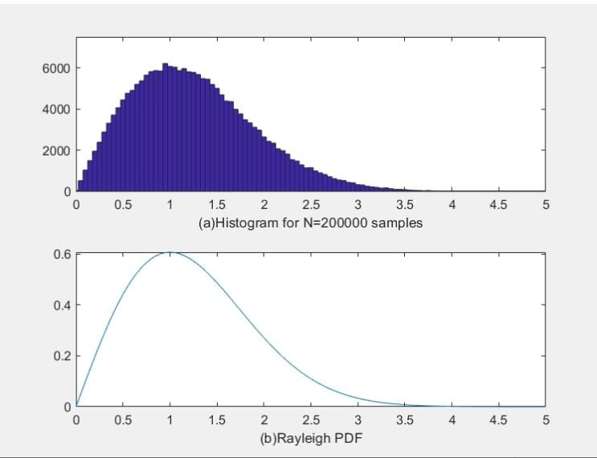

Result: The program for generation of Rayleight random variables was simulated successfully.