**FRONT PANEL**

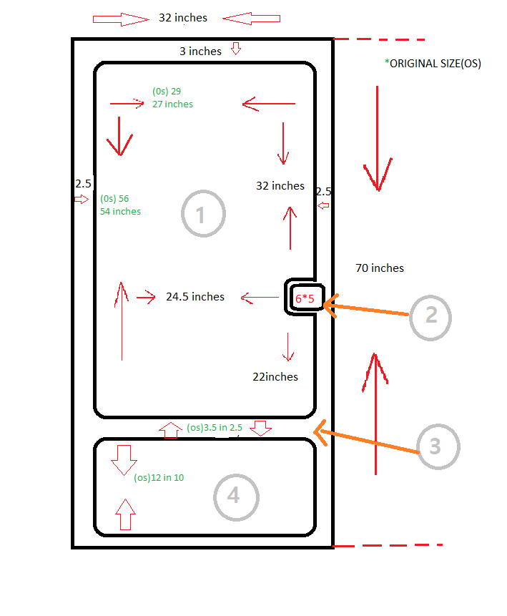

**This is the front view of our vending machine where the sizes are mentioned in the above diagram.**

1. This frame is made up of Fiber and it is transparent.
2. Key pad is used enter security key (OTP) to get the order which you have been placed.
3. It is a major front frame of vending machine.
4. This is a place where the delivered items/products can be picked by customer.

**SIDE PANELS**

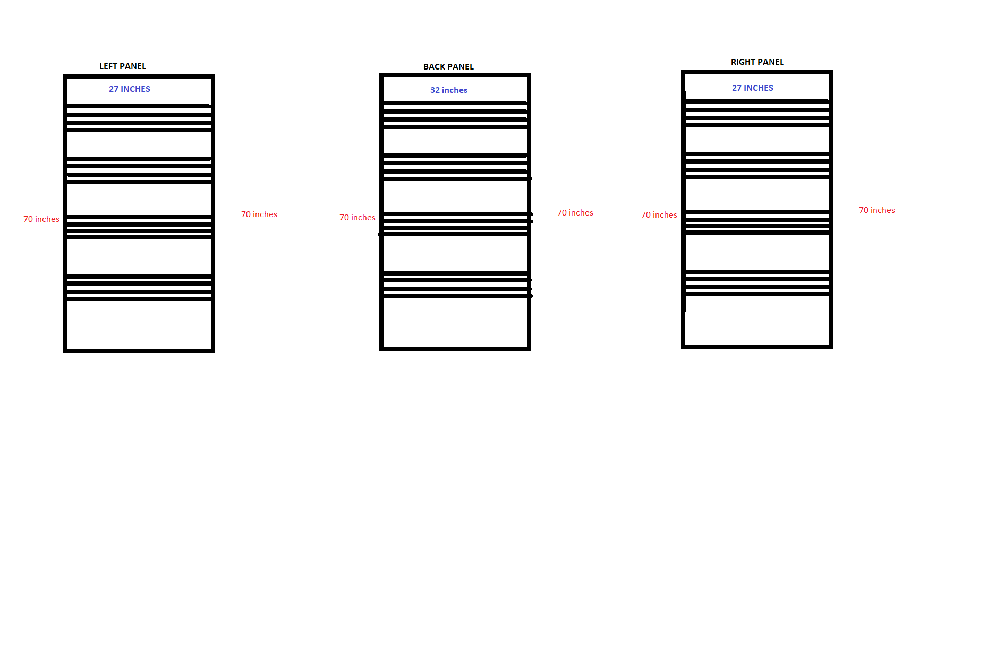

**The above cases show the side body of the machine which has different width with same height. The horizontal line holds the inner case.**

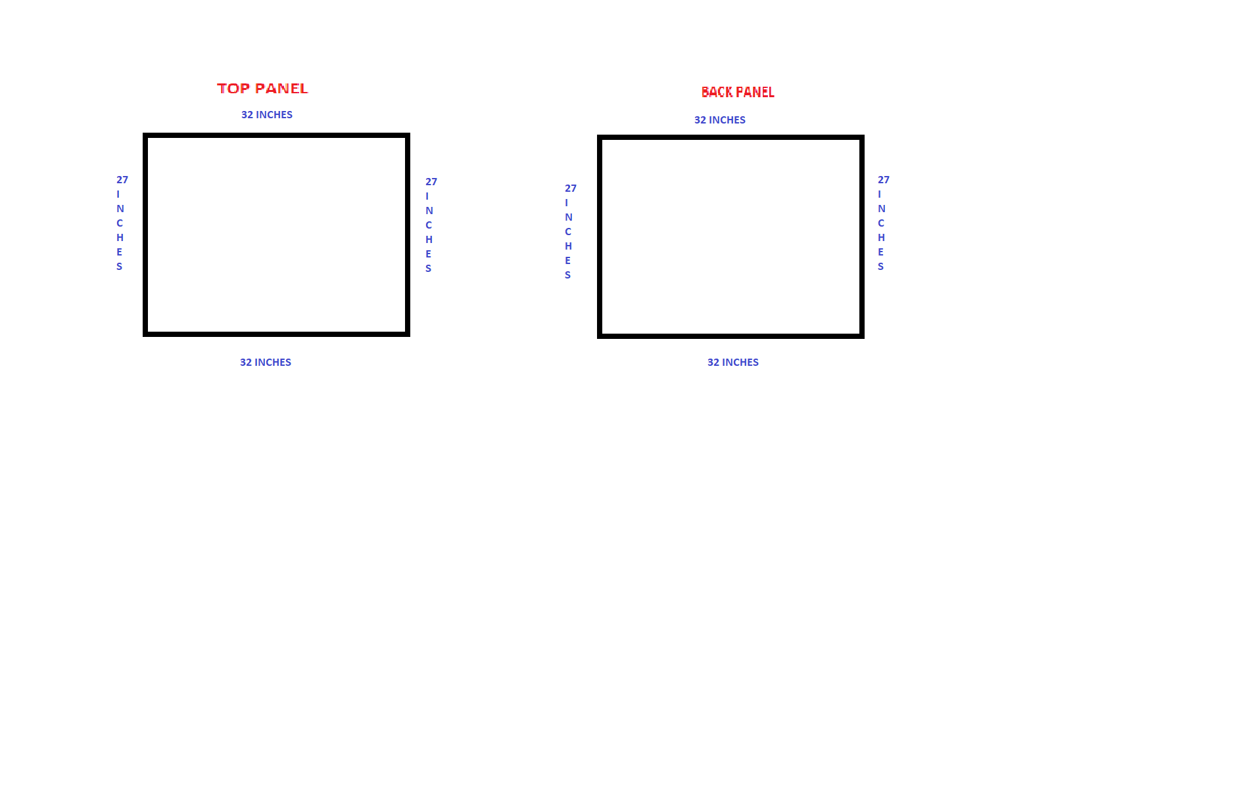**TOP-DOWN PANEL CASES**

As you already know the same fiber have been used here.

In order to maintain the minimum security of the vending machine, compare to left and right panel the top and bottom more durable.