**PES UNIVERSITY EC CAMPUS**

A Project Report On

**“VENDING MACHINE USING WALLET”**

Submitted in the fulfilment of the requirements for full credits on the course of

MICROPROCESSOR AND COMPUTER ARCHITECTURE

BACHELOR OF TECHNOLOGY IN COMPUTER SCIENCE ENGINEERING.

**Submitted By**

BHARTH B REDDY PES2UG20CS802

GURAM BALAJI PES2UG20CS805

PRADEEP R S PES2UG20CS807

SAI GANESH B PES2UG20CS810

SHRINIVAS V K PES2UG20CS811

Under the Support and Guidance of

**PRAJWALA T R**

Assistant Professor,

Department of CSE.

**CHANDRASHEKHAR P CHAVAN**

Assistant Professor,

Department of CSE.

**DR. SANDESH B J**

HEAD OF THE DEPARTMENT(CSE)

TABLE OF CONTENT

**History 4**

**Introduction** **4**

**Enhancement5**

**Future scope5**

**Advantage and disadvantages** **5**

**Case6-7**

Front panel6

Side panels7

Top-down panels cases 7

**Inner case8-9**

**Processing unit10-11**

Connecting keypad to Adriano mega board10

Working of Adriano mega board 11

**Sensors12-14**

Humidity Sensor12

Vibration Sensor 12

Temperature Sensor12

Smoke Sensor13

Rain Sensor 13

Motion Sensor 13

Ultrasonic ranging Sensor 14

Pressure Sensor 14

**User Panel15-10**

Login page 15

Register page15

Pick (select) an item 16

Cart page17

Alert page17

Generated OTP 18

My wallet page 18

Order page 19

Profile page 19

Setting page 20

Contact us 20

**Admin21-23**

Log in21

Dashboard21

User page22

Products page22

Transaction page23

Contact page23

**Working of entire** **module24**

**Conclusion25**

**VENDING MACHINE USING WALLET**

**HISTORY**

The first modern coin-operated vending machines were introduced in [London](https://en.wikipedia.org/wiki/London), [England](https://en.wikipedia.org/wiki/England) in the early 1880s, dispensing [postcards](https://en.wikipedia.org/wiki/Postcard). The machine was invented by Percival Everitt in 1883 and soon became a widespread feature at railway stations and post offices, dispensing [envelopes](https://en.wikipedia.org/wiki/Envelopes), [postcards](https://en.wikipedia.org/wiki/Postcard), and [notepaper](https://en.wikipedia.org/wiki/Notepaper). The Sweetmeat Automatic Delivery Company was founded in 1887 in England as the first company to deal primarily with the installation and maintenance of vending machines. In 1893, [Stollwerck](https://en.wikipedia.org/wiki/Stollwerck), a German chocolate manufacturer, was selling its chocolate in 15,000 vending machines. It set up separate companies in various territories to manufacture vending machines to sell not just chocolate, but cigarettes, matches, chewing gum, and soap products.

The first vending machine in the U.S. was built in 1888 by the [Thomas Adams Gum Company](https://en.wikipedia.org/wiki/Thomas_Adams_Gum_Company), selling gum on New York City train platforms. The idea of adding games to these machines as a further incentive to buy came in 1897 when the Pulver Manufacturing Company added small figures, which would move around whenever somebody bought some gum from their machines. This idea spawned a whole new type of mechanical device known as the "trade stimulators".

**INTRODUCTION**

An automated machine which is intended to provide the users with a diverse range of products: snacks, beverages, pizzas, cupcakes, newspapers, tickets, etc. A vending machine dispenses a product to the users based on the selection of the product. Vending machine is a 24x7 standalone unit which requires a standard power supply connection to function. It consists of simple electro-mechanical systems which helps to automate the entire vending process. In a nutshell, its basic function is to flawlessly issue users with a diverse range of products anytime.

Various types of food and [snack](https://en.wikipedia.org/wiki/Snack) vending machines exist in the world. Food vending machines that provide shelf-stable foods such as chips, cookies, cakes, and other such snacks are common. Some food vending machines are refrigerated or frozen, such as for chilled soft drinks and ice cream treats, and some machines provide hot food.

Some unique food vending machines exist that are specialized and less common, such as the [French fry vending machine](https://en.wikipedia.org/wiki/French_fry_vending_machine) and hot pizza vending machines, such as [Let's Pizza](https://en.wikipedia.org/wiki/Let%27s_Pizza). The [Beverly Hills Caviar Automated Boutique](https://en.wikipedia.org/wiki/Beverly_Hills_Caviar_Automated_Boutique) dispenses frozen caviar and other high-end foods.

We are going to design in same ways where it stores and deliveries the snacks, only such products which can be stored in non – refrigerated area. vending machine are not going to take money, instead we use application to interact with the vending machine and users. Where users can store money in their wallets to buy products which are in vending machine. We got this idea of wallets because the world is going on with the cashless modes.

Introducing Self Service Vending Machines (Snacks) to give 24*7 food facilities to the students. A customer is always willing to have some basic demands. And we are here to satisfy those, now from our vending machine.

**Enhancement:**

* We have reduced the burden of customers for longer period of time for the desired product through cash less transactions which would help to reduce lot of time for the customer.
* As we can keep track of the amount of fundings in real time with our embedded software, compared to the current vending machines in market.
* In order of security threats (theft) there will be robbery of money stored in vending machine, while in our machine it will be securely stored in digital wallets.
* As we are concern with security, we have made enhance development in security via powerful sensors, with respect to any unethical theft or damage to machine.

**Future scope:**

* We can assure that our machine can overtake the current machines with respect to (Security, time, performance). So, we assure you in future with better enhancement features.

The main objective of this project is to step forward towards digitalization and automation. This machine is a replica to show how automatic transaction works and how it makes life easier.

**ADVANTAGE AND DISADVANTAGES**

Advantage

* Low Maintenance.
* Variety of Options
* Saves Time and Money
* Accessibility and Convenience
* No Overhead Cost
* Healthier Options for a Healthier Lifestyle

Disadvantages

## Added Administrative Costs

## Competition for Other Food Vendors

## Quality and Quantity of Snacks Offered

## Costly Investment

**CASE**

**FRONT PANEL**

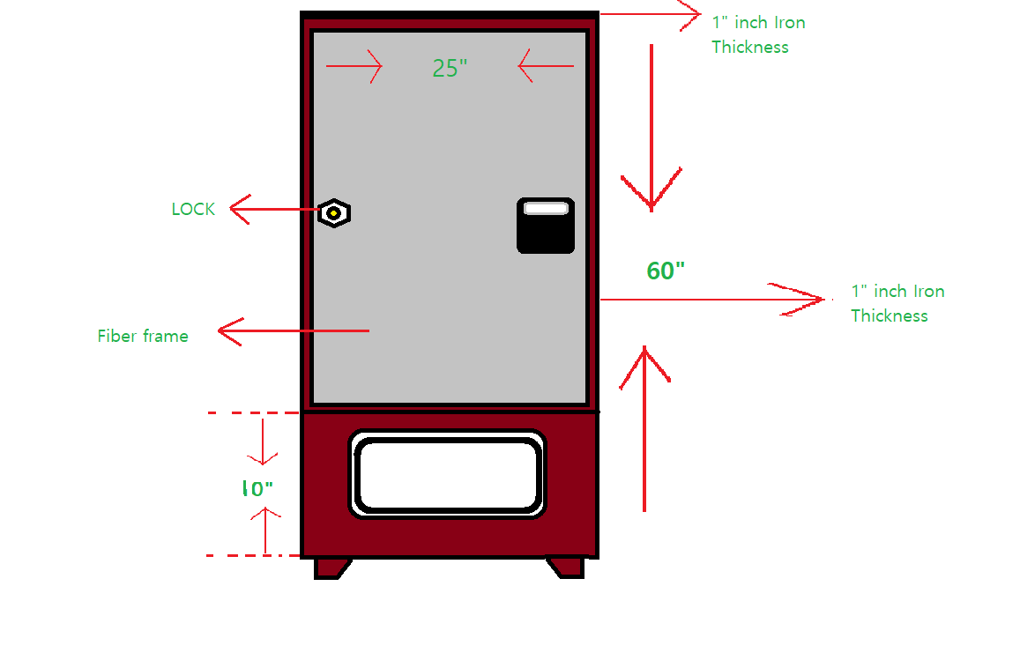

**This is the front view of our vending machine where the sizes are mentioned in the above diagram.**

1. This frame is made up of Fibre and it is transparent.
2. Key pad is used enter security key (OTP) to get the order which you have been placed.
3. It is a major front frame of vending machine.
4. This is a place where the delivered items/products can be picked by customer.

**SIDE PANELS**

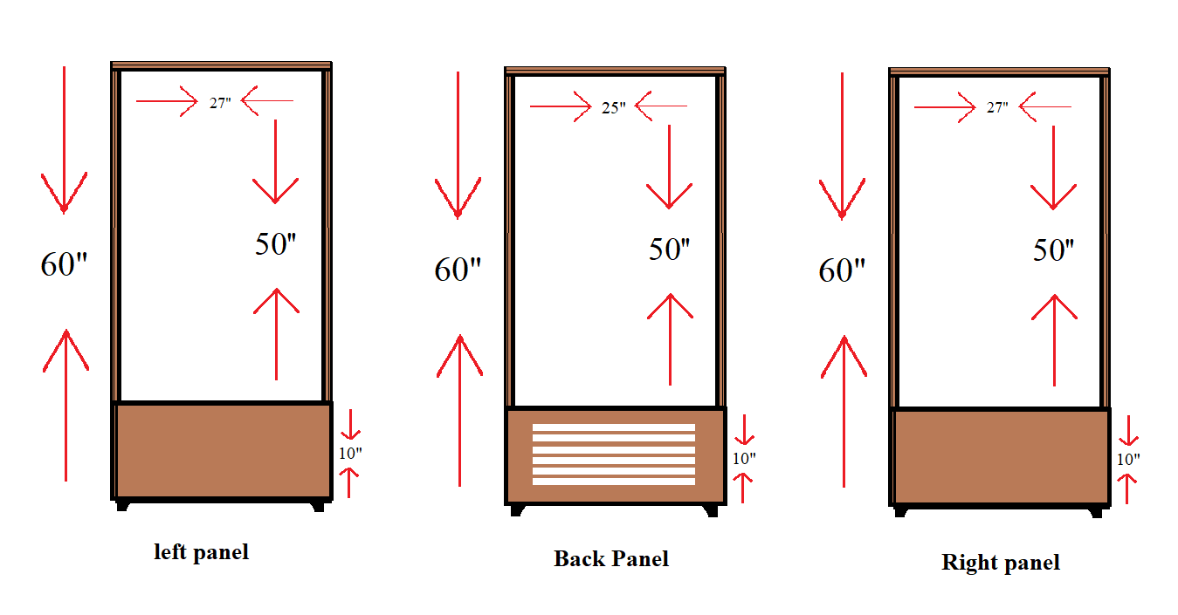

**The above cases show the side body of the machine which has different width with same height. The horizontal line holds the inner case.**

**TOP-DOWN PANEL CASES**

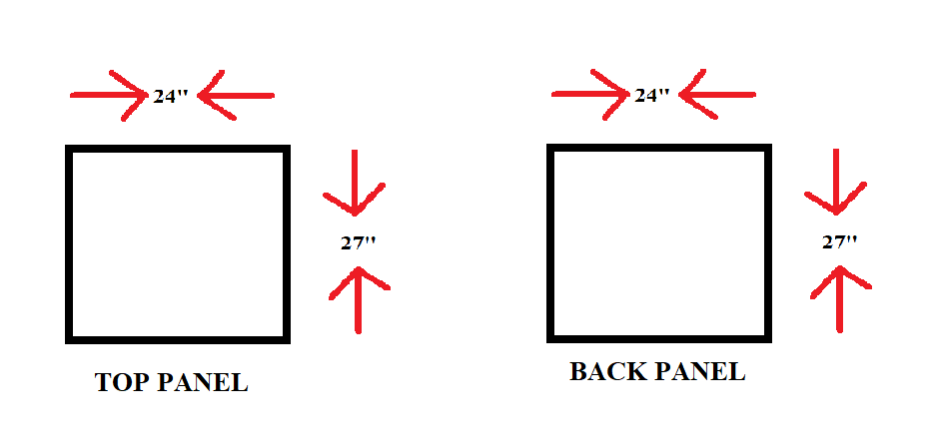

As you already know the same fibre have been used here.

In order to maintain the minimum security of the vending machine, compare to left and right panel the top and bottom more durable.

**INNER CASE**

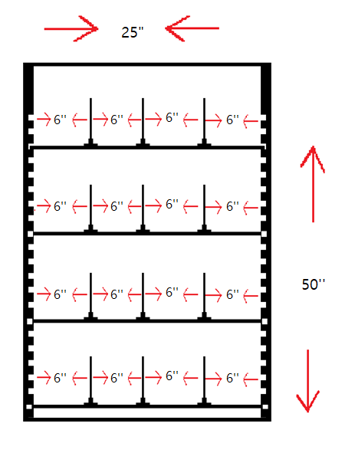

**Description:**

* Bold, Clear and Everlasting FLAT Metallic rack.

**NOTE:** we can adjust the rack position depending on the products as there will be no change in column section.

**Working:**

Many vending machines are equipped with metal spirals to hold products in place. Of course, those spirals are easy to observe if you're peering through a machine with a glass frame.

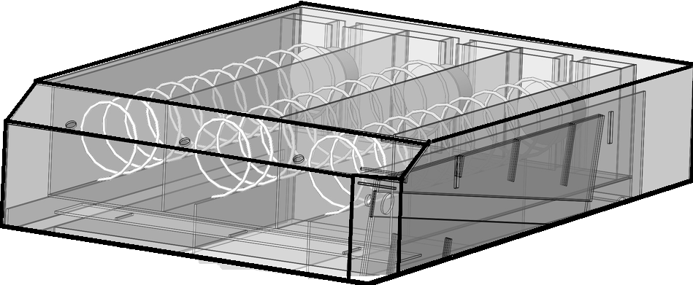

The metal spirals that hold products in place are controlled by a motor, which turns the coils once the processing unit has determined. This allows to deliver your products to drop to the bottom where you can finally pick it.

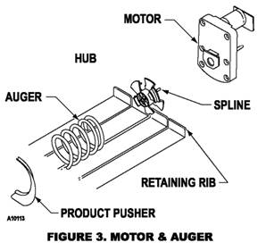

At the bottom of the vending machine, A motion sensor determines if your product has been released by the metal spirals. When your product falls motion sensor detects that there is a product successfully arrived.

**PROCESSING UNIT**

**CONNECTING MULTIPLE MOTORS TO** **ARDUINO MEGA BOARD**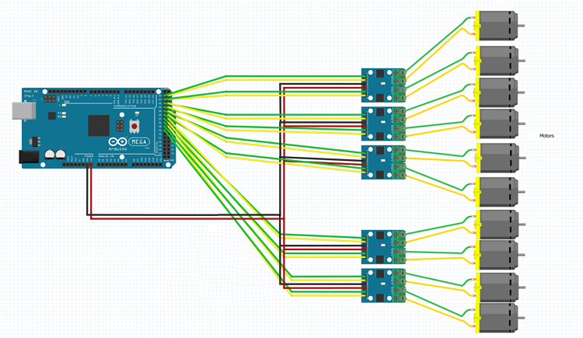

**CONNECTING KEYPAD TO ARDUINO MEGA BOARD**

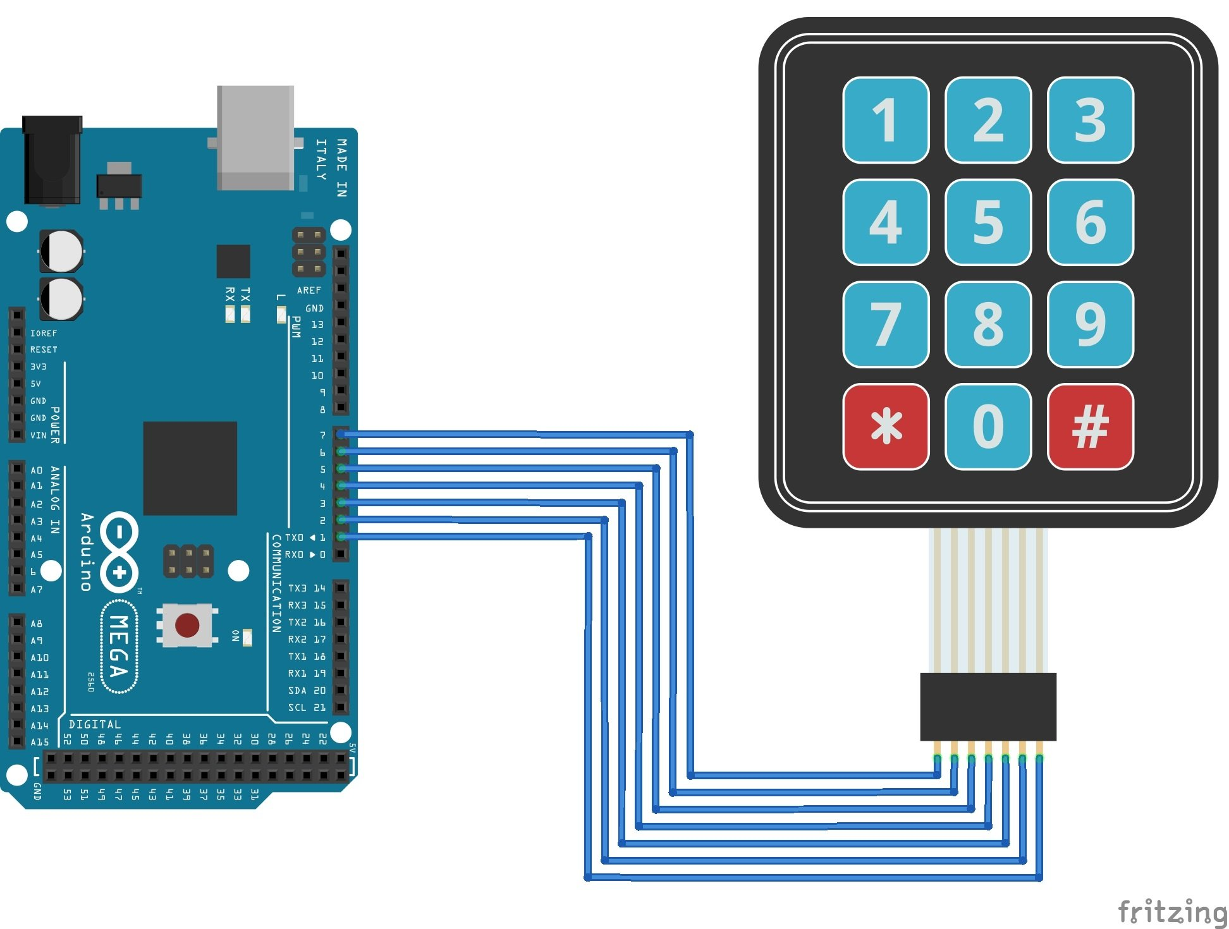

**WIFI Module Keypad Display**

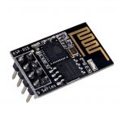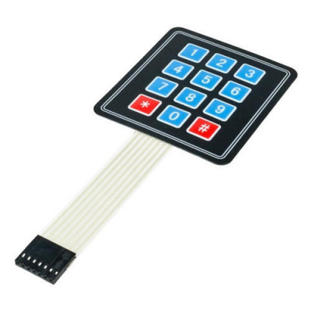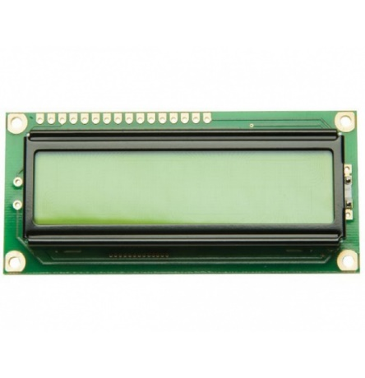

**WORKING OF ARDUINO MEGA BOARD:**

* It will connect to internet using Wi-Fi module.
* Then it will be connected to database.
* It will take input (OTP NUMBER) from the user by using keypad.
* It will display “Please wait” message.
* It will go to database and checks for OTP is present or not.
* If OTP doesn’t match it will display “Wrong OTP” message on display.
* If OTP match, it will get corresponding products ID from database.
* By using products ID, it will send request to the corresponding motors and motors will be rotated so that the required products will be delivered.
* There will be motion sensor which will sense whether the product has felled or not.
* If product has not felled it will again send request to the motor to rotate.
* So that the product will be felled down.
* It will display “Thank you” message.

**SENSORS**

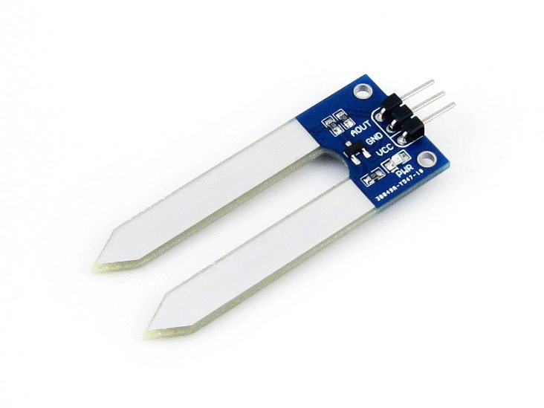

**1. HUMIDITY SENSORS**:

It is used to sense the humidity inside the machine. So that to remove the products which may be spoiled by humidity.

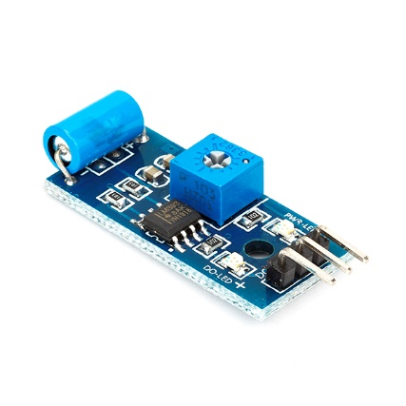

**2. VIBRATION SENSORS:**

It will sense any unwanted vibration in the machine. And alert buzzer is connected to it.

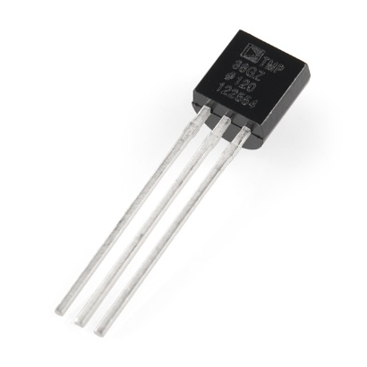

**3. TEMPERATURE SENSORS:**

It is used to sense the humidity inside the machine. So that to remove the products which may be spoiled by humidity.

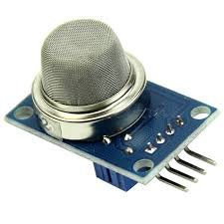

**4. SMOKE SENSOR:**

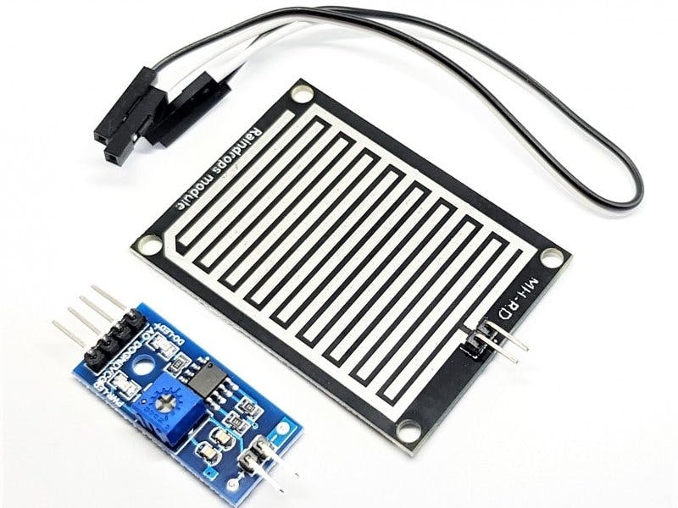It will detect any smoke inside machine. Which may be caused by fire inside machine.

**5. RAIN SENSOR:**

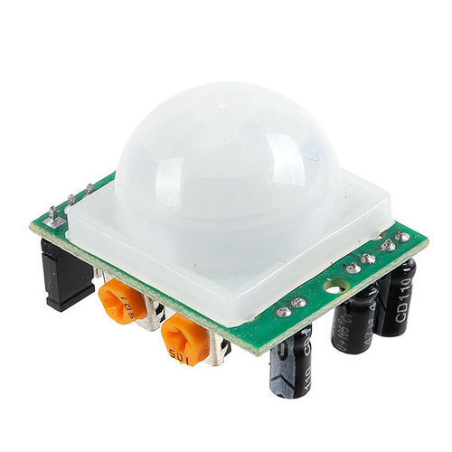It will sense any water around machine.

**6. MOTION SENSOR:**

It will detect whether the product has delivered or not.

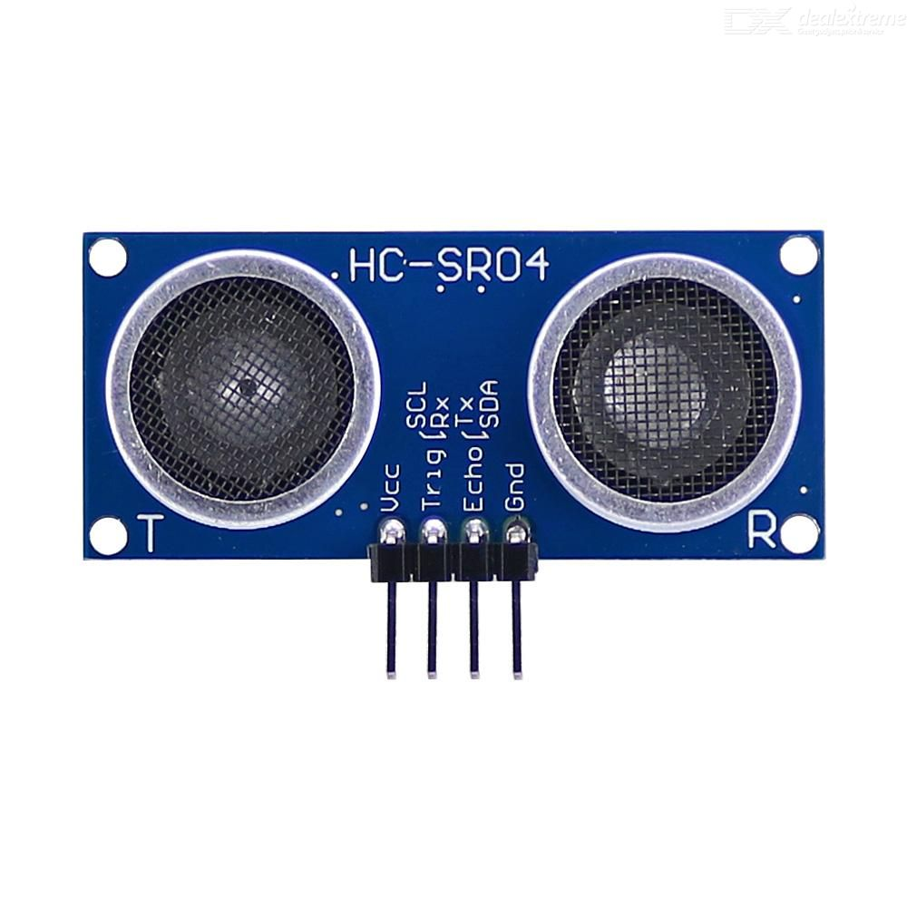

**7. ULTRASONIC RANGING SENSOR:**

It is used to detect if any person moved Infront of machine.

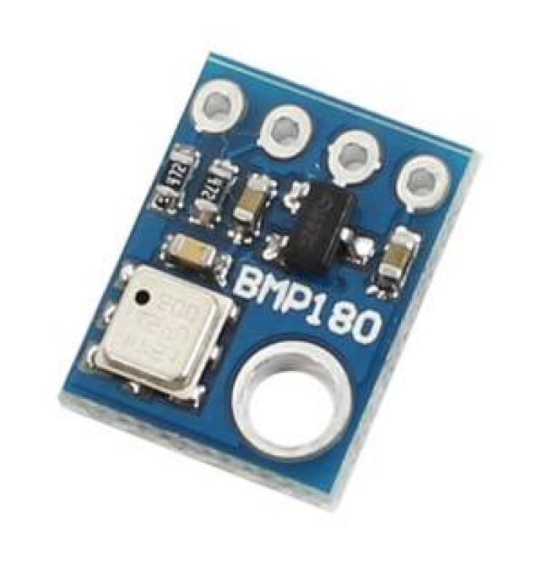

**8. PRESSURE SENSORS:**

It is used to sense the pressure inside machine.

**USER PANEL**

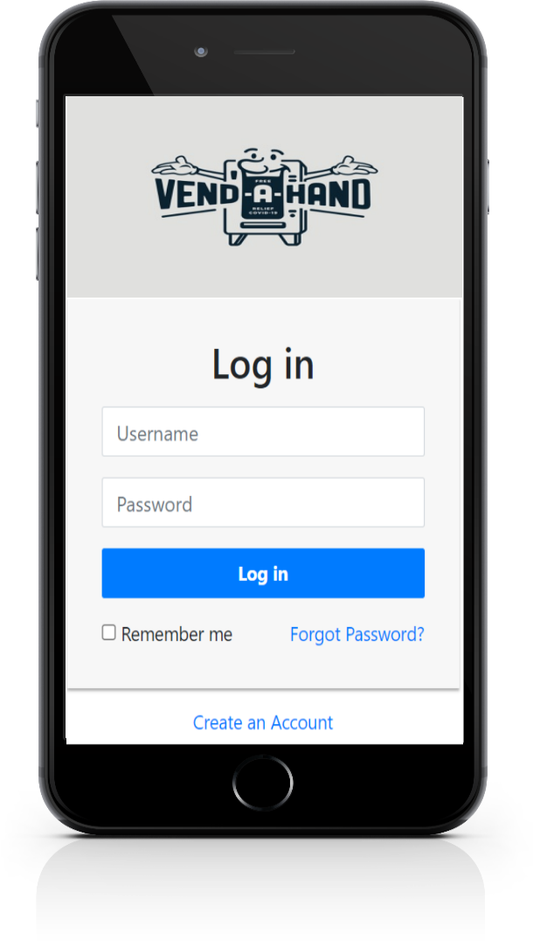

**LOGIN PAGE**:

user can proceed with this page if he has registered already. Or users should press a create a account (BUTTON) to create an account.

**CREATE AN ACCOUNT:**

This page helps to add a new user. for that user has to provide his name, phone no, mail-id & so on.

**PICK (SELECT) AN ITEM:**

This page usually lists existing items in vending machine and helps us to pick/select an item from list. Users can select multiple (of same item) & different items at a time.

**And there are options:**

**ADD TO CART:**

(Helps to pick many items) or users can purchase a selected item at any time.

**BUY NOW:**

This button triggers to PAY PAGE of the selected item.

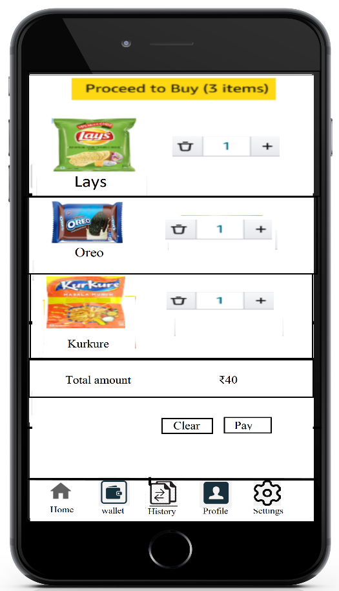

**CART PAGE:**

This cart page usually contains the selected item of the user and he can modify the quantity or clear the cart according to his needs, at last he can proceed with his selected items and it gives an estimated amount and he can pay for selected items using pay button at bottom of the page.

**ALERT PAGE:**

This just an alert page proceeds to buy.

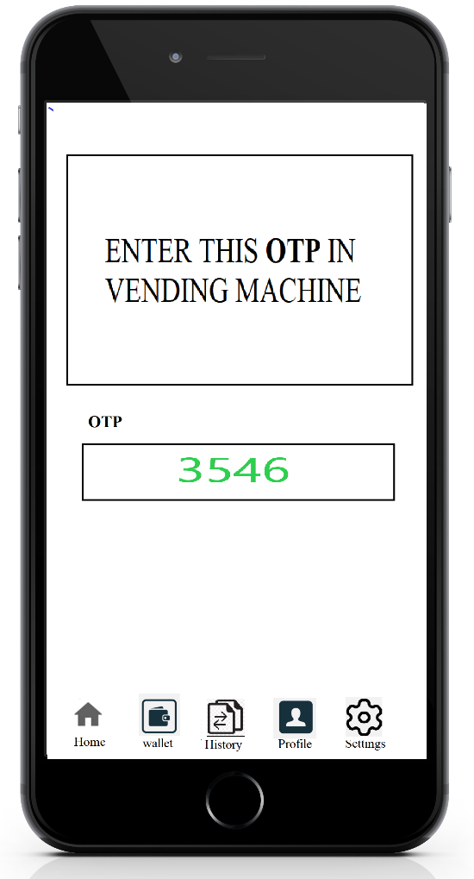**AUTO GENERATED OTP:**

at last user will get an OTP. this OTP play a key role for buying an item/s. user has to enter the correct OTP to buy the selected items in the vending machine.

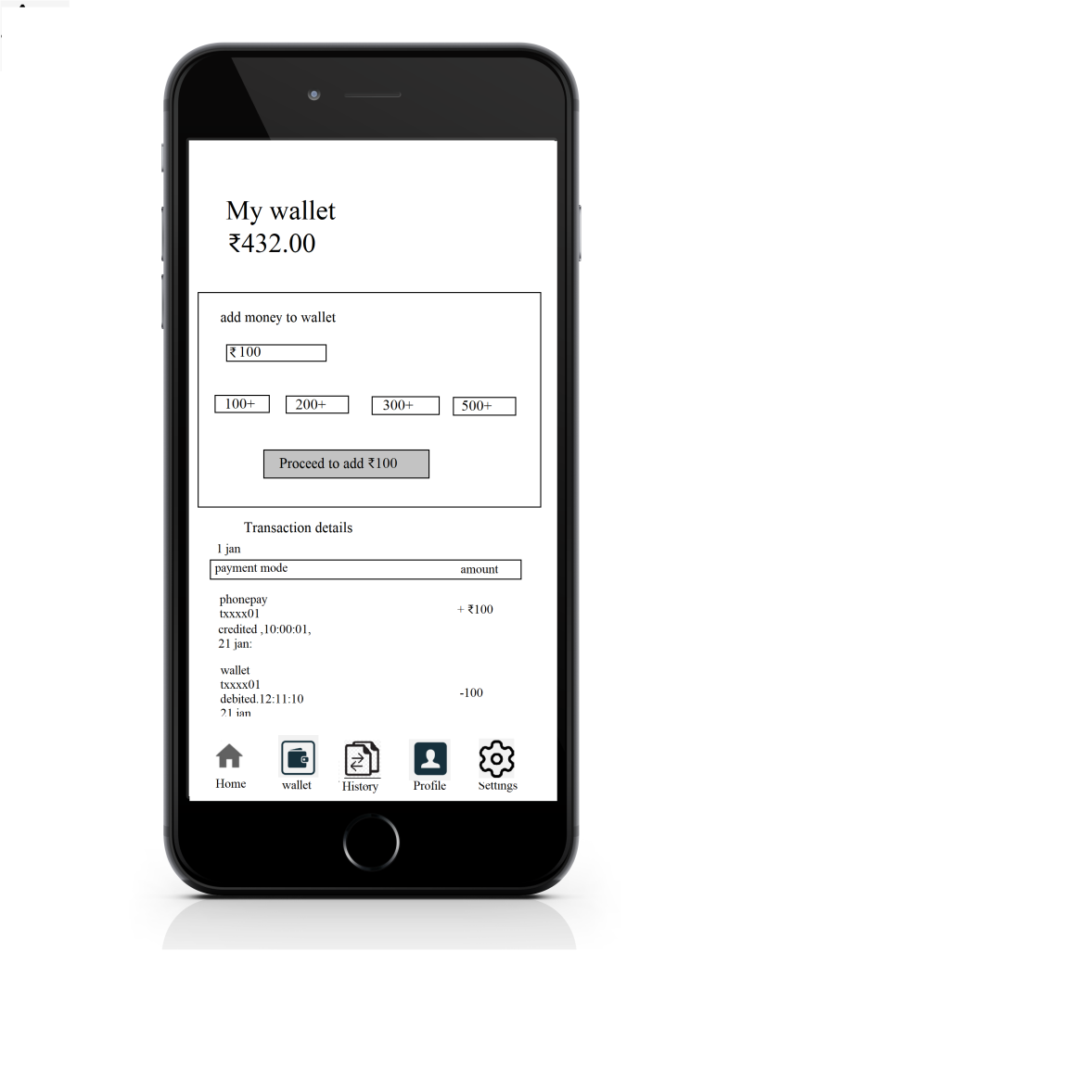

**MY WALLET:**

my wallet is used to buy items, and we can add the money from some payment modes (phone pay, Gpay, Paytm, and etc).

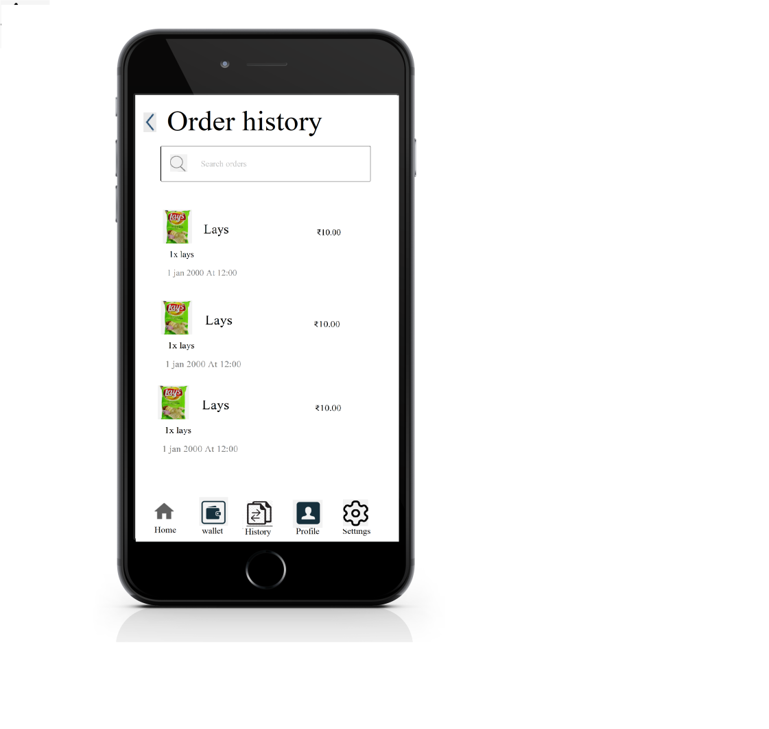

**ORDER’S HISTORY:**

We can see our order history, which we have ordered.

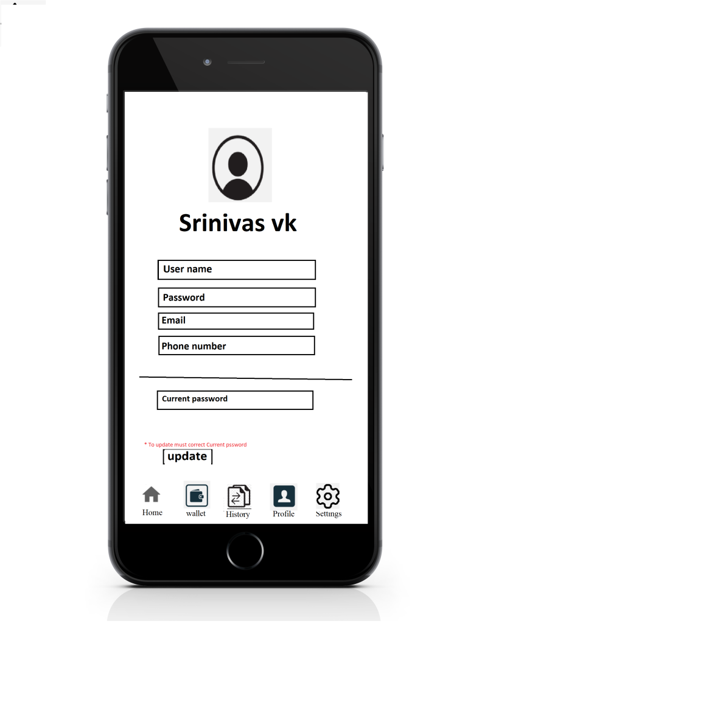

**PROFILE**:

In profile we can change Our user’s name, password, email, and number.

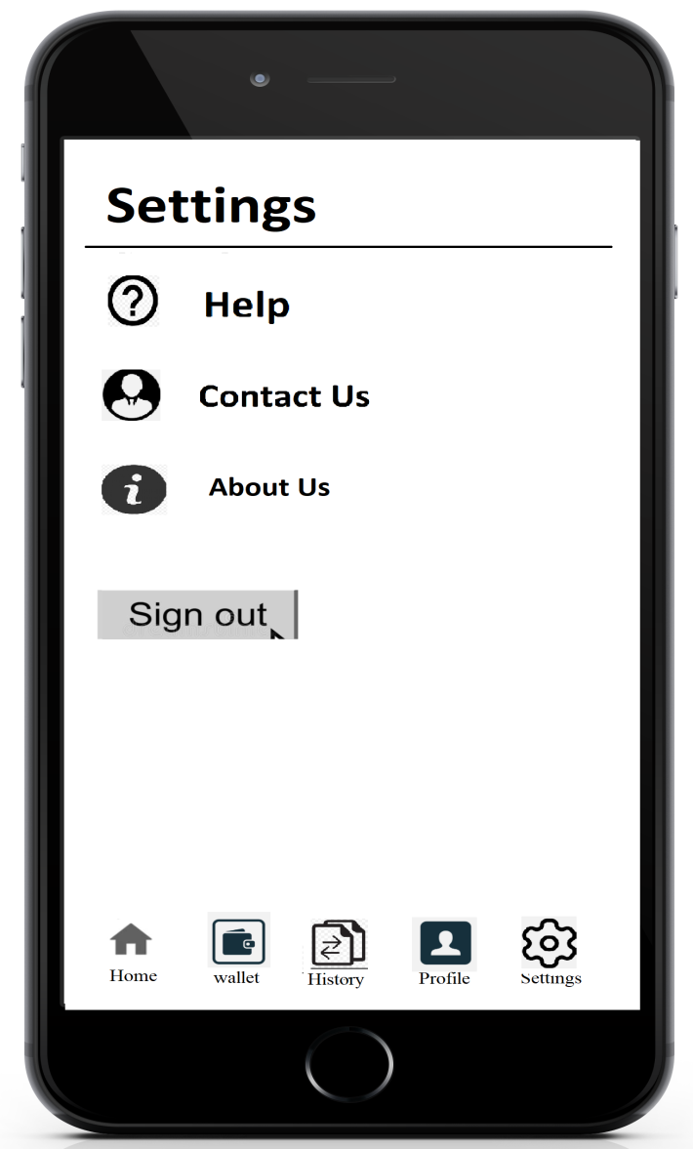

**SETTINGS**:

Setting to know Addition information.

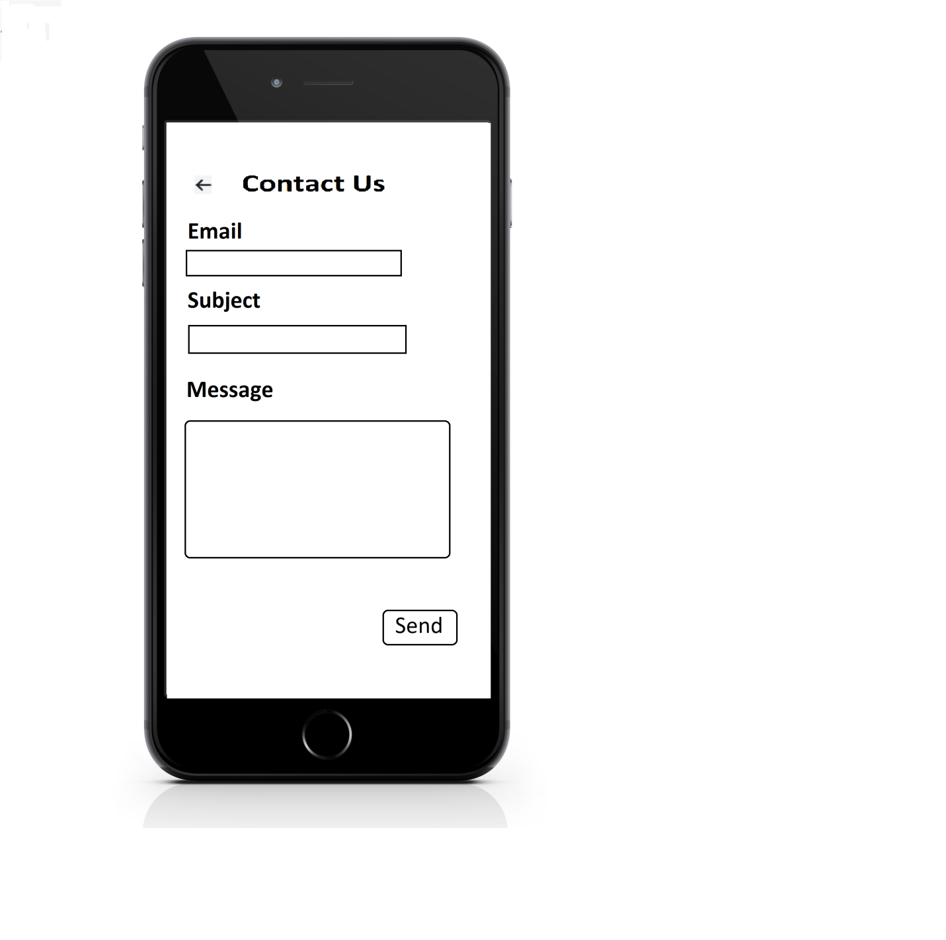

**CONTACT US:**

Using contact us page, the customer can contact with their issues.

**ADMIN PANEL**

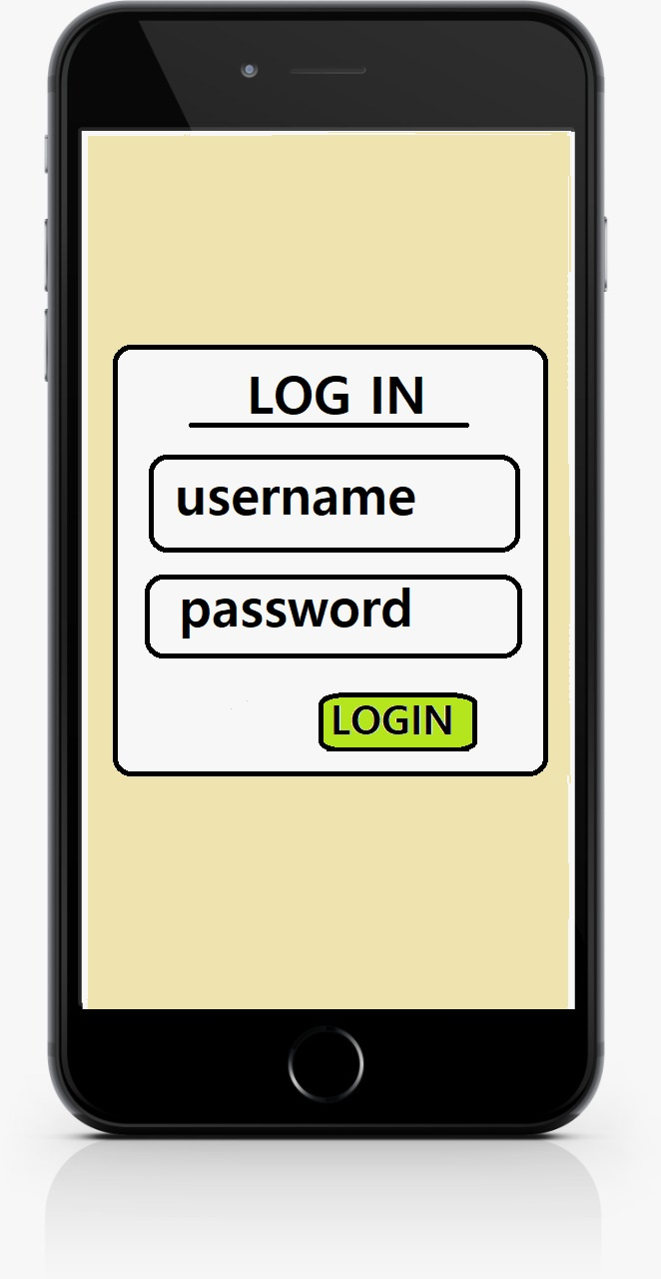

**LOGIN PAGE:**

Admin can login using this form to admin panel.

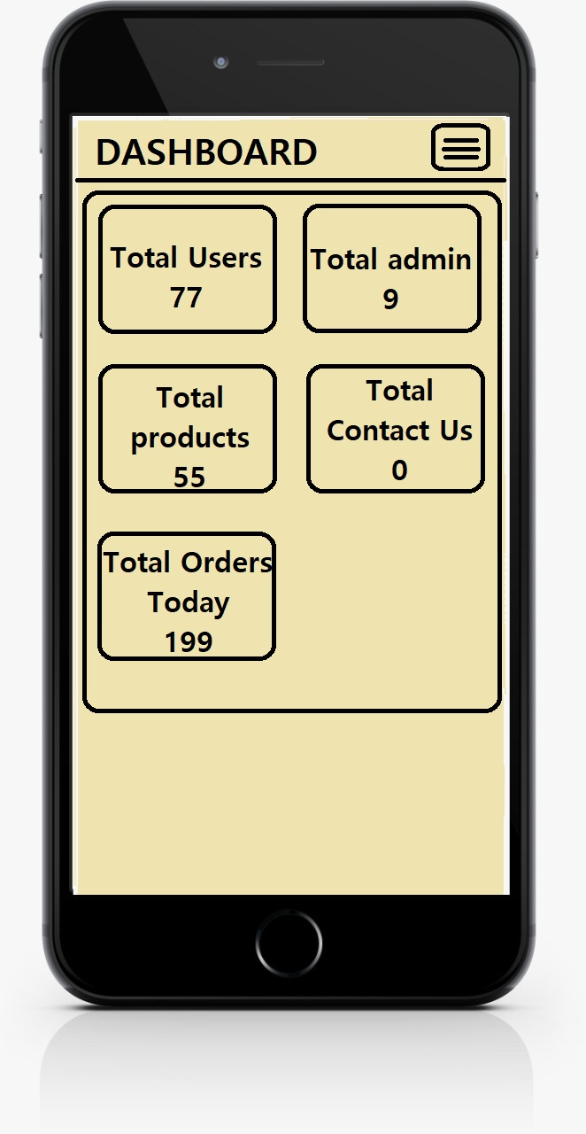

**DASHBOARD PAGE:**

This page shows the overview about all the content in the database.

Such as number of users, admin, products, contacts and orders.

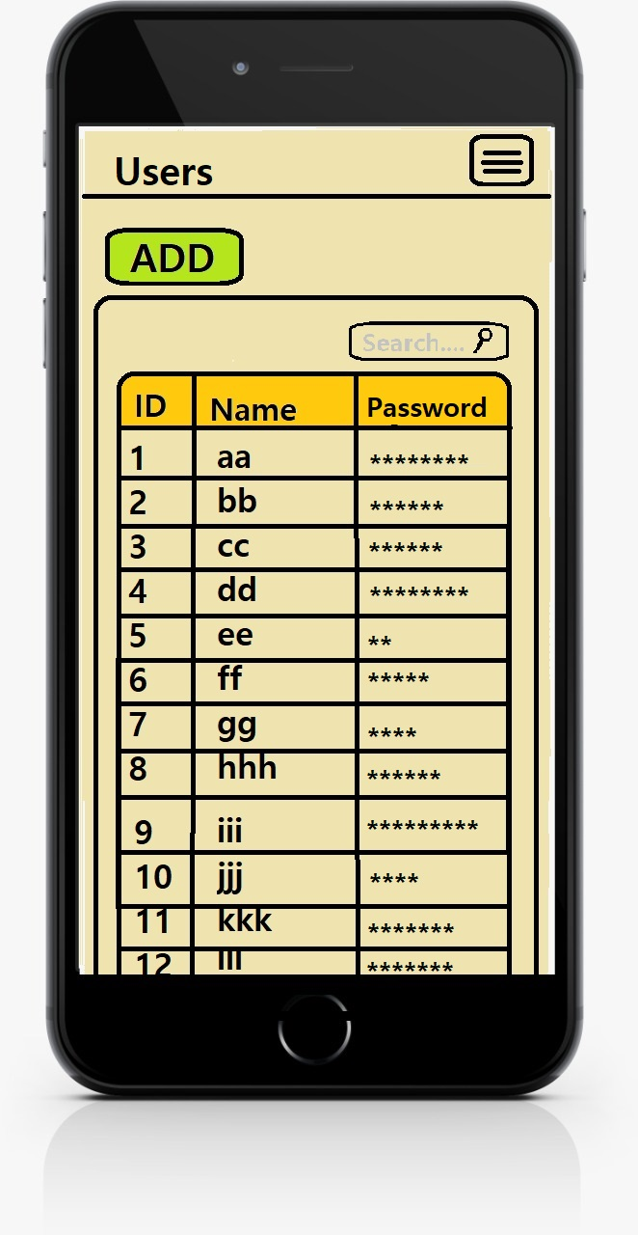

**USERS PAGE:**

This page shows the users details and also it allows to add new one and modify existing one.

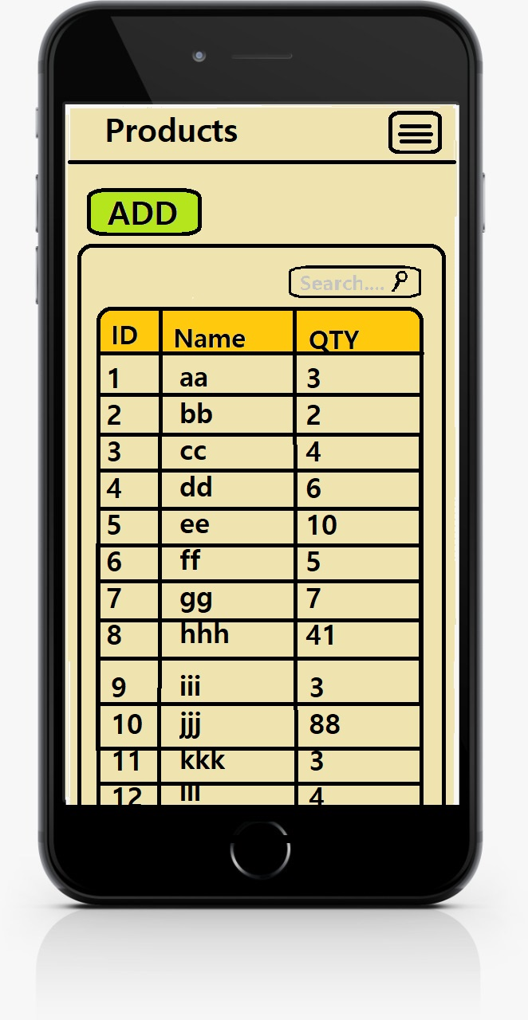

**PRODUCTS PAGE:**

This page shows the product details and also it allows to add new one and modify existing one.

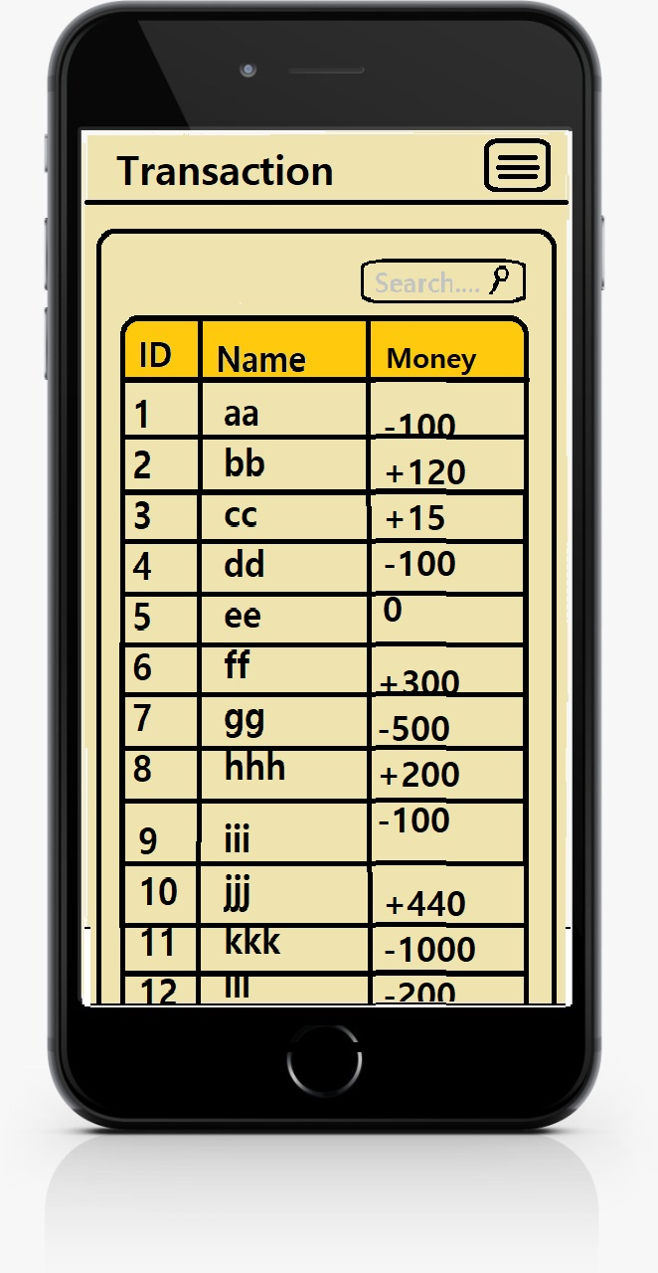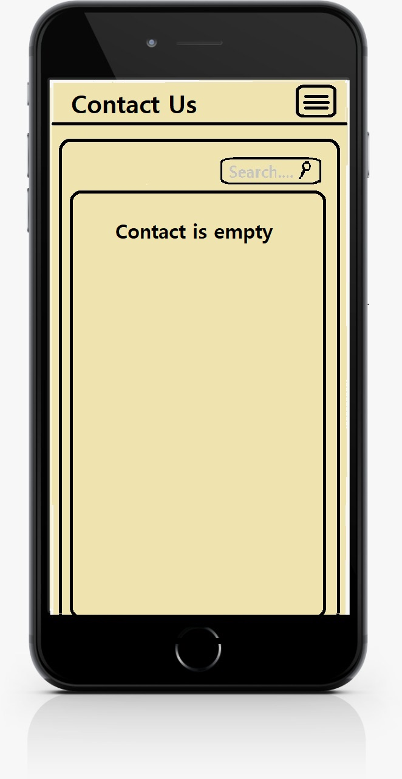

**TRANSACTION PAGE:**

This page shows the list of transactions that has been done by the users.

**CONTACT US PAGE:**

This page shows the list of contact us form filled details.

**WORKING OF ENTIRE MODULE:**

* First, we need to fill up the products in the machine.
* Enter what products and the number of products filled in the machine.
* User should register and login to website.
* Users has to recharge to their wallet before want to buy products.
* Users has to select the products and add to cart/click on buy now button.
* Go to cart and click buy now or can modify the quantity and click on pay button.
* The products and OTP are stored in database for feature verification.
* Amount will be deducted from wallet and it will show OTP, which is valid only for 10 minutes.
* Before 10 minutes users has to go to vending machine and enter OTP on keypad.
* The vending machine has processing unit which verifies with the database.
* If verification is successful the corresponding motor will rotate and product will fell down.
* If verification is not successful the error will be printed on to the display.
* There will be sensor which will be deducting whether the product will be felled or not.
* If verification is successful and the product has not felled then the motor will rotate again so that the product falls.

**CONCLUSION:**

The designed vending machine prototype was successfully implemented using “ARDUINO MEGA BOARD” as its main controller. It is equipped with interactive user interface system that eliminates the uses of coin detector. In conclusion, the project report has achieved all the proposed objectives to improve the overall performance of the vending machine on terms of cost saving, attractiveness, reliability, and not easily damaged by vandalism activities.

|  |  |  |  |  |
| --- | --- | --- | --- | --- |
| **Slno** | **Product** | **QTY** | **Amount (Each)** | **Sub Total** |
| 1 | Adriuno mega board | 2 | 1619 | 1619 |
| 2 | Keypad | 1 | 145 | 145 |
| 3 | Wi-Fi module | 1 | 180 | 180 |
| 4 | Display | 1 | 264 | 264 |
| 5 | Humidity sensor | 1 | 130 | 130 |
| 6 | Vibration sensor | 1 | 265 | 265 |
| 7 | Temperature sensor | 1 | 219 | 219 |
| 8 | Smoke sensor | 1 | 261 | 261 |
| 9 | Rain sensor | 1 | 168 | 168 |
| 10 | Motion sensor | 1 | 153 | 153 |
| 11 | Ultrasonic ranging sensor | 1 | 179 | 179 |
| 12 | Pressure sensor | 1 | 153 | 153 |
| 13 | Esp8266 | 1 | 333 | 333 |
| 14 | Patch cards | 2 | 179 | 358 |
| 15 | Relay control 8 channel | 3 | 421 | 1263 |
| 16 | Motors | 25 | 300 | 7,500 |
| 17 | Metal body | 1 | 20,000 | 20,000 |
| 18 | Fiber frame(6mm) front | 1 | 3000 | 3000 |
| 19 | Fiber frame(3mm) inner case | 1 | 1500 | 1500 |
| 20 | Power Controller | 1 | 800 | 800 |
| 21 | Web Hosting | 1 | 5000 | 5000 |
| 22 | Lock | 1 | 400 | 400 |
| 23 | Spray Paint | 2 | 315 | 630 |
| 24 | Sticker | 4 | 300 | 1200 |
| 25 | LED Lights | 2 | 400 | 800 |
| 26 | Grips | 1 | 1000 | 1000 |
| **TOTAL** | | | | **48,320** |

**ESTIMATION TABLE**

As per our real time Assumption, we have made a good estimation regarding materials etc. For your further clarification we will provide required proof of our working materials.