**PES UNIVERSITY EC CAMPUS**

A Mini Project Report On

**“VENDING MACHINE USING WALLET”**

Submitted in the fulfilment of the requirements for full credits on the course of

MICROPROCESSOR AND COMPUTER ARCHITECTURE

BACHELOR OF TECHNOLOGY IN COMPUTER SCIENCE ENGINEERING.

**Submitted By**

BHARTH B REDDY PES2UG20CS802

GURAM BALAJI PES2UG20CS805

PRADEEP R S PES2UG20CS807

SAI GANESH B PES2UG20CS810

SHRINIVAS V K PES2UG20CS811

Under the Support and Guidance of

**PRAJWALA T R**

Assistant Professor,

Department of CSE.

**CHANDRASHEKHAR P CHAVAN**

Assistant Professor,

Department of CSE.

**DR. SANDESH B J**

HEAD OF THE DEPARTMENT(CSE)

TABLE OF CONTENT

**History 4**

**Introduction** **4**

**Enhancement5**

**Future scope5**

**Advantage and disadvantages** **5**

**Sensors6-8**

Humidity Sensor6

Vibration Sensor 6

Temperature Sensor6

Smoke Sensor7

Rain Sensor 7

Motion Sensor 7

Ultrasonic ranging Sensor 8

Pressure Sensor 8

**Working of entire** **module9**

**Conclusion10**

**VENDING MACHINE USING WALLET**

**HISTORY**

The first modern coin-operated vending machines were introduced in [London](https://en.wikipedia.org/wiki/London), [England](https://en.wikipedia.org/wiki/England) in the early 1880s, dispensing [postcards](https://en.wikipedia.org/wiki/Postcard). The machine was invented by Percival Everitt in 1883 and soon became a widespread feature at railway stations and post offices, dispensing [envelopes](https://en.wikipedia.org/wiki/Envelopes), [postcards](https://en.wikipedia.org/wiki/Postcard), and [notepaper](https://en.wikipedia.org/wiki/Notepaper). The Sweetmeat Automatic Delivery Company was founded in 1887 in England as the first company to deal primarily with the installation and maintenance of vending machines. In 1893, [Stollwerck](https://en.wikipedia.org/wiki/Stollwerck), a German chocolate manufacturer, was selling its chocolate in 15,000 vending machines. It set up separate companies in various territories to manufacture vending machines to sell not just chocolate, but cigarettes, matches, chewing gum, and soap products.

The first vending machine in the U.S. was built in 1888 by the [Thomas Adams Gum Company](https://en.wikipedia.org/wiki/Thomas_Adams_Gum_Company), selling gum on New York City train platforms. The idea of adding games to these machines as a further incentive to buy came in 1897 when the Pulver Manufacturing Company added small figures, which would move around whenever somebody bought some gum from their machines. This idea spawned a whole new type of mechanical device known as the "trade stimulators".

**INTRODUCTION**

An automated machine which is intended to provide the users with a diverse range of products: snacks, beverages, pizzas, cupcakes, newspapers, tickets, etc. A vending machine dispenses a product to the users based on the selection of the product. Vending machine is a 24x7 standalone unit which requires a standard power supply connection to function. It consists of simple electro-mechanical systems which helps to automate the entire vending process. In a nutshell, its basic function is to flawlessly issue users with a diverse range of products anytime.

Various types of food and [snack](https://en.wikipedia.org/wiki/Snack) vending machines exist in the world. Food vending machines that provide shelf-stable foods such as chips, cookies, cakes, and other such snacks are common. Some food vending machines are refrigerated or frozen, such as for chilled soft drinks and ice cream treats, and some machines provide hot food.

Some unique food vending machines exist that are specialized and less common, such as the [French fry vending machine](https://en.wikipedia.org/wiki/French_fry_vending_machine) and hot pizza vending machines, such as [Let's Pizza](https://en.wikipedia.org/wiki/Let%27s_Pizza). The [Beverly Hills Caviar Automated Boutique](https://en.wikipedia.org/wiki/Beverly_Hills_Caviar_Automated_Boutique) dispenses frozen caviar and other high-end foods.

We are going to design in same ways where it stores and deliveries the snacks, only such products which can be stored in non – refrigerated area. vending machine are not going to take money, instead we use application to interact with the vending machine and users. Where users can store money in their wallets to buy products which are in vending machine. We got this idea of wallets because the world is going on with the cashless modes.

Introducing Self Service Vending Machines (Snacks) to give 24*7 food facilities to the students. A customer is always willing to have some basic demands. And we are here to satisfy those, now from our vending machine.

**Enhancement:**

* We have reduced the burden of customers for longer period of time for the desired product through cash less transactions which would help to reduce lot of time for the customer.
* As we can keep track of the amount of fundings in real time with our embedded software, compared to the current vending machines in market.
* In order of security threats (theft) there will be robbery of money stored in vending machine, while in our machine it will be securely stored in digital wallets.
* As we are concern with security, we have made enhance development in security via powerful sensors, with respect to any unethical theft or damage to machine.

**Future scope:**

* We can assure that our machine can overtake the current machines with respect to (Security, time, performance). So, we assure you in future with better enhancement features.

The main objective of this project is to step forward towards digitalization and automation. This machine is a replica to show how automatic transaction works and how it makes life easier.

**ADVANTAGE AND DISADVANTAGES**

Advantage

* Low Maintenance.
* Variety of Options
* Saves Time and Money
* Accessibility and Convenience
* No Overhead Cost
* Healthier Options for a Healthier Lifestyle

Disadvantages

## Added Administrative Costs

## Competition for Other Food Vendors

## Quality and Quantity of Snacks Offered

## Costly Investment

**SENSORS**

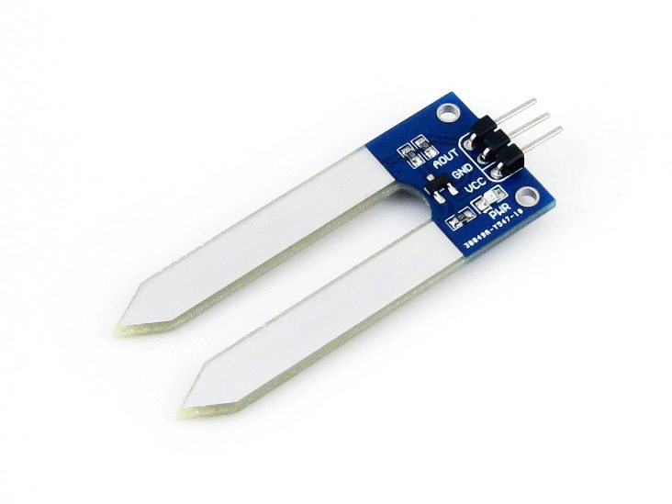

**1. HUMIDITY SENSORS**:

It is used to sense the humidity inside the machine. So that to remove the products which may be spoiled by humidity.

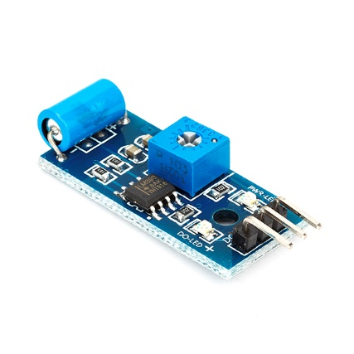

**2. VIBRATION SENSORS:**

It will sense any unwanted vibration in the machine. And alert buzzer is connected to it.

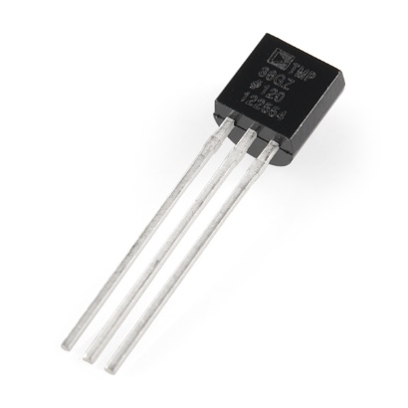

**3. TEMPERATURE SENSORS:**

It is used to sense the humidity inside the machine. So that to remove the products which may be spoiled by humidity.

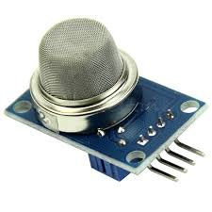

**4. SMOKE SENSOR:**

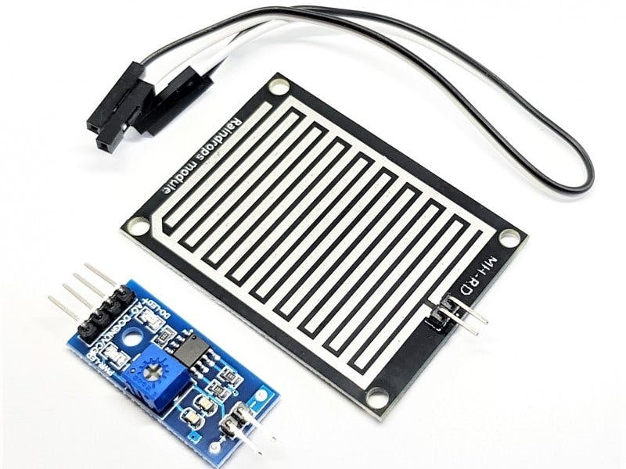It will detect any smoke inside machine. Which may be caused by fire inside machine.

**5. RAIN SENSOR:**

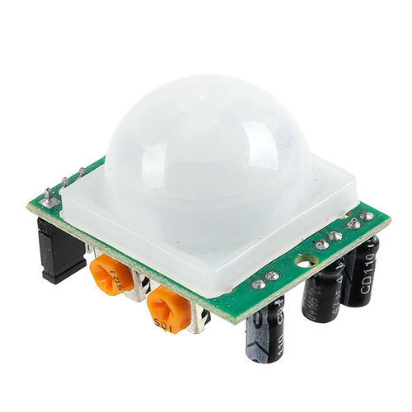It will sense any water around machine.

**6. MOTION SENSOR:**

It will detect whether the product has delivered or not.

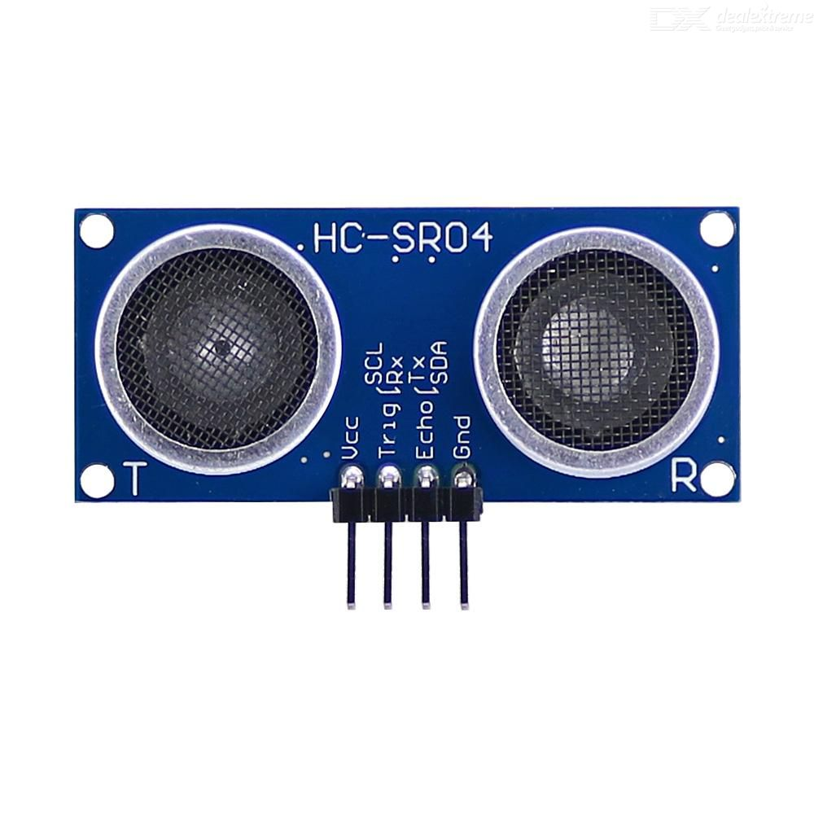

**7. ULTRASONIC RANGING SENSOR:**

It is used to detect if any person moved Infront of machine.

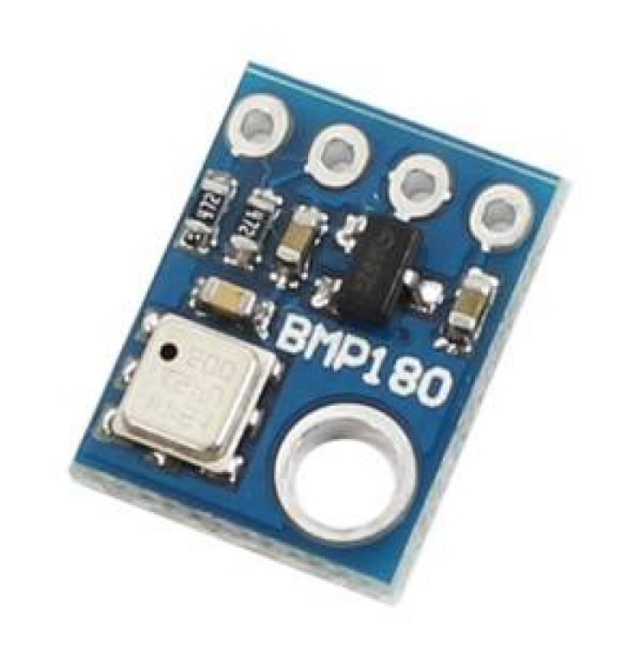

**8. PRESSURE SENSORS:**

It is used to sense the pressure inside machine.

**WORKING OF ENTIRE MODULE:**

* First, we need to fill up the products in the machine.
* Enter what products and the number of products filled in the machine.
* User should register and login to website.
* Users has to recharge to their wallet before want to buy products.
* Users has to select the products and add to cart/click on buy now button.
* Go to cart and click buy now or can modify the quantity and click on pay button.
* The products and OTP are stored in database for feature verification.
* Amount will be deducted from wallet and it will show OTP, which is valid only for 10 minutes.
* Before 10 minutes users has to go to vending machine and enter OTP on keypad.
* The vending machine has processing unit which verifies with the database.
* If verification is successful the corresponding motor will rotate and product will fell down.
* If verification is not successful the error will be printed on to the display.
* There will be sensor which will be deducting whether the product will be felled or not.
* If verification is successful and the product has not felled then the motor will rotate again so that the product falls.

**CONCLUSION:**

The designed vending machine prototype was successfully implemented using “ARDUINO MEGA BOARD” as its main controller. It is equipped with interactive user interface system that eliminates the uses of coin detector. In conclusion, the project report has achieved all the proposed objectives to improve the overall performance of the vending machine on terms of cost saving, attractiveness, reliability, and not easily damaged by vandalism activities.