Na’Imah Muttalib

Web Mapping Lab 5

4/20/16

Introduction

The aim of this web map was to use an API, (Application Programming Interface), and code the map using Java Script. An API is analogous to a ‘middleman’ between the programmer and the application. It allows the web map to be automatically updated. In this particular web map the API was used to scrape data from Instagram. The area of my web map is Washington DC. I chose this area specifically due to the timing of the political primary season. I had expected to find voters and lobbyist type post for specific campaigns. Rather what I found was random in nature pictures of different users. This web map updates automatically so it would be interesting to view it periodically to see is there a theme presented due to what is going on at a particular time in a particular place.

Method

I used Leaflet as my stylesheet for the map, an [open source](https://en.wikipedia.org/wiki/Open-source_license) [JavaScript](https://en.wikipedia.org/wiki/JavaScript) [library](https://en.wikipedia.org/wiki/Library_(computing)) used to build [web mapping](https://en.wikipedia.org/wiki/Web_mapping) [applications](https://en.wikipedia.org/wiki/Application_software). Next, I needed to download a reqwest library to allow my Instagram photos to be displayed on my map. The script source of the map is Leaflet.Instagram. From there I needed to enter the parameters for the map to display Instagram photos for only Washington DC. I accomplished this simply by writing the geographic coordinates for Washington DC. Since Instagram photos are geocoded the request returned photos for the areas of that city only. I could have included a distance beyond Washington DC if I wanted to extend the photos to surrounding areas. An access token was needed to get access to the Instagram photos. Usually the access token comes by way of a registration, but the access token can be shared among multiple users as in the case of this particular web map. That might have benefits if obtaining an access token is too cumbersome and a company wants to allow its programmers access to the company’s access token. The last step in producing this web map was to design a base map. I use the Open Street Map style for its simplistic readability.

Results

The results of this map is a user friendly experience. Users can pan around the map and click on the various photos to enlarge it. The zoom min, 15, and zoom max, 19, allows users to see many areas in a single view and zoom in on particular posts of interest. The base map gives more meaning to the photos as the location of the photo adds to the story of it.

Conclusion

This map was rather simple to make but its capabilities are extended from a simple story tour map. In the story tour map the photos are written in by the programmer and are constant. Whereas in this web map I used an API that allows the map to be updated automatically; the map you see today will not necessarily be the same map tomorrow. This updating capability is important to continuously changing forms of data. For example a weather app needs the capability to change with the new day and even throughout the day. Applications that have the ability to maneuver and even adapt is the direction this web map is headed in.

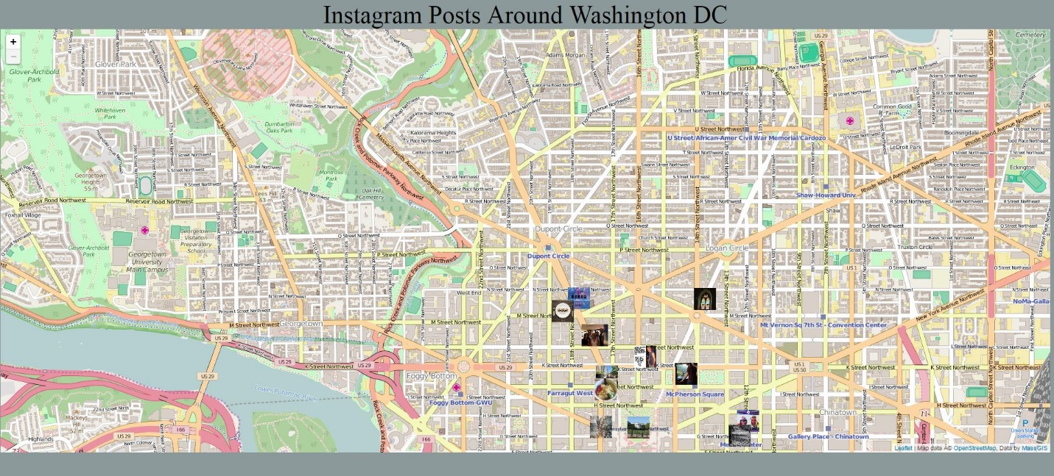

<http://gus8068spr16.github.io/LAB_5/NMuttalibLab5.html>