Joyce Rasing

15 April 2016

Lab 5

**Introduction**

The objective of this lab is to access an API and external JavaScript libraries and pull uploaded pictures from Instagram that are associated with a geographic location or geocoded.

**Methods**

This lab requires the understanding of JavaScript and also API commands. Understanding how APIs work require the knowledge of the API commands, such as GET, POST, PUT, and DELETE. These are important because they are commands that receive and disseminate information to the server, from the client.

In order to use the Instagram API, it is necessary to have an Instagram account and to register a new client for an access token. This access token will allow special privileges to be pulled from the site and uniquely identifies the user pulling the information.

The script is set in JavaScript and uses the Leaflet.js engine. The Instagram pictures are overlaid on top of the Leaflet.js map. Much like Leaflet.js maps created in previous labs, the extent and set.View is based on a coordinate pair. This script particularly links to the access token required to scrape the geocoded pictures onto the map using the var at = “ACCESS_TOKEN”.

Before using the access token, the “reqwest” library must be stored in the HTML file and then embedded in the script. This is stored in the class workspace GitHub account.

<script src="http://gus8068spr16.github.io/reqwest.min.js"></script>

<script src=" http://gus8068spr16.github.io/Leaflet.Instagram/dist/Leaflet.Instagram.js"></script>

**Results**

After the reqwest script from the class GitHub link and all of the parameters set for the Leaflet.js map including the coordinates and extent to which the map is displayed on the page, Instagram pictures pop up using the geographic location and copies the caption and hashtags that the user included in their original post.

**Conclusion**

In conclusion, the API returns uploaded Instagram pictures within the vicinity of the coordinates listed in the beginning script. This function can be done for any coordinate pair around the world, but may not return as many results as highly populous areas or tourist attractions. Metro Manila, as exemplified in the .html site, is a highly populated area in the Philippines with locals and tourists. Any geography associated with the Instagram post will allow the API to pull that information and post it on the map. Along with the photo, the information that the user posts in their caption, will also be available through the API.

**Tables and Figures**

Link to Web Map Application: <http://rasjo.github.io/rasing_lab5.html> - No longer available; on Class GH

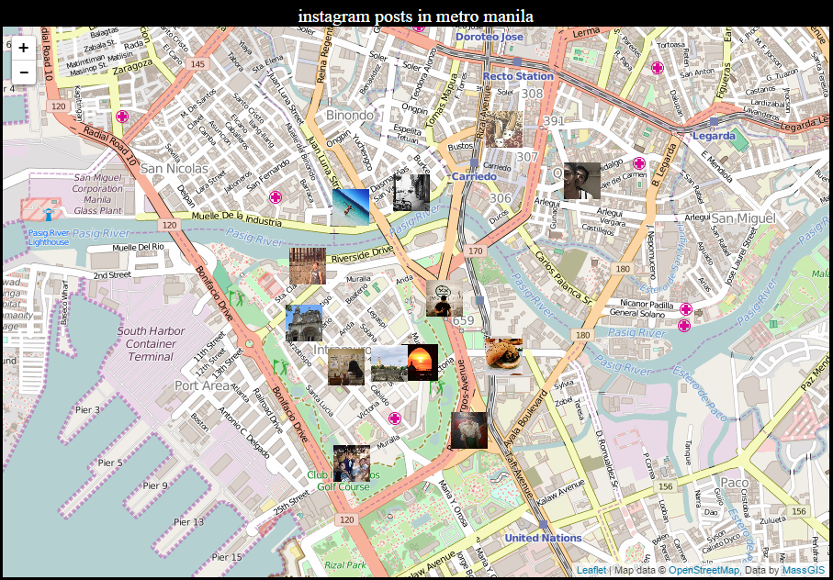

Figure 1: Instagram posts in Metro Manila, Philippines using a standard Leaflet.js basemap.

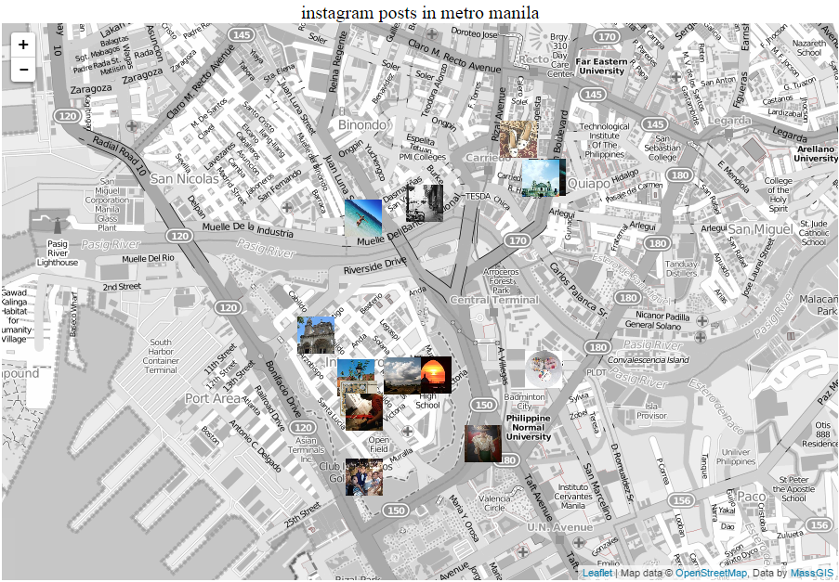

Figure 2: Instagram posts in Metro Manila, Philippines using a black and white OpenStreetMap.