Scott Stolp

LAB 5

4/16/16

*Goblins, Ghouls and Instagram fools*

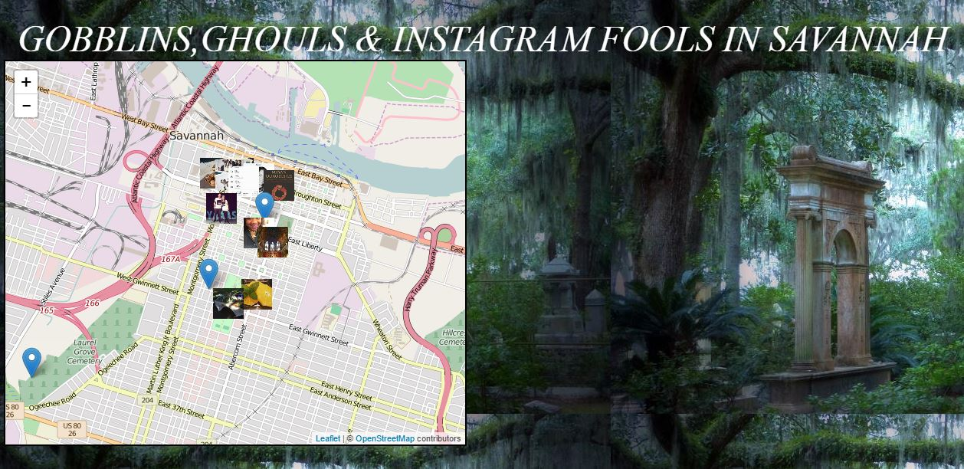As one of the oldest and most finely preserved cities in the U.S, Savannah Georgia, has an abundance of historical attractions worthy of daily excursion for visitors and locals alike. With the release of “Midnight in the Garden of Good and Evil”, by author John Berendt, Savannah’s hauntingly beautiful and gothic like cemeteries became a desired destination for many looking to capture a glimpse of the past, take in the impressive graveyard stone work, or simply get goose bumps and chills while on haunted grave yard tours. *Goblins, Ghouls and Instagram fools* map pinpoints the sites of three cemetery locations in Savannah Ga, while also displaying random Instagram photos obtained by inserting a provided access token into the script of the webpage which was written on Github.

METHODS

*Goblins, Ghouls and Instagram fools* was created using leaflet with an OpenStreetMap basemap; a geojson formatting structure was used to create three cemetery location points. On popup, these points reveal horrifying photos intended to scare the bejesus out of even the most fearless of souls. Originally it was intended that individual API keys were to be created in order to overlay Instagram API on the map. However, due to changes in Instagram’s latest terms of service, individual API keys did not work, so therefore, a provided API key was used instead.

RESULTS

The resulting web map offers users the ability to locate some of the scariest places that Savannah has to offer. In addition, in order to mitigate the fright factor which this map undoubtedly generates, a stream of Instagram photos has been added through Instagram API. People who incessantly take pictures of themselves and their meals that they are about to eat are funny, and these pictures will help counterbalance the terror which the ghoulish photos provided as geojson popups evoke.

CONCLUSION

Adding Instagram photos to a webmap is a great way to turn a web mapping project into an endeavor with social bearing. To finish this project, a complete listing of Savannah’s cemeteries in geojson format, with photo popups will need to be added.