Jeffery Schiele

Web Mapping

Lab 5

4/15/16

**Introduction**

Though the use of data from Instagram and other geolocating social media outlets has become increasingly included in contemporary web maps, many areas in Philadelphia have been left unexplored. In this write-up I report on my efforts to synthesize a map that utilizes data from the Leaflet.Instagram API in the spatial context of City Hall. In doing this my intent is to explore the ways in which this sort of qualitative data can inform the viewer on aspects of the social landscapes in Philadelpia. Ultimately, while this map is not intended to be overtly analytical, I reflect on the trends in the qualitative data of the Instagram posts as it relates to the urban area and structure.

**Methods**

The creation of this map can be broken into two distinct categories: the creation of code to access/scrape/display data from the Instagram API, and the creation of code to format and create the web mapping page. To being, Github was used as a platform to place the code for this map. In order to display Instagram photos and posts on the map through the Leaflet.Instagram library, a previously download Instagram access token was utilized. The area of spatial inquiry was defined within the L.instagram command by inserting City Hall’s coordinates in the ‘lat=’ and ‘long=’ section of the code. This ensured that all the scrapped data from the Leaflet.Instragram API would be within the general area of City Hall. To format the map, code was written to specify the zoom limits, spatial focus, extent and aesthetics. The spatial focus was specified using the same coordinates that were in the L.instagram command. The extent was defined at 16, and the zoom limits were placed within the range of 12 and 18. Finally, a basic background color, font size, and font color were chosen to create a visually coherent map.

**Results**

*Figure 1* shows the Instagram pictures and posts in and around City Hall. While there are three picture within City Hall’s actual building, the majority of the Instagram posts are dispersed outside of City Hall. These posts seem to be clustered in commercial areas, like the gayborhood, and parks that surround City Hall. Looking at the posts, there are three distinct categories—pictures of architecture (most prominent within City Hall’s limits), pictures of food (most prominent in commercial areas—particularly walnut street), and pictures of the human subject (which were dispersed in between different areas).

**Conclusion**

This map speaks to the ways in which the cityscape is being moved through, perceived, and utilized by human actors in Philadelphia. A general trend that arose is the dominance selfies or pictures of human subjects, which demonstrates the ways in which social networking technologies are being used by human actors. This map also demonstrates the presence of food culture in Philadelphia, and could be used to obtain qualitative information like reviews and photos in the commercial areas of the map. Thus, in using Instagram posts, one gets a better picture of the social landscape of Philadelphia in this area that would not be evident using other forms of data in the code. Ultimately, this sort of information has the potential to inform future planning— the qualitative data (in the form of Instagram posts) can be used to connect planners with the sentiments of the social actors/ sub-cultures that experience the city, whose voices would otherwise be left out of the conversation. What is particularly interesting about this map is the fact that the data is being constantly updated as Instagram users create new posts in the area of focus. Thus, the map becomes a disembodied representation of the temporal elements of movement through and urban structure.

**Figures**

*Figure 1*

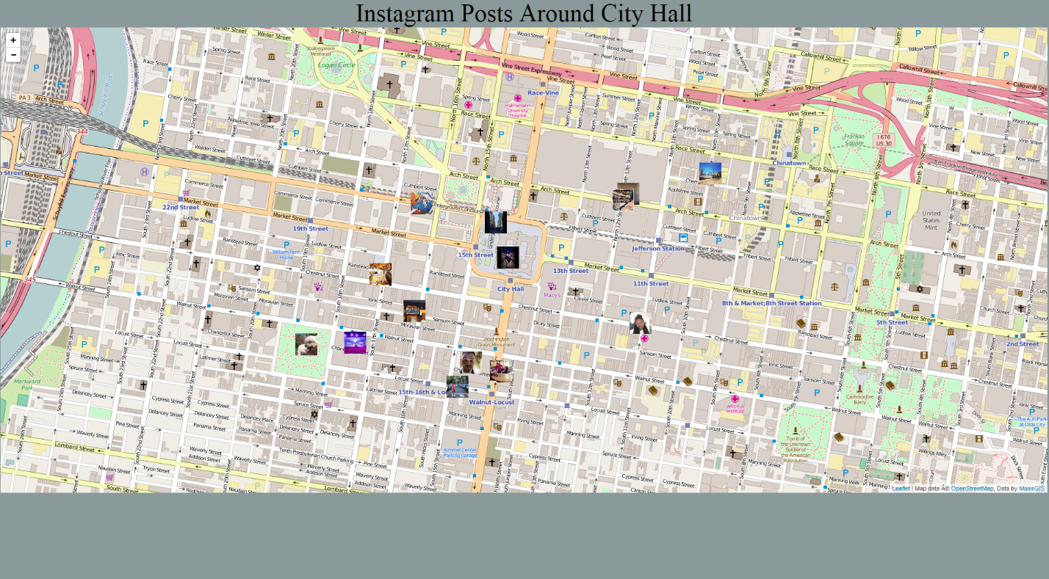

**\*\***This map can be found at <http://gus8068spr16.github.io/exercises/Schiele_Lab5.html>