BAC WEBSITE DEVELOPMENT BRIEF
OBJECTIVE: Develop BAC Website in Wordpress
Website Design: https://sketch.cloud/s/jg2Kz
Final Design: https://www.dropbox.com/s/fqr1gmkfiagwy3l/BAC%20Design.sketch?dl=0
DEADLINE: 24 February (4 weeks of work)
BAC WEBSITE DETAILS:
Website Beecholmeadultcare.co.uk
FTP password 7wD%UOAT8-@-
database password 2uW.1EhSOm2U

Domain: beecholmeadultcare.co.uk
Directory: bac
FTP-Password: 7wD%UOAT8-@- Copy
Create Database?: Yes
Database password: 2uW.1EhSOm2U Copy
SSL Certificate: Yes

DB Hostname: sql-01.dd24.net
DB Name: db_76vg3q8rmn
DB User: db_76vg3q8rmn
DB Pass: 2uW.1EhSOm2U
PHPMyAdmin: https://sql-01.dd24.net/?pma_username=db_76vg3q8rmn

FTP-Server: beecholmeadultcare.co.uk
FTP-User: beecholmeadultcare.co.uk

FTP-Password: 7wD%UOAT8-@-

WEBSITE STRUCTURE

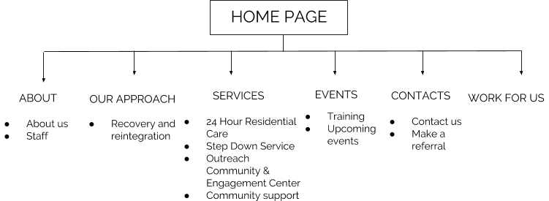

CMF FEATURES :
What we need to do with the CMS? This a list of some of the features we need (please share with us any comment or suggestion)

CONTENT
- Easy to use text editor
- Automatically saved drafts
- Image Manager - upload, resize and edit images
- Drag and drop text files from your desktop to your website.
- Drag and drop uploading
- Drag and drop image organization
- Supports one or multiple images
- Auto-resizing with Adaptive Image technology
- Customizable captions
- Add video
- Customisable layouts
- Customisable headings, meta tags, page descriptions

MORE IN DETAIL...:

FOR ALL PAGES

- Possibility to change and add hero image for each page
- Hero Images: possibility to add videos linked to youtube (especially on the Home page)
- CTA buttons (book a visit, make a referral, get in contact ) have to redirect the user to the related page and form
  - BOOK A VISIT or GET in CONTACT >>>> Contact us page
  - MAKE A REFERRAL >>>> Make a referral page
- SOCIAL MEDIA ICONS:
  - FACEBOOK https://www.facebook.com/BeecholmeAdultCare/
  - TWITTER @BeecholmeAC
  - LINKEDIN: https://www.linkedin.com/company/beecholme-adult-care-ltd/
  - INSTAGRAM: to be opened

HOME PAGE:

- Collect the data coming from the registration form
- Change and add text for Service menu + Features
- Link ACCOMODATION box to the section 24H RESIDENTIAL CARE
- Link ACTIVITIES box to OUTREACH & ACTIVITIES CENTER
- Link VIDEOS box to YOUTUBE CHANNEL (still to open)
- Link BROCHURES box to brochures section (this section is not visible, it will open only if the user click on the brochures box)
- ACCOMMODATION , ACTIVITIES , VIDEOS and BROCHURES BOXES : each of them will have an animated icon (we are creating them right now)
- TESTIMONIAL SECTION: carousel that can be scrolled where we should be able to add text
- Link the bar “ Also see our rating and reviews….” to http://www.cqc.org.uk/location/1-121892109
ABOUT:
- ABOUT US
  - Possibility to change the text
  - We are producing icons to replace the current ones

- STAFF:
  - Possibility to edit text
  - Possibility to add pictures of the staff + brief description
OUR APPROACH:
- Possibility to edit the text
SERVICES:
- 12 WEEKS PROGRAM:
  - Possibility to edit text
  - Possibility to change pictures of the page and add documents (MENU OF THE WEEK)
- 24 H RESIDENTIAL CARE:
  - Carousel of pictures : possibility to add and change pictures
  - Possibility to edit text
- SEMI INDEPENDENT STEP DOWN SERVICE:
  - Possibility to edit text
  - Delete the long green bar “Book a visit”
- COMMUNITY OUTREACH & ENGAGEMENT CENTER:
  - Possibility to change text
  - Possibility to update the icons and text in the table
- COMMUNITY SUPPORT:
  - Possibility to edit the text

EVENTS:
- UPCOMING EVENTS:
  - Possibility to change text in the table and to update it
- TRAINING:
  - Possibility to edit text, add tables , images

CONTACT:
- CONTACT US: Develop a CONTACT US/ BOOK A VISIT form. The requests has to be sent to info@beecholmeadultcare.co.uk (possibility to change the mail address)

(* mandatory fields)

Nature of enquiry*:
- Book a visit
- I am looking for a care for myself
- General Enquiry
Name*:
Email*:
Contact Number*:
Preferred day of visit (in case of Book a visit a calendar appear and the user can choose the day)
Preferred time of visit (in case of Book a visit the user can choose the time )
Message:
How did I hear about Beecholme?

- MAKE A REFERRAL: All the submitted requests has to be sent to info@beecholmeadultcare.co.uk (possibility to change the mail address)

WORK OF US
All the submitted requests has to be sent to info@beecholmeadultcare.co.uk (possibility to change the mail address)

