SUPERMARKET SALES ANALYSIS
Data Analytics Project Report
IBM SkillsBuild Data Analytics with AI Academic Internship Program
BharatCares in association with AICTE

Project | Supermarket Sales Analysis
Dataset Size | 500 sales transactions
Primary Tools | Python, Pandas, NumPy, Matplotlib, Jupyter Notebook
Dataset Link | Google Sheets dataset provided for the project

1. Problem Statement
The aim of this project is to analyze supermarket sales transaction data and identify useful information about products, branches, categories, customers, payment methods, and customer ratings. The analysis converts raw transaction data into measurable insights that can support business decisions.

2. Dataset Description
The dataset contains 500 sales transactions. Each transaction includes information such as invoice ID, date, branch, city, customer type, gender, product, category, quantity, unit price, payment method, customer rating, and sales amount.
Dataset link: https://docs.google.com/spreadsheets/d/1QIX__4VObHFMEXnRM2xJyXmB5JAB2peHrJcQ41_U9TE/edit?usp=sharing

3. Technologies and Libraries
- Python
- Pandas
- NumPy
- Matplotlib
- Jupyter Notebook
- OpenPyXL for Excel input

4. Methodology
- Load the Excel/CSV-style tabular dataset into Pandas.
- Inspect the dataset structure, missing values, duplicates, and data types.
- Convert the Date column to a date format suitable for analysis.
- Calculate Sales independently as Quantity × Unit Price and compare it with the supplied Sales column.
- Group and summarize transactions by product, branch, category, payment method, and customer type.
- Calculate key performance indicators such as total sales, average transaction value, and average rating.
- Create visualizations to communicate the major findings.
- Translate the findings into practical business decisions.

5. Data Quality Validation
The dataset contains 500 rows and 13 original columns. No missing values were found across the dataset. There were 0 duplicate rows. Sales was independently recalculated using Quantity × Unit Price; 0 transactions showed a mismatch after rounding to two decimal places.

6. Key Performance Indicators
KPI | Value
Total sales | ₹244,411.08
Average transaction value | ₹488.82
Total quantity sold | 2,768 units
Average customer rating | 3.99/5

7. Analysis and Findings

7.1 Product Performance
Cheese generated the highest sales among the products, with total sales of ₹27,906.30. This indicates that the product was a major contributor to revenue in the analyzed dataset.
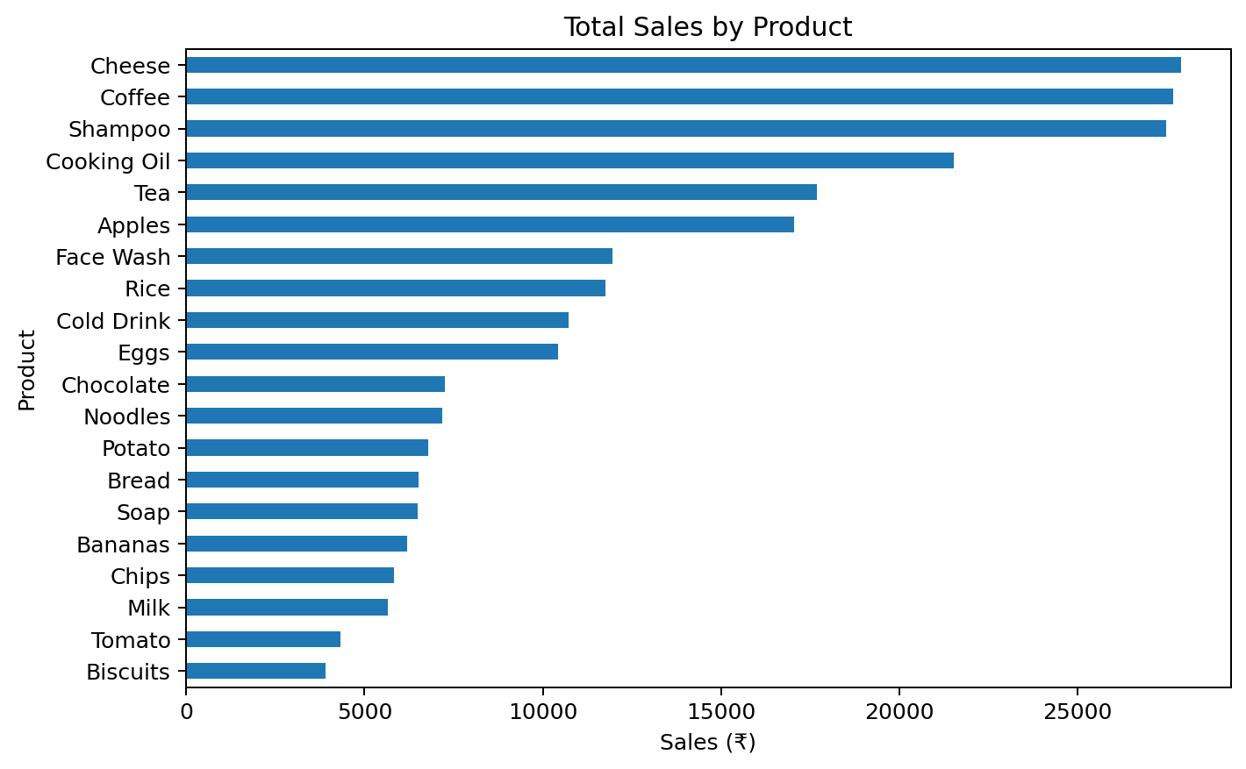

7.2 Branch Performance
Branch C in Mumbai recorded the highest sales, with ₹72,469.45. The other branches can be compared against this result to understand differences in performance.
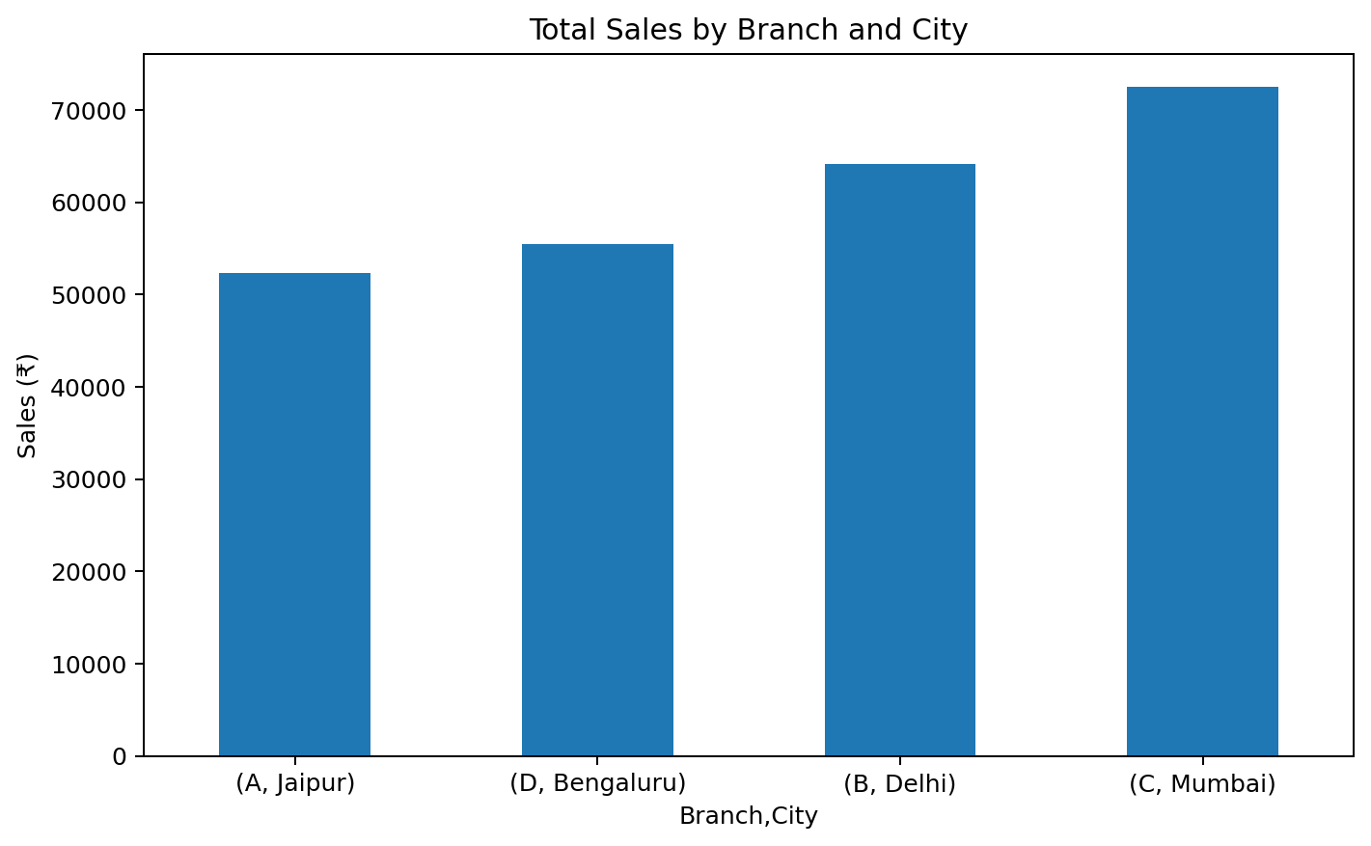

7.3 Category Performance
Beverages was the highest-sales category, generating ₹56,108.24. This category can therefore receive attention in inventory and sales planning.
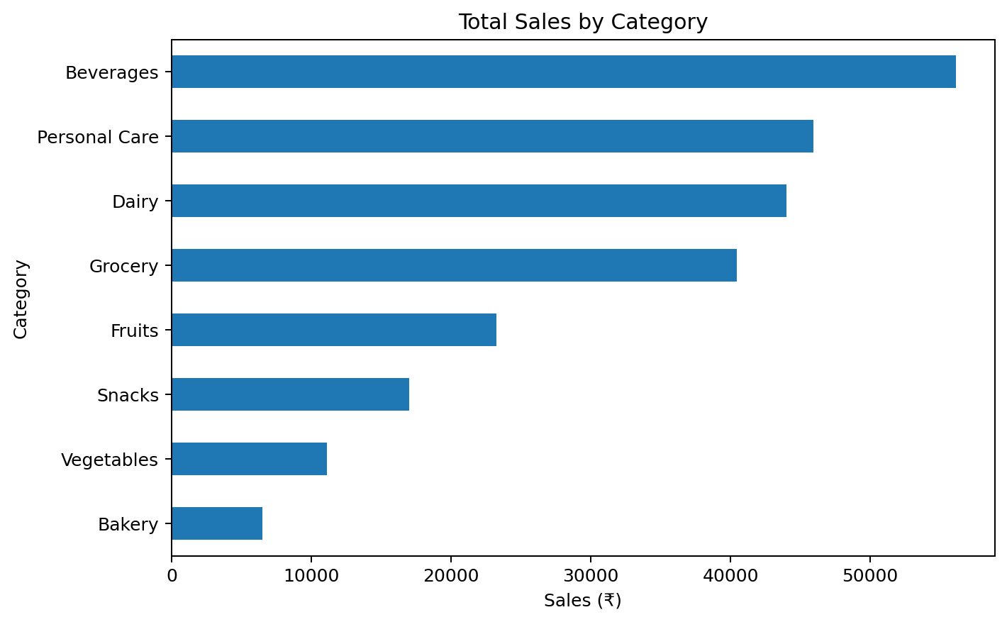

7.4 Payment Method
UPI was the most frequently used payment method, with 127 transactions. The distribution also shows that customers used multiple payment methods.
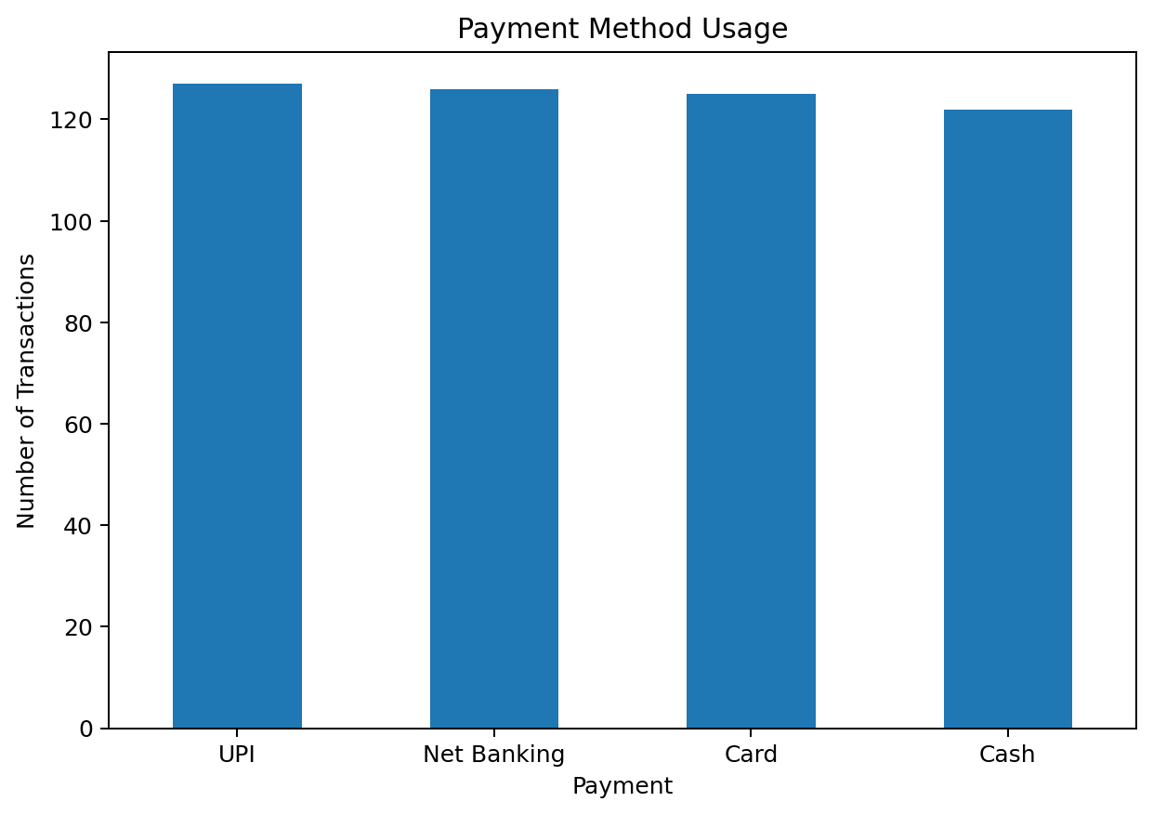

7.5 Member vs Normal Customers
The average transaction value for Members was ₹483.14, while Normal customers averaged ₹497.07. In this sample, the Normal-customer average was higher. This comparison can help when designing or reviewing membership offers.

7.6 Customer Rating
The average customer rating was 3.99 out of 5. Ratings provide a useful indicator for monitoring customer experience and identifying areas where service improvements may be needed.

8. Business Decisions and Recommendations
- Maintain sufficient stock of high-sales products, especially Cheese, and monitor high-performing categories such as Beverages.
- Study the operational factors associated with the strong sales performance of Branch C in Mumbai, such as product mix, customer demand, and transaction patterns.
- Continue supporting UPI payments while retaining other payment options because all four payment methods are actively used.
- Monitor customer ratings regularly and use lower-rated areas as signals for customer-service improvement.
- Use the Member vs Normal spending comparison when designing membership promotions instead of assuming that membership automatically results in higher transaction value.

9. Limitations
- The analysis is based on 500 transactions, so the findings describe this dataset and may not represent all supermarket activity.
- The dataset does not include costs, profit margins, inventory levels, promotions, or customer lifetime value, so profitability cannot be determined directly.
- Branch performance differences are descriptive; additional operational data would be needed to determine the causes of those differences.

10. Conclusion
This project demonstrates how supermarket transaction data can be cleaned, validated, summarized, and visualized using Python. The analysis identified the highest-selling product, strongest branch, leading category, most-used payment method, customer-type spending comparison, and average customer rating. These insights can support inventory planning, branch review, payment support, customer-service improvement, and membership strategy.

11. Project Files
- GVL_Sahithi_SupermarketSalesAnalysis.ipynb — Jupyter Notebook
- GVL_Sahithi_SupermarketSalesAnalysis.py — Python analysis script
- requirements.txt — required Python libraries
- README.md — project overview, dataset, setup instructions, and results
- SUPER MARKET DATA.xlsx — dataset used for analysis

