# OBJECTIVE:

Kavitha Molakathalla

Phone: 963245 57564

Email Id:

[**kavithamreddy03@gmail.com**](mailto:kavithamreddy03@gmail.com)

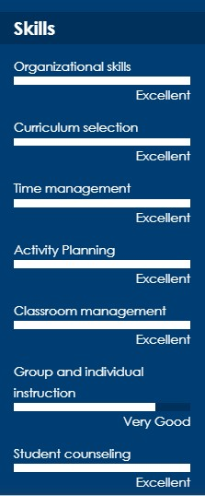

Just want to explore and continue my carrier as being   
 a “Passionate pre-primary Teacher for more than 8 years in all kind of school environment.

Proven history of creating engaged classroom environments supporting diverse educational styles. Versatile student-oriented approach consistently supporting optimum performance and advancement “in every organization I work for

# EDUCATION

**B.A & N.T.T  
High School Education Anantapur *07/1991* - *04/1993***

**SSC 05/1991**

**EXPERICENCE & ACTIVITIES:**

**Mecalay English School 01/2011-12/2011**

**Johnson’s English School 01/2012-12/2012**

**Sri Chaithanya concept school *01/2013* - *Now***

Having 8+ years of teaching experience in the current organization and 2+ years in other school, I have had the below experience and activities done by me

# Used learning stations to incorporate colors, shapes and textures to help students develop communication skills and build relationships.

# Developed learning objectives for each subject area to quantify learning and set benchmarks.

# Assessed and improved lesson plans through implementation and experimentation.

# Administered various reading tests and determined student reading levels based on assessment findings.

# Distributed and collected classroom materials such as worksheets, quizzes and tests.

# Maintained student portfolios to monitor learning progress and completion of work required for promotion to next grade level.

# Created study guides, research materials, and syllabi for students.

# Coached students on physical and emotional safety as part of health curriculum

# MORE INFORMATION :

* Name : Kavitha Molakathalla
* W/o : D. Raghunath Reddy
* Languages Known & speak : Kannada, English
* Mother Tongue : Telugu

# Hobbies: 1. DIY ( Do It Yourself ) homemade and hand works & arts

# 2. Research in free time to learn modern day teaching and concepts