ProfileBook Final Completion Report

Table Of Contents
1. About the Project 2. Software Development Life Cycle (SDLC) 2.1 Types of SDLC Models 2.2 Agile Software Development Model 2.3 Design Principles Used 2.4 Design Patterns Used 2.5 Agile Implementation in ProfileBook 2.6 Testing 3. Types of Users 3.1 Normal User 3.2 Administrator (Admin) 4. User and Admin Stories 4.1 User Stories 4.2 Admin Stories 5. Figma Brainstorming 6. Use Case Diagram 7. Database Design 7.1 Users Table 7.2 Posts Table 7.3 Messages Table 7.4 Reports Table 7.5 Groups Table 7.6 Additional Tables Implemented 7.7 Database Implementation Using Entity Framework Core 8. Backend Architecture 8.1 Controllers 8.2 Models 8.3 Data (DbContext) 8.4 DTOs 8.5 Migrations 8.6 Design Patterns 8.7 Services and Repositories 8.8 Helpers and Authentication 8.9 SignalR Real-Time Communication 9. Frontend Implementation 9.1 Public Pages 9.2 User Module 9.3 Admin Module 9.4 State Management and API Handling 9.5 Route Guards and Authentication Flow 10. Testing 10.1 Smoke Testing 10.2 Functional Testing 10.3 Integration Testing 10.4 API Testing 10.5 Real-Time Verification 11. Final Completion Status 12. Pending Limitations and Future Improvements 13. Conclusion 14. Output

1. About the Project
ProfileBook is a full-stack social networking web application developed using Angular for the frontend and ASP.NET Core Web API on .NET 8 for the backend. The system enables users to register, log in, manage their profile, create posts, send messages, search for other users, send friend requests, react to content, and report inappropriate behavior. The platform also includes an administrator workflow for post moderation, user management, report handling, group management, and emergency alert broadcasting.
The application follows a client-server architecture. The Angular frontend provides the user interface, while the ASP.NET Core backend handles authentication, business logic, database operations, and real-time communication. SQL Server is used for data persistence through Entity Framework Core using the Code-First approach. SignalR is used to support real-time chat, live notifications, typing indicators, and message read updates.
Compared to the earlier sprint-stage report, the project has now progressed into a functionally complete application with implemented user-facing and admin-facing workflows. The system now includes both the originally planned capstone features and several additional enhancements that improve usability, moderation, and real-time communication.

2. Software Development Life Cycle (SDLC)
The Software Development Life Cycle (SDLC) is a structured process used to plan, build, test, and improve software applications. It helps in dividing the development work into organized stages so that the system can be implemented in a manageable and quality-focused way.
In the ProfileBook project, SDLC concepts were used to move from requirements and design toward implementation, testing, and final completion. The project began as a sprint-based capstone plan and gradually evolved into a complete working system.

2.1 Types of SDLC Models
Common SDLC models include:
- Waterfall Model
- Agile Model
- Spiral Model
- V-Model
- Incremental Model
- Iterative Model
Different projects use different models depending on their complexity, flexibility, and delivery requirements.

2.2 Agile Software Development Model
The Agile Software Development Model is an iterative and incremental methodology in which software is built in small stages instead of being delivered all at once. Each cycle focuses on implementing a set of features, testing them, and then continuing with the next set of improvements.
Agile was suitable for ProfileBook because the project involved multiple modules such as authentication, posts, messaging, moderation, notifications, and group management. By implementing the project step by step, it was possible to continuously test and improve the application while gradually integrating the frontend and backend.

2.3 Design Principles Used
During implementation, the system was developed using modular design principles to keep the code maintainable, readable, and extensible. The backend separates concerns through controllers, services, DTOs, helpers, and data models. Controllers are responsible for receiving HTTP requests and returning responses, while services contain business logic. DTOs are used to control the shape of request and response data instead of exposing internal entity models directly.
Dependency Injection was used throughout the ASP.NET Core backend to register and consume services such as admin services, user services, database context, and SignalR integrations. This reduces tight coupling and improves testability.
On the frontend, Angular standalone components and route guards were used to keep the application organized. Shared service classes were used for API communication, authentication, state handling, and toast notifications. Reducer-style state services were introduced for user and admin modules so that data can be shared across components in a structured way.

2.4 Design Patterns Used
The implemented system includes multiple design patterns to improve code structure and maintainability.
Factory Pattern: The Factory Pattern is used through the NotificationFactory class to generate notification labels for different system events such as post creation and messaging. This centralizes notification creation logic and makes it easier to extend in the future.
Observer Pattern: The Observer Pattern is implemented through INotificationObserver, NotificationSubject, and NotificationService. This pattern is used to support event-driven notification behavior and separates notification publishing from notification handling.
State Pattern: The State Pattern is represented through post state classes such as PendingState, ApprovedState, and RejectedState. These reflect the moderation lifecycle of posts and align with the post review workflow in the system.
In addition to these formal patterns, the system also applies service-layer abstraction, DTO-based communication, and centralized helper utilities for password handling, normalization, and authentication resolution.

2.5 Agile Implementation in ProfileBook
The development of ProfileBook followed an Agile-style implementation process in which the system was built incrementally and refined over multiple phases. While the original capstone report described the work in sprint form, the final repository shows that the planned sprint objectives were completed and later extended with additional features.
Sprint 1 focused on the database structure, backend setup, and initial authentication-related development. Core models such as Users, Posts, Messages, Reports, and Groups were created using Entity Framework Core.
Sprint 2 focused on API implementation and frontend setup. During this phase, the Angular application structure, authentication pages, and the initial backend controllers were developed.
Sprint 3 focused on feature integration, admin flows, and system refinement. At this stage, post moderation, reporting, user management, group management, frontend-backend integration, and administrative dashboards were completed.
After the core sprint goals were achieved, the project was further extended with additional features such as friend requests, notifications, emergency alerts, profile image upload, forgot password and reset password flow, typing indicators, read receipts, and admin credential expiration logic. Therefore, the current project state represents a completed and enhanced version of the originally planned capstone scope.

2.6 Testing
Testing was carried out throughout development to verify backend APIs, frontend workflows, and integration between the Angular frontend, ASP.NET Core backend, SignalR communication layer, and SQL Server database.
Smoke testing was performed first to confirm that the essential backend APIs such as registration, login, Swagger access, and post operations were functioning correctly. These tests were supported by screenshots available in the Testing folder.
Functional testing was then performed to validate key user and admin workflows such as user registration, user login, admin login, dashboard access, post creation, and report-related operations.
Integration testing confirmed that frontend forms and actions were correctly connected to backend APIs and that data was being stored and retrieved correctly from the database.
Additional verification was also performed for real-time features such as live message delivery, notification updates, post review refresh behavior, and read/unread workflow handling.
Testing artifacts are available inside the repository under the Testing folder, including Swagger screenshots, frontend testing screenshots, and a Postman collection.

3. Types of Users
The ProfileBook system currently supports two primary role types: Normal User and Administrator. In addition, the administrator role is internally divided into Main Admin and Child Admin to support stronger governance over administrative actions.
Normal Users interact with the social platform through profile management, post creation, friendship workflows, messaging, notifications, and reporting. Administrators moderate the platform, manage users, review reports, review pending posts, manage groups, and broadcast alerts.
The Main Admin has the highest level of control in the system. Main Admin privileges include creating child admins, creating users, managing user accounts, extending admin credentials, and transferring main admin responsibility. Child Admins can access moderation features but do not have the same level of control over sensitive administrative functions.

3.1 Normal User
A Normal User is a registered user of the ProfileBook platform who can log in and participate in the social networking workflow. Users can create posts, upload post images, view approved posts from their own account and accepted friends, like posts, add comments, and share posts with friends.
Users can also search for other users, send friend requests, accept or reject requests, send direct messages to friends, participate in group conversations where applicable, receive notifications, and report inappropriate users. Each user can also manage their own profile information and upload a profile image.
The system ensures that user-generated posts are moderated before becoming publicly visible. Newly created posts are stored with a pending state and are only shown in the public feed after administrative approval.

3.2 Administrator (Admin)
An Administrator is responsible for platform moderation and operational control. Admins can access the admin dashboard and perform actions such as reviewing pending posts, approving or rejecting user posts, monitoring reports submitted by users, and managing user groups.
The system includes two admin levels: Main Admin and Child Admin. The Main Admin has the authority to create admins, create users, update or delete users, extend child admin credentials, and assign the main admin role to another administrator. Child Admin accounts are subject to credential expiration rules, while the Main Admin account does not expire.
Admins can also broadcast emergency alerts to all users. These alerts are stored in the database, converted into notifications, and pushed to users in real time through SignalR.

4. User and Admin Stories

4.1 User Stories
The implemented user stories in the final system are as follows:
- As a User, I should be able to register and create an account in the system.
- As a User, I should be able to log in using my email, username, or mobile number.
- As a User, I should be able to reset my password using the forgot password and reset password workflow.
- As a User, I should be able to manage my own profile information and upload a profile image.
- As a User, I should be able to create posts with optional images and submit them for admin approval.
- As a User, I should be able to view approved posts in my feed.
- As a User, I should be able to like, comment on, and share posts.
- As a User, I should be able to search for other users.
- As a User, I should be able to send and respond to friend requests.
- As a User, I should be able to send direct messages to accepted friends.
- As a User, I should be able to participate in group messaging where I belong to a group.
- As a User, I should be able to receive live notifications and emergency alerts.
- As a User, I should be able to report inappropriate users to the administrator.

4.2 Admin Stories
The implemented admin stories in the final system are as follows:
- As an Admin, I should be able to log in to the system.
- As an Admin, I should be able to view dashboard statistics.
- As an Admin, I should be able to review and approve or reject pending posts.
- As an Admin, I should be able to reject a post with a specific reason.
- As an Admin, I should be able to view and manage users.
- As an Admin, I should be able to create users and child admins.
- As an Admin, I should be able to review user reports and take actions such as dismiss, warn, or deactivate.
- As an Admin, I should be able to create and delete groups.
- As an Admin, I should be able to broadcast emergency alerts to users.
- As a Main Admin, I should be able to extend child admin credentials and transfer main admin ownership.

5. Figma Brainstorming
Before implementation, Figma was used as a brainstorming and planning tool to visualize the high-level structure of the application. This helped in organizing the relationships between users, administrators, posts, messages, reports, and groups before starting development.
The brainstorming phase supported module planning, feature grouping, and navigation flow understanding. It also helped in mapping the system into frontend pages and backend controllers.
Figma Link: https://www.figma.com/board/Ep58i50BZDZxA65sFx39Cr/Untitled?node-id=0-1&p=f&t=zmUenVerygir4lEz-0

6. Use Case Diagram
The use case diagram provides a high-level representation of how the two main actors of the system, User and Administrator, interact with ProfileBook.
The User can register, log in, manage profile information, create posts, view approved posts, like posts, comment on posts, search for users, send friend requests, send messages, receive notifications, and report users.
The Administrator can log in, review pending posts, manage users, manage groups, review reports, and broadcast alerts.
The project repository also contains separate use case documents and diagrams for important modules such as login, signup, message flow, reporting, and posting.

7. Database Design
The ProfileBook system uses SQL Server as the database management system for storing and managing application data. The database was implemented using the Code-First approach of Entity Framework Core in ASP.NET Core.
The final implemented database extends beyond the initial sprint-stage design. In addition to the original core tables, the system now includes tables that support likes, comments, post sharing, archived deleted users, password reset tokens, user notifications, emergency alerts, and friend requests. These additions were introduced as the system evolved from a basic capstone prototype into a more complete social networking platform.

7.1 Users Table
The Users table stores all registered users, including normal users and administrators.
Important fields include:
- UserId
- Username
- Email
- Password
- MobileNumber
- Role
- ProfileImage
- CreatedAt
- LastLoginAt
- CredentialsExpireAt
- IsActive
- CreatedBy
- IsMainAdmin

7.2 Posts Table
The Posts table stores user-created posts.
Important fields include:
- PostId
- UserId
- Content
- PostImage
- Status
- CreatedAt
- ReviewedAt
- ReviewedBy
- RejectionReason

7.3 Messages Table
The Messages table stores both direct and group messages.
Important fields include:
- MessageId
- SenderId
- ReceiverId
- GroupId
- MessageContent
- TimeStamp
- IsRead
- ReadAt

7.4 Reports Table
The Reports table stores reports submitted by users against other users.
Important fields include:
- ReportId
- ReportedUserId
- ReportingUserId
- Reason
- TimeStamp
- Status
- ActionTaken
- AdminNotes
- ResolvedAt
- ResolvedBy

7.5 Groups Table
The Groups table stores user group information.
Important fields include:
- GroupId
- GroupName
- GroupMembers
- CreatedAt
- CreatedBy

7.6 Additional Tables Implemented
As the project progressed, additional tables were added to support newly implemented features in the application. These tables include:
- FriendRequests - stores pending, accepted, or rejected friendship relationships between users.
- AlertMessages - stores emergency alerts broadcast by administrators.
- UserNotifications - stores post-related, report-related, and alert-based notifications delivered to users.
- PostLikes - stores user likes on approved posts.
- PostComments - stores comments made on approved posts.
- PostShares - stores records of post sharing between users.
- DeletedUsers - stores archived information of users deleted by administrators.
- PasswordResetTokens - stores temporary reset tokens used in the forgot password and reset password workflow.
These additional tables were implemented through Entity Framework Core migrations and are now part of the final database schema of the ProfileBook system.

7.7 Database Implementation Using Entity Framework Core
All database tables in the ProfileBook system were created using Entity Framework Core models with data annotations. The ProfileBookDbContext class defines the database sets, while model classes define the schema structure and validation rules. Entity Framework Core migrations were used to create and update the database schema during development.
This approach kept the C# models and SQL Server schema synchronized throughout implementation and made the database easier to extend as new features were added.

8. Backend Architecture
The backend of the ProfileBook system is developed using ASP.NET Core Web API built on .NET 8. The backend is responsible for authentication, business logic, moderation workflows, database operations, and API communication with the Angular frontend.
Compared to the earlier report version, the backend architecture is now more complete and includes additional modules for administration, alerts, groups, friend requests, user notifications, helpers, SignalR real-time communication, and service-layer business logic. The backend is no longer limited to basic user, post, message, and report operations, but now supports a broader workflow for moderation and platform control.

8.1 Controllers
The following controllers are implemented in the final backend:
- UserController - handles registration, login, forgot password, reset password, profile retrieval, profile update, and user listing.
- AdminController - handles admin dashboard operations, user management, admin creation, credential extension, and admin profile functions.
- PostController - handles post creation, feed retrieval, likes, comments, sharing, and post moderation.
- MessageController - handles direct messaging, group messaging, and message read updates.
- ReportController - handles reporting of users and administrative action on reports.
- GroupController - handles group creation, group listing, and deletion.
- FriendRequestController - handles sending, responding to, and viewing friend requests.
- AlertController - handles admin broadcast alerts and alert delivery.
- UserNotificationController - handles retrieval and read-status updates for user notifications.
- PlaceholderController - provides MVC placeholder pages included for architectural completeness.

8.2 Models
The backend models represent the database entities of the system. Core models include User, Post, Message, Report, and Group. Additional models such as FriendRequest, UserNotification, AlertMessage, PostLike, PostComment, PostShare, DeletedUser, and PasswordResetToken extend the schema to support the final implemented features.

8.3 Data (DbContext)
The ProfileBookDbContext class is responsible for managing the connection between the application and the SQL Server database. It defines the DbSet collections for all entities and configures unique indexes such as email, username, mobile number, post-like uniqueness, and password reset token uniqueness.

8.4 DTOs
DTOs are used extensively in the backend to safely transfer data between the frontend and backend without directly exposing entity models. In the final implementation, DTOs are used for login, registration, forgot password, reset password, post creation, post commenting, post sharing, admin creation, user update, group creation, report creation, report action, messaging, alert broadcasting, and friend request processing.
This DTO-based approach improves validation, reduces tight coupling, and ensures that only the required data is accepted by each API endpoint.

8.5 Migrations
The Migrations folder contains Entity Framework Core migration files that track changes in the database schema across development stages. These migrations include the initial schema, deleted users table, post rejection reason support, post engagement tables, and password reset token support.

8.6 Design Patterns
The backend contains design pattern implementations and pattern-oriented helpers:
- Factory Pattern for notification creation
- Observer Pattern for notification/event propagation
- State Pattern for post state representation such as Pending, Approved, and Rejected
These patterns improve organization and make the code easier to extend.

8.7 Services and Repositories
The backend includes a service layer that separates business logic from controller logic. The main service classes implemented are UserService and AdminService. These services are responsible for operations such as authentication, registration validation, password reset handling, admin creation, user updates, admin credential governance, and user deletion workflows.
Although the original report mentioned a repository layer as part of the architecture, the final code relies primarily on Entity Framework Core DbContext and the service layer for data access and business coordination. This still provides structured separation of responsibilities and keeps the backend maintainable.

8.8 Helpers and Authentication
The backend includes helper classes to centralize reusable logic. AuthHelper is used to resolve the current user identity from JWT claims and bearer tokens. PasswordHelper manages password hashing and verification, while PasswordPolicyHelper enforces password rules such as uppercase, special character, and minimum length requirements. IdentityNormalizer is used to normalize email addresses, usernames, mobile numbers, and login identifiers for consistent comparison and validation.
JWT authentication is implemented to protect user and admin routes. Role-based authorization is used to restrict access to admin-only operations, and additional main-admin checks are used for highly privileged actions.

8.9 SignalR Real-Time Communication
SignalR is used in the backend to provide real-time communication capabilities. A ChatHub was implemented to support direct messaging, group messaging, typing indicators, message read notifications, and live application notifications.
This real-time layer improves user interaction by allowing messages and notifications to appear immediately without requiring full page reloads. It is also used to notify admins about newly submitted posts and to push emergency alerts and user notifications live to connected clients.

9. Frontend Implementation
The frontend of the ProfileBook system is implemented using Angular with standalone components, routing, route guards, service-based API communication, and SignalR integration for live functionality. The frontend is no longer limited to a basic static dashboard, but now includes a complete set of user and admin modules connected directly to the backend APIs.
The final frontend includes the following implemented pages:
- Welcome Page
- Login Page
- Signup Page
- Forgot Password Page
- Reset Password Page
- User Dashboard
- User Messages Page
- User Notifications Page
- User Friend Requests Page
- User Search Users Page
- User Profile Page
- Admin Dashboard
- Manage Users Page
- Reports Page
- Review Posts Page
- Groups Page
These pages interact with the backend using a shared fetch-based API client service. Authentication state, user state, and admin state are handled using Angular services and route guards.

9.1 Public Pages
The public module includes the Welcome page, Login page, Signup page, Forgot Password page, and Reset Password page. These pages provide the entry points for authentication and account recovery.

9.2 User Module
The user module includes the User Dashboard, User Messages page, User Notifications page, User Friend Requests page, User Search Users page, and User Profile page.
The user dashboard supports post creation, post feed viewing, likes, comments, sharing, alerts, and notification handling. The messages page supports direct messaging, group messaging, unread tracking, typing indicators, and read receipts. The profile page allows username updates and profile image uploads. The search and friend-request pages support social connectivity features.

9.3 Admin Module
The admin module includes the Admin Dashboard, Manage Users page, Reports page, Review Posts page, and Groups page.
The admin dashboard shows system statistics and expiring admin credential information. The Manage Users page supports user creation, admin creation, updates, and deletions. The Reports page supports moderation decisions. The Review Posts page supports post approval, rejection, and deletion. The Groups page supports group creation and deletion.

9.4 State Management and API Handling
The frontend uses a shared fetch-based API client service to communicate with the ASP.NET Core backend. Authentication tokens are stored in session storage and automatically included in authorized requests.
To manage shared UI data, reducer-style Angular services were implemented for both user and admin modules. These services allow components to reactively share information such as dashboard statistics, posts, notifications, groups, and user management data. Although React Context API is not applicable in Angular, the implemented reducer-style services satisfy the same requirement intent of centralized state handling.

9.5 Route Guards and Authentication Flow
The frontend includes route guards to protect user and admin pages. UserGuard restricts user routes to authenticated users with the User role. AdminGuard restricts admin routes to authenticated administrators. MainAdminGuard provides an additional layer of protection for features that should only be accessible to the Main Admin, such as sensitive user management and group administration.
This route protection ensures that the Angular frontend aligns with the backend authorization model based on JWT roles and custom main-admin claims.

10. Testing
Testing was performed across backend APIs, frontend pages, and integrated workflows. Swagger was used to verify backend endpoints, and a Postman collection is available in the repository for API testing. Frontend behavior was tested through functional navigation, form validation, login flows, and dashboard behavior.
The available testing screenshots in the repository cover welcome page verification, successful registration, static user login, admin login, admin dashboard behavior, Swagger smoke testing, fetch post testing, signup testing, and login testing. These screenshots provide direct visual evidence of system execution and support the capstone demonstration.
In addition to smoke and functional testing, integration testing was performed to confirm that Angular forms and actions correctly communicate with the ASP.NET Core backend and SQL Server database. Real-time features such as notifications, message flow, and moderation refresh behavior were also verified during development.

10.1 Smoke Testing
Smoke testing was used to confirm that essential features such as API startup, registration, login, Swagger access, and post retrieval were functioning correctly.

10.2 Functional Testing
Functional testing was performed on user registration, login, admin login, dashboard navigation, post creation, and admin dashboard access.

10.3 Integration Testing
Integration testing verified the communication between Angular frontend components, backend APIs, SignalR, and SQL Server persistence.

10.4 API Testing
Swagger and Postman were used to validate request and response behavior of the implemented API endpoints.

10.5 Real-Time Verification
Real-time verification covered message delivery, typing indicators, message read handling, app notifications, and admin alert delivery.

11. Final Completion Status
The earlier version of this report described several major functionalities as upcoming work under Sprint 2 and Sprint 3. After comparing that report with the current repository, those planned deliverables are now implemented.
Completed items include:
- Angular frontend with routing and multiple modules
- User authentication and admin authentication
- JWT-based authorization
- User CRUD-related admin management
- Profile management with image upload
- Post creation, approval, rejection, likes, comments, and sharing
- User search and friend request flow
- Direct and group messaging
- User reporting and admin report actions
- Group management
- Swagger API documentation
- SignalR real-time communication
- User notifications and emergency alert broadcasting
- Forgot password and reset password flow
Therefore, the project can now be presented as a completed full-stack capstone system rather than a partial sprint-stage implementation.

12. Pending Limitations and Future Improvements
Although the core capstone requirements and many advanced features have already been implemented, a few practical improvements are still pending if the system is considered from a production-ready perspective.
The current pending improvements are:
- Email-based password reset delivery is not yet implemented. The system currently returns the reset token in the backend response for testing and demonstration purposes.
- The project uses local file storage for uploaded images instead of cloud-based storage.
- Formal performance testing, load testing, and deployment hardening are not yet included.
- Some backend compatibility logic exists to support database evolution during development and could be simplified in a clean production deployment.
- The repository contains placeholder MVC views mainly for architectural completeness, while the actual application workflow is handled through Angular.
These pending items do not block the capstone demonstration, but they can be presented as future enhancement areas.

13. Conclusion
ProfileBook has evolved from an initially planned sprint-based capstone project into a functionally complete social networking web application. The final system now includes user authentication, admin moderation, post workflows, social interaction features, messaging, reporting, notifications, profile management, group management, and real-time communication through SignalR.
The frontend, backend, and database are fully integrated, and the project includes both the originally required capstone features and several additional enhancements such as friend requests, emergency alerts, typing indicators, read receipts, and password reset flow.
From a capstone submission perspective, the project should now be documented and presented as a completed full-stack application. The main work remaining is not system development, but updating the report so that it accurately reflects the final implemented state of the repository.

14. Output
To make the project easier to evaluate without running the application, output screenshots are included in this report. These screenshots visually demonstrate the implemented frontend pages, backend API verification, and system workflows. This helps the reader understand the actual execution of the application directly from the report.
The following screenshots can be added in this section:
- Welcome Page
- Successful User Registration
- User Login
- Admin Login
- Admin Dashboard
- Swagger Default Page
- Signup API Testing
- Login API Testing
- Fetch Post Testing
- Post Creation Testing
These screenshots are available in the repository under the Testing folder. Adding them in the Output section gives evaluators a direct idea of the implemented features even if they do not execute the project manually.

14.1 Welcome Page
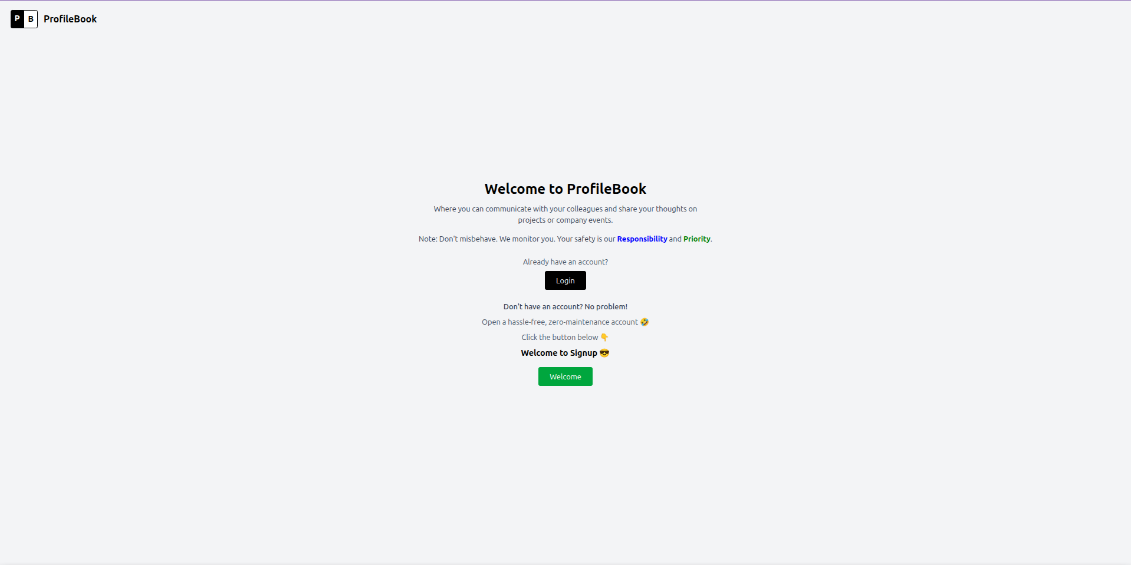Welcome Page

14.2 Successful User Registration
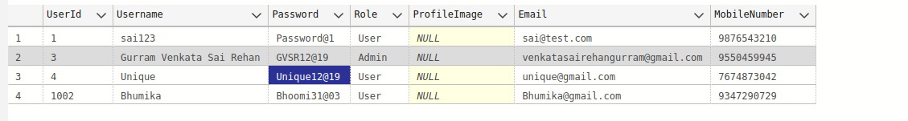Successful User Registration

14.3 User Login
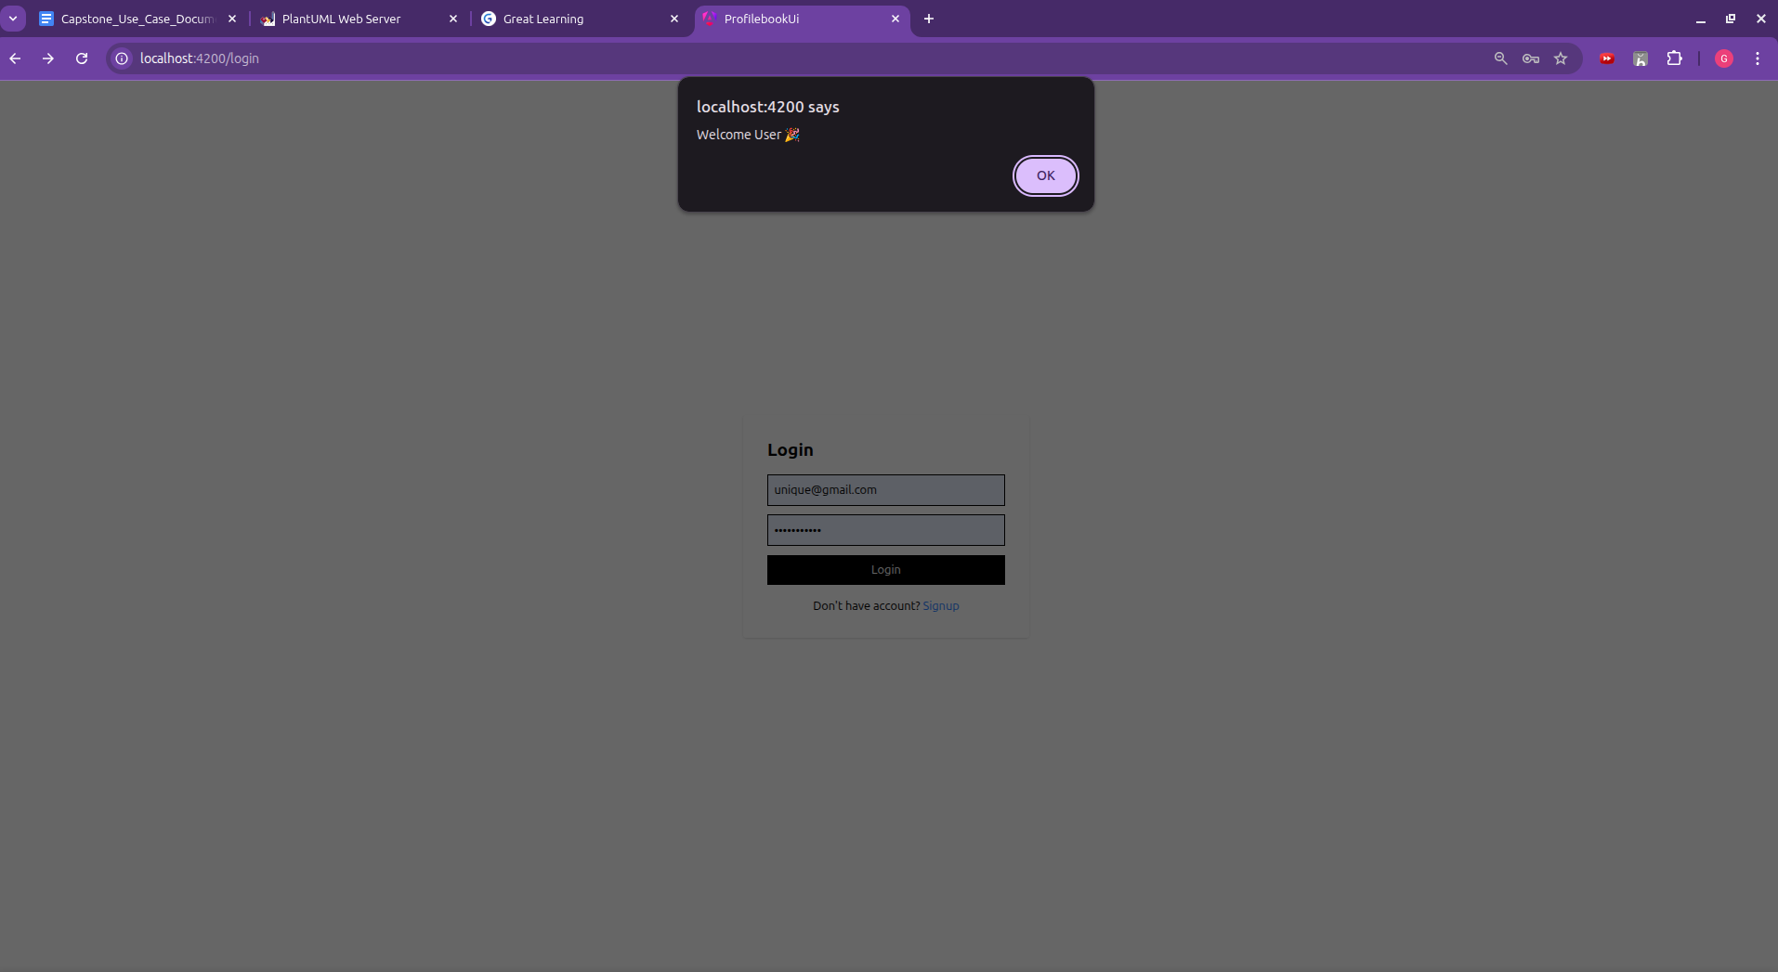User Login

14.4 Admin Login
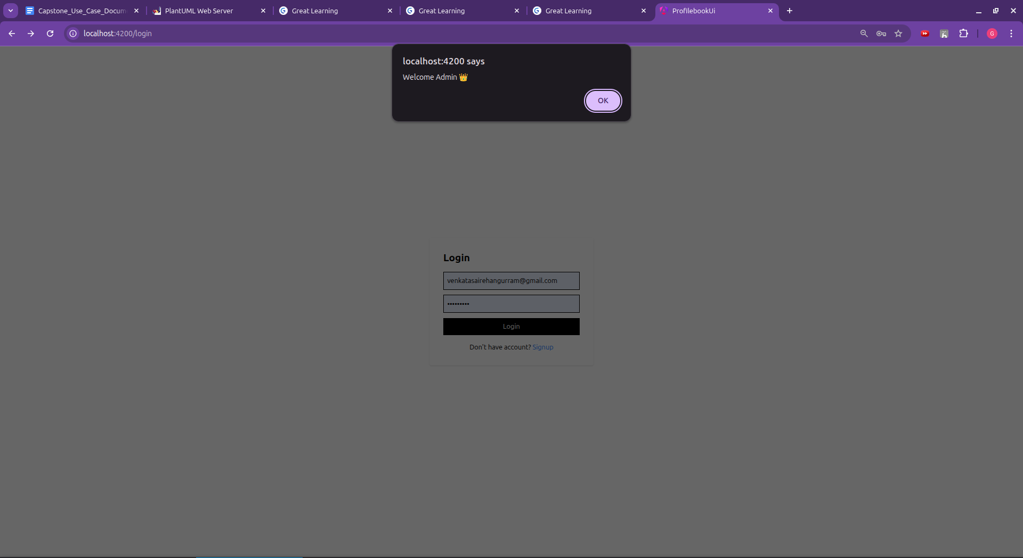Admin Login

14.5 Admin Dashboard
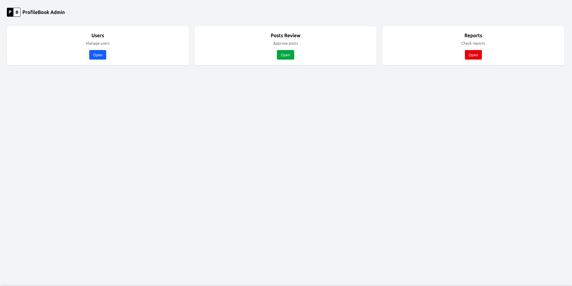Admin Dashboard

14.6 Swagger Default Page
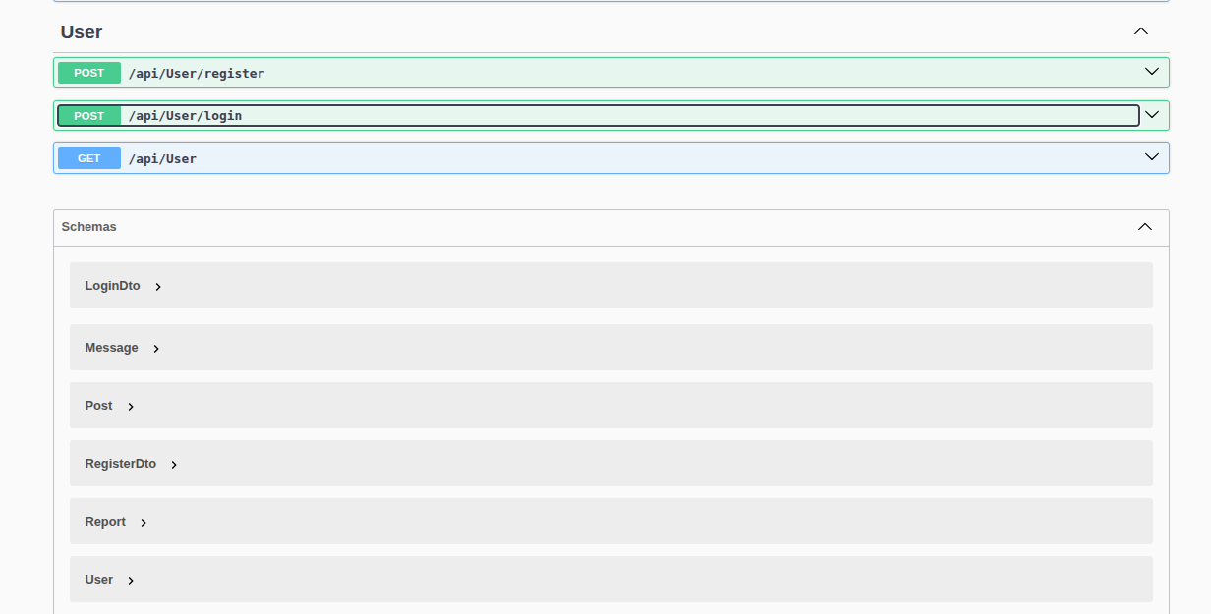Swagger Default Page

14.7 Signup API Testing
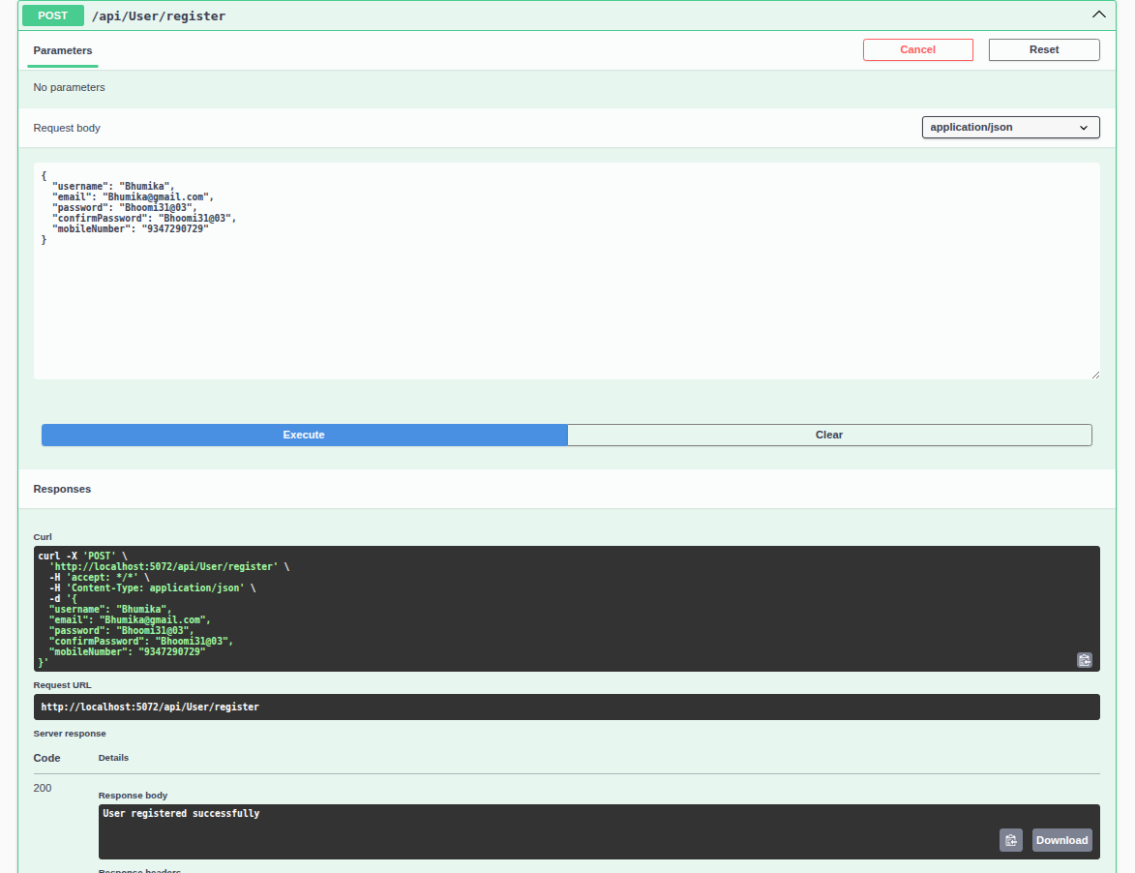Signup API Testing

14.8 Login API Testing
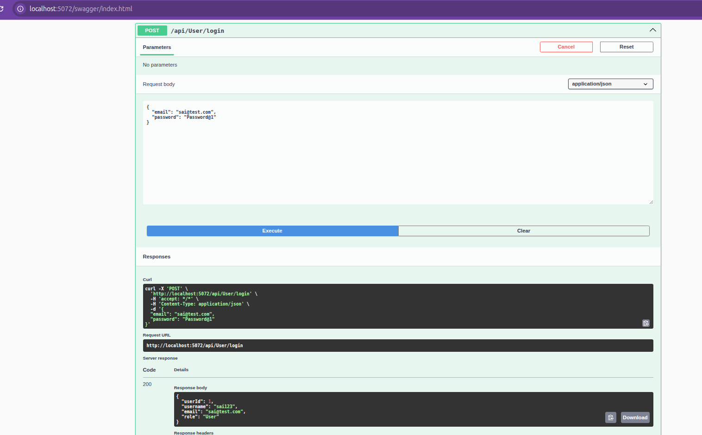Login API Testing

14.9 Fetch Post Testing
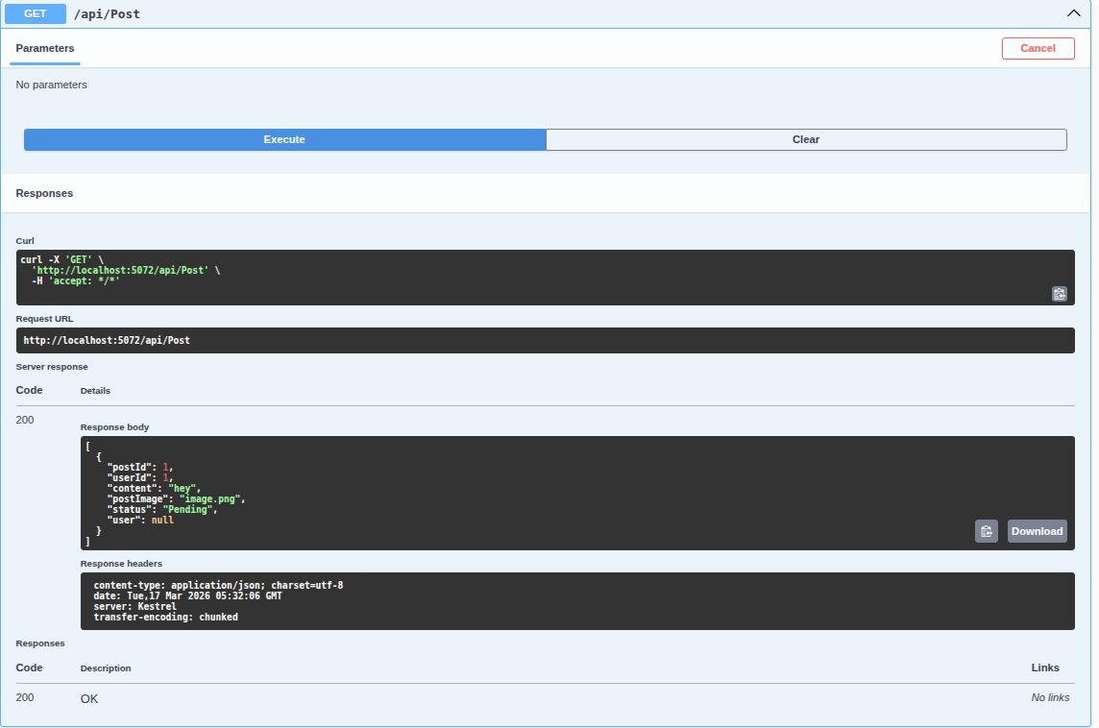Fetch Post Testing

14.10 Post Creation Testing
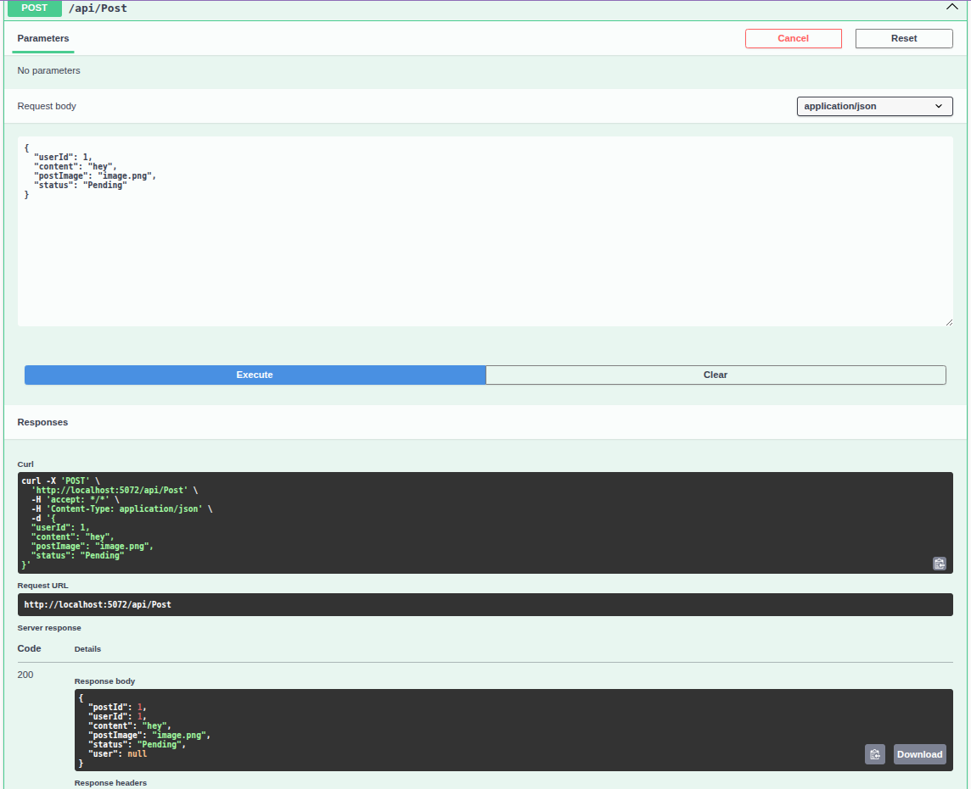Post Creation Testing

