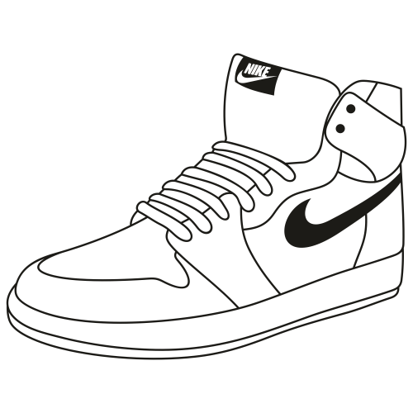

**Documentation**

PRESENTED BY

Work with

GitHub

REPOSITORY

**Table of contents**

**1. Team 3**

**1.1 Георги Стоянов 3**

**2. Used technologies 4**

**3. Idea 5**

**4. Process 6**

**1. Team:**

Георги Стоянов:

GVStoyanov20@codingburgas.bg

**2. Used technologies:**

|  |  |
| --- | --- |
| Technologies | Use |
| Dart  C++  CMake  HTML  Swift  C  Other | Languages that we used for the site and the game |
| Word | To make the documentation of our project |
| GitHub | For managing the files |

**3. Idea**

**I was searching for new shoes and then an idea sparked in my mind to create my project on the same basis.**

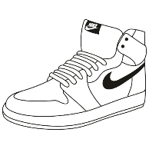

**4. Development  
  
Firstly, I downloaded Flutter and made it fork with the project that Martin Dobrev made for us. Then I started to look around to find how I can edit the code and pictures. I changed the background and logo, I added a new category with a few cards added to it and lastly I made a voice file myself for the cards.  
  
To summarize everything, it was very interesting and fun but it was very time consuming to make sure everything works like a charm.**