TASK-2
A. Powertrain Architecture
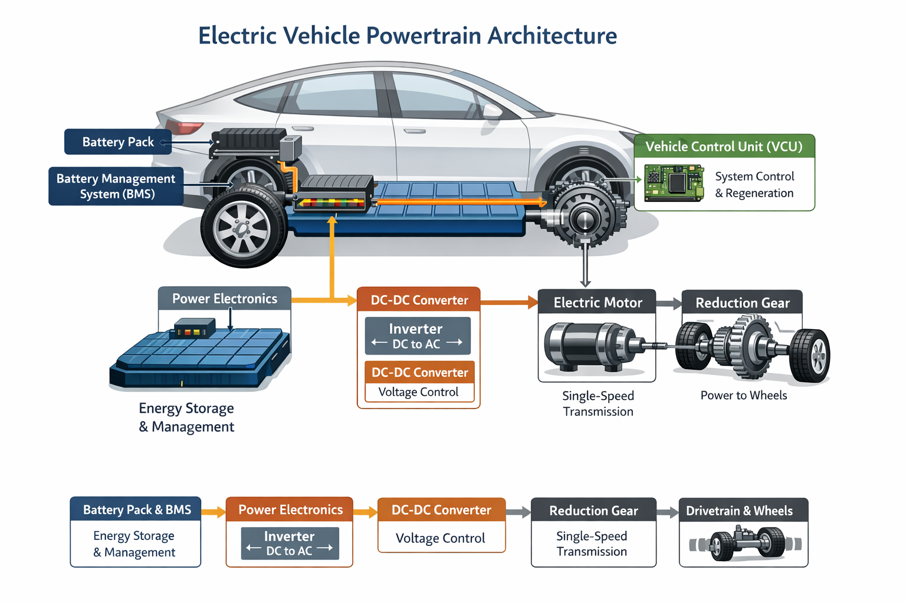

Battery Pack & Management System (BMS)
Stores electrical energy and delivers controlled power to the rest of the system.
Power Electronics (Inverter & Converters)
Inverter: Converts DC from the battery into AC for the motor.
DC-DC Converter: Steps down voltage for auxiliary systems like lights, HVAC, etc.
Electric Motor(s)
Converts electrical energy into mechanical rotation (torque). One or more motors can be used depending on the vehicle’s configuration (single, dual, or multiple motors).
Transmission/Reduction Gear
Most EVs use a single-speed reduction gear since electric motors deliver wide-range torque without shifting gears.
Controller / Vehicle Control Unit (VCU)
The “brain” that manages energy flow, motor torque, regenerative braking, and overall system safety.
Drivetrain & Wheels
Mechanical elements like axles and differentials that transfer motor torque to the wheels.

B. Motor Type Case Study-Tesla Model 3
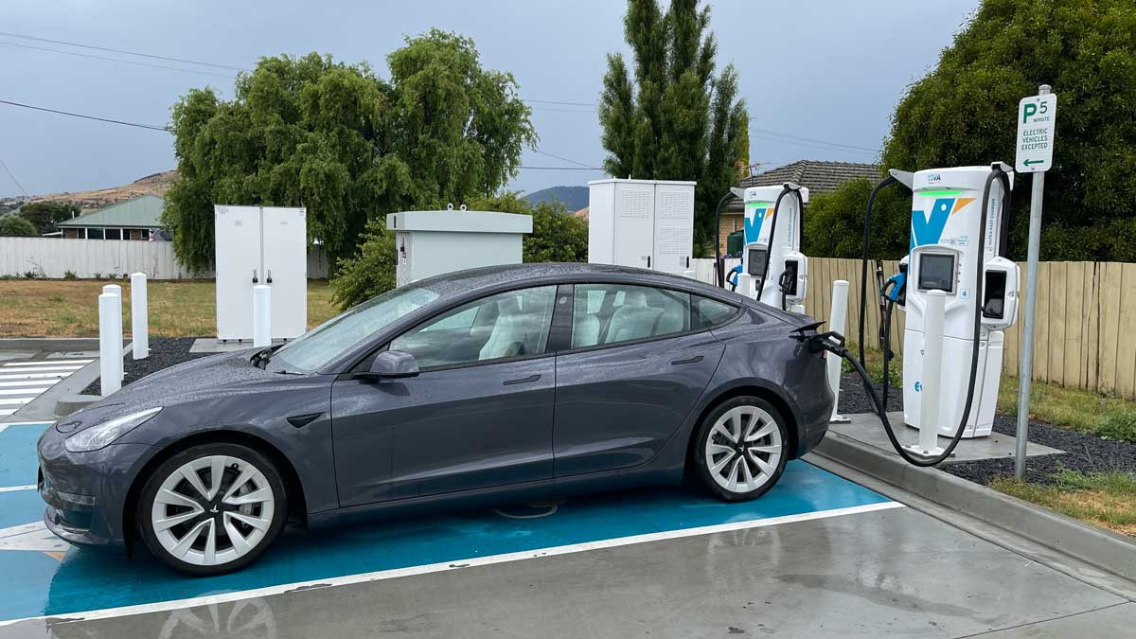
The Tesla Model 3 is one of the most technologically advanced mass-produced electric vehicles, particularly known for its innovative motor architecture. Unlike many EVs that rely on a single motor type, Tesla uses a combination of motor technologies depending on the vehicle variant.
The Tesla Model 3 primarily uses two types of electric motors:
1. Permanent Magnet Synchronous Motor (PMSM) / Interior Permanent Magnet Synchronous Reluctance Motor (IPM-SynRM)
This motor is typically mounted on the rear axle and acts as the primary drive motor. It offers high efficiency, high torque density, and compact size. The IPM-SynRM design reduces energy losses and improves driving range, making it ideal for long-distance efficiency.
2. AC Induction Motor (in Dual-Motor AWD variants)
In All-Wheel Drive (AWD) versions, Tesla adds an induction motor on the front axle. Induction motors are robust, magnet-free, and suitable for handling additional torque demands. This setup allows torque distribution between front and rear wheels for improved traction and performance.
Performance Characteristics
Depending on the variant (Rear-Wheel Drive, Long-Range AWD, or Performance AWD), the motor specifications vary:
- Power output ranges approximately from 137 kW to 220 kW for individual motors.
- Torque ranges between 219 Nm and 440 Nm.
- The system operates at around 320 V nominal battery voltage.
- Motors are liquid-cooled for thermal stability and efficiency.
Engineering Advantages
- High Efficiency: The rear PMSM/IPM motor ensures better energy utilization and extended driving range.
- Instant Torque Delivery: Provides rapid acceleration from standstill.
- Dual-Motor Control (AWD variants): Enables dynamic torque vectoring and improved stability.
- Compact and Lightweight Design: Enhances overall vehicle performance.
C. BMS Safety Study
A Battery Management System (BMS) is the central intelligence of an electric vehicle battery pack. It continuously monitors voltage, current, and temperature to ensure safe and efficient operation of lithium-ion cells. In modern electric vehicles, battery packs operate at high voltages ranging from 300V to 800V and contain hundreds of cells connected in series and parallel combinations. Because lithium-ion chemistry is sensitive to overcharging, deep discharging, overheating, and excessive current flow, accurate estimation of battery states such as State of Charge (SOC), State of Health (SOH), and State of Power (SOP) becomes extremely important. State of Charge (SOC) represents the available charge remaining in the battery compared to its nominal capacity.
SOC = (Remaining Capacity / Nominal Capacity) × 100%
One common method to calculate SOC is Coulomb counting, which integrates battery current over time:
SOC(t) = SOC(t0) − (1/C_nom) ∫ I(t) dt
where C_nom is nominal capacity in ampere-hours and I(t) is current as a function of time.
For example, consider a battery rated at 50 Ah with an initial SOC of 100%.
If the vehicle draws a constant 10 A for 2 hours, the discharged capacity becomes:
Q = I × t = 10 × 2 = 20 Ah
The remaining capacity is 30 Ah. Therefore:
SOC = (30 / 50) × 100 = 60%
Thus, the vehicle dashboard will display approximately 60% charge remaining. However, Coulomb counting accumulates sensor errors over time. Therefore, modern BMS systems combine voltage-based estimation and Extended Kalman Filter algorithms to improve accuracy.
State of Health (SOH) indicates battery aging and overall condition compared to its original state. It is defined as:
SOH = (Current Maximum Capacity / Rated New Capacity) × 100%
If a battery originally had 50 Ah capacity but after years of use delivers only 42 Ah, then:
SOH = (42 / 50) × 100 = 84%
This means the battery retains 84% of its original capacity. Another method to estimate SOH uses internal resistance growth:
SOH_R = (R_new / R_current) × 100%
If initial resistance was 20 mΩ and increases to 30 mΩ:
SOH_R = (20 / 30) × 100 = 66%
Higher resistance reduces efficiency and limits power capability. For example, if an EV originally provided 400 km range and now delivers only 330 km, approximate SOH is:
SOH ≈ (330 / 400) × 100 = 82.5%
State of Power (SOP) defines the maximum power the battery can safely deliver or absorb at a specific moment. It depends on SOC, SOH, temperature, and internal resistance. The basic power equation is:
P = V × I
Considering internal resistance, terminal voltage becomes:
V_terminal = V_oc − I × R
To avoid voltage dropping below minimum safe limit (V_min), maximum allowable current is:
I_max = (V_oc − V_min) / R
Maximum power is then:
P_max = V_terminal × I_max
For example, if V_oc = 400 V, V_min = 350 V, and R = 0.05 Ω:
I_max = (400 − 350) / 0.05 = 1000 A
P_max = 400 × 1000 = 400 kW
If aging increases resistance to 0.1 Ω:
I_max = 50 / 0.1 = 500 A
P_max = 400 × 500 = 200 kW
Thus, power capability reduces significantly due to aging.
In practical EV driving, SOC, SOH, and SOP are interrelated. Low SOC limits acceleration even if the battery is healthy. Poor SOH reduces range and peak power. Low temperature increases internal resistance and reduces SOP. Advanced BMS systems use
equivalent circuit models such as:
V = V_oc(SOC) − I R0 − V_RC
Thermal runaway
Thermal runaway is a dangerous and self-accelerating temperature rise that occurs in lithium-ion batteries when internal heat generation exceeds heat dissipation. It typically begins due to conditions such as overcharging, short circuits, high current discharge, mechanical damage, or manufacturing defects. When the battery temperature crosses a critical threshold (around 80°C–120°C), internal chemical reactions become unstable and exothermic, generating additional heat. The heat produced due to resistive losses can be expressed as Q = I²R, meaning higher current results in greater heat generation. As temperature increases, reaction rates rise exponentially, often described using the Arrhenius equation, which further accelerates heat production. The separator may melt, leading to internal short circuits, electrolyte decomposition, oxygen release, and rapid pressure buildup inside the cell. If uncontrolled, this process can result in fire, explosion, and toxic gas emission. In battery packs, thermal runaway can propagate from one cell to neighboring cells, causing a chain reaction failure. Therefore, Battery Management Systems (BMS) play a critical role by continuously monitoring voltage, current, and temperature, and by disconnecting the battery or activating cooling mechanisms to prevent catastrophic failure.
Conclusion
A Battery Management System (BMS) prevents battery failure by continuously monitoring critical parameters such as voltage, current, and temperature of individual cells and the overall pack. It ensures that each cell operates within safe voltage limits to prevent overcharging and deep discharging, which can damage the battery. The BMS detects abnormal current flow and protects against short circuits and overcurrent conditions by disconnecting the load using contactors. It monitors temperature through sensors and activates cooling systems or shuts down the battery if overheating is detected. Cell balancing is performed to equalize voltage differences between cells, preventing localized stress and premature aging. The BMS estimates State of Charge (SOC) and State of Health (SOH) to manage energy usage efficiently and avoid unsafe operating conditions. It communicates with the vehicle control unit to limit power during critical situations. Fault detection algorithms identify internal faults early before they escalate into severe failures. By maintaining thermal stability and electrical safety, the BMS reduces the risk of thermal runaway. Overall, it acts as the protective brain of the battery pack, ensuring reliability, safety, and long service life.

