Voice-to-Text Agent
Architecture overview

What it does
The Voice-to-Text Agent is a small, standalone backend service. You send it an audio recording and it sends back the spoken words as text, with the detected language and timestamps for each part of the speech.
It is built with Python and FastAPI, has one main endpoint (POST /v1/transcribe), and can use either a cloud speech-to-text service or a Whisper model running on its own server.

The big picture
Each request travels through the same five steps:
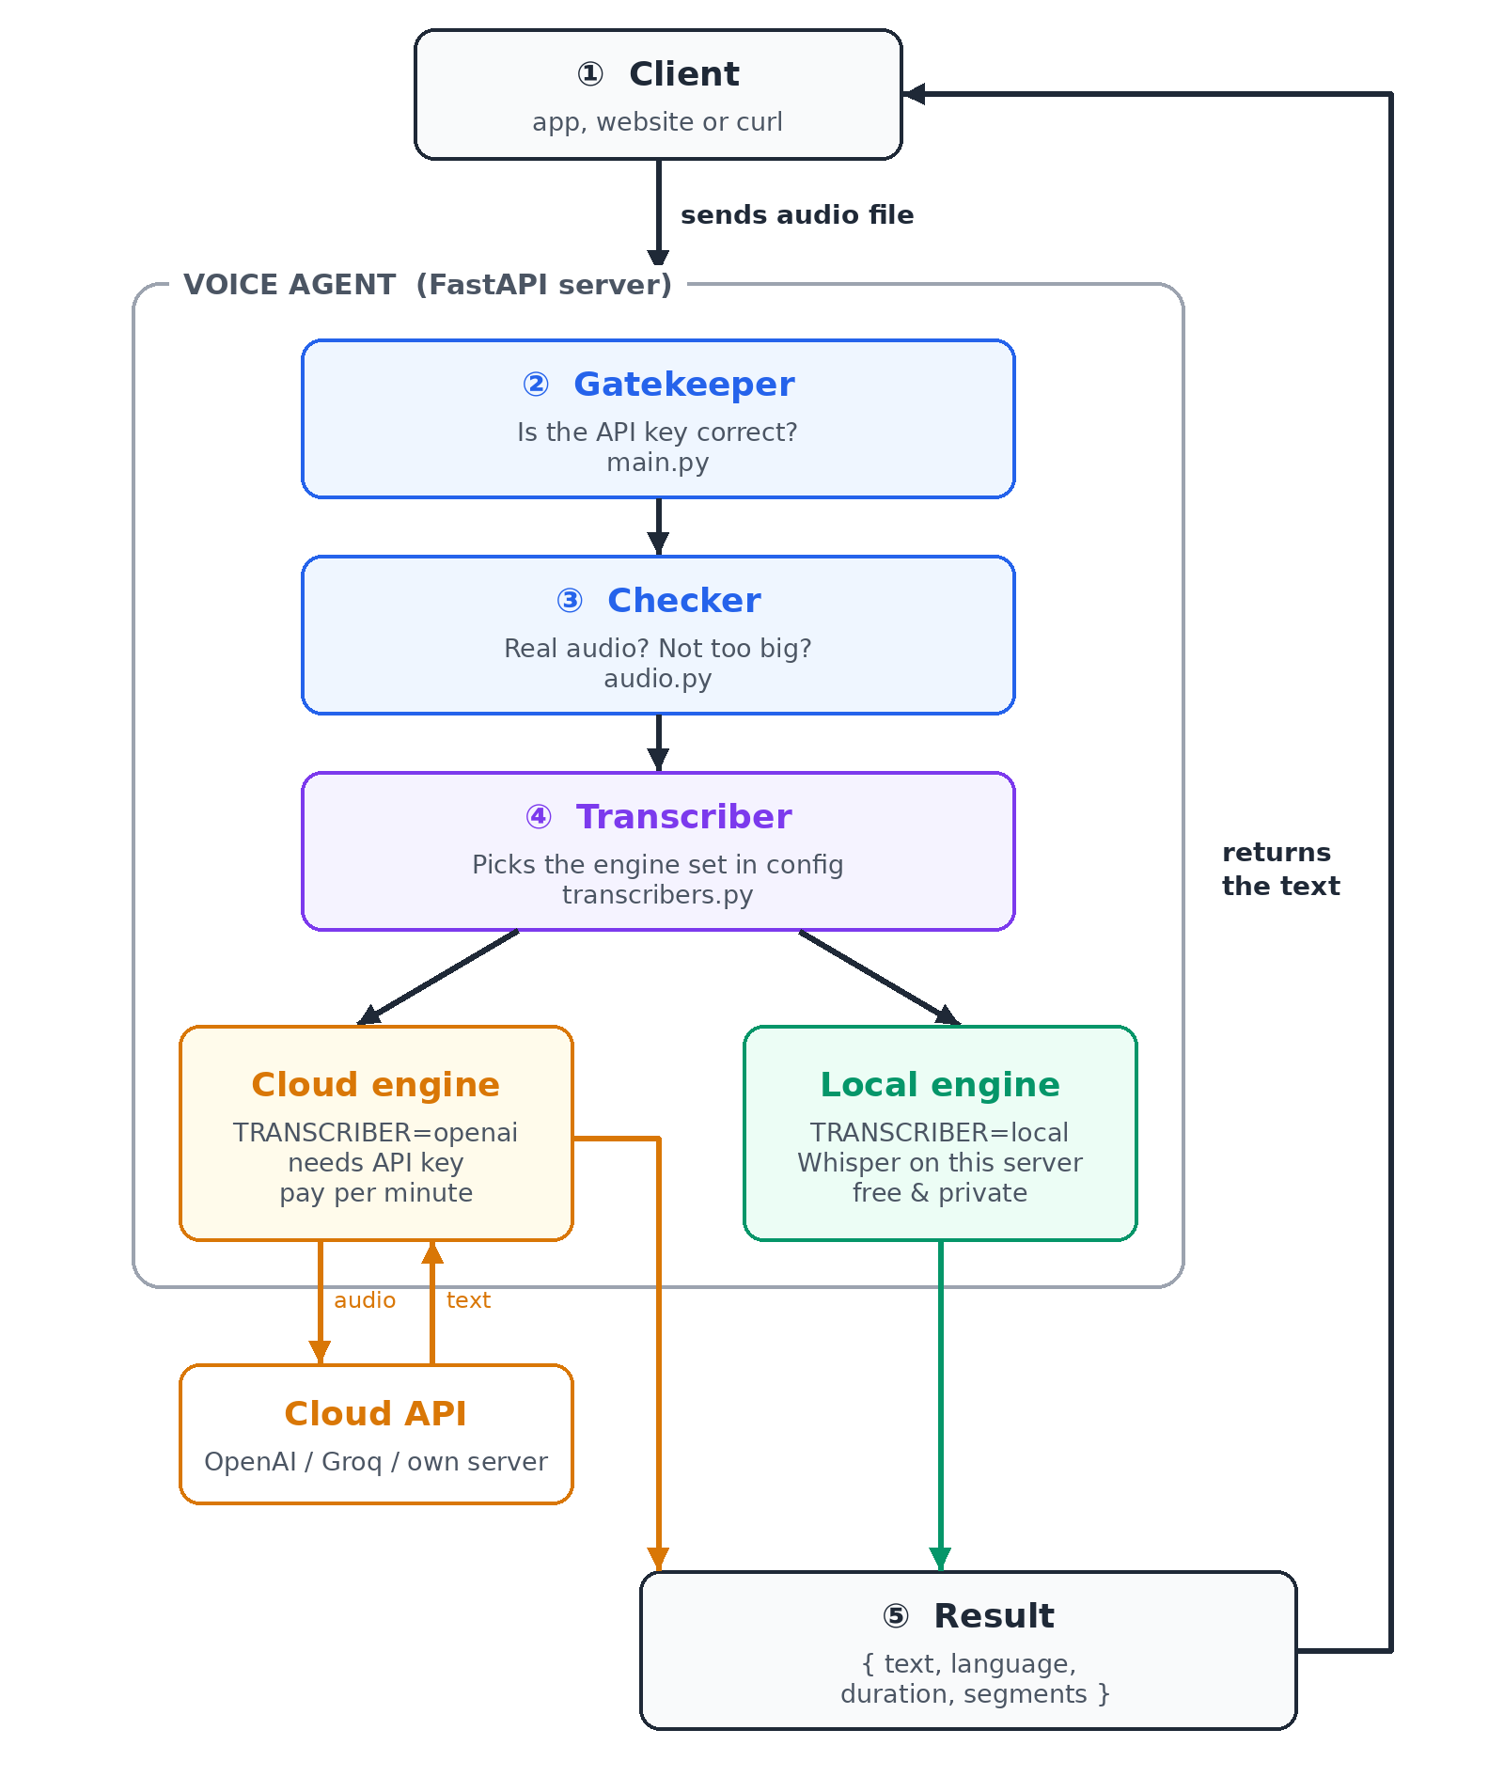
Figure 1 – How a recording becomes text

How a request flows
- Client – an app, website or command-line tool uploads an audio file.
- Gatekeeper – if an API key is configured, the request must include it; otherwise it is refused.
- Checker – confirms the file really is audio (WAV, MP3, M4A, WebM, OGG or FLAC) and is not too large.
- Transcriber – sends the audio to the engine chosen in the settings: the cloud engine or the local engine.
- Result – the text, language, duration and timestamped segments go back to the client.

The building blocks
File | What it does
main.py | Front door: the API routes, the API-key check and friendly error messages.
audio.py | Checks the upload: detects the real format from the file contents and enforces the size limit.
transcribers.py | The two engines (cloud and local) behind one common interface.
config.py | Reads all settings from environment variables or a .env file.
schemas.py | Defines the shape of the JSON responses.

Two engines, one switch
You choose the engine with a single setting, TRANSCRIBER. No code changes are needed.
 | Cloud engine | Local engine
Setting | TRANSCRIBER=openai | TRANSCRIBER=local
Runs on | OpenAI, Groq or your own Whisper server | Your server (faster-whisper)
Needs | An API key | Extra install; model downloads on first use
Cost | Pay per minute of audio | Free (uses your CPU/GPU)
Privacy | Audio is sent to the provider | Audio never leaves your server
Best for | Quick start, no hardware | Privacy, offline use, high volume

The API at a glance
Endpoint | Purpose
POST /v1/transcribe | Upload audio (field “file”), optionally “language” (e.g. en) and a “prompt” hint. Returns the transcript.
GET /health | Shows which engine is active and whether it is ready.

Example request
curl -X POST http://localhost:8000/v1/transcribe \
-H "Authorization: Bearer <API_KEY>" \
-F file=@meeting.m4a -F language=en
Example response
{
"text": "Hello, welcome to the meeting.",
"language": "en",
"duration_seconds": 3.2,
"segments": [{ "start": 0.0, "end": 3.2, "text": "Hello, welcome to the meeting." }],
"engine": "openai",
"model": "whisper-1"
}

When something goes wrong
Every error comes back in the same simple format with a code and a readable message:
Status | Code | Meaning
400 | unsupported_format | The file is not a supported audio format.
401 | unauthorized | API key missing or wrong.
413 | file_too_large | The file is bigger than the allowed size (default 25 MB).
422 | no_speech | No speech was detected in the recording.
502 | transcription_failed | The cloud speech service did not respond correctly.
503 | engine_not_configured | The chosen engine is not set up (e.g. no API key).

How to run it
- Install: pip install -r requirements.txt (or requirements-local.txt for the local engine).
- Configure: copy .env.example to .env and set OPENAI_API_KEY, or TRANSCRIBER=local.
- Start: uvicorn app.main:app --reload
- Try it: open http://localhost:8000/docs in a browser.
A Dockerfile is included as well. Build it with: docker build -t voice-agent .

Key design choices
- Standalone: independent of any other project; it can live in its own repository.
- Pluggable engines: adding a new provider means writing one small class.
- Safe input: files are checked by their real contents, never by their name.
- Nothing stored: audio is kept in memory for one request only, then discarded.
- Responsive: transcription runs in a background thread so the server keeps serving others.

