**Best Practices for Object Diagram**

An Object Diagram represents instances of classes at a particular moment in time. It's crucial for understanding the state of the system and how objects are related.

1. **Keep it Simple and Focused**
   * Show only relevant objects: Avoid overloading the diagram with too many objects. Only include those that are necessary to represent the scenario being modeled.
   * Limit the number of instances: Focus on a subset of objects that represent a specific scenario or interaction.
2. **Use Clear Object Names**
   * The object name should be clear and descriptive. It should represent the instance and sometimes its state (e.g., John_Student).
   * Include the object's class name, followed by its current state (e.g., student1:name="John", grade="A").
3. **Show Important Relationships**
   * Represent associations and references clearly by showing relationships between objects (e.g., Student has a Result).
   * Use simple lines to show associations and arrows to represent dependencies.
4. **Consistency**
   * Ensure that object names, attribute values, and the diagram’s layout remain consistent with other parts of your design.
   * When using attributes in object instances, use consistent formats, such as showing the values in a specific format (<attributeName>:<value>).
5. **Avoid Redundancy**
   * Don't repeat information that is already present in the Class Diagram unless necessary for the scenario.
   * Object Diagrams should only depict the state of objects, not duplicate the class-level design.

**Best Practices for Class Diagram**

A Class Diagram provides a static view of the system’s structure, representing classes, attributes, methods, and relationships.

1. **Keep it Simple and Abstract**
   * Focus on high-level classes and avoid unnecessary details. Only include the attributes and methods that are essential for understanding the system's structure.
   * Avoid overcomplicating with too many classes, especially in the initial stages of design.
2. **Use Meaningful Names for Classes and Attributes**
   * Class names should be nouns that clearly describe the object or concept (e.g., Student, Course, Result).
   * Attribute names should describe the characteristics of the object (e.g., studentId, email, grade).
   * Method names should represent actions (e.g., enrollInCourse(), assignGrade()).
3. **Define Relationships Clearly**
   * Clearly define the types of relationships between classes using appropriate UML notations:
     + Association: Represented by a simple line, indicating that classes are related.
     + Inheritance: Represented by a line with a triangle, indicating a superclass/subclass relationship.
     + Aggregation/Composition: Represented by lines with diamonds, denoting "whole-part" relationships (composition has a stronger relationship than aggregation).
     + Use the right multiplicity (e.g., one-to-many, many-to-many) to describe how classes are related.
4. **Show Interfaces and Abstract Classes When Needed**
   * If you're modeling interfaces, use the dashed line with a triangle pointing to the implementing class. This clarifies which class is fulfilling a contract.
   * Abstract classes should be represented with italics or a clear indication that they cannot be instantiated.
5. **Use Proper Access Modifiers**
   * Indicate whether attributes and methods are public, private, or protected (e.g., +, -, #).
   * This helps clarify the visibility and encapsulation of each component in the class.
6. **Group Classes into Packages**
   * In larger systems, group related classes into packages. This reduces clutter and improves readability.
   * Use packages to logically group related classes (e.g., student, course, results).

**Best Practices for Sequence Diagram**

A Sequence Diagram models the interaction between objects over time, focusing on the sequence of messages.

1. **Clear and Consistent Object Naming**
   * The objects in the diagram should be clearly labeled with meaningful names. Use class names followed by object identifiers (e.g., Student1, Teacher_MrSmith).
   * Use consistent naming conventions for messages, such as placeOrder(), enrollInCourse().
2. **Limit the Number of Objects in the Diagram**
   * Too many objects can make the sequence diagram cluttered and hard to read. Limit the number of objects to only those essential for the particular scenario you’re modeling.
   * If necessary, break complex interactions into smaller diagrams.
3. **Represent Lifelines and Activations Properly**
   * Lifelines represent the existence of objects and are drawn as dashed vertical lines.
   * Activation bars represent when an object is active and performing a task. Ensure that the lifeline’s activation bar is clearly defined for each method call.
4. **Use Clear and Meaningful Messages**
   * Messages should clearly indicate what is happening between the objects. Use consistent naming conventions for method calls (e.g., getStudentResult() or calculateGrade()).
   * Return messages should be dashed arrows, indicating that the method has completed and returned control or a value to the calling object.
5. **Ensure Proper Message Ordering**
   * Messages in a sequence diagram should be drawn in top-to-bottom order to reflect the logical sequence of operations. The first message should appear at the top, followed by the subsequent messages.
   * Use arrows to indicate the flow of communication, with clear labels for each message.
6. **Show Conditionals and Loops When Needed**
   * If the flow depends on certain conditions, use alt (alternatives) or opt (optional) boxes to represent decision points or optional operations.
   * For loops or repeated actions, use loop boxes and clearly show the repetition.
7. **Keep It Focused on a Single Use Case**
   * Each sequence diagram should represent a single use case or scenario, making it easier to follow.
   * Avoid combining multiple interactions in one sequence diagram. If a scenario has multiple branches or steps, create separate diagrams for each.

**Sample Problem 1: School Results Application**

* **Class Diagram**
  + **Diagram Description**:
    - Classes: Student, Subject, GradeCalculator
    - Relationships:
      * A Student has multiple Subject entries (Aggregation).
      * GradeCalculator computes the results for a Student.

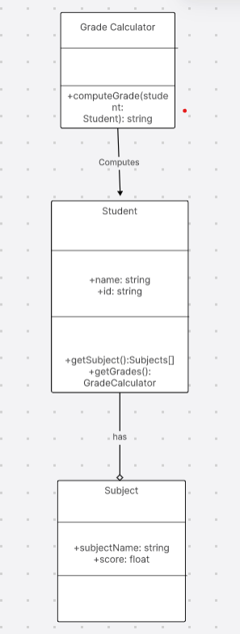

* **Object Diagram**
  + **Example**:
    - Student: John
    - Subjects: Maths, Science
    - Marks: 90, 85

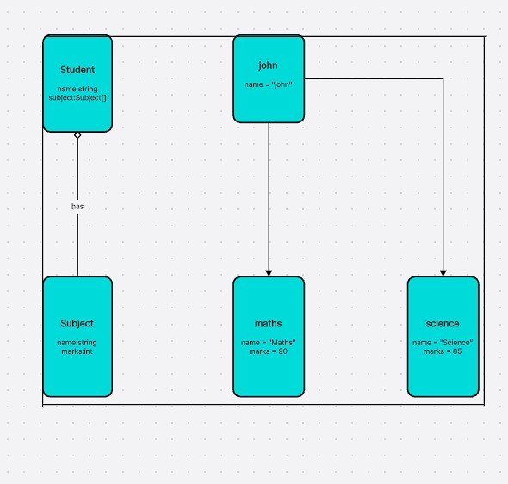

* **Sequence Diagram**
  + **Scenario**: A student requests their grade based on marks in subjects.
  + **Actors**: Student, GradeCalculator

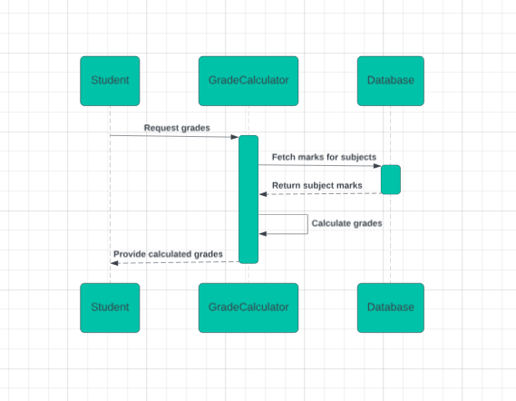

**Sample Problem 2: Grocery Store Bill Generation Application**

* **Class Diagram**
  + **Diagram Description**:
    - Classes: Customer, Product, BillGenerator
    - Relationships:
      * A Customer can purchase multiple Product items (Composition).
      * BillGenerator computes the total for the Customer.

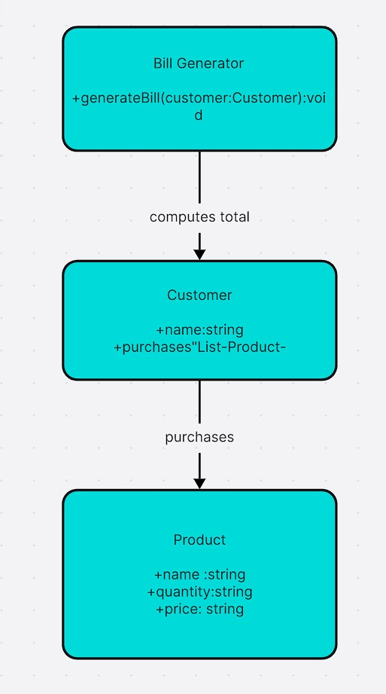

* **Object Diagram**
  + **Example**:
    - Customer: Alice
    - Products:
      * Apples (2 kg at $3 per kg)
      * Milk (1 liter at $2 per liter)

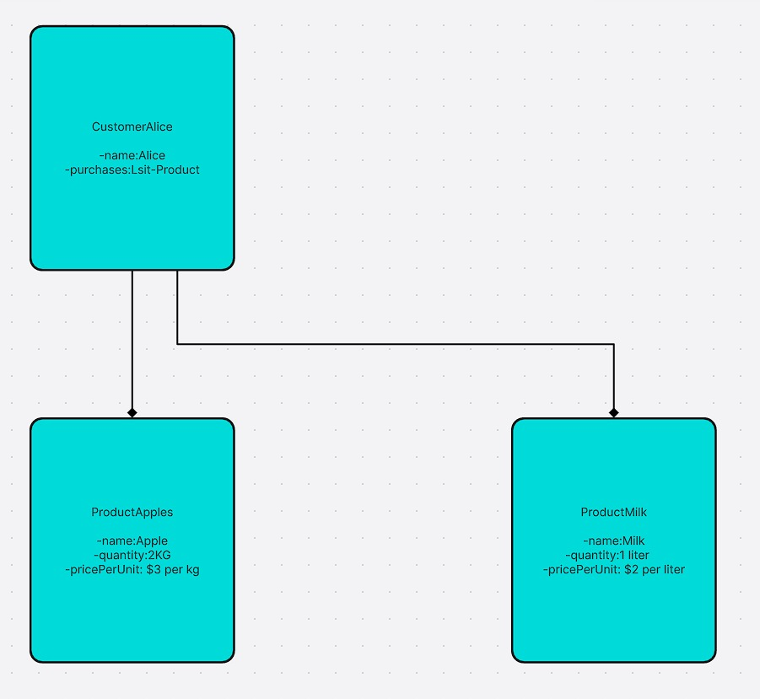

* **Sequence Diagram**
  + **Scenario**: A customer checks out at the grocery store, and the total bill is generated.
  + **Actors**: Customer, BillGenerator

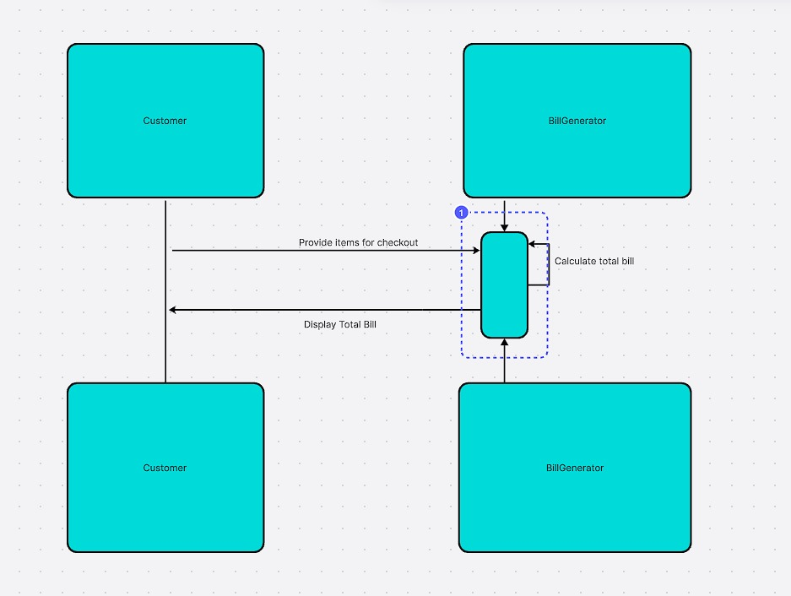

**Comparison of the Two Scenarios**

| **Feature** | **School Results Application** | **Grocery Store Bill Application** |
| --- | --- | --- |
| **Classes** | Student, Subject, GradeCalculator | Customer, Product, BillGenerator |
| **Relationships** | Aggregation | Composition |
| **Primary Functionality** | Calculate grade | Generate total bill |
| **Key Entities** | Students, Subjects, Grades | Customers, Products, Bills |