## **Update/Remove Data (add/delete/change points on the map)**

1. Once logged into ArcGis Online, navigate to Content tab
2. Select the Feature Layer of interest
   1. Select Export Data as CSV
   2. 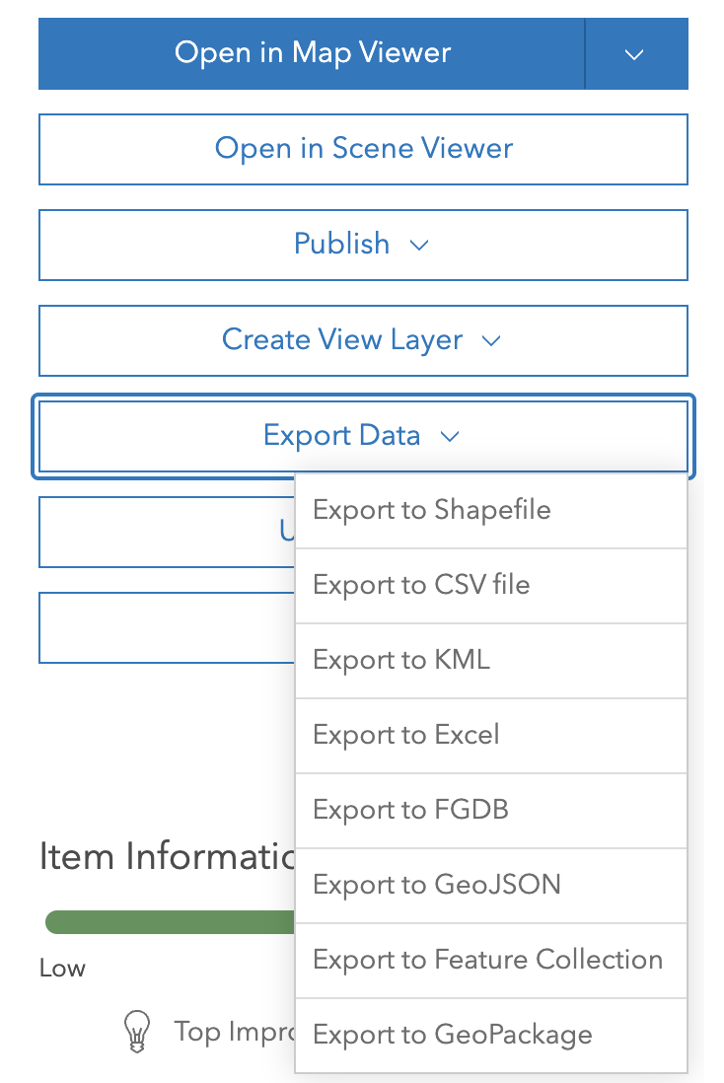
   3. Update your CSV file with the new points/remove points
      1. Make sure to add a Unique ID (next number in sequence is fine)
   4. Return to Feature Layer and select Update Data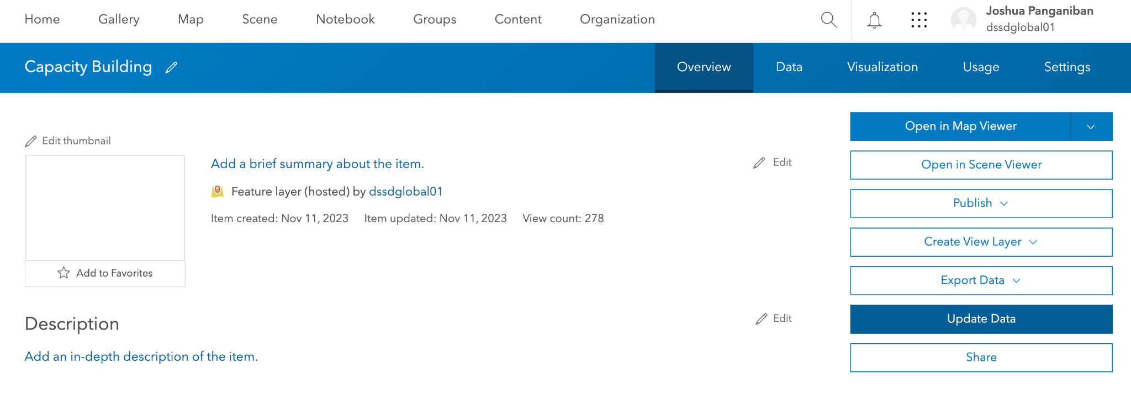
   5. Select what kind of update:
      1. **Add Feature** = Appending completely new point
      2. **Update Feature** = Change attribute of existing feature (update link, change photo, etc)
      3. **Add and Update** = Combination of adding a new point and editing existing points
      4. **Overwrite entire feature** = Replace a feature, delete a feature (appending a CSV where the point/s you want to delete are not present in the document will delete the feature)
   6. Continue with the selections

## **Change Symbology/Colors/Etc**

1. Once logged into ArcGis Online, navigate to Content tab
2. Select the [**mbbi_map**](https://dssdglobal.maps.arcgis.com/home/item.html?id=5cdcdaf60b6f4fa7aa46b61693c27e0a) layer
   1. 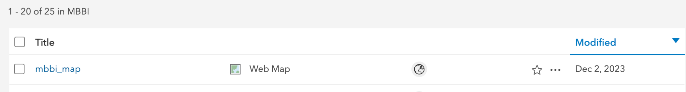
3. Open in map viewer
4. Select the layer you would like to edit in contents tab and select show properties
   1. 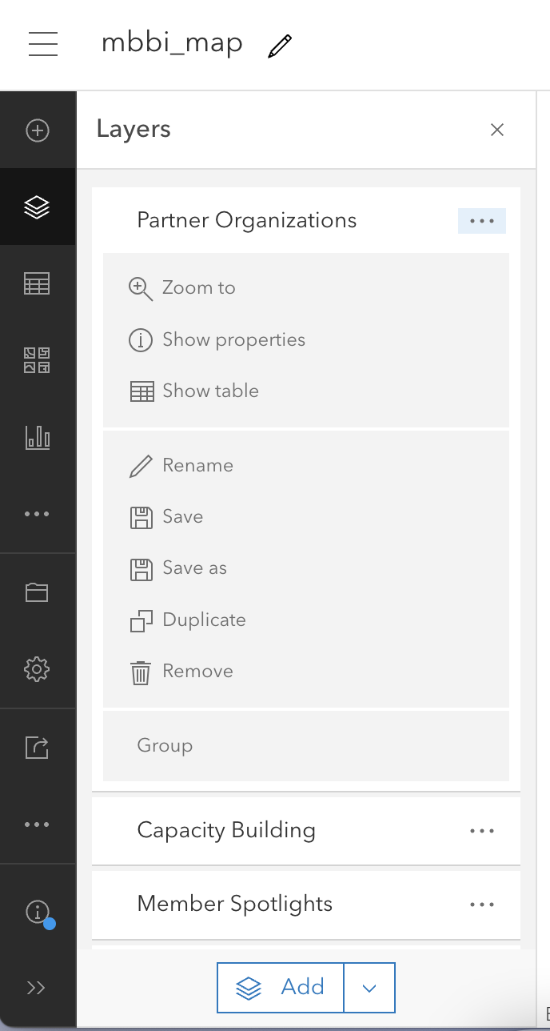
5. Select “Edit Layer Style” and configure desired setting
   1. 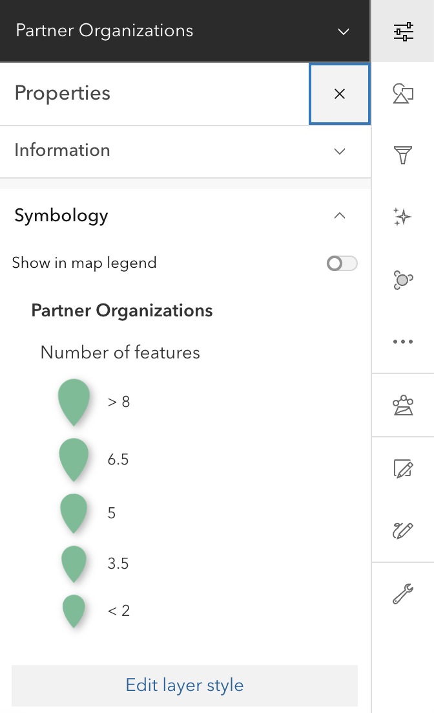
6. Click on Style Options on right hand side:
   * 1. 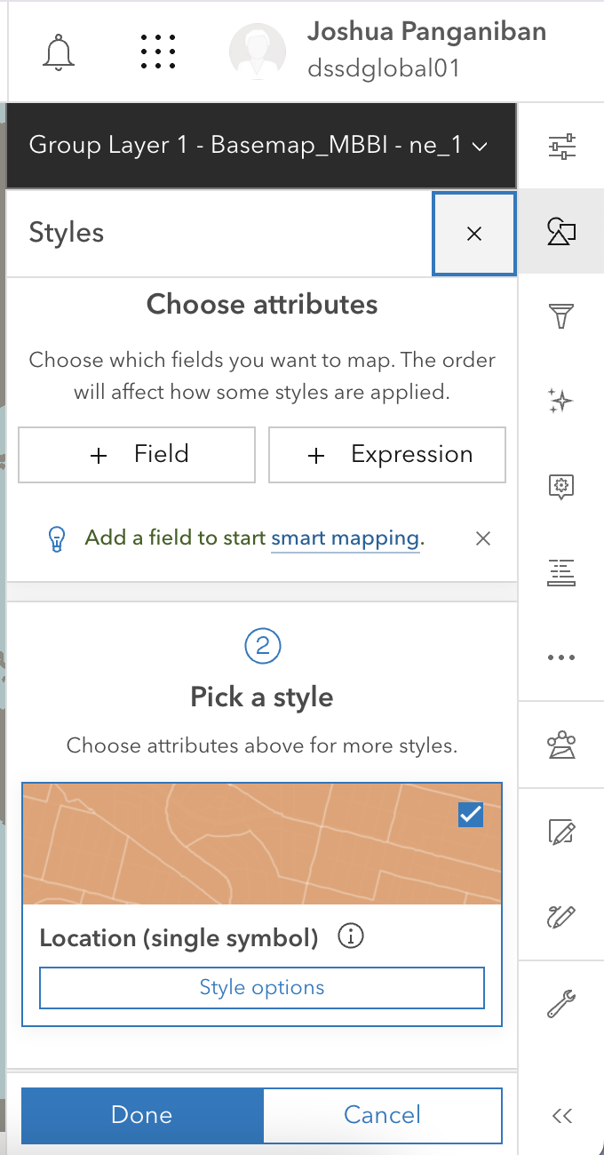
   1. Select Symbol Style & make edits to color:
      1. 